Grade 6
Unit 2Lesson 17CC BY NC Illustrative Mathematics, based on IM 6–8 Math, CC BY Open Up Resources.
Unit 2, Lesson 17

A Fermi Problem
Let’s solve a Fermi problem.
Grade 6
Unit 2Lesson 17CC BY NC Illustrative Mathematics, based on IM 6–8 Math, CC BY Open Up Resources.

17.1Problems to Ponder
Here are some questions.
- How many times does your heart beat in a month?
- How many hours of television do you watch in a year?
- How many tubes of toothpaste would you need in a lifetime?
- Is one month enough time to read the dictionary out loud?
- Is one gallon of hand sanitizer enough to sanitize the hands of everyone in the school over a school day?
- How long would it take to paddle across the Pacific Ocean?
- How long would it take to give every dog in America a bath?
Which question do you find most interesting? Which question do you find the least interesting? Be prepared to explain your reasoning.
Grade 6
Unit 2Lesson 17CC BY NC Illustrative Mathematics, based on IM 6–8 Math, CC BY Open Up Resources.

17.2Solving a Fermi Problem
- What are some smaller questions, or sub-questions, to figure out before solving the chosen Fermi problem? Record the Fermi problem and your sub-questions here.
- 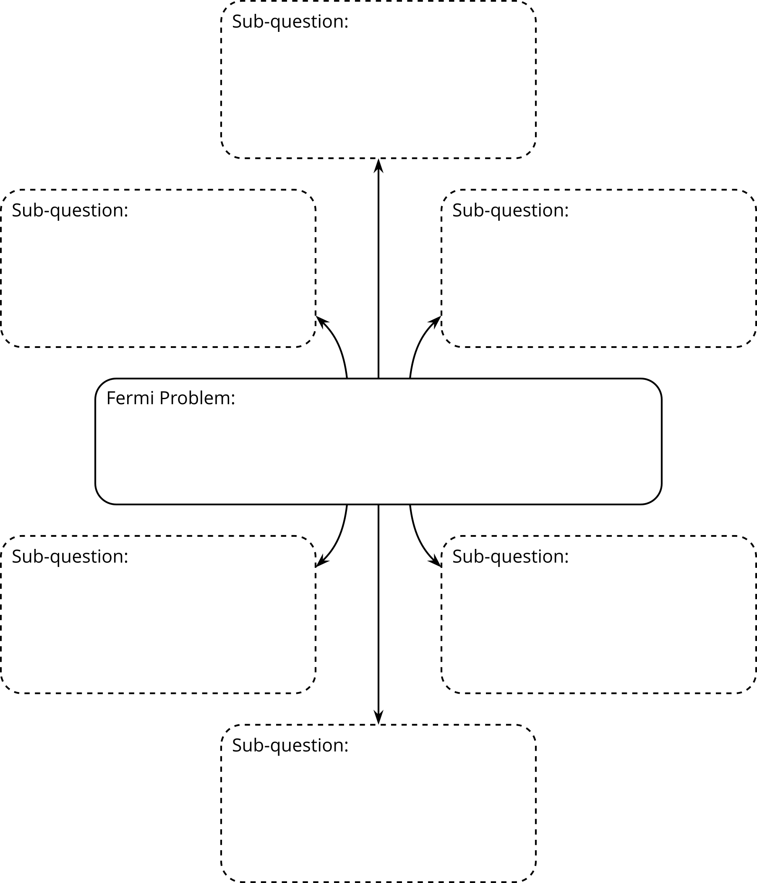
- Think about how the sub-questions should be organized. Label each sub-question to show the order in which they should be answered.
- If you notice a gap in your sub-questions (or that some information is needed before the next sub-question could be answered), write a new sub-question to fill the gap.
- Let’s start answering the sub-questions! Use the given organizer.
  - Write your sub-questions in order.
  - Find the information you need to answer each sub-question. Research, measure, estimate, and perform any necessary calculations.
  - Record any fact you find and any assumption you make.
- Fermi Problem:
- Sub-question 1:
- Facts or assumptions:
- Answer:
- Sub-question 2:
- Facts or assumptions:
- Answer:
- Sub-question 3:
- Facts or assumptions:
- Answer:
- Sub-question 4:
- Facts or assumptions:
- Answer:
- Sub-question 5:
- Facts or assumptions:
- Answer:
- Sub-question 6:
- Facts or assumptions:
- Answer:
- What is your answer to the Fermi problem? Explain or show your reasoning.
Grade 6
Unit 2Lesson 17CC BY NC Illustrative Mathematics, based on IM 6–8 Math, CC BY Open Up Resources.

17.3Researching Your Own Fermi Problem
- Brainstorm at least five Fermi problems that you want to research and solve. If you get stuck, consider using these starters:
  - How much (or how many) . . . would it take to . . . ?
  - How long would it take to . . . ?
  - Would . . . be enough to . . . ?
- Discuss your ideas with your teacher and then select one problem.
- What are some smaller questions, or sub-questions, to figure out before solving the chosen Fermi problem? Record the Fermi problem and the sub-questions here.
- Let’s start answering the sub-questions! Use the given organizer.
  - Write your sub-questions in order.
  - Find the information you need to answer each sub-question. Research, measure, estimate, and perform any necessary calculations.
  - Record any fact you find and any assumption you make.
- Fermi Problem:
- Sub-question 1:
- Facts or assumptions:
- Answer:
- Sub-question 2:
- Facts or assumptions:
- Answer:
- Sub-question 3:
- Facts or assumptions:
- Answer:
- Sub-question 4:
- Facts or assumptions:
- Answer:
- Sub-question 5:
- Facts or assumptions:
- Answer:
- Sub-question 6:
- Facts or assumptions:
- Answer:
- What is your answer to the Fermi problem? Explain or show your reasoning.

