Lesson 17: Compare Fractions
- Let’s compare more fractions in different situations.

Warm-up: Estimation Exploration: Ladybug Length
What is the length of this ladybug?
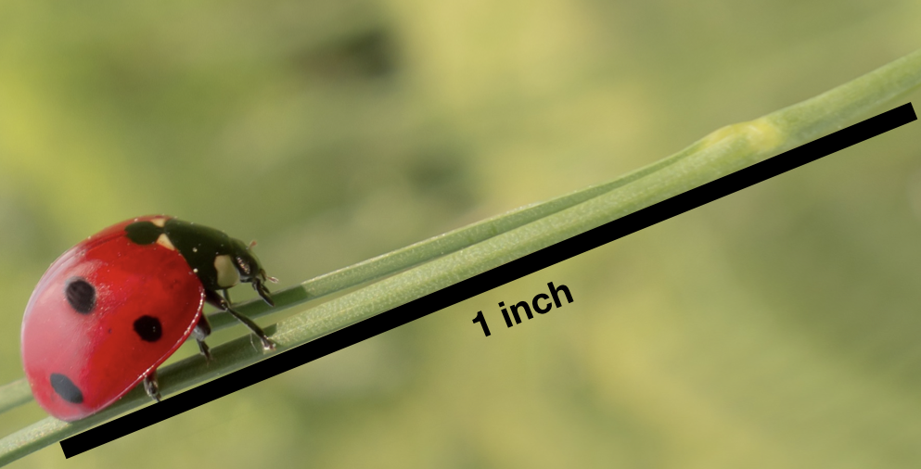
Record an estimate that is:
too low | about right | too high

17.1: Comparison Problems
For each problem:
- Answer the question and explain or show your reasoning.
- Represent your answer with a statement that uses the symbols >, <, or =.
- A beetle crawled $\frac{2}{8}$ of the length of a log. A caterpillar crawled $\frac{2}{3}$ of the length of the same log. Which insect crawled farther?
- A grasshopper is 4 centimeters long. A caterpillar is $\frac{12}{3}$ centimeters long. Which insect is longer?
- 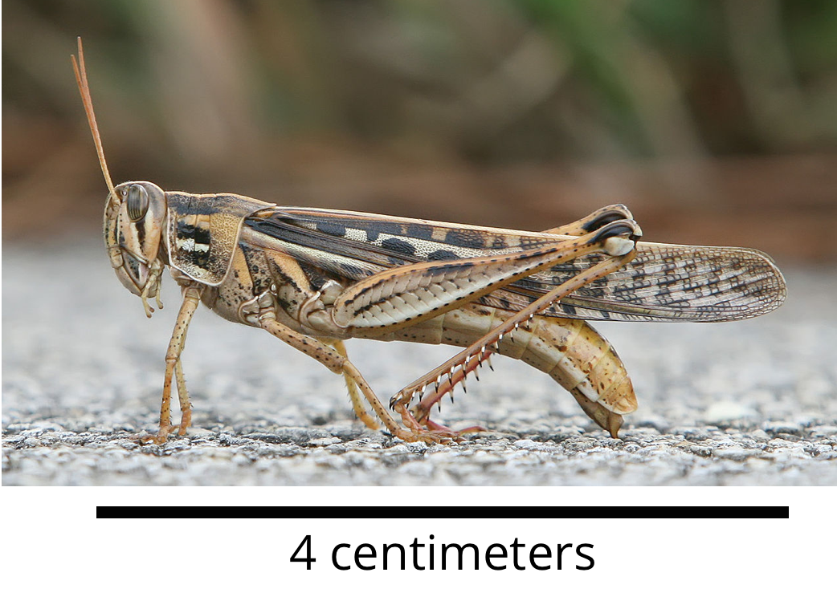
- A ladybug crawled $\frac{3}{8}$ the length of a branch. An ant crawled $\frac{5}{8}$ the length of the same branch. Which insect crawled farther?
- A grasshopper jumped $\frac{5}{8}$ the width of the sidewalk. A frog jumped $\frac{5}{6}$ the width of the same sidewalk. Which jumped a longer distance?

17.2: What Fraction Makes Sense?
- Oh, no! Some juice spilled on Noah’s fractions. Help him figure out what was written before the juice was spilled.
- Find as many numbers as you can to make each statement true. Explain or show your reasoning.

  - 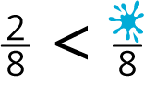

  - 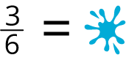

  - 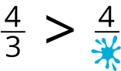
- For each fraction, find a fraction that is less, one that is greater, and one that is equivalent. Then, write a statement that uses the symbols >, <, or = to record each comparison.
  - Less than $\frac{4}{6}$: __________
  - Statement:
  - More than $\frac{4}{6}$: __________
  - Statement:
  - Equivalent to $\frac{4}{6}$: __________
  - Statement:
  - Less than $\frac{3}{4}$: __________
  - Statement:
  - More than $\frac{3}{4}$: __________
  - Statement:
  - Equivalent to $\frac{3}{4}$: __________
  - Statement:

17.3: Ultimate Locate and Label
Locate and label each fraction on the number line. Be prepared to share your reasoning.
$\frac{1}{2},\frac{3}{8},\frac{13}{8},\frac{2}{4},\frac{3}{4},\frac{9}{8},\frac{5}{4},\frac{12}{6},\frac{5}{2},\frac{9}{3},\frac{20}{8}$

Section Summary
Section Summary
In this section, we compared fractions with the same numerator or denominator and used the symbols >, =, or < to record our results. We used diagrams and number lines to represent our thinking.
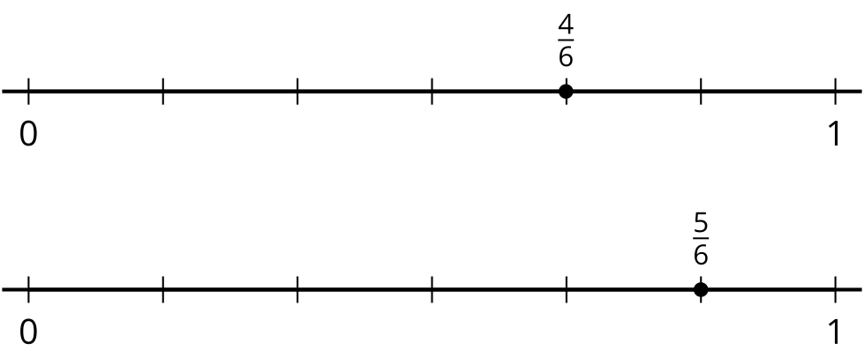
$\frac{4}{6}<\frac{5}{6}$
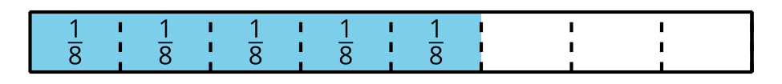


$\frac{5}{6}>\frac{5}{8}$
© CC BY 2021 Illustrative Mathematics®

