Grade 2
Unit 9Lesson 4CC BY NC 2024 Illustrative Mathematics®
Unit 9, Lesson 4

Measure and Plot
- Let’s create line plots and add and subtract measurements of length.
Grade 2
Unit 9Lesson 4CC BY NC 2024 Illustrative Mathematics®

Warm-up Notice and Wonder: Line Plots
What do you notice? What do you wonder?
patient | foot length in centimeters
A | 12
B | 18
C | 20
D | 18
E | 18
F | 20
G | 17
H | 21
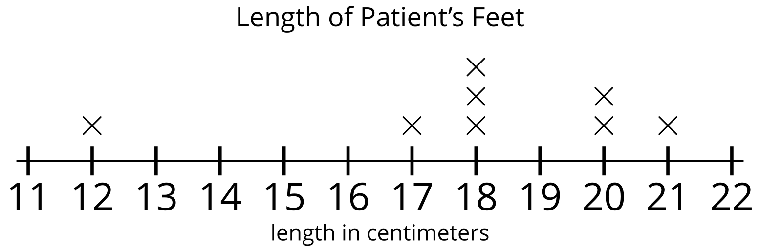
Grade 2
Unit 9Lesson 4CC BY NC 2024 Illustrative Mathematics®

Activity 1 May I Sharpen My Pencil?
group | length of pencils in centimeters |  |  |  | total length
A | 8 | 13 | 12 | 7
B | 9 | 15 | 7 | 10
C | 12 | 13 | 8 | 6
D | 9 | 9 | 11 | 13
E
- Measure the length of your pencil. _______ cm
- Write the lengths of your group’s pencils in the last row of the table.
- Find the total length of each group’s pencils.
Grade 2
Unit 9Lesson 4CC BY NC 2024 Illustrative Mathematics®

Activity 2 A Plot Twist
- Use the pencil measurements to create a line plot.
- What is the most common pencil length? _______
- What is the shortest pencil length? _______
- How many pencils are longer than 10 cm? _______
- What is the difference between the longest pencil and the shortest pencil? Write an equation to represent the difference.
- What is the difference between the shortest pencil and the length of an unsharpened pencil? Write an equation to represent the difference.

