Algebra 1
Unit 7Lesson 17CC BY NC 2024 Illustrative Mathematics®
Unit 7, Lesson 17

Changing the Vertex
- Let’s write new quadratic equations in vertex form to produce certain graphs.
Algebra 1
Unit 7Lesson 17CC BY NC 2024 Illustrative Mathematics®

17.1Graphs of Two Functions
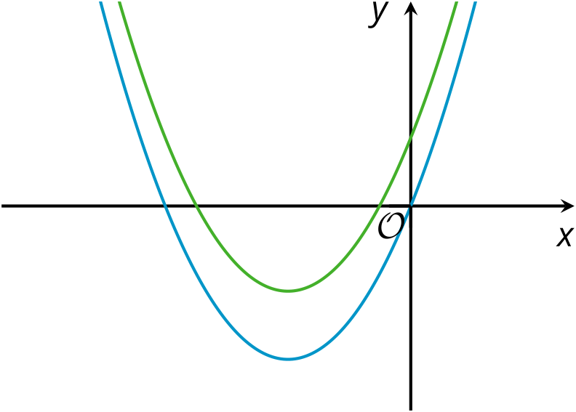
Here are graphs representing two functions, $f$ and $g$, given by $f\left(x\right)=x\left(x+6\right)$ and $g\left(x\right)=x\left(x+6\right)+4$.
- Which graph represents each function? Explain how you know.
- Where does the graph of $f$ meet the $x$-axis? Explain how you know.
Algebra 1
Unit 7Lesson 17CC BY NC 2024 Illustrative Mathematics®

17.2Shifting the Graph
- How would you change the equation $y=x^{2}$ so that the vertex of the graph of the new equation is located at the following coordinates and so that the graph opens as described?
  - $\left(0,11\right)$, opens upward
  - $\left(7,11\right)$, opens upward
  - $\left(7,\text{-}3\right)$, opens downward
- Use graphing technology to verify your predictions. Adjust your equations if necessary.
- Kiran graphed the equation $y=x^{2}+1$ and noticed that the vertex is at $\left(0,1\right)$. He changed the equation to $y={\left(x−3\right)}^{2}+1$ and saw that the graph shifted 3 units to the right and the vertex is now at $\left(3,1\right)$.
- Next, he graphed the equation $y=x^{2}+2x+1$ and observed that the vertex is at $\left(\text{-}1,0\right)$. Kiran thought, “If I change the squared term $x^{2}$ to ${\left(x−5\right)}^{2}$, the graph of $y={\left(x−5\right)}^{2}+2x+1$ will be 5 units to the right and the vertex will be at $\left(4,0\right)$.”
- Do you agree with Kiran? Explain or show your reasoning.
Algebra 1
Unit 7Lesson 17CC BY NC 2024 Illustrative Mathematics®

17.3A Peanut Jumping over a Wall
Mai is learning to create computer animation by programming. In one part of her animation, she uses a quadratic function to model the path of the main character, an animated peanut, jumping over a wall.
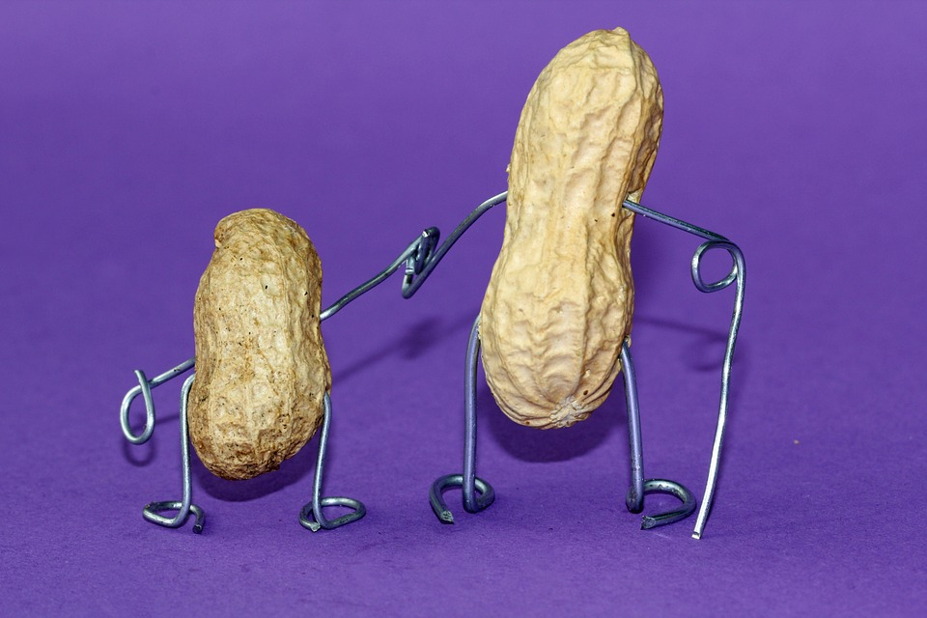
Mai uses the equation $y=\text{-}0.1{\left(x−h\right)}^{2}+k$ to represent the path of the jump. $y$ represents the height of the peanut as a function of the horizontal distance, $x$, that it travels.
On the screen, the base of the wall is located at $\left(22,0\right)$, with the top of the wall at $\left(22,4.5\right)$. The dashed curve in the picture shows the graph of 1 equation that Mai tried, where the peanut fails to make it over the wall.
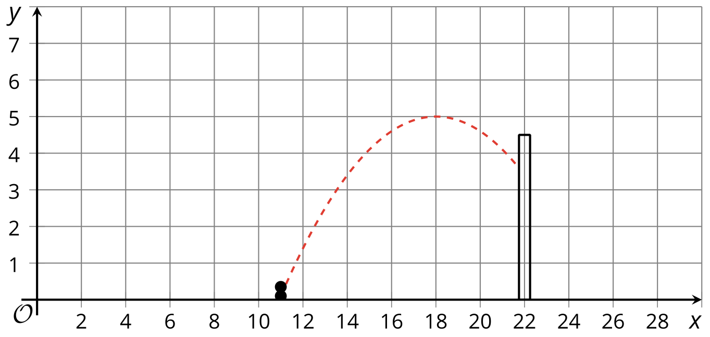
- What are the values of $h$ and $k$ in this equation?
- Starting with Mai’s equation, choose values for $h$ and $k$ that will guarantee that the peanut stays on the screen but also makes it over the wall. Be prepared to explain your reasoning.
Algebra 1
Unit 7Lesson 17CC BY NC 2024 Illustrative Mathematics®

17.4Smiley Face
Do you see 2 “eyes” and a smiling “mouth” on the graph? The 3 arcs on the graph all represent quadratic functions that were initially defined by $y=x^{2}$, but whose equations were later modified.
- Write equations to represent each curve in the smiley face.
- What domain is used for each function to create this graph?
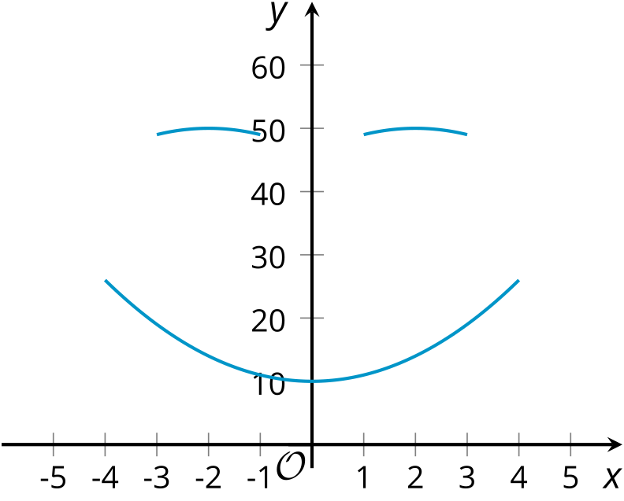

Lesson 17 Summary
The graphs of $y=x^{2}$, $y=x^{2}+12$ and $y={\left(x+3\right)}^{2}$ all have the same shape but their locations are different. The graph that represents $y=x^{2}$ has its vertex at $\left(0,0\right)$.
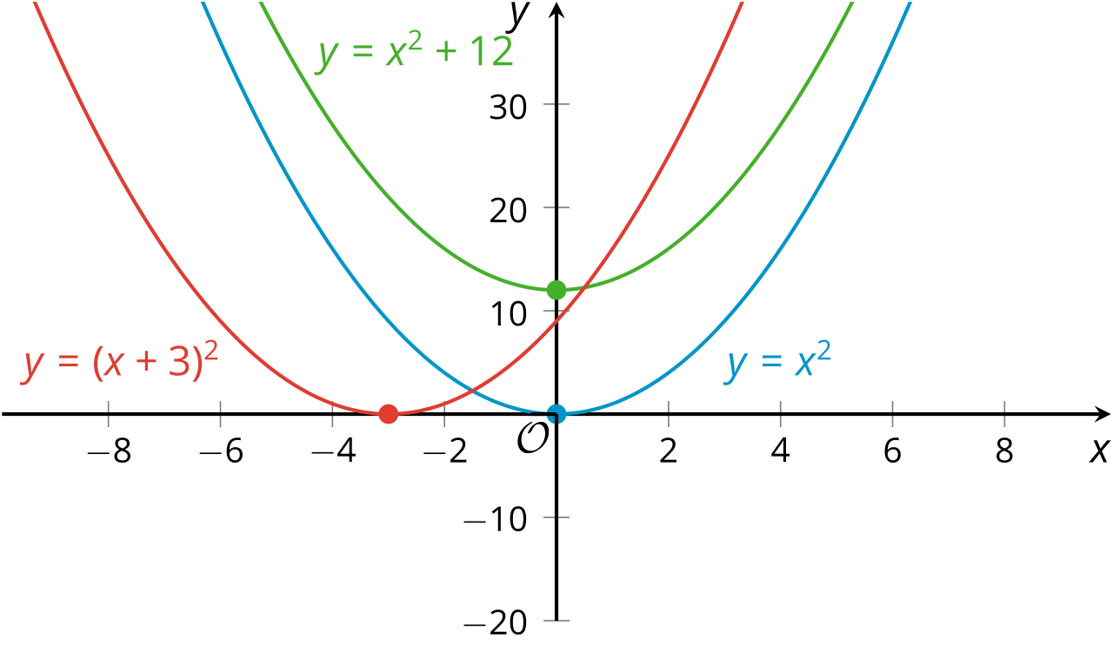
Notice that adding 12 to $x^{2}$ raises the graph by 12 units, so the vertex of that graph is at $\left(0,12\right)$. Replacing $x^{2}$ with ${\left(x+3\right)}^{2}$ shifts the graph 3 units to the left, so the vertex is now at $\left(\text{-}3,0\right)$.
We can also shift a graph both horizontally and vertically.
The graph that represents $y={\left(x+3\right)}^{2}+12$ will have the same shape as $y=x^{2}$ but it will be shifted 12 units up and 3 units to the left. Its vertex is at $\left(\text{-}3,12\right)$.
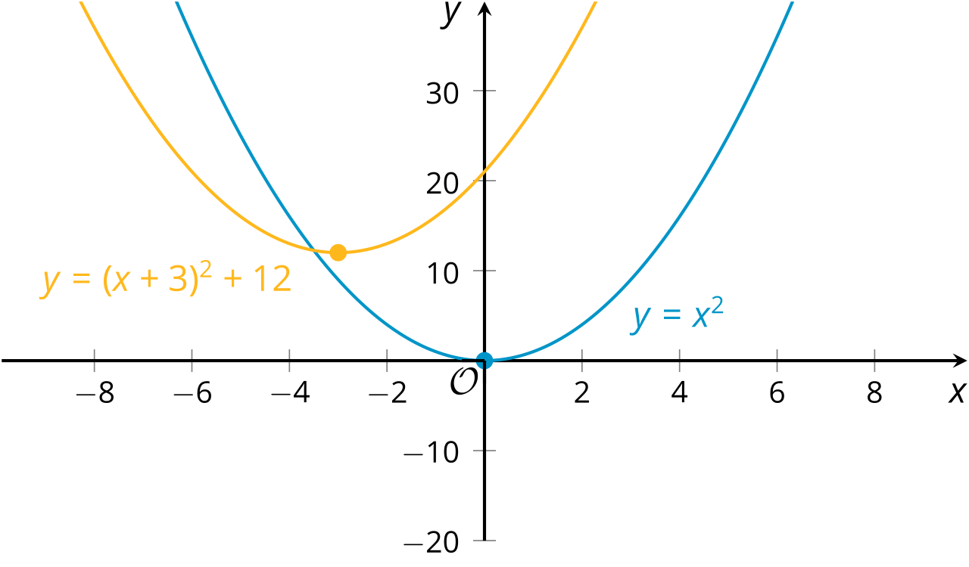
The graph representing the equation $y=\text{-}{\left(x+3\right)}^{2}+12$ has the same vertex at $\left(\text{-}3,12\right)$, but because the squared term ${\left(x+3\right)}^{2}$ is multiplied by a negative number, the graph is flipped over horizontally, so that it opens downward.
