Lesson 9: Composing Figures
Let’s use reasoning about rigid transformations to find measurements without measuring.

9.1: Angles of an Isosceles Triangle
Here is a triangle.
- Reflect triangle $ABC$ over line $AB$. Label the image of $C$ as $C^{′}$.
- Rotate triangle $ABC^{′}$ around $A$ so that $C^{′}$ matches up with $B$.
- What can you say about the measures of angles $B$ and $C$?
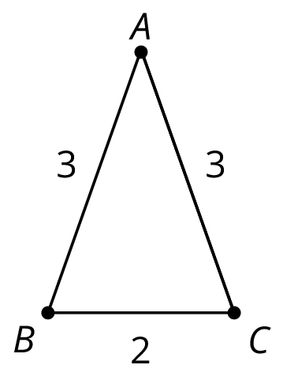

9.2: Triangle Plus One
Here is triangle $ABC$.
- Draw midpoint $M$ of side $AC$.
- Rotate triangle $ABC$ 180 degrees using center $M$ to form triangle $CDA$. Draw and label this triangle.
- What kind of quadrilateral is $ABCD$? Explain how you know.
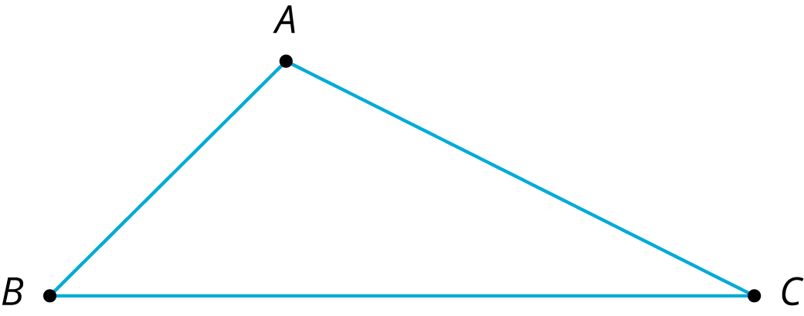

Are you ready for more?
In the activity, we made a parallelogram by taking a triangle and its image under a 180-degree rotation around the midpoint of a side. This picture helps you justify a well-known formula for the area of a triangle. What is the formula and how does the figure help justify it?

9.3: Triangle Plus Two
The picture shows 3 triangles. Triangle 2 and Triangle 3 are images of Triangle 1 under rigid transformations.
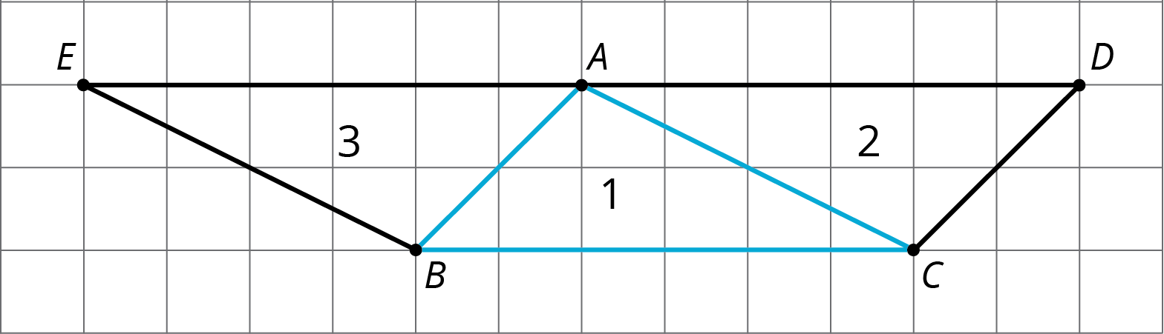
- Describe a rigid transformation that takes Triangle 1 to Triangle 2. What points in Triangle 2 correspond to points $A$, $B$, and $C$ in the original triangle?
- Describe a rigid transformation that takes Triangle 1 to Triangle 3. What points in Triangle 3 correspond to points $A$, $B$, and $C$ in the original triangle?
- Find two pairs of line segments in the diagram that are the same length, and explain how you know they are the same length.
- Find two pairs of angles in the diagram that have the same measure, and explain how you know they have the same measure.

9.4: Triangle ONE Plus
Here is isosceles triangle $ONE$. Its sides $ON$ and $OE$ have equal lengths. Angle $O$ is 30 degrees. The length of $ON$ is 5 units.
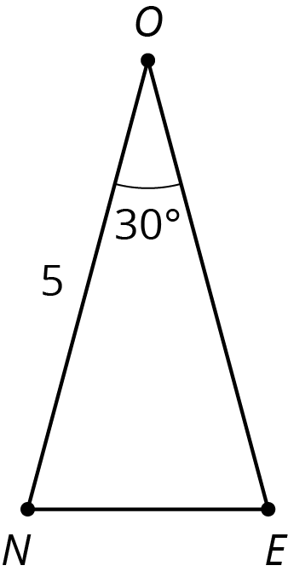
- Reflect triangle $ONE$ across segment $ON$. Label the new vertex $M$.
- What is the measure of angle $MON$?
- What is the measure of angle $MOE$?
- Reflect triangle $MON$ across segment $OM$. Label the point that corresponds to $N$ as $T$.
- How long is $\overset{¯}{OT}$? How do you know?
- What is the measure of angle $TOE$?
- If you continue to reflect each new triangle this way to make a pattern, what will the pattern look like?

Lesson 9 Summary
Earlier, we learned that if we apply a sequence of rigid transformations to a figure, then corresponding sides have equal length and corresponding angles have equal measure. These facts let us figure out things without having to measure them!
For example, here is triangle $ABC$.
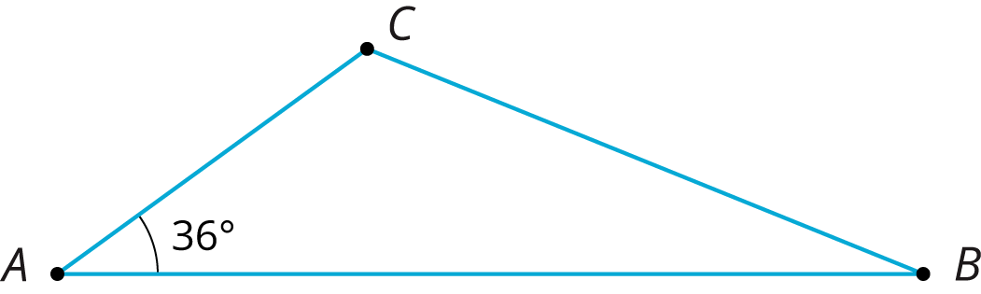
We can reflect triangle $ABC$ across side $AC$ to form a new triangle:
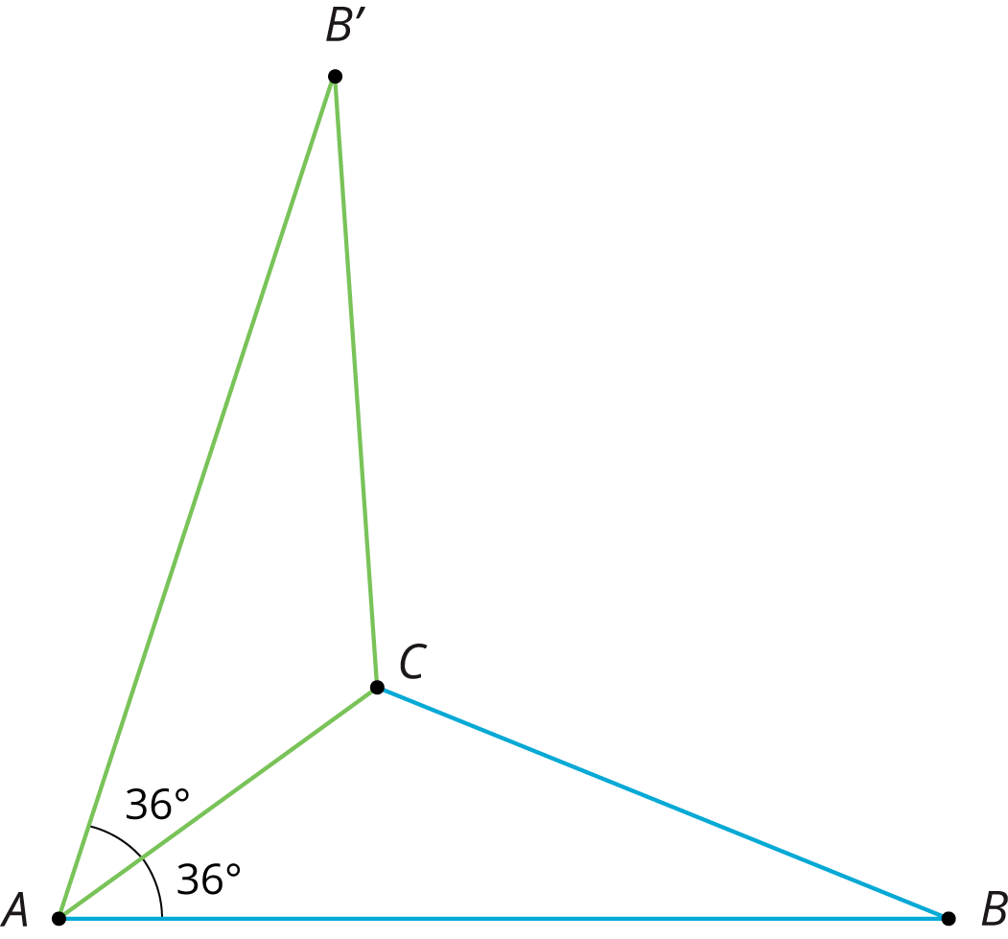
Because points $A$ and $C$ are on the line of reflection, they do not move. So the image of triangle $ABC$ is $AB^{′}C$. We also know that:
- Angle $B^{′}AC$ measures ${36}^{∘}$ because it is the image of angle $BAC$.
- Segment $AB^{′}$ has the same length as segment $AB$.
When we construct figures using copies of a figure made with rigid transformations, we know that the measures of the images of segments and angles will be equal to the measures of the original segments and angles.
© CC BY Open Up Resources. Adaptations CC BY IM.

