Lesson 17: Logarithmic Functions
- Let’s graph log functions.

17.1: Which One Doesn’t Belong: Functions
Which one doesn’t belong? Be prepared to explain your reasoning.
$f\left(x\right)=4⋅{\left(0.75\right)}^{x}$
$g\left(x\right)=4⋅e^{\left(0.75x\right)}$
$h\left(x\right)=\left(0.75\right)⋅4^{x}$
$j\left(x\right)=4⋅logx$

17.2: How Long Will It Take?
A colony of 1,000 bacteria doubles in population every hour.
- Explain why we can write $h=\log_{2}x$ to represent the number of hours, $h$, it takes for the one thousand bacteria to reach a population of $x$ thousand.
- Complete the table with the corresponding values of $h$.
- $x$ (thousands) | - 1 | - 2 | - 4 | - 8 | - 16 | - 50 | - 80
- $h$ (hours)
- Plot the pairs of values on the coordinate plane. Make two observations about the graph.
- 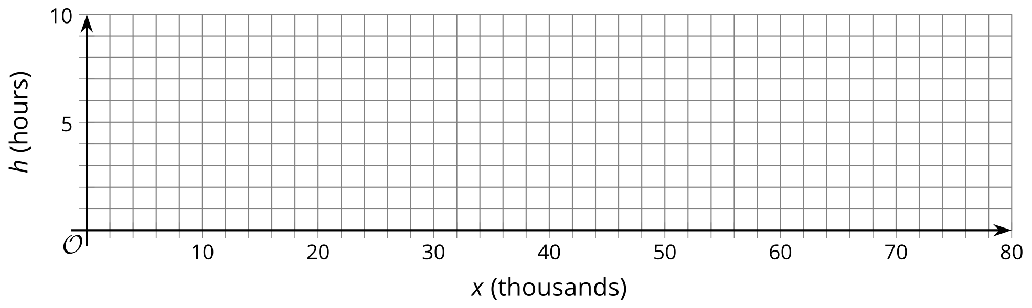
- Use the graph to estimate the missing values in the table.
- $x$ (thousands) | - 10 | - 24 | - 72
- $h$ (hours)

17.3: Another Logarithmic Function
Earlier we saw that $h=\log_{2}x$ represents the number of hours for 1 thousand bacteria, doubling every hour, to reach a population of $x$, in thousands.
- Suppose the function $d$, defined by $d\left(x\right)=\log_{10}x$, represents the number of days it takes 1 thousand of another species of bacteria to reach a population of $x$, in thousands. How is this population of bacteria growing?
- Graph $d$ using graphing technology. Make two observations about the graph.
- Use your graph to estimate the values of $d\left(50\right)$ and $d\left(20,​000\right)$. (Adjust your graphing window as needed.) Explain what each value means in this situation.
- Estimate or find the population after 5 days.

Are you ready for more?
- Without graphing, how do you think the graphs of the equations $y=\log_{2}\left(x\right)$ and $y=\log_{10}\left(x\right)$ compare? Do they ever meet?
- Graph both equations on the same axes to test your conjectures.
- 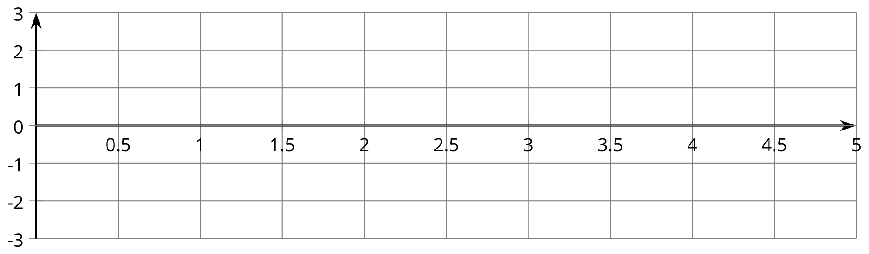

Lesson 17 Summary
Earlier we have studied exponential relationships where the input values are the exponent in the function. Sometimes we want to express an exponential relationship where the values we want to find, the outputs, are the exponents. A logarithmic function can help us do that.
For example: Suppose the population of a town starts at one thousand and doubles every decade since first measured. We can write $P=1⋅2^{d}$ or $P=2^{d}$ to represent the population, in thousands, after $d$ decades.
But if we want to know how long, in decades, it would take to reach certain population sizes, in thousands, we can write a logarithmic function $d=\log_{2}P$. In this function, the input is $P$, population in thousands, and the output is $d$, time in decades. Here is a graph representing that function.
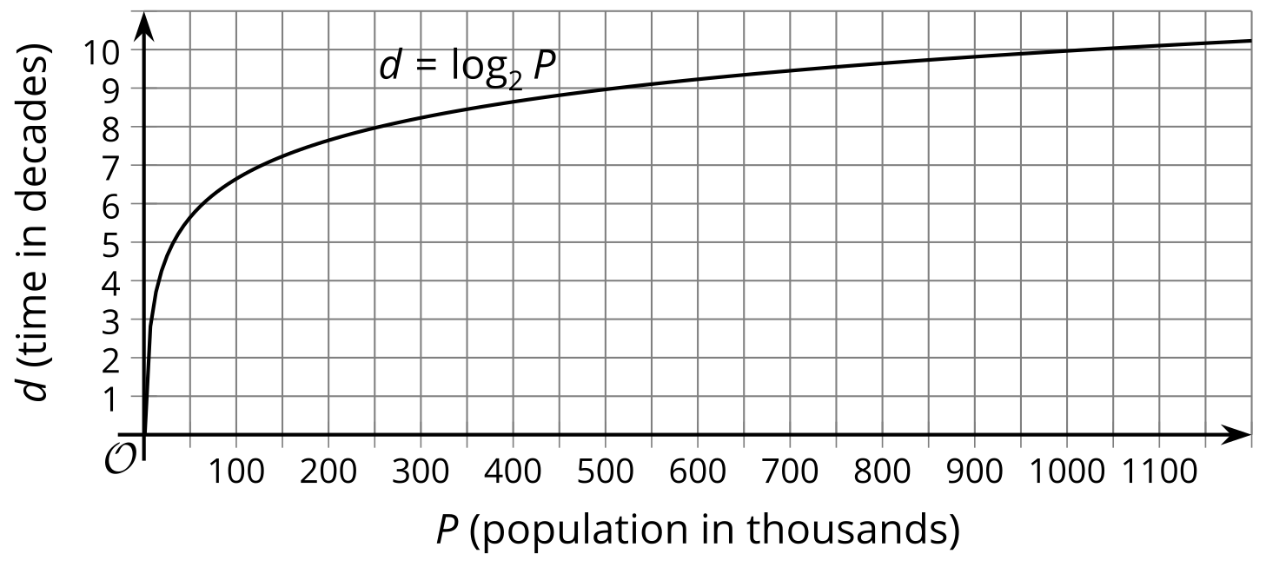
We can use the graph to estimate the answer to a question such as, “How many decades will it take for the population to reach a million?” In this case, the answer is about 10 decades, because one million is 1,000 thousands and $\log_{2}1,​000≈10$ (or, thinking in terms of powers of 2, we know that $2^{10}=1,​024$).
Suppose the population of that town expands by a factor of 10 every decade instead of by a factor of 2. The function representing the time it takes to reach a certain population, in thousands, would be $d=\log_{10}P$.
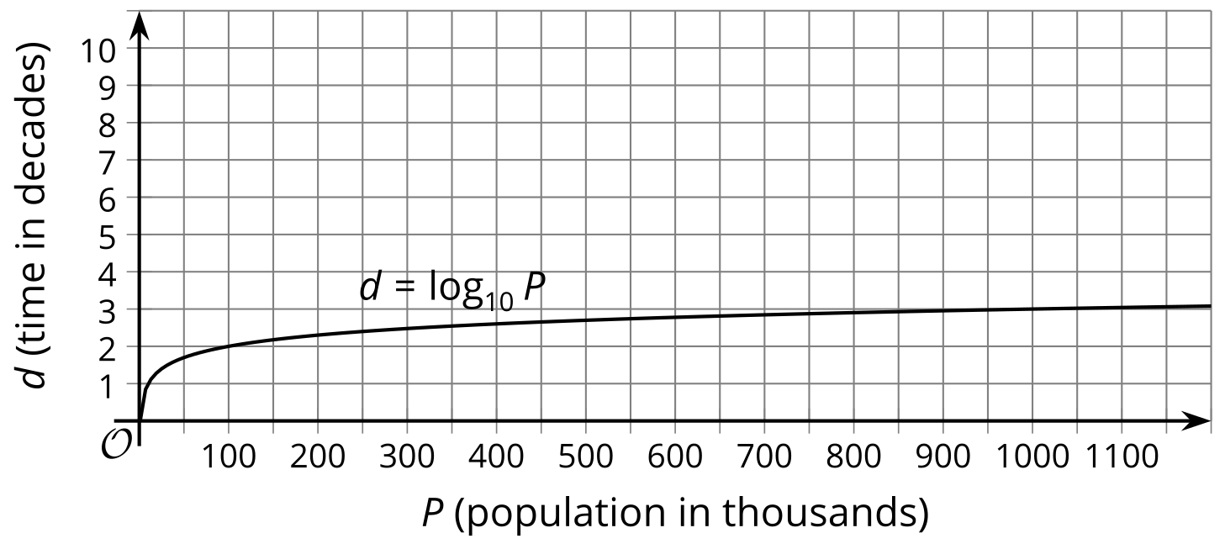
From the graph, we can see that it takes only 3 decades to reach 1,000 thousands, because $\log_{10}1,​000=3$ (or ${10}^{3}=1,​000$).
© CC BY 2019 by Illustrative Mathematics®

