Lesson 6: Compongamos y descompongamos figuras

Standards Alignments
Building On | 1.G.A.2
Addressing | 2.G.A.1
Building Towards | 2.G.A.3

Teacher-facing Learning Goals
- Compose new shapes from equal-size smaller shapes, and identify the shapes.

Student-facing Learning Goals
- Usemos figuras pequeñas de igual tamaño para hacer otras figuras.

Lesson Purpose
The purpose of this lesson is for students to compose shapes and to recognize shapes that are made up of equal-size shapes.
In previous grades, students learned that shapes can be made up of other shapes. In previous lessons, students identified shapes based on the number of sides and corners and drew shapes having specific attributes.
In this lesson, students continue to practice identifying shapes based on their attributes using the vocabulary from previous lessons. They also extend their understanding of the attributes of shapes by considering how a shape may be composed of other shapes. In particular, this lesson focuses on composing a shape from the same equal-size shape. This lesson prepares students for partitioning shapes into equal-size pieces and naming equal-size pieces in upcoming lessons.

Access for:

Students with Disabilities
- Representation (Activity 1)

English Learners
- MLR8 (Activity 1)

Instructional Routines
Notice and Wonder (Warm-up)

Materials to Gather
- Pattern blocks: Activity 1, Activity 2

Materials to Copy
- Compose a Butterfly, Spanish (groups of 2): Activity 1
- Centimeter Dot Paper - Standard (groups of 1): Activity 2
- Isometric Dot Paper - Standard (groups of 1): Activity 2

Lesson Timeline
Warm-up | 10 min
Activity 1 | 15 min
Activity 2 | 20 min
Lesson Synthesis | 10 min
Cool-down | 5 min

Teacher Reflection Question
In the first section, students spent time describing and drawing shapes with given attributes. How did this work help prepare them for composing and decomposing shapes in this lesson?

Cool-down
(to be completed at the end of the lesson) 5min
Busca figuras de igual tamaño

Standards Alignments
Building On | 1.G.A.2
Addressing | 2.G.A.1

Student-facing Task Statement
- Marca las figuras que están compuestas solamente por figuras más pequeñas, todas de igual tamaño.
- 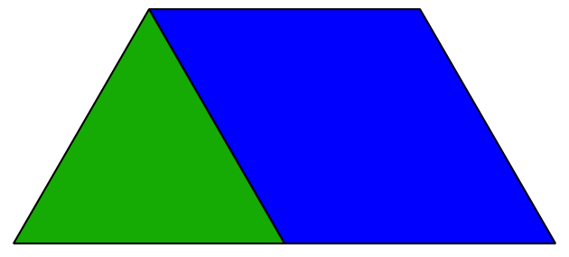
- 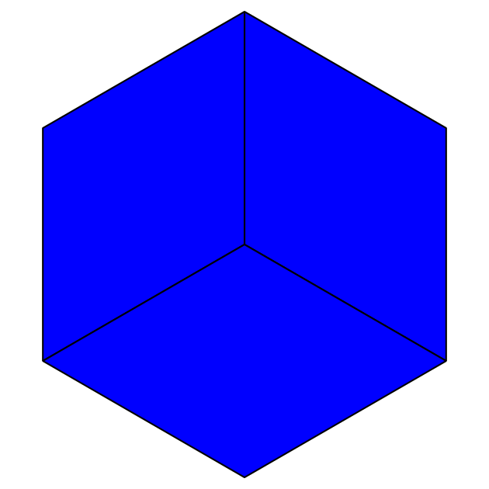
- 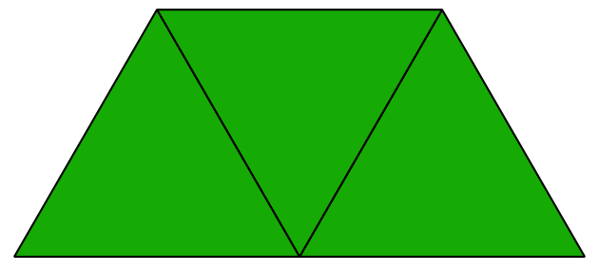
- 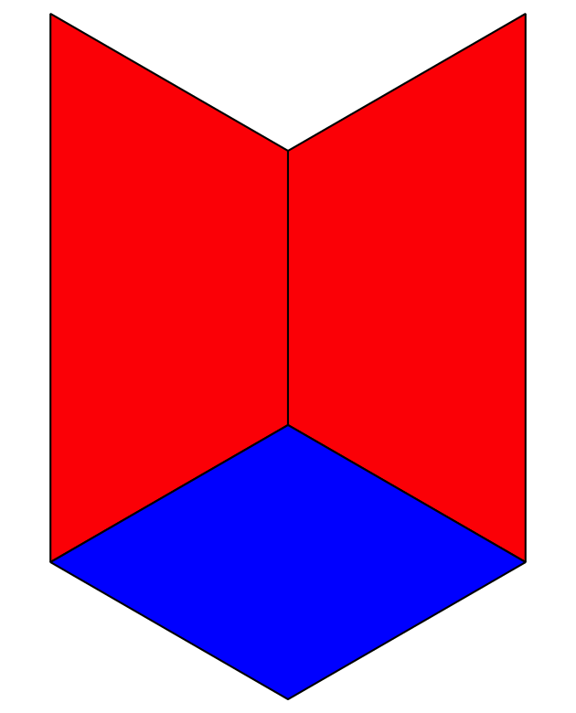
- 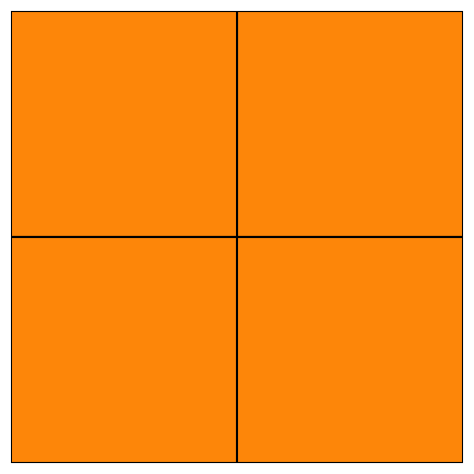
- Escoge 1 figura que hayas marcado y describe las figuras que la componen.
- El ___________________________________________________ está formado por
- ______________________________________________________________________.

Student Responses

- Sample response: The hexagon is composed of 3 quadrilaterals or rhombuses.

