Grade 6
Unit 9Lesson 2CC BY NC Illustrative Mathematics, based on IM 6–8 Math, CC BY Open Up Resources.
Unit 9, Lesson 2

Energy Flow
Let's compare numbers and rates.
Grade 6
Unit 9Lesson 2CC BY NC Illustrative Mathematics, based on IM 6–8 Math, CC BY Open Up Resources.

2.1Know the Flow
Andre, Lin, and Kiran are studying their water usage from showers. They need to find the flow rate of their shower heads, which measures how much water flows out when the shower head is turned to the maximum. Flow rate is measured in gallons per minute.
To collect data, each student turns on the shower head to the maximum and measures the time it takes to fill a container of a known volume.
- Andre fills a 5-gallon container in 2 minutes.
- Lin fills a 3-gallon container in $\frac{3}{4}$ minute.
- Kiran fills a 1.5-gallon container in $\frac{1}{2}$ minute.
For each question, explain or show your reasoning.
- Whose shower head has the highest flow rate?
- If the students wish to limit their water use to no more than 10 gallons a shower, to what amount of time do they need to limit their shower?
- The shower head in one student's home was on for a total of 19.5 minutes and 58.5 gallons of water was used. Whose home was that?

Are you ready for more?
To help conserve water, there are laws that specify the maximum flow rate of shower heads.
- By federal law, the flow rate of new shower heads made in 1992 or later cannot exceed 2.5 gallons per minute.
- The shower head in Lin’s home is used for about 21 minutes a day. If her family switches to a new shower head, how would their daily water use change? Explain or show your reasoning.
- Some state governments specify even lower flow rates than the federal law. For example, California, Hawaii, and Washington require a maximum flow rate of 1.8 gallons per minute.
- Andre’s family uses about 45 gallons of water for showers each day. How much water would they save each month by switching to a newer shower head with a flow rate of 1.8 gallons per minute? Explain or show your reasoning.
Grade 6
Unit 9Lesson 2CC BY NC Illustrative Mathematics, based on IM 6–8 Math, CC BY Open Up Resources.

2.2Power Sources, Power Uses
For each question, explain or show your reasoning. Organize it so it can be followed by others. If you get stuck, consider drawing a double number line diagram, table, or tape diagram.
- A small building gets its electricity from two sources: solar panels and a power company. The ratio of electricity from solar panels to the electricity from the power company is 4 to 3.
- In a typical week, the building uses 42 kilowatt-hours (kWh) of electricity. How many kWh of electricity is from solar panels?
- 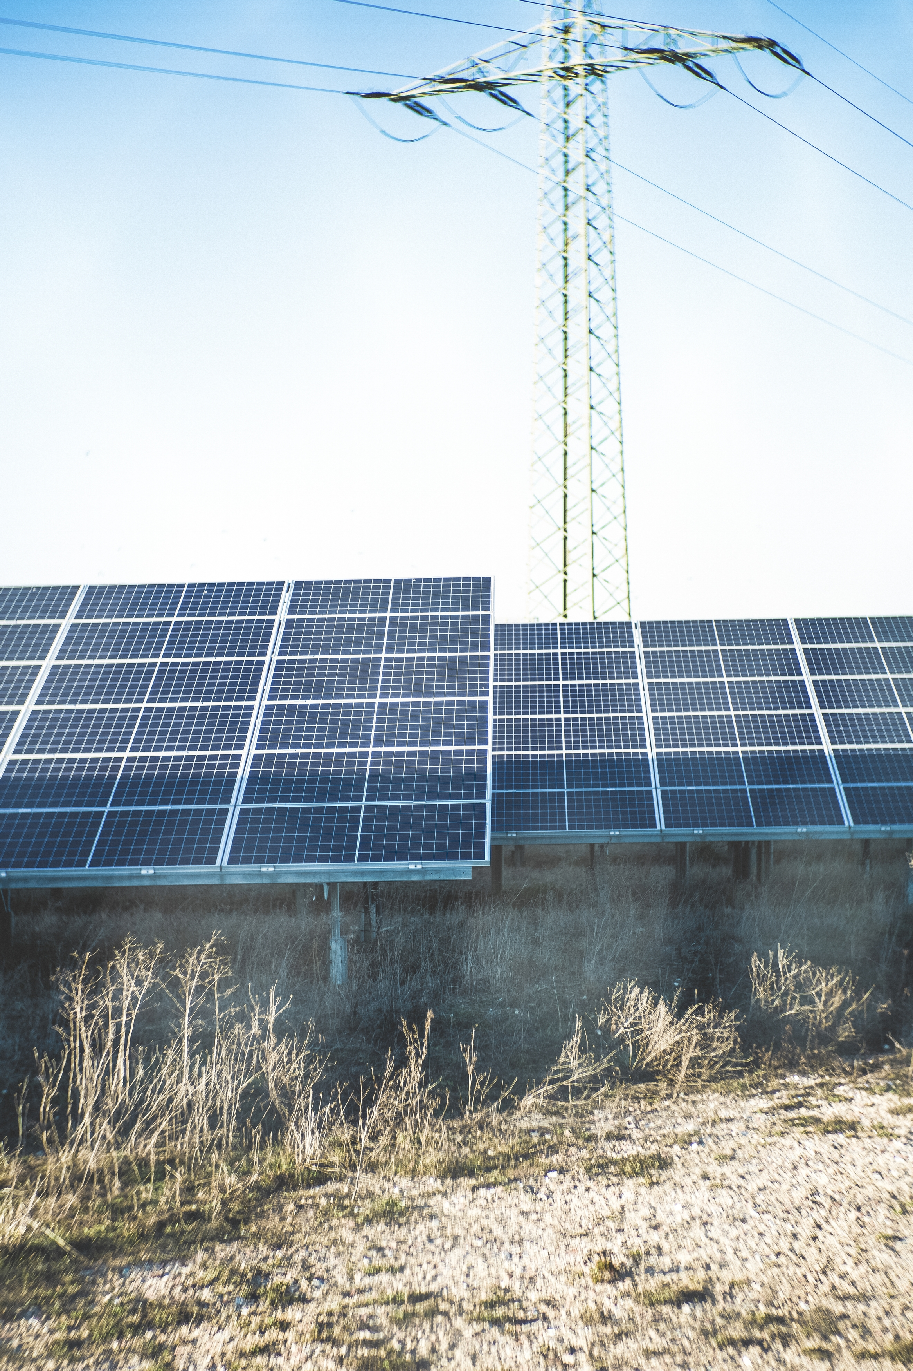
- The building has two rooms: One is cooled with a ceiling fan and the other with an air conditioner. Both appliances are turned on and off at the same time. It takes 0.2 kWh to power the fan for 6 hours and 4 kWh to power the air conditioner for 6 hours.
- During a warm week, the fan and air conditioner used a total of 42 kWh of electricity. For how many hours were they on?

