Unit 2 Lesson 1: Representations of Fractions (Part 1)

WU What Do You Know About $\frac{1}{2}$? (Warm up)

Student Task Statement
What do you know about $\frac{1}{2}$?

1 Fraction Strips

Student Task Statement
Your teacher will give you strips of paper. Each strip represents 1.
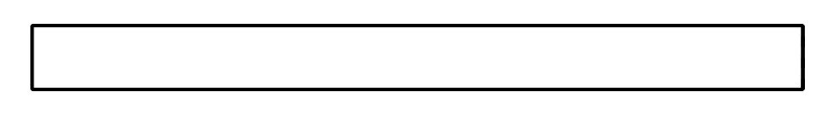
- Use the strips to represent halves, fourths, and eighths.
- Use one strip for each fraction and label the parts.
- What do you notice about the number of parts or the size of the parts? Make at least two observations.

Activity Synthesis
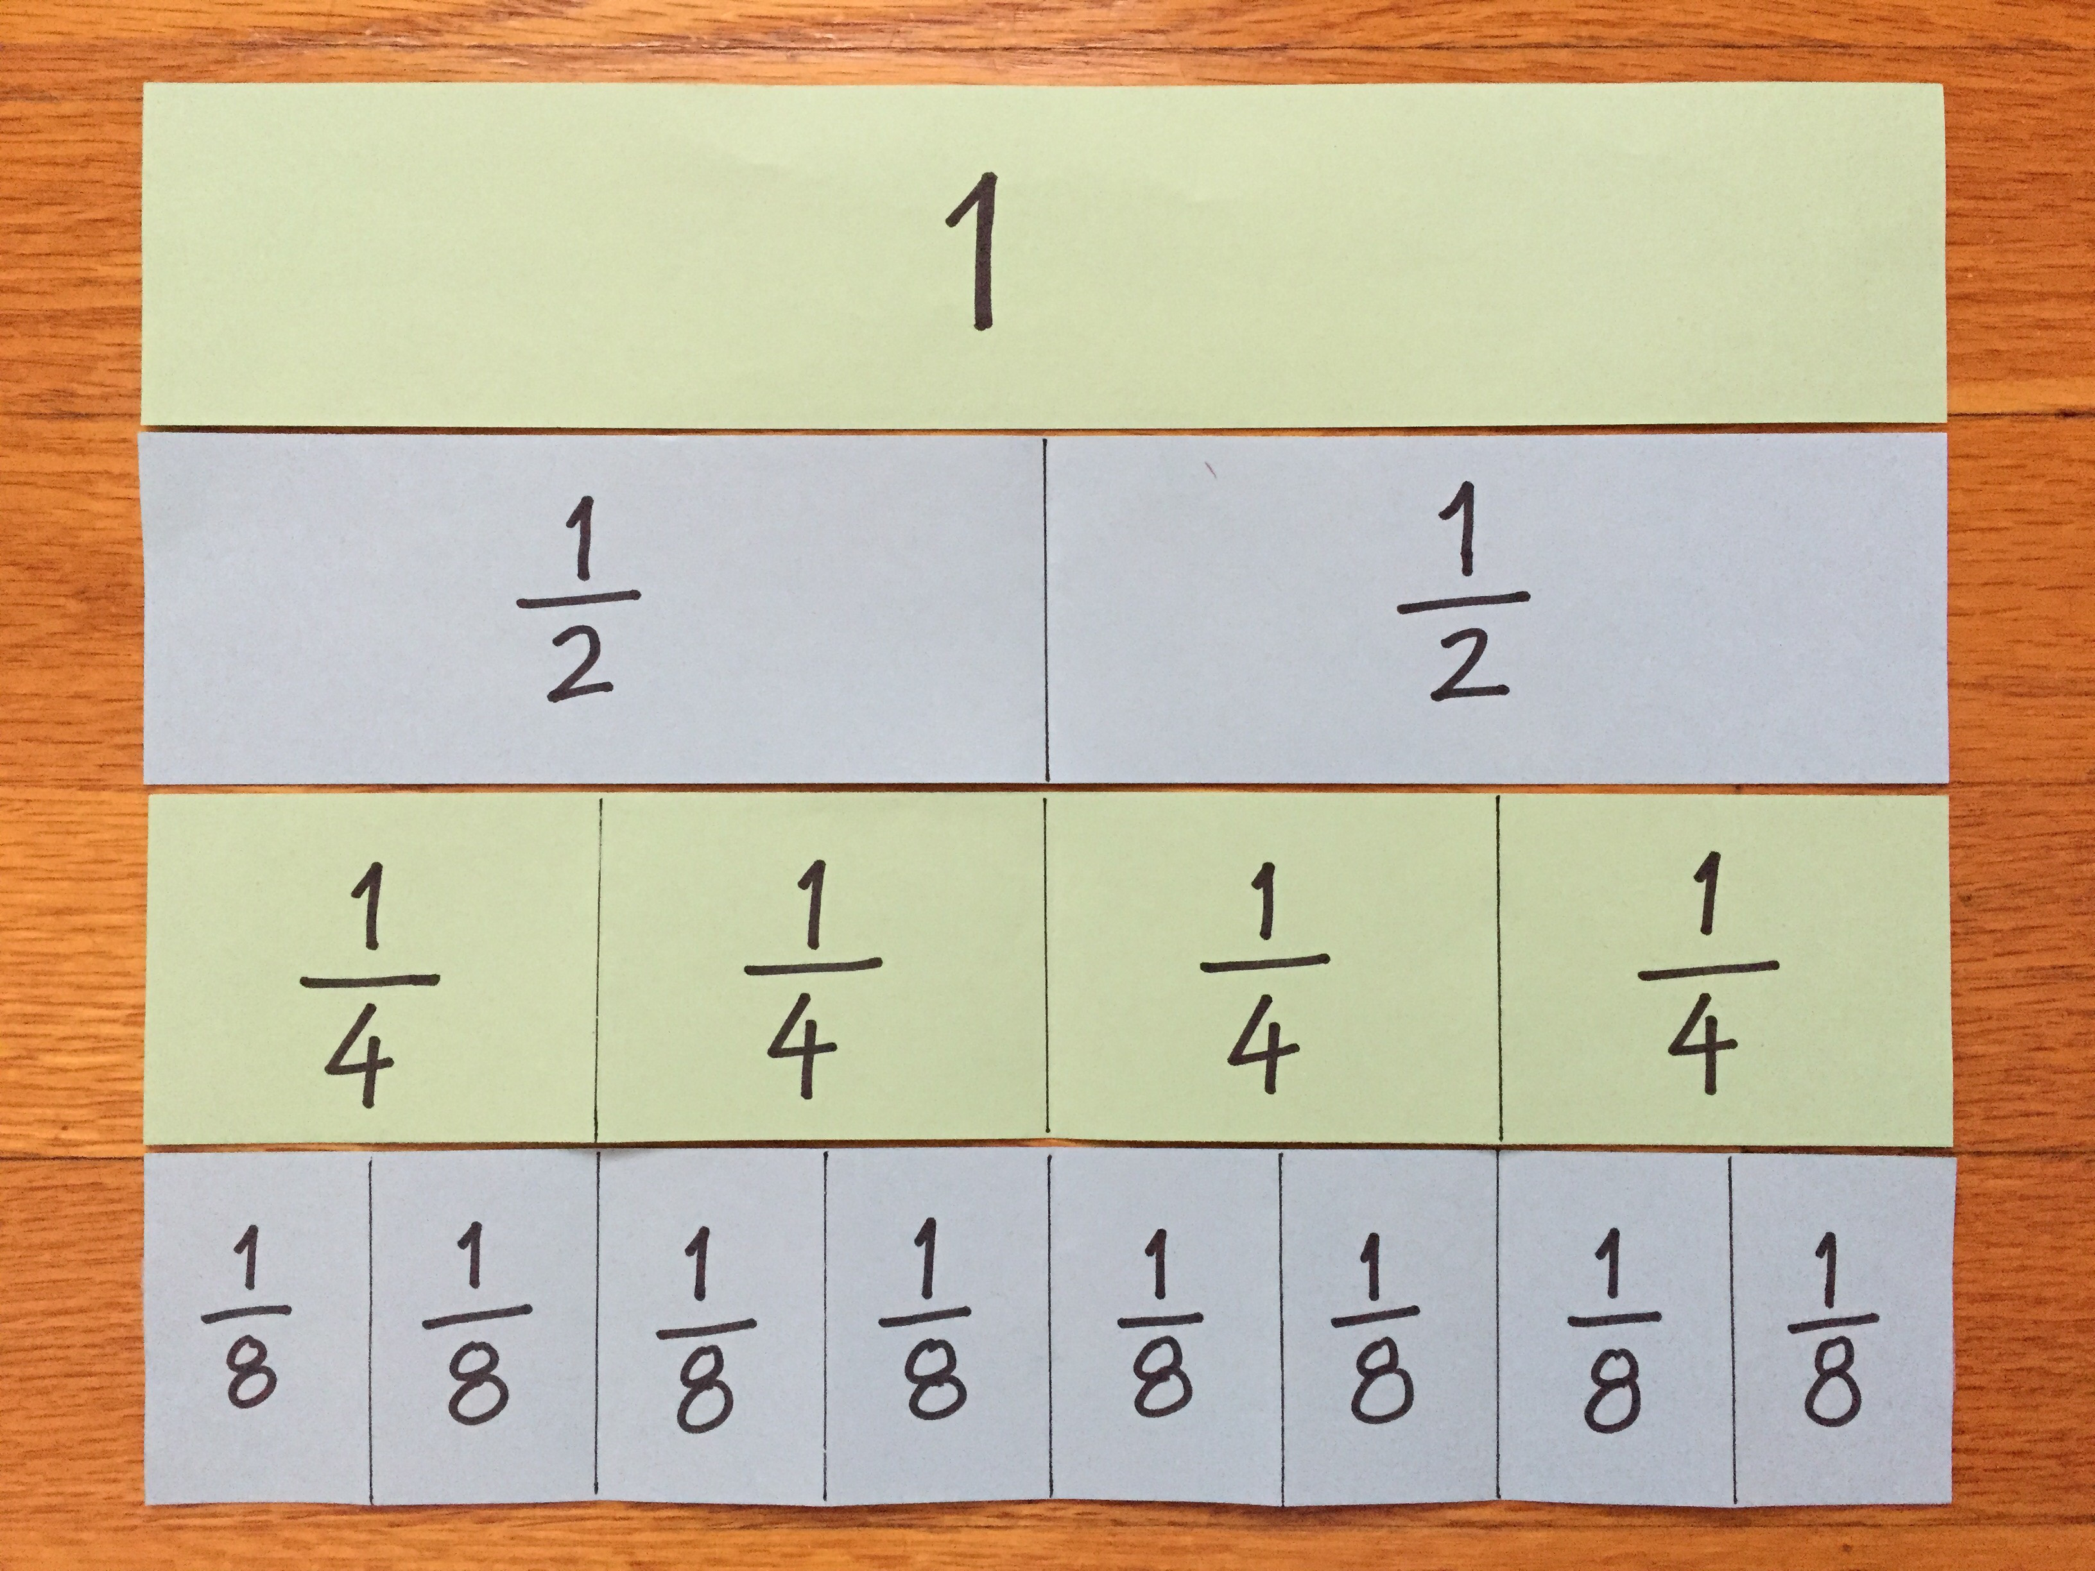

2 Fractions, Represented

Student Task Statement
- If each full diagram represents 1, what fraction does each shaded part represent?
  - 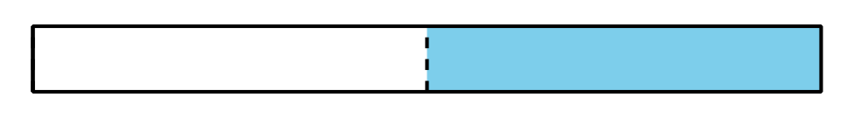
  - 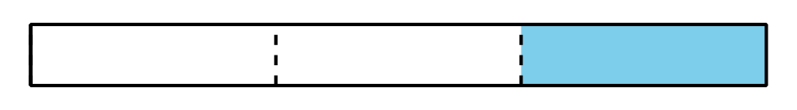
  - 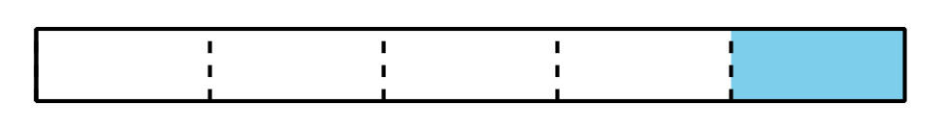
- Here are four blank diagrams. Each diagram represents 1. Partition each diagram and shade one part so that the shaded part represents the given fraction.
  - $\frac{1}{6}$
  - $\frac{1}{8}$
  - $\frac{1}{10}$
  - $\frac{1}{12}$
- Suppose you are creating a representation of $\frac{1}{20}$ using the same blank diagram. Would the shaded part be larger or smaller than the shaded part in the diagram of $\frac{1}{10}$? Explain how you know.
© CC BY 2021 Illustrative Mathematics®

