Lesson 13: Usemos gráficas de barras para comparar

Standards Alignments
Addressing | 2.MD.D.10, 2.OA.B.2

Teacher-facing Learning Goals
- Solve Compare problems with an unknown difference within 20.
- Write equations to represent Compare problems.

Student-facing Learning Goals
- Usemos gráficas de barras para resolver problemas de comparación.

Lesson Purpose
The purpose of this lesson is for students to make sense of and solve Compare problems using the structure of a bar graph and equations.
In grade 1, students use the relationship between addition and subtraction to solve and represent Compare problems. They create diagrams and write equations to represent how they think about the quantities within the Compare problems. In this lesson, students interpret bar graphs and use their visual structure to compare quantities. They write equations to represent comparisons and connect these equations to the structure of the bar graph (MP2). In upcoming lessons, students will use bar graphs to make sense of tape diagrams that represent Compare problems.

Access for:

Students with Disabilities
- Representation (Activity 2)

English Learners
- MLR8 (Activity 1)

Instructional Routines
True or False (Warm-up)

Lesson Timeline
Warm-up | 10 min
Activity 1 | 15 min
Activity 2 | 20 min
Lesson Synthesis | 10 min
Cool-down | 5 min

Teacher Reflection Question
In future lessons, students will make sense of tape diagrams to represent Compare problems.
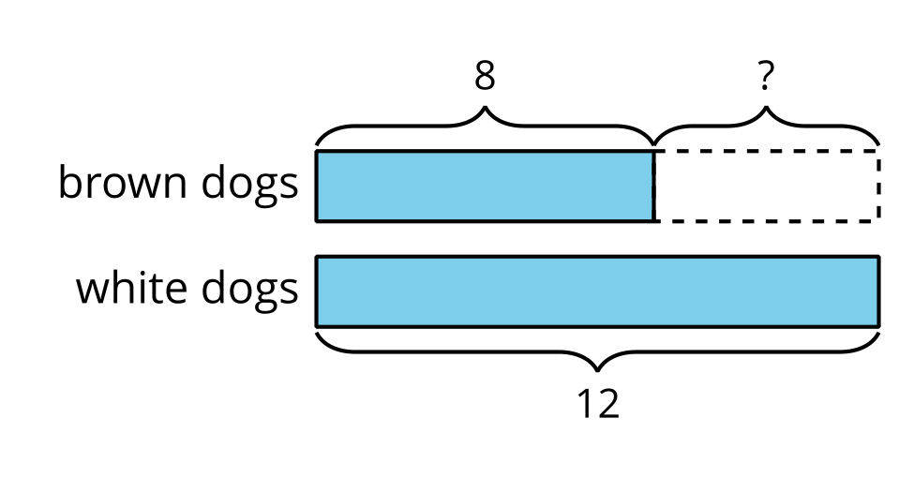
How does the work with the bar graphs today help build students’ understanding of this more abstract diagram?

Cool-down
(to be completed at the end of the lesson) 5min
Ausencias en el segundo grado

Standards Alignments
Addressing | 2.MD.D.10

Student-facing Task Statement
La escuela recolectó datos sobre la asistencia para ver cuántos estudiantes de segundo grado estuvieron ausentes cada mes desde septiembre hasta diciembre. Los datos se muestran en esta gráfica de barras.
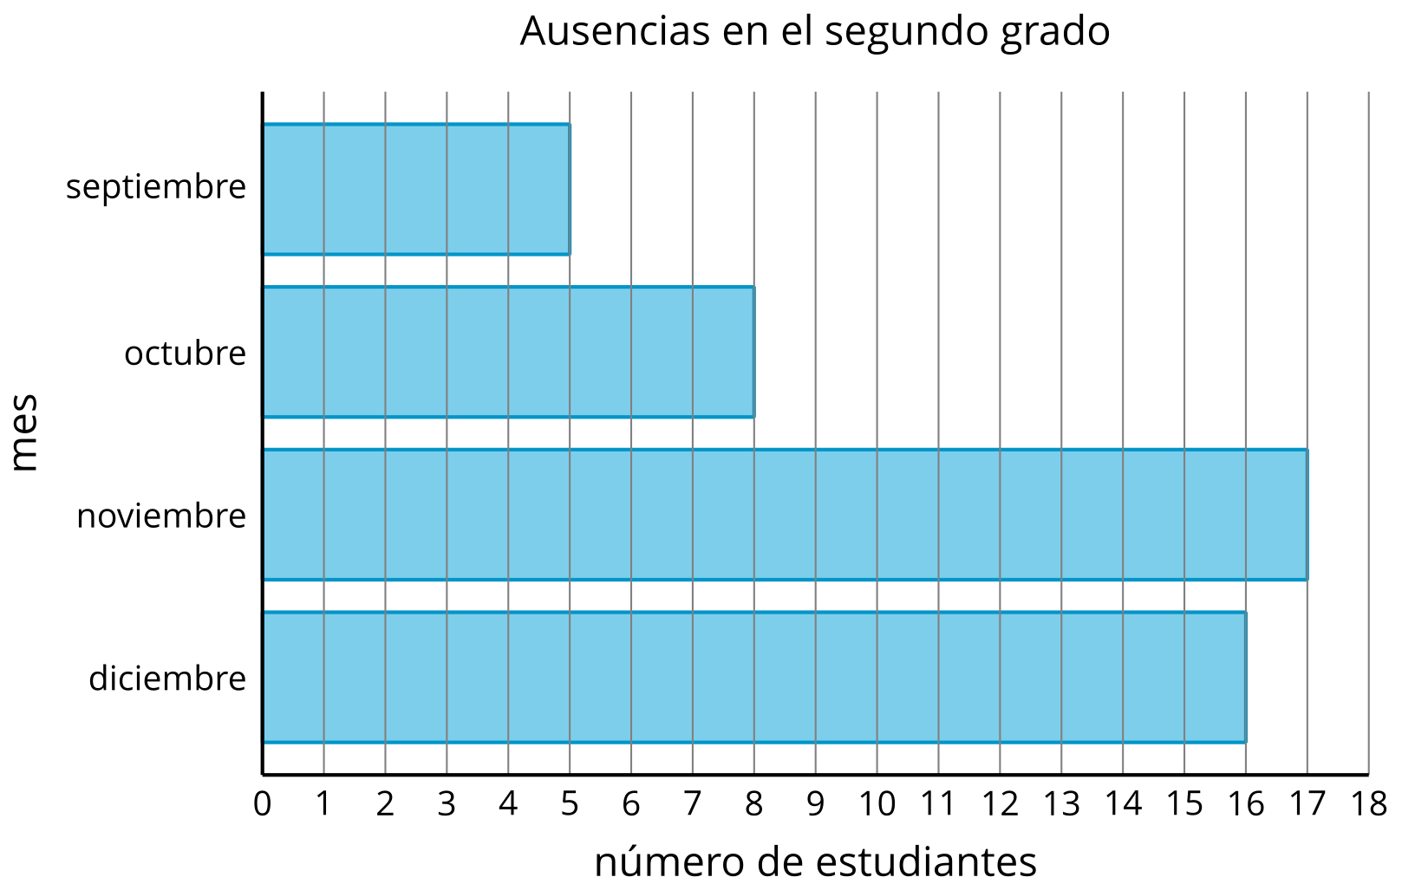
- ¿Cuántos estudiantes menos estuvieron ausentes en octubre que en noviembre? Muestra cómo pensaste. Usa dibujos, números o palabras.
- Escribe una ecuación para mostrar cómo encontraste la diferencia. ¿Puedes escribir otra ecuación que muestre cómo encontrar la diferencia?

Student Responses
- 9 fewer students were absent in October than November. Sample responses:
  - First break apart 8 into 7 and 1. Then subtract $17−7=10$ and $10−1=9$.
  - Student shows counting on from 8 to 17 and labeling 9 fewer students.
- Sample responses:
  - $17−8=9$
  - $8+9=17$
  - $8+?=17$

