Grade 2
Unit 7Lesson 3CC BY NC 2024 Illustrative Mathematics®
Unit 7, Lesson 3

Count On or Count Back to Subtract
- Let’s find the difference between numbers.
Grade 2
Unit 7Lesson 3CC BY NC 2024 Illustrative Mathematics®

Warm-up Number Talk: Tens and Hundreds
Find the value of each expression mentally.
- $120+20$
- $120+200$
- $124+30$
- $124+300$
Grade 2
Unit 7Lesson 3CC BY NC 2024 Illustrative Mathematics®

Activity 1Jump Back, Back, Back
Jada and Andre find the value of $375−24$.
Jada’s work
$375−24=351$
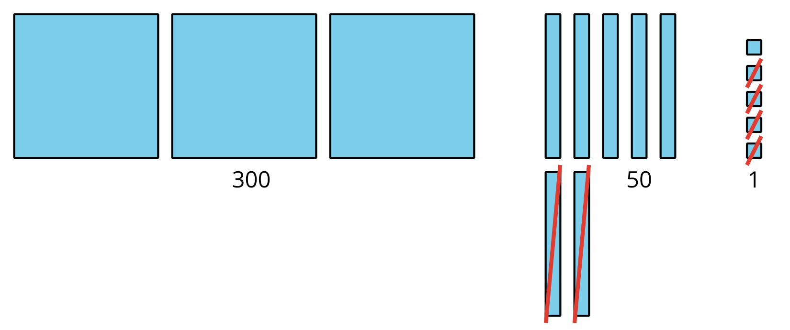
Andre’s work
$375−20=355355−4=351375−24=351$
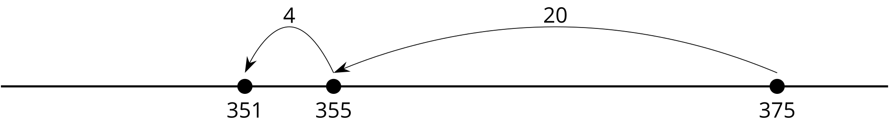
What do you notice? What do you wonder?
- Try Andre’s way. Find the value of $189−73$. Show your thinking, using drawings, numbers, or words.
- Use a number line if it helps.
- Find the value of $647−46$. Show your thinking, using drawings, numbers, or words.
- Use a number line if it helps.
Grade 2
Unit 7Lesson 3CC BY NC 2024 Illustrative Mathematics®

Activity 2 Who Spilled Paint?
Oh no! Diego spilled paint on his paper. He can’t see all the numbers.

Find the number that makes each equation true.

 
 
 
 
 

