Grade 2
Unit 3Lesson 1CC BY NC 2024 Illustrative Mathematics®
Unit 3, Lesson 1

Standard Units of Measure
- Let’s measure length.
Grade 2
Unit 3Lesson 1CC BY NC 2024 Illustrative Mathematics®

Warm-upWhat Do You Know about Measuring?
What do you know about measuring?

Grade 2
Unit 3Lesson 1CC BY NC 2024 Illustrative Mathematics®

Activity 1Priya’s Pet
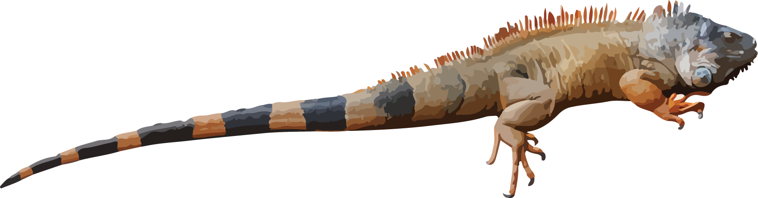
Use straws to measure your string. The string shows the length of Priya’s iguana.
Priya’s iguana is ____________ straws long.
Grade 2
Unit 3Lesson 1CC BY NC 2024 Illustrative Mathematics®

Activity 2Use a Standard Unit
Use the cubes to measure Priya’s string.
- Priya’s iguana is ______ cubes long.
- Compare your measurement with another group.

