Grade 2
Unit 6Lesson 22CC BY NC 2024 Illustrative Mathematics®
Unit 6, Lesson 22

Spending Money
- Let's think about spending money.
Grade 2
Unit 6Lesson 22CC BY NC 2024 Illustrative Mathematics®

Warm-up Notice and Wonder: The Fair
What do you notice? What do you wonder?
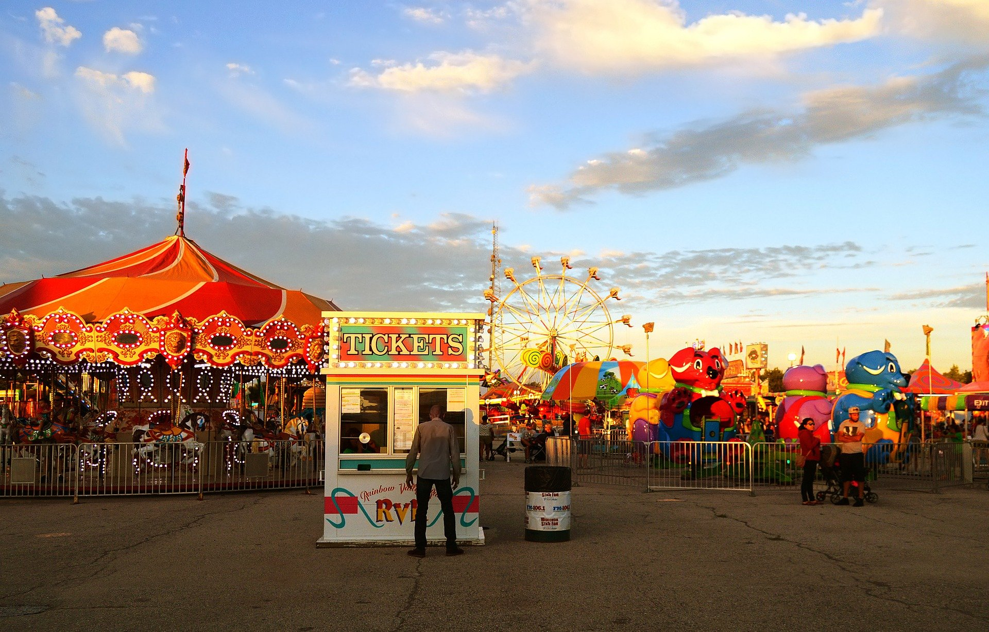
Grade 2
Unit 6Lesson 22CC BY NC 2024 Illustrative Mathematics®

Activity 1Han’s Spending Money
Han has $40 to spend this weekend. He and his cousins are going to the fair and the aquarium.
Solve the problems. Show your thinking, using drawings, numbers, or words.
- Han spends $11 on rides, $8 on face painting, and $4 on snacks. How much money does he have left?
- Han wants to play a game that costs $8. Does he have enough money to play the game? How do you know?
- What will happen to Han's money if he plays the game? What will happen if he doesn’t? Do you think he should play the game? Explain your reasoning.
Grade 2
Unit 6Lesson 22CC BY NC 2024 Illustrative Mathematics®

Activity 2Your Spending Money
- How much money did you bring to the fair?
- Use the table. Decide how to spend your money.
- ride | - price
- arcade game | - $3
- roller coaster | - $7
- Ferris wheel | - $4
- water ride | - $5

- snack | - price
- ice cream | - $4
- popcorn | - $2
- cotton candy | - $3
- candy apple | - $5

- souvenir | - price
- T-shirt | - $15
- magnet | - $8
- bookmark | - $4
- postcard | - $2
- Record the money you spend. What did you buy? How much money do you have left?

