Grade 2
Unit 1Lesson 10CC BY NC 2024 Illustrative Mathematics®
Unit 1, Lesson 10

Represent Data Using Picture Graphs and Bar Graphs
- Let’s make our own bar and picture graphs.
Grade 2
Unit 1Lesson 10CC BY NC 2024 Illustrative Mathematics®

Warm-upWhich Three Go Together: Data
Which 3 go together?
A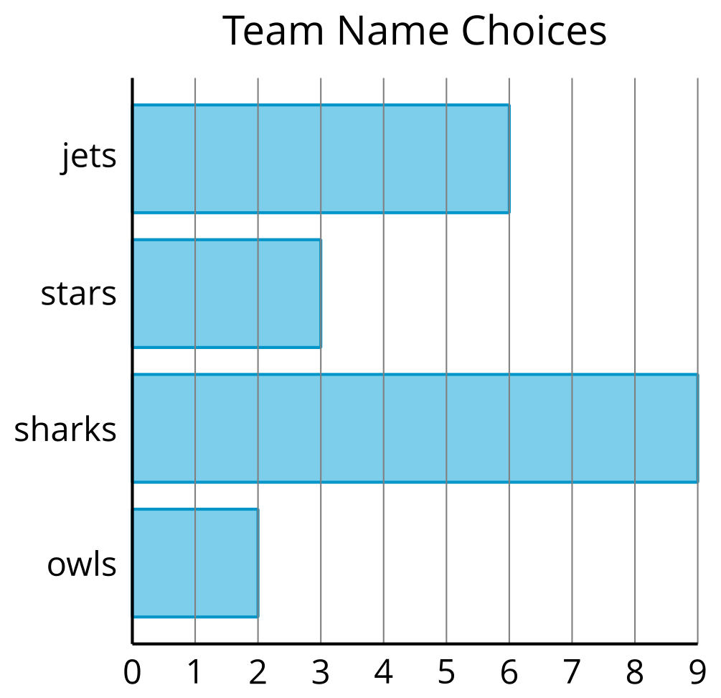
B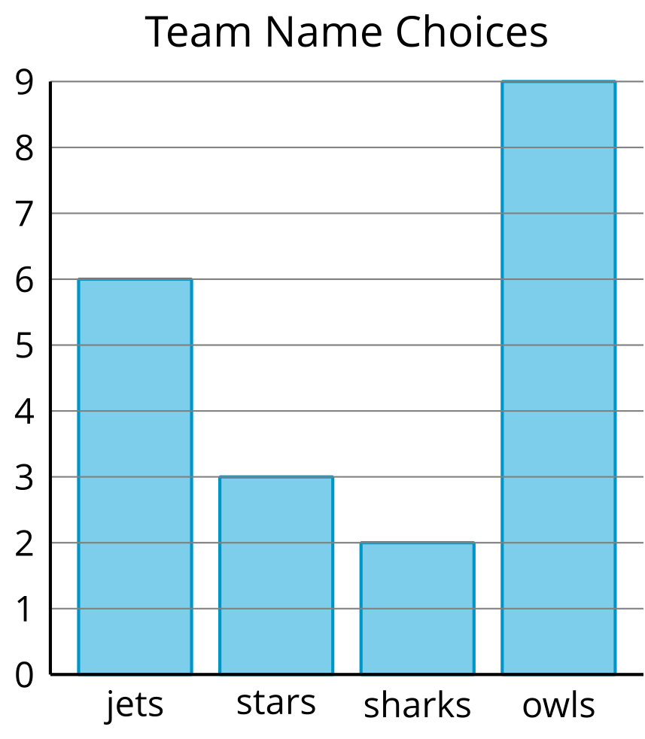
C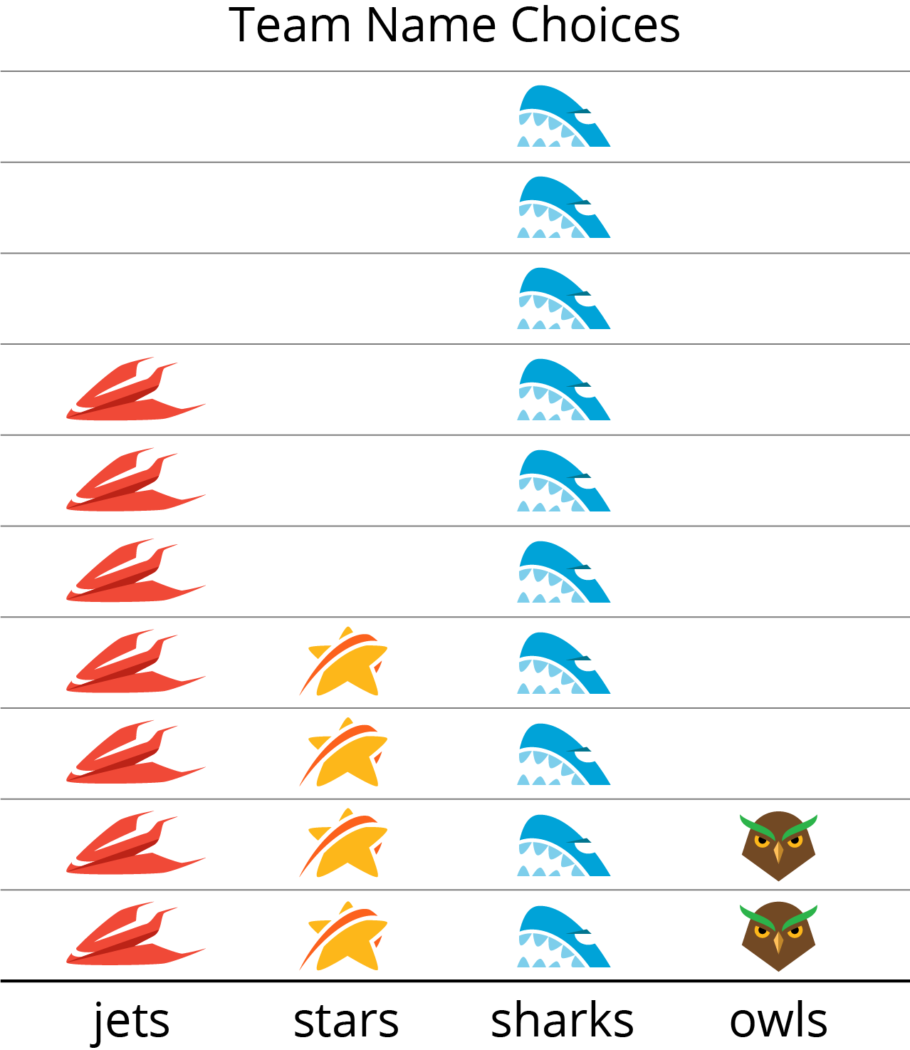
D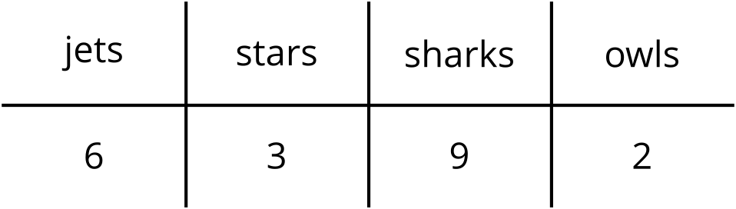
Grade 2
Unit 1Lesson 10CC BY NC 2024 Illustrative Mathematics®

Activity 1Draw Picture Graphs
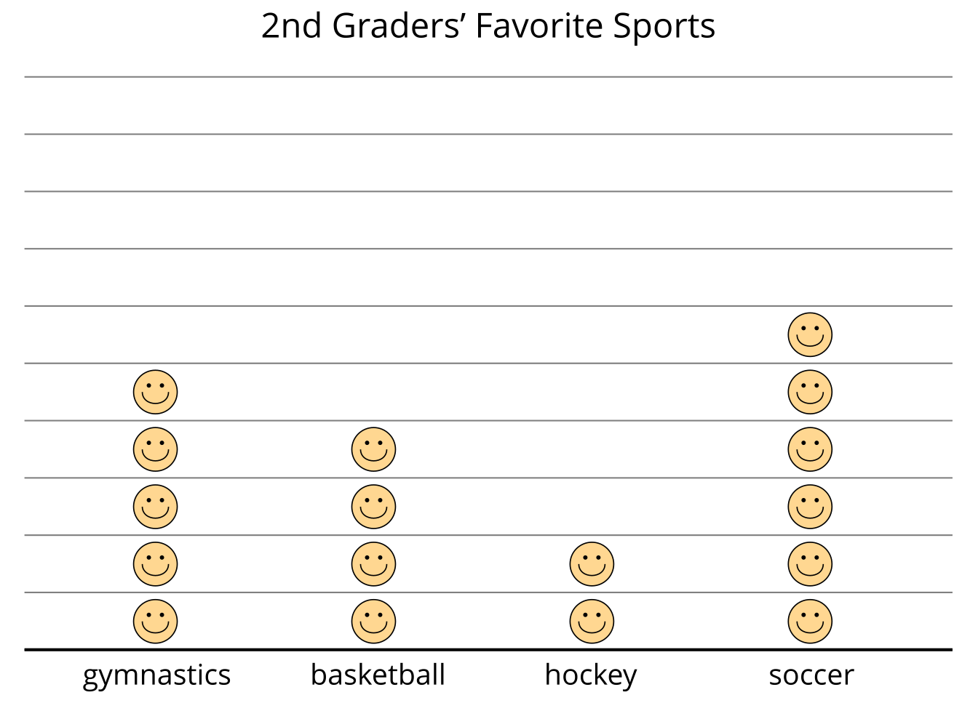
Represent the table data shown in your table in a picture graph.
Table # _______
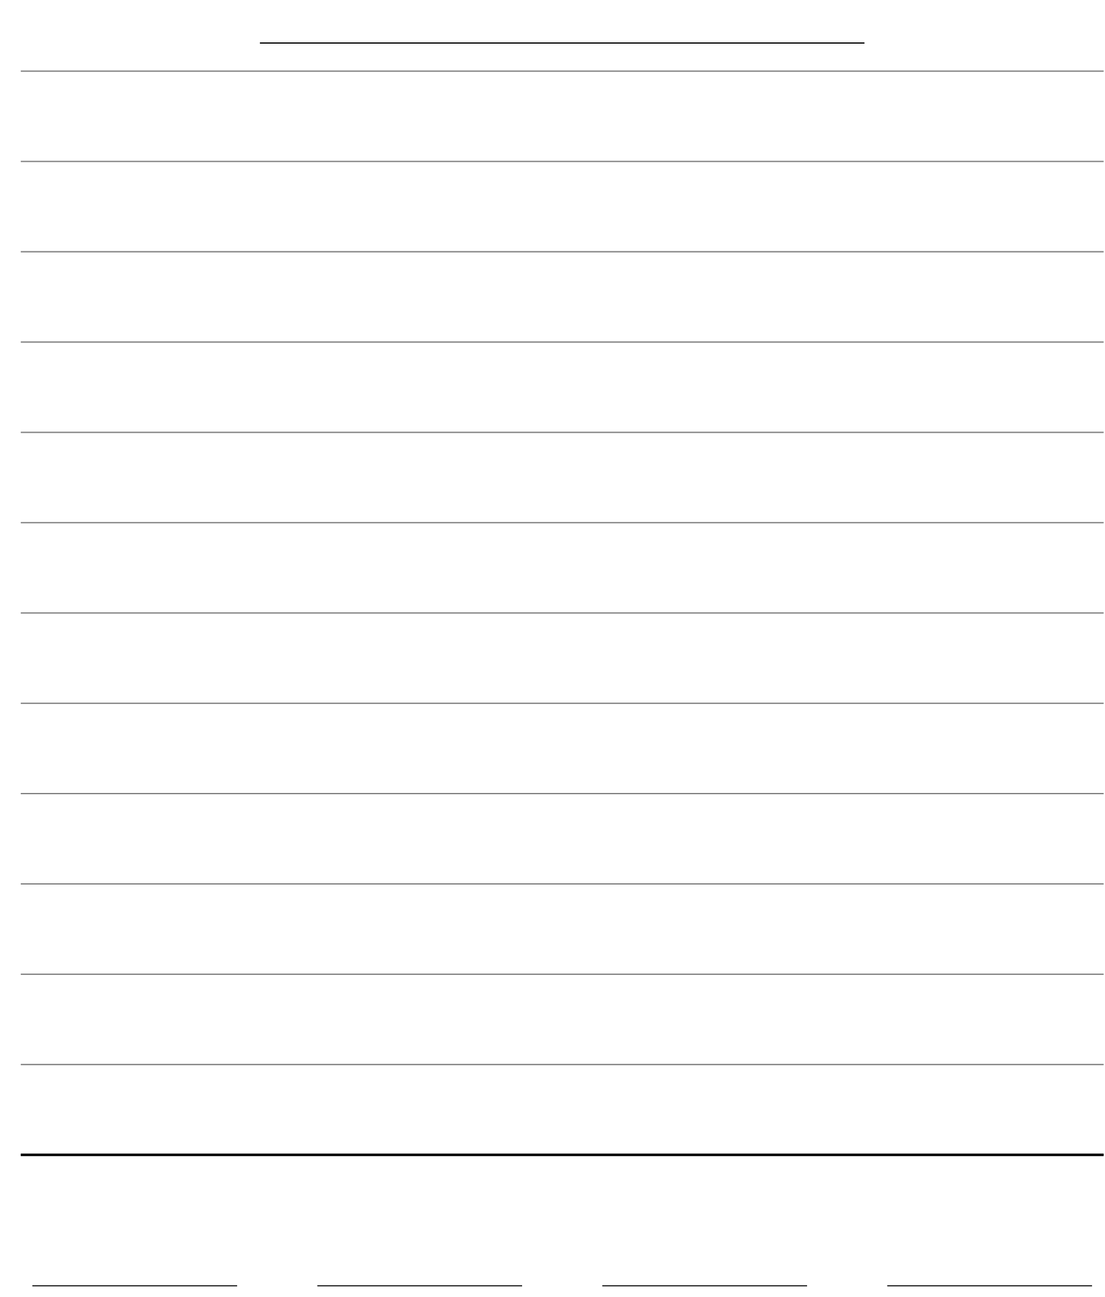
Grade 2
Unit 1Lesson 10CC BY NC 2024 Illustrative Mathematics®

Activity 2Draw Bar Graphs
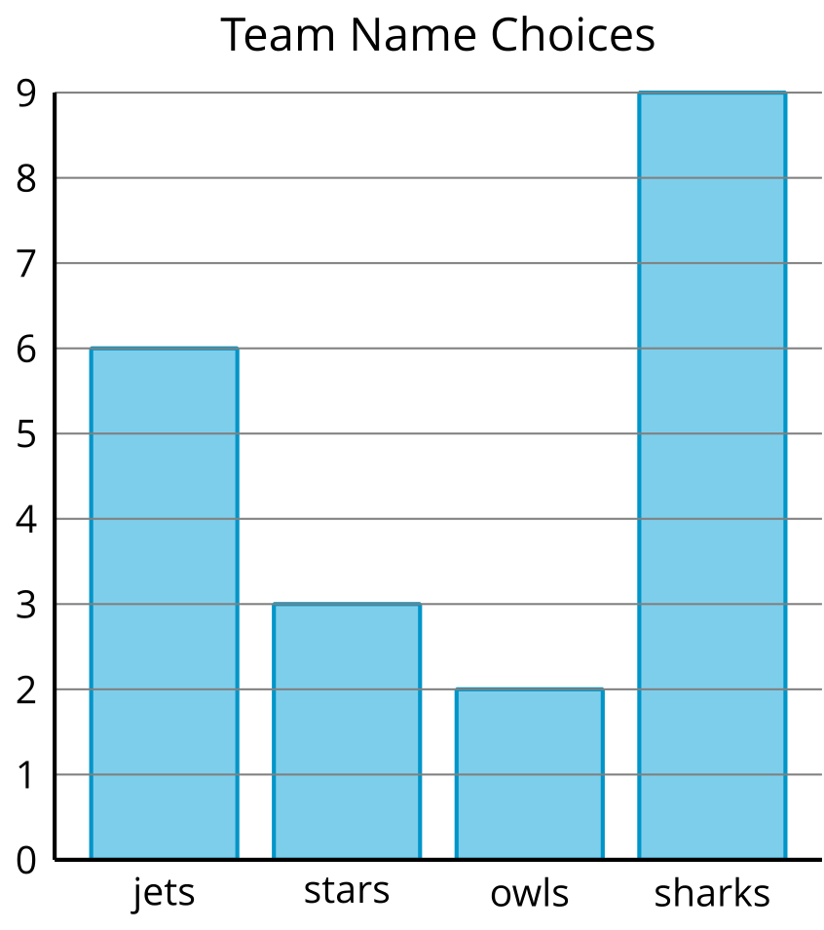

Represent your table data in a bar graph.
Table # _______

