Grade 2
Unit 1Lesson 9CC BY NC 2024 Illustrative Mathematics®
Unit 1, Lesson 9

Interpret Bar Graphs
- Let’s answer bar graph data questions.
Grade 2
Unit 1Lesson 9CC BY NC 2024 Illustrative Mathematics®

Warm-upNotice and Wonder: Favorite Pets
What do you notice? What do you wonder?
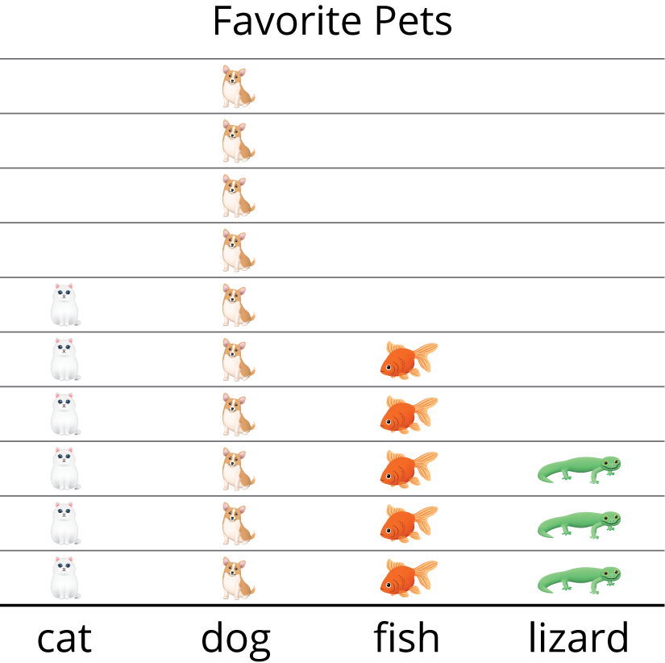
Unable to process <img src="/tikz_files/236535.svg">Failed: rsvg-convert --format png --dpi-x 300 --dpi-y 300 /app/tmp/svgtopng-1786380664.8708694.svg --output /app/tmp/svgtopng-1786380664.8708694.png Backtrace: /app/app/services/script/runner.rb:34:in `block in run_cmd' <internal:kernel>:90:in `tap' /app/app/services/script/runner.rb:32:in `run_cmd' /app/app/services/script/svg_to_png.rb:27:in `convert_svg_to_png' /app/app/services/script/svg_to_png.rb:17:in `to_png' /app/vendor/bundle/ruby/3.3.0/gems/embeddable_content-1.1.0/app/services/embeddable_content/images/image_downloader.rb:37:in `png_rendered_from_svg' /app/vendor/bundle/ruby/3.3.0/gems/embeddable_content-1.1.0/app/services/embeddable_content/images/image_downloader.rb:33:in `raw_image_data' /app/vendor/bundle/ruby/3.3.0/gems/embeddable_content-1.1.0/app/services/embeddable_content/images/image_downloader.rb:13:in `block in save' <internal:kernel>:90:in `tap' /app/vendor/bundle/ruby/3.3.0/gems/embeddable_content-1.1.0/app/services/embeddable_content/images/image_downloader.rb:13:in `save'
Grade 2
Unit 1Lesson 9CC BY NC 2024 Illustrative Mathematics®

Activity 1Field Trip Choices
Groups of students in different classes were asked, “Where would you like to go on a field trip?” Their responses are shown in these bar graphs:
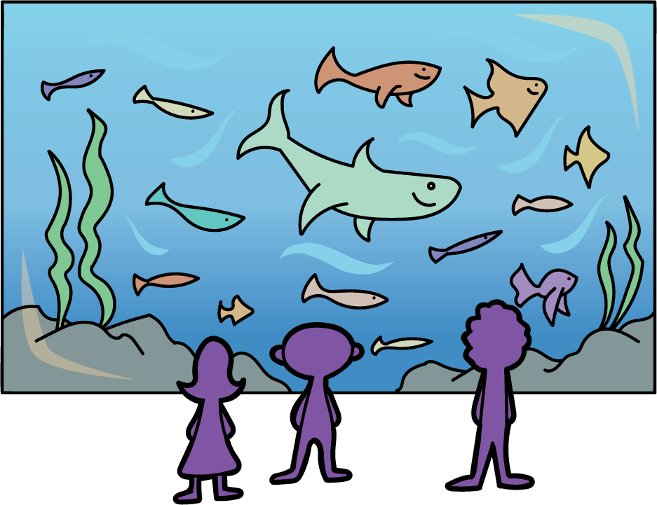
Write as many statements as you can about each bar graph.
Unable to process <img src="/tikz_files/237774.svg">Failed: rsvg-convert --format png --dpi-x 300 --dpi-y 300 /app/tmp/svgtopng-1786380665.0358436.svg --output /app/tmp/svgtopng-1786380665.0358436.png Backtrace: /app/app/services/script/runner.rb:34:in `block in run_cmd' <internal:kernel>:90:in `tap' /app/app/services/script/runner.rb:32:in `run_cmd' /app/app/services/script/svg_to_png.rb:27:in `convert_svg_to_png' /app/app/services/script/svg_to_png.rb:17:in `to_png' /app/vendor/bundle/ruby/3.3.0/gems/embeddable_content-1.1.0/app/services/embeddable_content/images/image_downloader.rb:37:in `png_rendered_from_svg' /app/vendor/bundle/ruby/3.3.0/gems/embeddable_content-1.1.0/app/services/embeddable_content/images/image_downloader.rb:33:in `raw_image_data' /app/vendor/bundle/ruby/3.3.0/gems/embeddable_content-1.1.0/app/services/embeddable_content/images/image_downloader.rb:13:in `block in save' <internal:kernel>:90:in `tap' /app/vendor/bundle/ruby/3.3.0/gems/embeddable_content-1.1.0/app/services/embeddable_content/images/image_downloader.rb:13:in `save'
Unable to process <img src="/tikz_files/237775.svg">Failed: rsvg-convert --format png --dpi-x 300 --dpi-y 300 /app/tmp/svgtopng-1786380665.1106389.svg --output /app/tmp/svgtopng-1786380665.1106389.png Backtrace: /app/app/services/script/runner.rb:34:in `block in run_cmd' <internal:kernel>:90:in `tap' /app/app/services/script/runner.rb:32:in `run_cmd' /app/app/services/script/svg_to_png.rb:27:in `convert_svg_to_png' /app/app/services/script/svg_to_png.rb:17:in `to_png' /app/vendor/bundle/ruby/3.3.0/gems/embeddable_content-1.1.0/app/services/embeddable_content/images/image_downloader.rb:37:in `png_rendered_from_svg' /app/vendor/bundle/ruby/3.3.0/gems/embeddable_content-1.1.0/app/services/embeddable_content/images/image_downloader.rb:33:in `raw_image_data' /app/vendor/bundle/ruby/3.3.0/gems/embeddable_content-1.1.0/app/services/embeddable_content/images/image_downloader.rb:13:in `block in save' <internal:kernel>:90:in `tap' /app/vendor/bundle/ruby/3.3.0/gems/embeddable_content-1.1.0/app/services/embeddable_content/images/image_downloader.rb:13:in `save'
Unable to process <img src="/tikz_files/237776.svg">Failed: rsvg-convert --format png --dpi-x 300 --dpi-y 300 /app/tmp/svgtopng-1786380665.1804163.svg --output /app/tmp/svgtopng-1786380665.1804163.png Backtrace: /app/app/services/script/runner.rb:34:in `block in run_cmd' <internal:kernel>:90:in `tap' /app/app/services/script/runner.rb:32:in `run_cmd' /app/app/services/script/svg_to_png.rb:27:in `convert_svg_to_png' /app/app/services/script/svg_to_png.rb:17:in `to_png' /app/vendor/bundle/ruby/3.3.0/gems/embeddable_content-1.1.0/app/services/embeddable_content/images/image_downloader.rb:37:in `png_rendered_from_svg' /app/vendor/bundle/ruby/3.3.0/gems/embeddable_content-1.1.0/app/services/embeddable_content/images/image_downloader.rb:33:in `raw_image_data' /app/vendor/bundle/ruby/3.3.0/gems/embeddable_content-1.1.0/app/services/embeddable_content/images/image_downloader.rb:13:in `block in save' <internal:kernel>:90:in `tap' /app/vendor/bundle/ruby/3.3.0/gems/embeddable_content-1.1.0/app/services/embeddable_content/images/image_downloader.rb:13:in `save'
Grade 2
Unit 1Lesson 9CC BY NC 2024 Illustrative Mathematics®

Activity 2Our Favorite Seasons
A group of students were asked, “What is your favorite season?” Their responses are shown in the bar graph.
Unable to process <img src="/tikz_files/237777.svg">Failed: rsvg-convert --format png --dpi-x 300 --dpi-y 300 /app/tmp/svgtopng-1786380665.2471876.svg --output /app/tmp/svgtopng-1786380665.2471876.png Backtrace: /app/app/services/script/runner.rb:34:in `block in run_cmd' <internal:kernel>:90:in `tap' /app/app/services/script/runner.rb:32:in `run_cmd' /app/app/services/script/svg_to_png.rb:27:in `convert_svg_to_png' /app/app/services/script/svg_to_png.rb:17:in `to_png' /app/vendor/bundle/ruby/3.3.0/gems/embeddable_content-1.1.0/app/services/embeddable_content/images/image_downloader.rb:37:in `png_rendered_from_svg' /app/vendor/bundle/ruby/3.3.0/gems/embeddable_content-1.1.0/app/services/embeddable_content/images/image_downloader.rb:33:in `raw_image_data' /app/vendor/bundle/ruby/3.3.0/gems/embeddable_content-1.1.0/app/services/embeddable_content/images/image_downloader.rb:13:in `block in save' <internal:kernel>:90:in `tap' /app/vendor/bundle/ruby/3.3.0/gems/embeddable_content-1.1.0/app/services/embeddable_content/images/image_downloader.rb:13:in `save'
- How many students voted for summer?
- What is the total number of students who voted for fall or spring?
- Which 2 seasons have a total of 10 votes?
- How many students voted?

