Algebra 1
Unit 7Lesson 8CC BY NC 2024 Illustrative Mathematics®
Unit 7, Lesson 8

Equivalent Quadratic Expressions
- Let’s use diagrams to help us rewrite quadratic expressions.
Algebra 1
Unit 7Lesson 8CC BY NC 2024 Illustrative Mathematics®

8.1Diagrams of Products
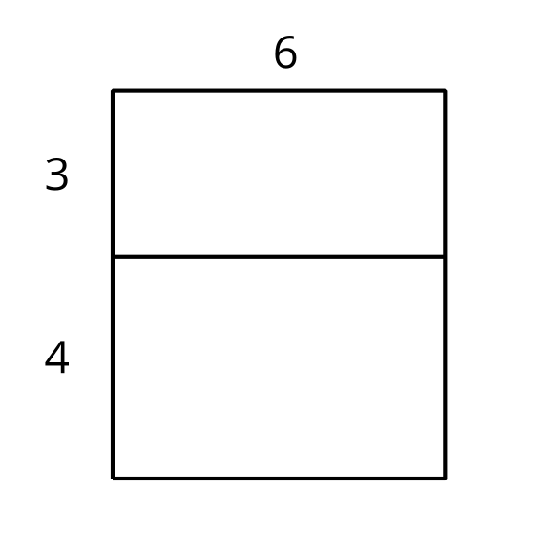
- Explain why the diagram shows that $6\left(3+4\right)=6⋅3+6⋅4$.
- Draw a diagram to show that $5\left(x+2\right)=5x+10$.
Algebra 1
Unit 7Lesson 8CC BY NC 2024 Illustrative Mathematics®

8.2Drawing Diagrams to Represent More Products
Applying the distributive property to multiply out the factors of, or expand, $4\left(x+2\right)$ gives us $4x+8$, so we know the two expressions are equivalent. We can use a rectangle with side lengths of $\left(x+2\right)$ and 4 to illustrate the multiplication.
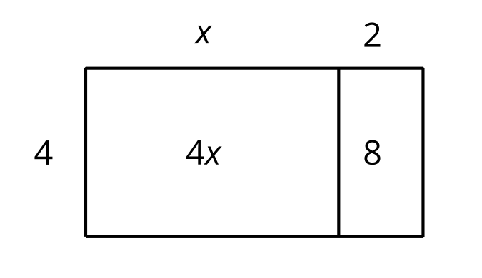
- Draw a diagram to show that $n\left(2n+5\right)$ and $2n^{2}+5n$ are equivalent expressions.
- For each expression, use the distributive property to write an equivalent expression. If you get stuck, consider drawing a diagram.
- a. $6\left(\frac{1}{3}n+2\right)$
- b. $p\left(4p+9\right)$
- c. $5r\left(r+\frac{3}{5}\right)$
- d. $\left(0.5w+7\right)w$
Algebra 1
Unit 7Lesson 8CC BY NC 2024 Illustrative Mathematics®

8.3Using Diagrams to Find Equivalent Quadratic Expressions
- Here is a diagram of a rectangle with side lengths of $x+1$ and $x+3$. Use this diagram to show that $\left(x+1\right)\left(x+3\right)$ and $x^{2}+4x+3$ are equivalent expressions.
- 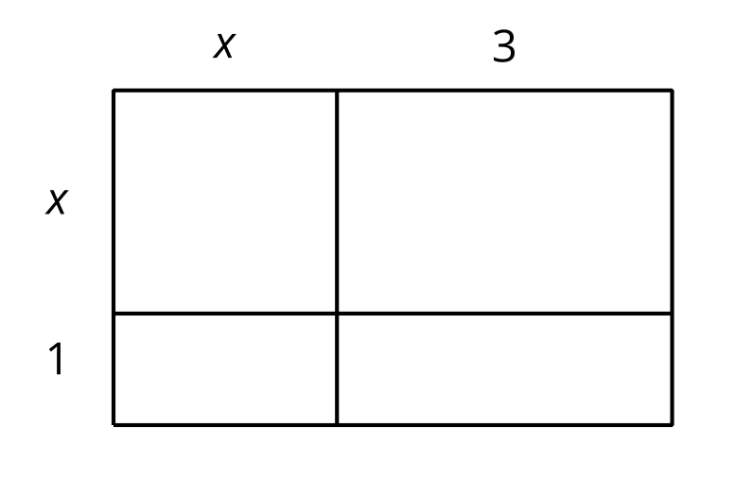
- Draw diagrams to help you write an equivalent expression for each of the following:
  - $\left(2x+1\right)\left(x+3\right)$
  - ${\left(x+5\right)}^{2}$
- Here is a diagram of a rectangle with the same area as in the first question. Use this diagram to show that $\left(x+1\right)\left(x+3\right)$ and $x\left(x+3\right)+1\left(x+3\right)$ are equivalent expressions. Then explain how you could rewrite that expression as $x^{2}+4x+3$, without a diagram.
- 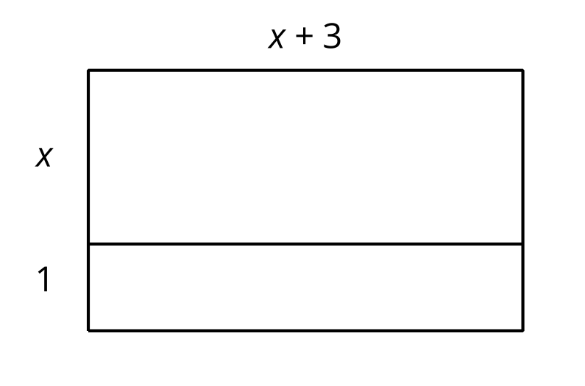
- Write an equivalent expression for each expression:
  - $\left(x+2\right)\left(x+6\right)$
  - $\left(x+m\right)\left(x+n\right)$

Are you ready for more?
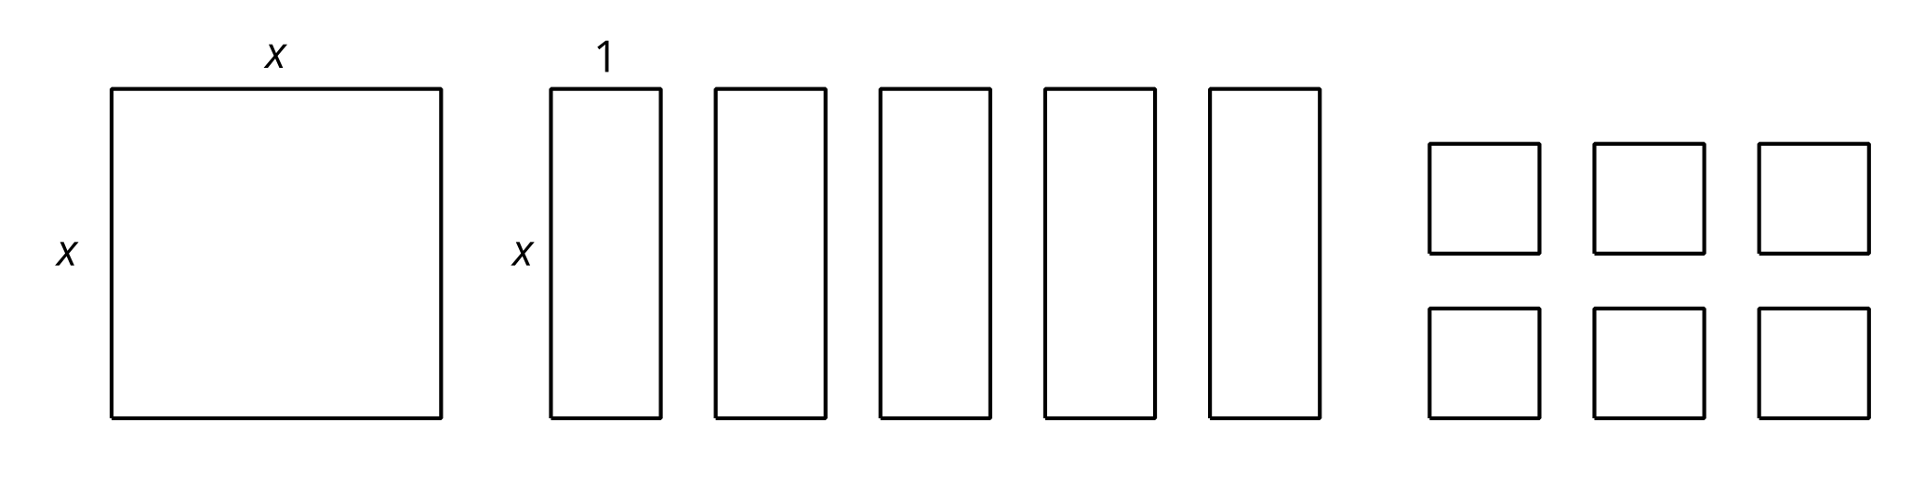
- Is it possible to arrange an $x$-by-$x$ square, five $x$-by-1 rectangles and six 1-by-1 squares into a single large rectangle? Explain or show your reasoning.
- What does this tell you about an equivalent expression for $x^{2}+5x+6$?
- Keeping the $x$-by-$x$ square and the five $x$-by-1 rectangles, can you form a different rectangle by using a different number of 1-by-1 squares than what is shown?

Lesson 8 Summary
A quadratic function can often be defined by many different but equivalent expressions. For example, we saw earlier that the predicted revenue, in thousands of dollars, from selling a downloadable movie at $x$ dollars can be expressed with $x\left(18−x\right)$, which can also be written as $18x−x^{2}$.
Sometimes a quadratic expression is a product of two factors that are each a linear expression, for example $\left(x+2\right)\left(x+3\right)$. We can write an equivalent expression by thinking about each factor, the $\left(x+2\right)$ and $\left(x+3\right)$, as the side lengths of a rectangle, with each side length being decomposed into a variable expression and a number.
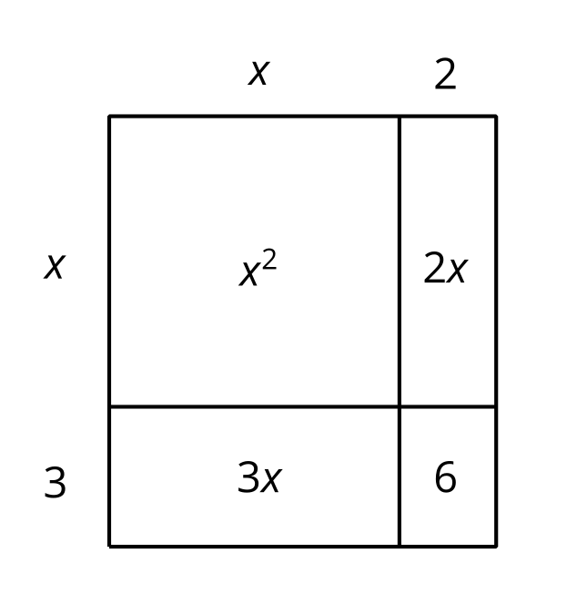
Multiplying $\left(x+2\right)$ and $\left(x+3\right)$ gives the area of the rectangle. Adding the areas of the four sub-rectangles also gives the area of the rectangle. This means that $\left(x+2\right)\left(x+3\right)$ is equivalent to $x^{2}+2x+3x+6$, or to $x^{2}+5x+6$.
Notice that the diagram illustrates the distributive property being applied. Each term of one factor (say, the $x$ and the 2 in $x+2$) is multiplied by every term in the other factor (the $x$ and the 3 in $x+3$).
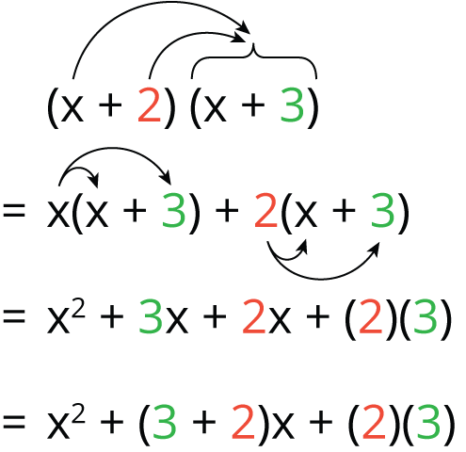
In general, when a quadratic expression is written in the form of $\left(x+p\right)\left(x+q\right)$, we can apply the distributive property to rewrite it as $x^{2}+px+qx+pq$, or as $x^{2}+\left(p+q\right)x+pq$.

