## Lesson 5: What is an Angle?

* Let’s look for angles and find out ways to describe them.

### Warm-up: Notice and Wonder: A Wall of Clocks

What do you notice? What do you wonder?

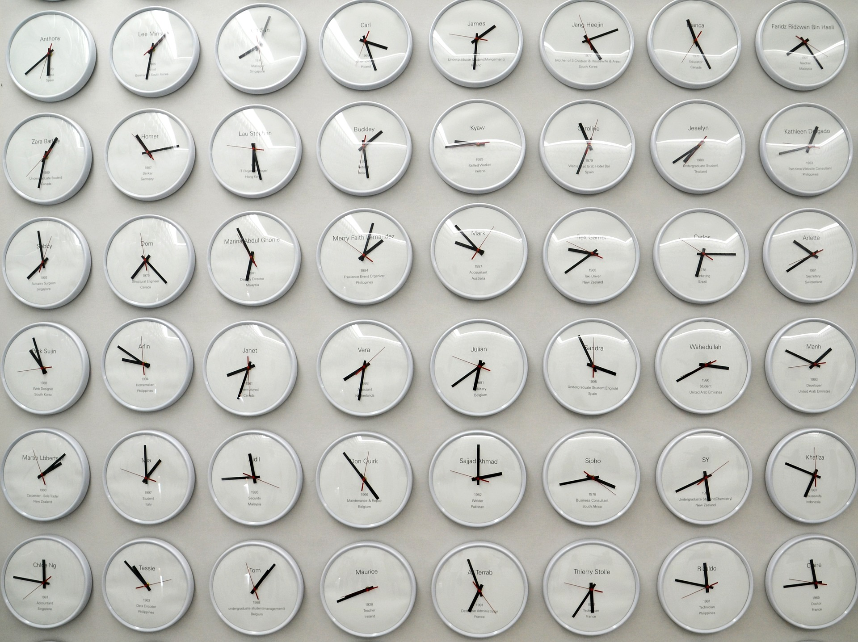

### 5.1: Tricky Figures

Work with a partner in this activity. Choose a role: A or B. Sit back to back, or use a divider to keep one person from seeing the other person’s work.

Partner A:

* Your teacher will give you a card. Don’t show it to your partner.
* Describe both images on the card—as clearly and precisely as possible—so that your partner can draw the same images.

Partner B:

* Your partner will describe two images. Listen carefully to the descriptions.
* Create the drawings as described. Follow the instructions as closely as possible.

1. When done, compare the drawings to the original images. Discuss:
   * Which parts were accurate? Which were off?
   * How could the descriptions be improved so the drawing could be more accurate?
2. Switch roles and repeat the exercise. Compare the drawings to the original images afterwards.

If you have time: Request two new cards from your teacher (one card at a time). Take turns describing and drawing the geometric figure on each card.

### 5.2: Angles or Not Angles?

1. Decide if each figure shows at least one angle. Explain or show your reasoning for each.

* 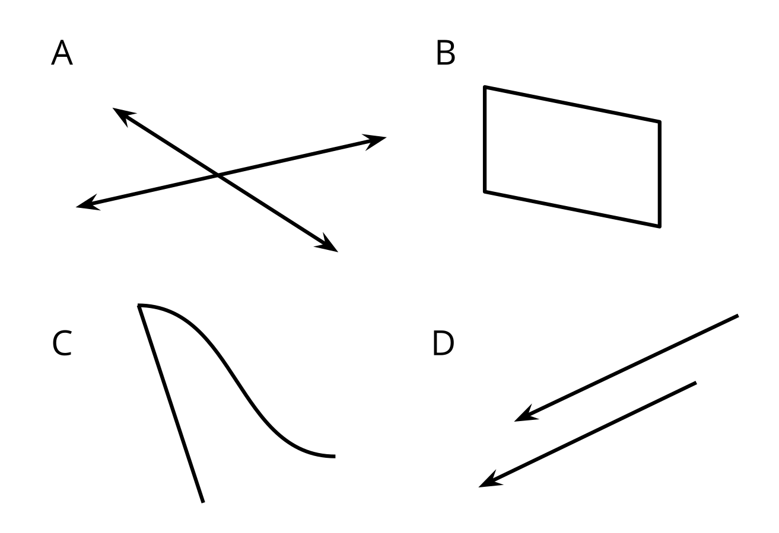

1. Clare and Kiran are looking at this diagram. Clare says there are no angles because the rays do not meet at a point. Kiran says he sees two angles.

* 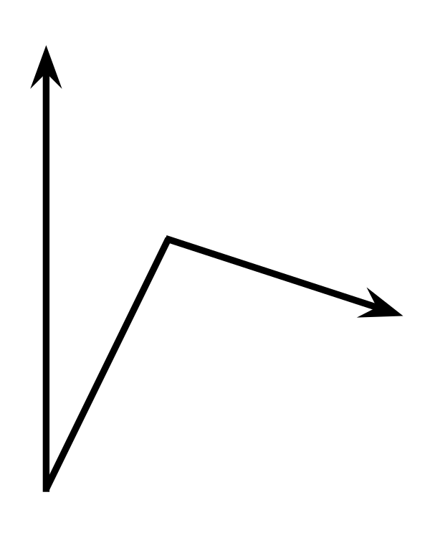
* Do you agree with either of them? How many angles do you see?

### 5.3: Discover Angles

Here are two figures.



1. Find 2–3 angles in each figure. Draw pairs of rays to show the angles.
2. Sketch a part of your classroom that has 2–3 angles. Draw pairs of rays to show the angles.

### Section Summary

Section Summary

In this section, we learned the meanings of **points**, **lines**, **line segments**, and **rays.** We used these terms to describe figures and used these geometric parts to create drawings.

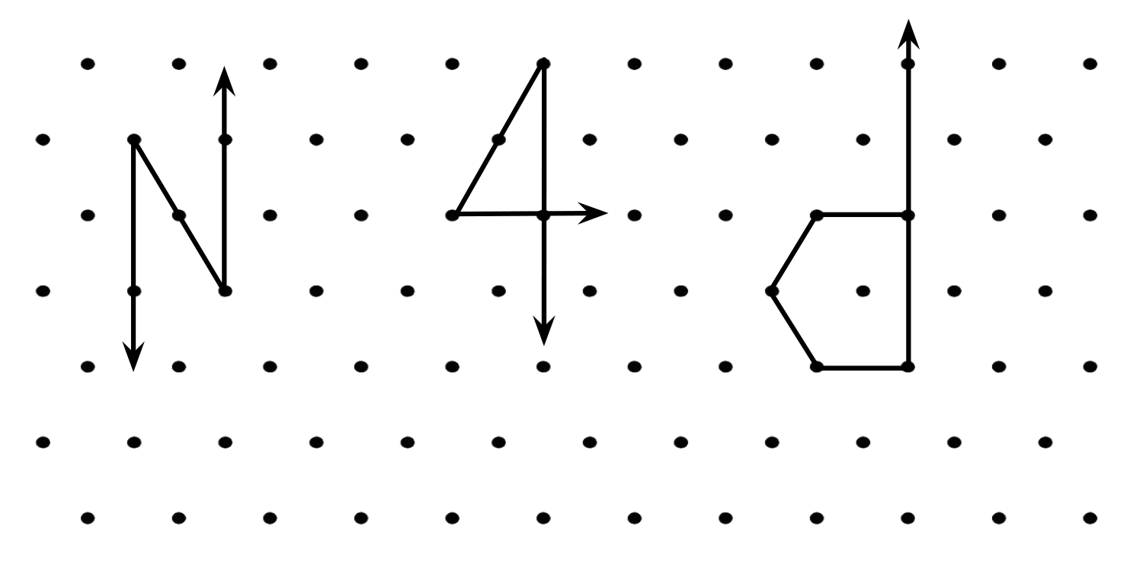

We learned about lines that cross—**intersecting lines**—and lines that never do—**parallel lines**, and we looked for examples of intersecting lines and parallel lines and segments in life.





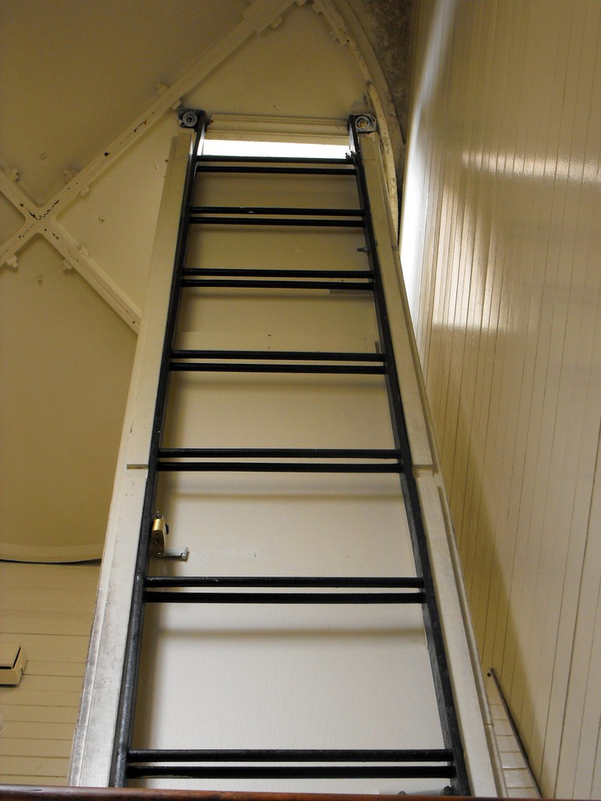

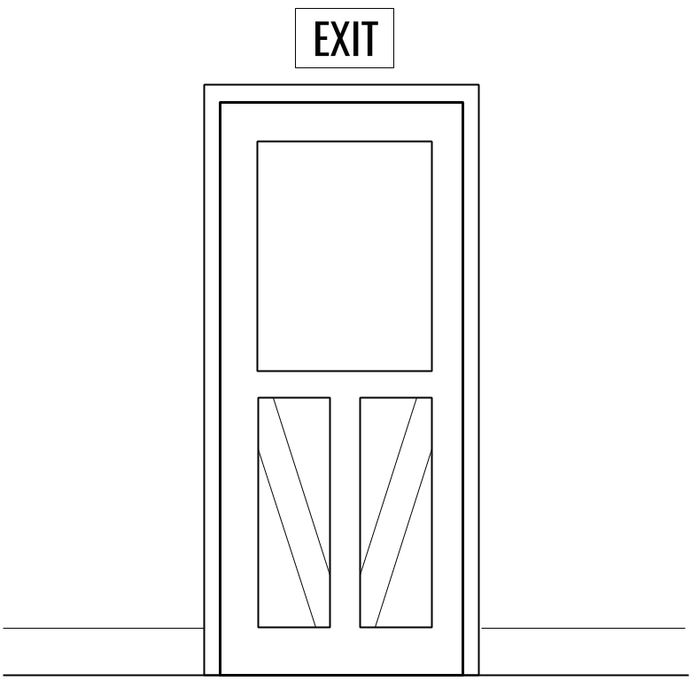

Finally, we learned that an **angle** is a figure made up of two rays that share the same endpoint, and that the shared point is the **vertex** of the angle.

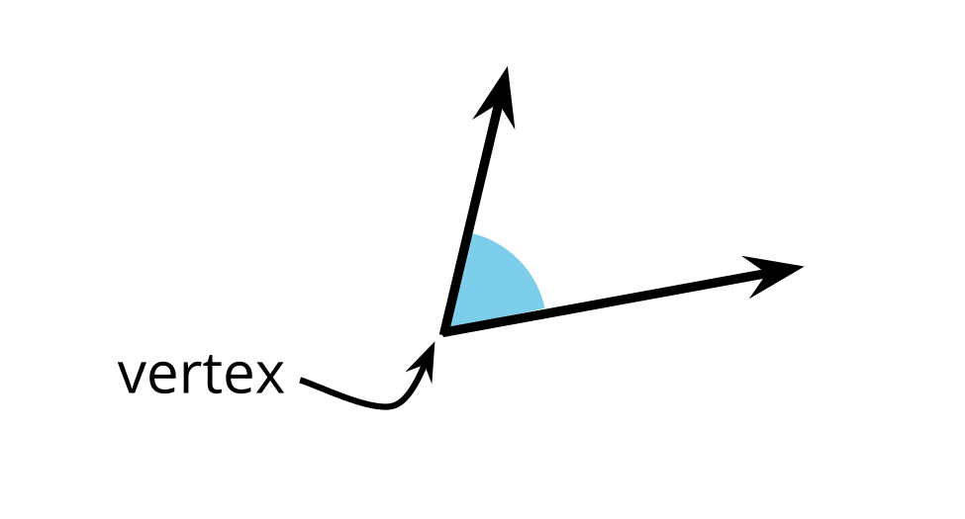



© CC BY 2021 Illustrative Mathematics®