Grade 2
Unit 5Lesson 6CC BY NC 2024 Illustrative Mathematics®
Unit 5, Lesson 6

Represent Numbers in Different Ways
- Let’s represent numbers in different ways.
Grade 2
Unit 5Lesson 6CC BY NC 2024 Illustrative Mathematics®

Warm-upWhich Three Go Together: Numbers in Different Ways
Which 3 go together?
A
B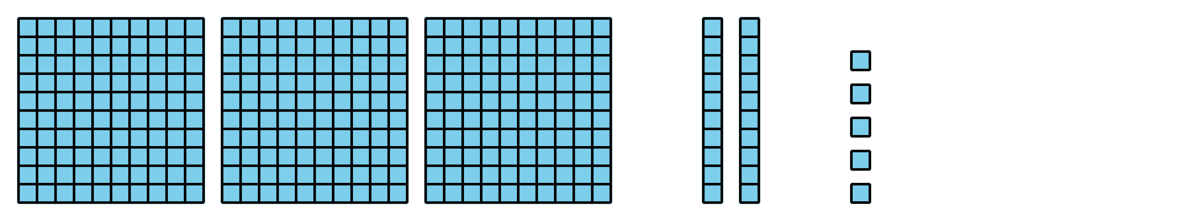
C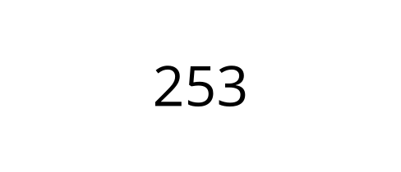
D
Grade 2
Unit 5Lesson 6CC BY NC 2024 Illustrative Mathematics®

Activity 1Numbers as Words
- Fill in the blanks. Represent 248 with words.
- two ___________________ forty-________________
- Fill in the blanks. Represent 562 with words.
- ______________ hundred _____________- _______
- Represent this number with words.
- 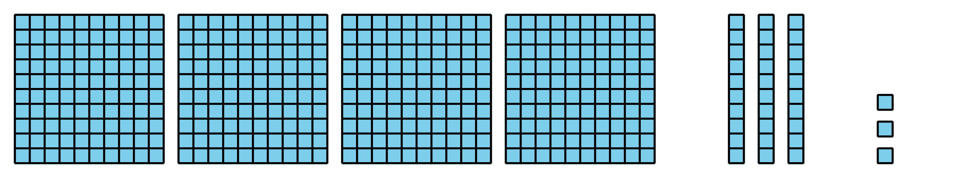
- Represent 627 with words.
- Represent $900+50+1$ with words.
- Represent three hundred eighteen in 2 different ways.
Grade 2
Unit 5Lesson 6CC BY NC 2024 Illustrative Mathematics®

Activity 2Represent the Numbers
Represent the number on your poster. Use:
- a 3-digit number
- a base-ten diagram
- expanded form
- words
If you have time: Represent the number using tens and ones. Then represent the number in a different way.

Section A Summary
We learned that a hundred is a group of 10 tens or 100 ones. We represented hundreds with base-ten blocks and diagrams. We represented numbers using hundreds, tens, and ones. We learned to read and write 3-digit numbers. We used the expanded form to write a number as the sum of the values of its digits.
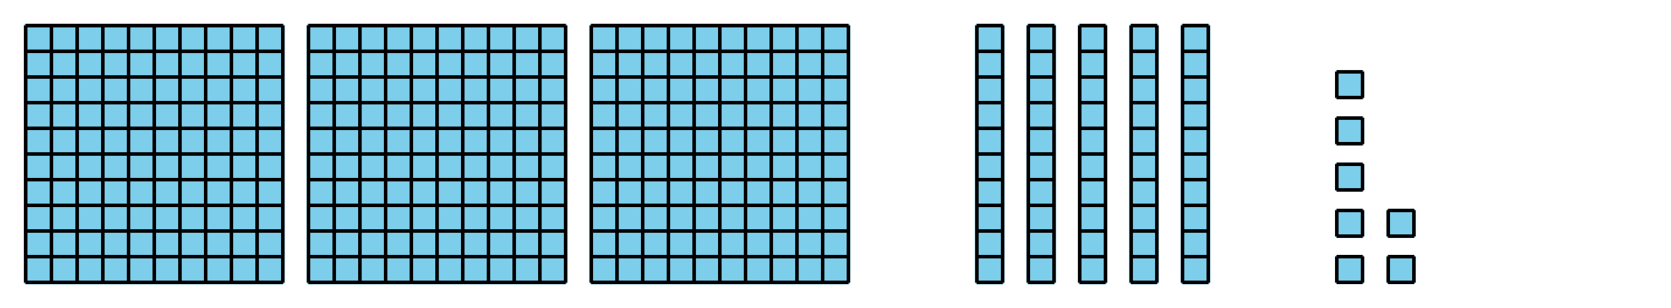
3 hundreds 5 tens 7 ones
357
$300+50+7$
three hundred fifty-seven

