Lesson 16: Bank Shot
- Let’s use similarity to solve problems.

16.1: Notice and Wonder: Right Triangles
What do you notice? What do you wonder?
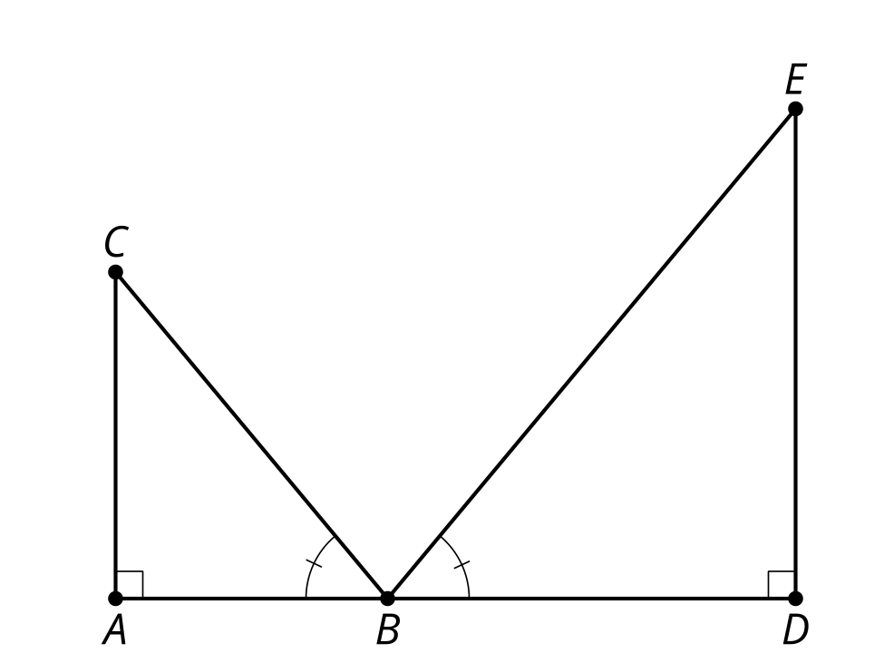

16.2: Bank Shot
- You need to make a bank shot. Sketch the path of the cue ball so it will bounce off of the bottom side and knock the solid orange 5 ball into the upper right corner pocket.
- A true bank shot will create 2 similar right triangles. Determine the measures of the triangles you drew. Are they similar?
- Calculate the exact point on the bottom side to aim for and then precisely draw the path of the ball.

Are you ready for more?
How would you hit the ball so that it will end in the hole after one stroke?
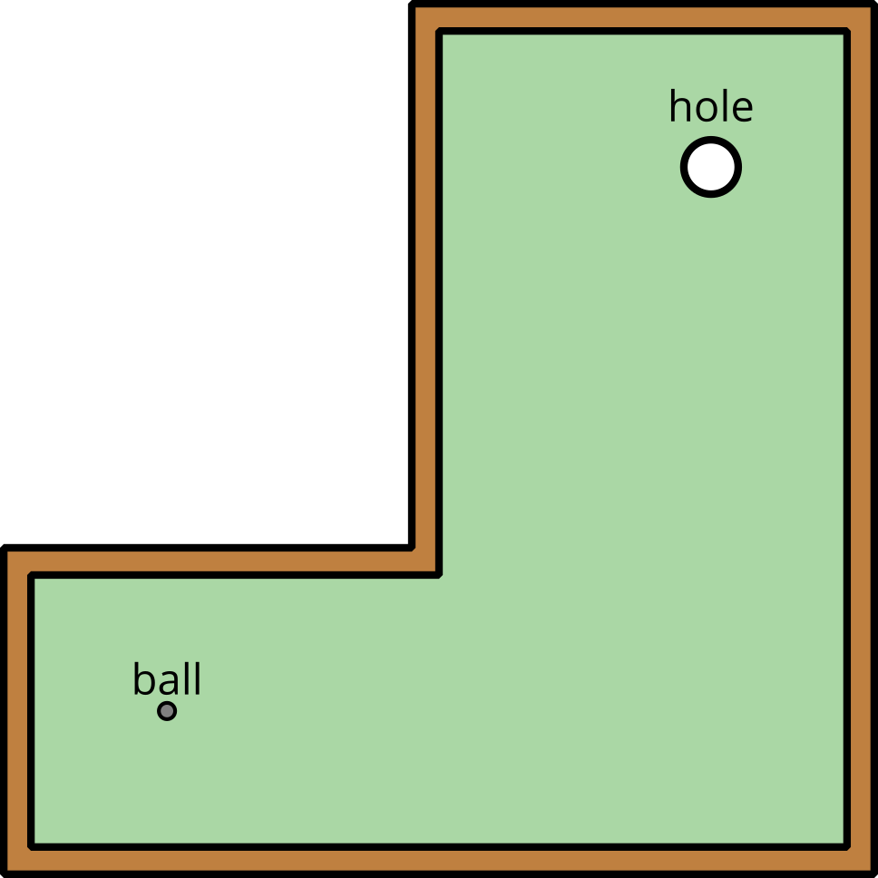

16.3: Indirect Measurement (Mirrors)
Use mirrors to measure the height of a tall object. Label this image with the measurements you made.
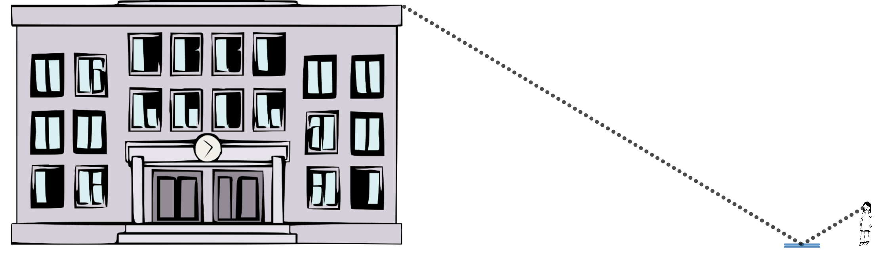
Calculate the unknown height.

16.4: Indirect Measurement (No Mirrors)
What if you don’t have a mirror when you’re trying to measure the height of something too tall to measure directly? Brainstorm as many methods other than the mirror method as you can.
Add to your brainstorm by:
- Imagining you have access to any tool you can think of.
- Imagining you only had a piece of scrap paper and pencil with you.
Pick a method you would like to try, and use it to measure the height of the object your teacher assigns you.

Lesson 16 Summary
We know that 2 triangles are similar if they meet the Angle-Angle Triangle Similarity Theorem. One way to create triangles with congruent angles is to use reflection. When light bounces off a mirror or a ball bounces off a hard surface the angle it hits is the same as the angle it returns. In one-wall handball people bounce a ball off a wall and try to aim for a spot their opponent won't be able to return the ball from.
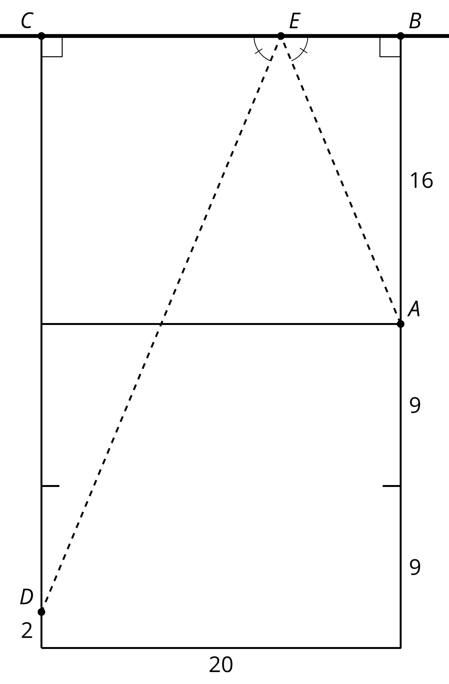
Where on the wall should we aim if we're standing at point $A$ and want the ball to land at point $D$? We know the triangles are similar because of the Angle-Angle Triangle Similarity Theorem. Segment $AB$ corresponds to segment $DC$. So the scale factor to go from triangle $DCE$ to triangle $ABE$ is $\frac{16}{32}$. Segments $BE$ and $CE$ also correspond so they must have the same scale factor. Since $\frac{16}{32}=\frac{1}{2}$, segments $BE$ and $CE$ must be in a $1:2$ ratio. Dividing the 20 foot wall into 3 equal parts tells us that $BE=6\frac{2}{3}$. In practice it's easier to think about aiming for a third of the way along the wall from the right hand side than it is to aim for a spot $6\frac{2}{3}$ feet away from point $B$.
© CC BY 2019 by Illustrative Mathematics®

