Unit 4 Lesson 8: Interpreting and Creating Graphs

1 Which One Doesn't Belong: Temperature Over Time

Student Task Statement
Which graph doesn’t belong?

A
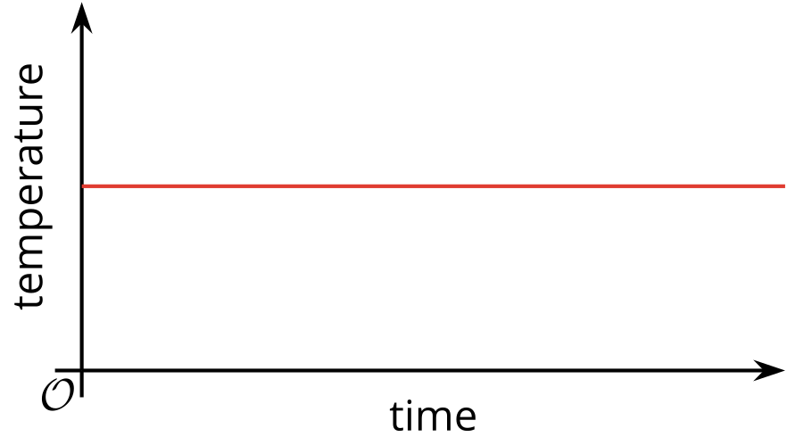

B
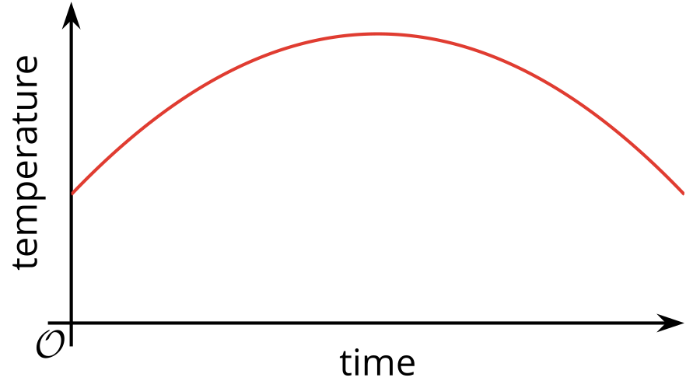

C
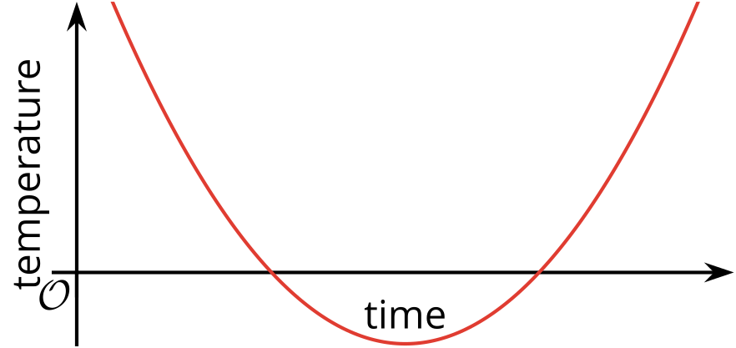

D
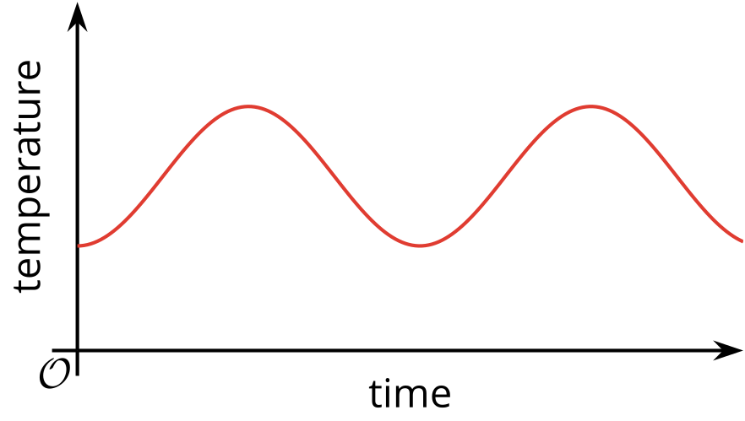

2 Flag Raising (Part 1)

Student Task Statement
A flag ceremony is held at a Fourth of July event. The height of the flag is a function of time.
Here are some graphs that could each be a possible representation of the function.


A
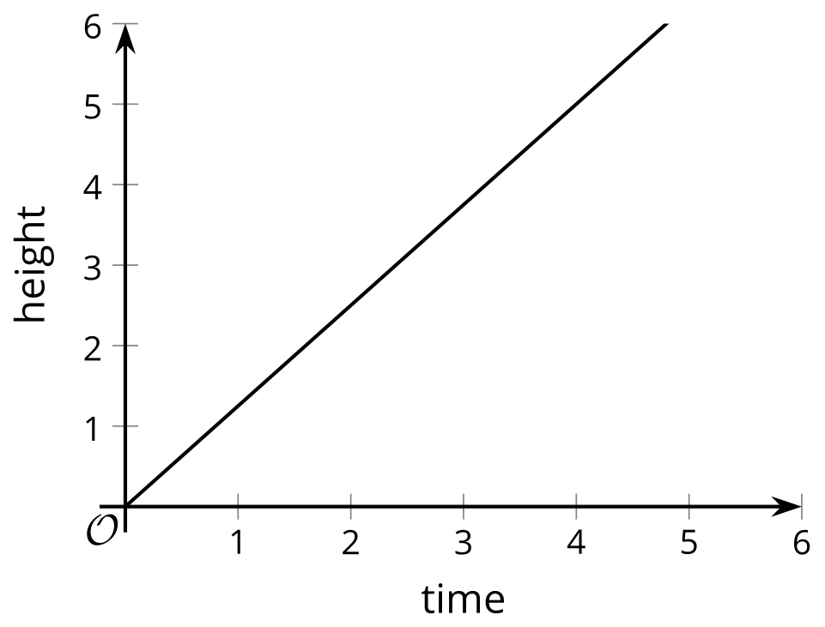

B
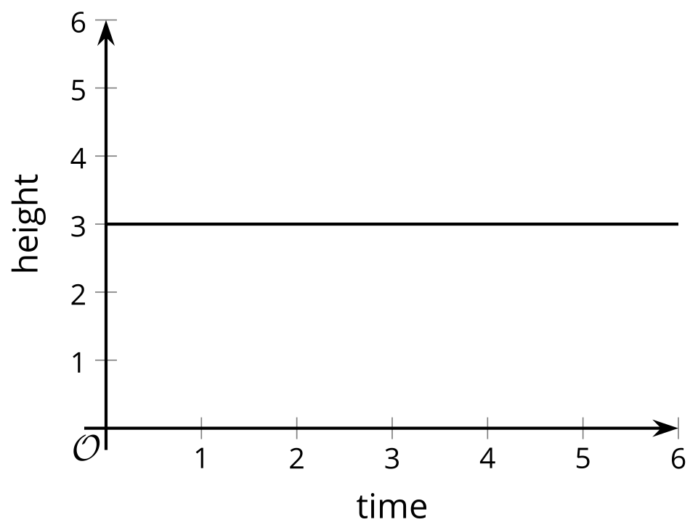

C
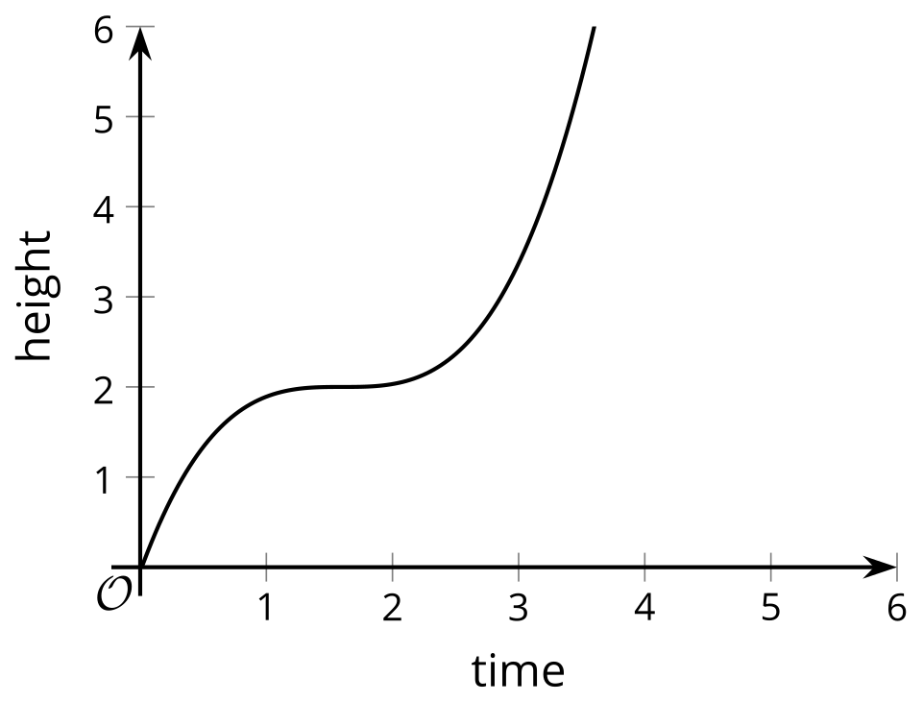

D
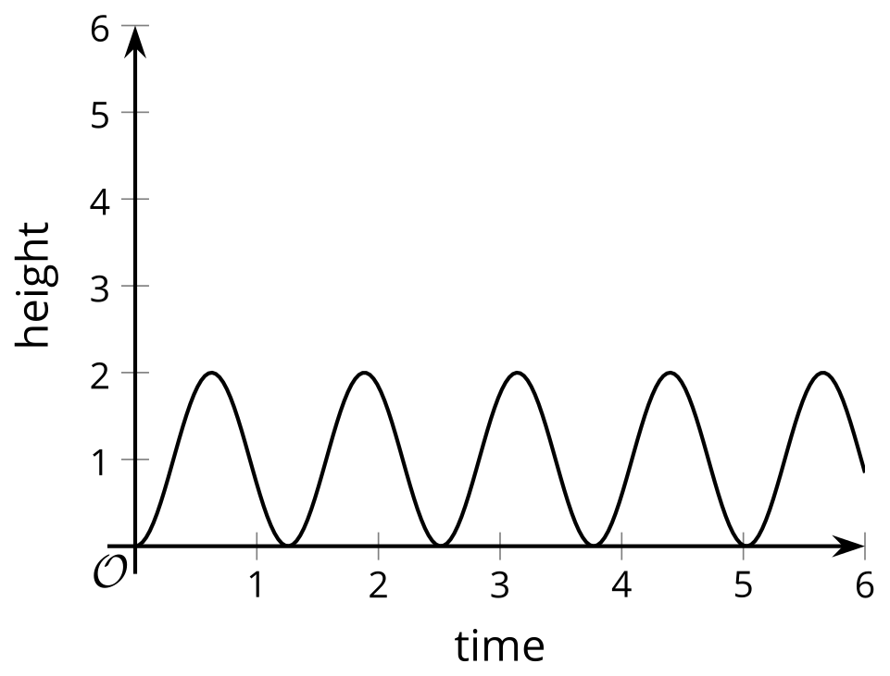

E
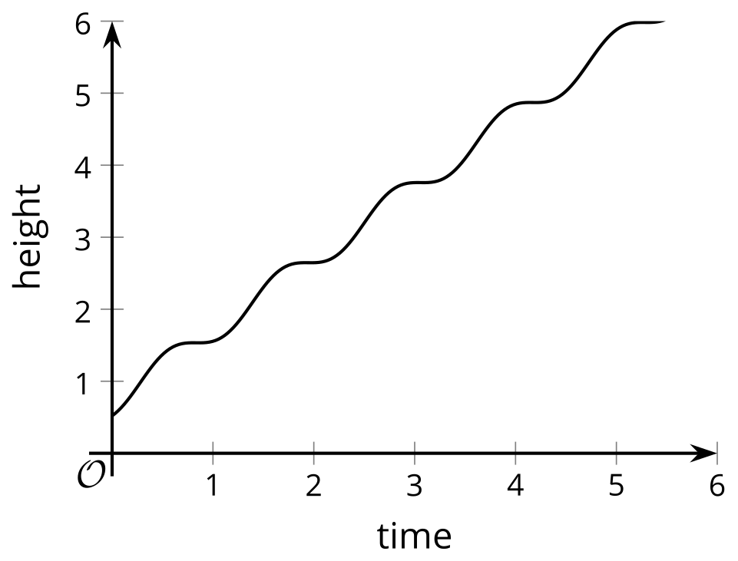

F
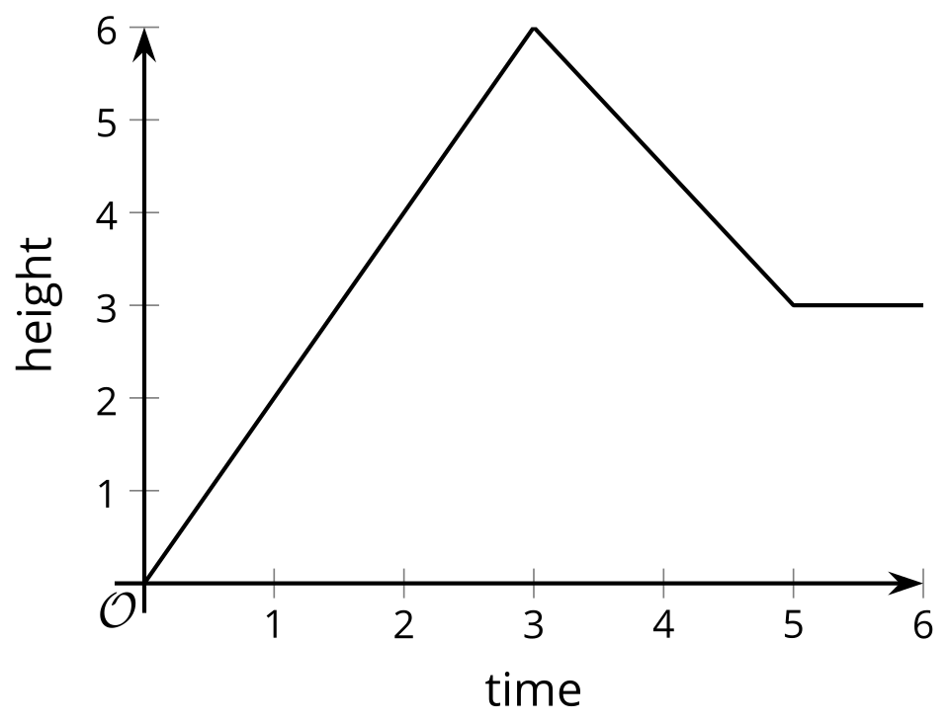

  - For each graph assigned to you, explain what it tells us about the flag.
  - Graph: $\underset{_}{}$
  - Decide as a group which graph(s) appear to be most realistic and which ones least realistic.
- Here is another graph that relates time and height.
- 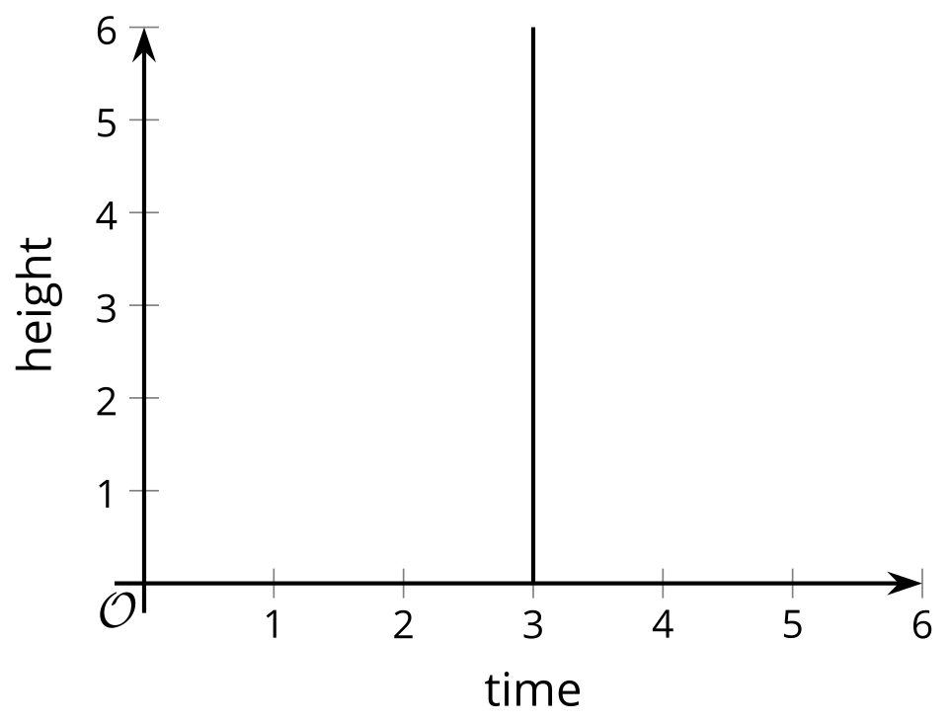
  - Can this graph represent the time and height of the flag? Explain your reasoning.
  - Is this a graph of a function? Explain your reasoning.

3 Flag Raising (Part 2)

Student Task Statement
Your teacher will show a video of a flag being raised. Function $H$ gives the height of the flag over time. Height is measured in feet. Time is measured in seconds since the flag is fully secured to the string, which is when the video clip begins.
- On the coordinate plane, sketch a graph that could represent function $H$. Be sure to include a label and a scale for each axis.
- 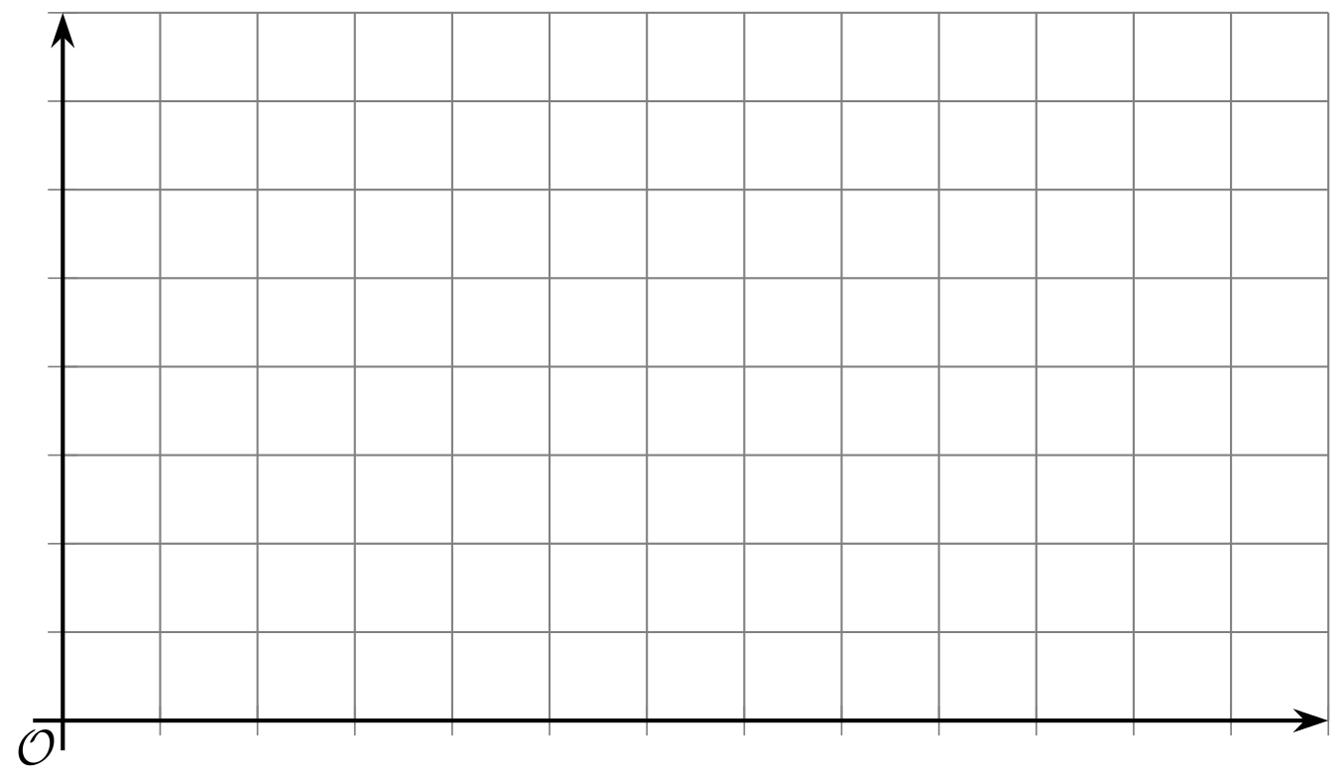
- Use your graph to estimate the average rate of change from the time the flag starts moving to the time it stops. Be prepared to explain what the average rate of change tells us about the flag.

4 Two Pools (Optional)

Student Task Statement
To prepare for a backyard party, a parent uses two identical hoses to fill a small pool that is 15 inches deep and a large pool that is 27 inches deep.
The height of the water in each pool is a function of time since the water is turned on.

Here are descriptions of three situations. For each situation, sketch the graphs of the two functions on the same coordinate plane, so that $S\left(t\right)$ is the height of the water in the small pool after $t$ minutes, and $L\left(t\right)$ is the height of the water in the large pool after $t$ minutes.
In both functions, the height of the water is measured in inches.
- Situation 1: Each hose fills one pool at a constant rate. When the small pool is full, the water for that hose is shut off. The other hose keeps filling the larger pool until it is full.
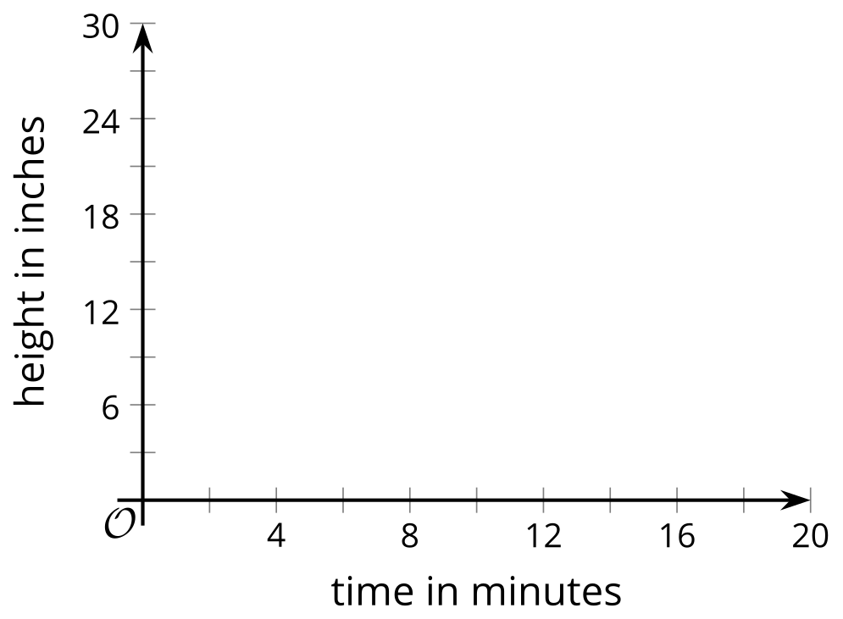
- Situation 2: Each hose fills one pool at a constant rate. When the small pool is full, both hoses are shut off.
- Situation 3: Each hose fills one pool at a constant rate. When the small pool is full, both hoses are used to fill the large pool until it is full.

5 The Bouncing Ball (Optional)

Student Task Statement
Your teacher will show you one or more videos of a tennis ball being dropped. Here are some still images of the situation.
The height of the ball is a function of time. Suppose the height is $h$ feet, $t$ seconds after the ball is dropped.
- Use the blank coordinate plane to sketch a graph of the height of the tennis ball as a function of time.
- To help you get started, here are some pictures and a table. Complete the table with your estimates before sketching your graph.

- 0 seconds
- 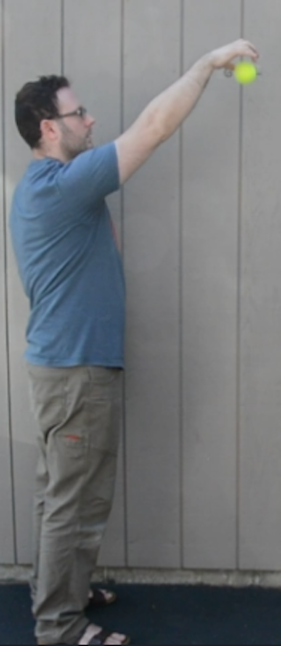

- 0.28 seconds
- 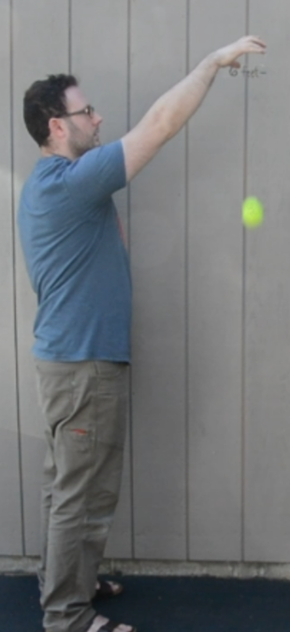

- 0.54 seconds
- 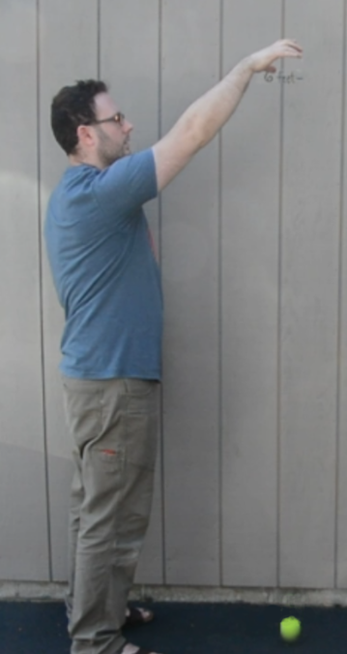

- 0.74 seconds
- 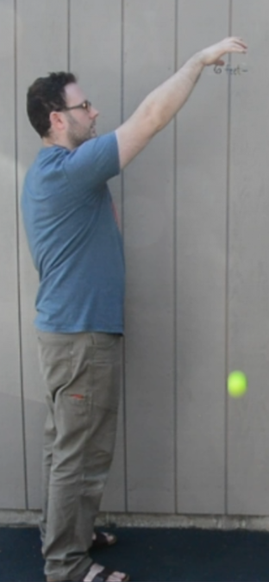

- 1.03 seconds
- 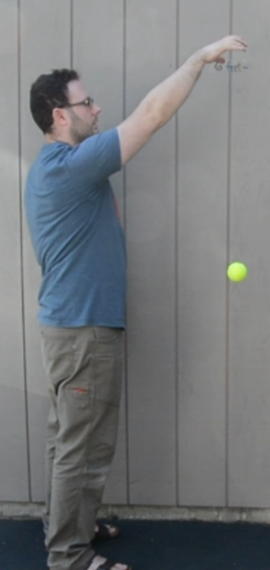

- 1.48 seconds
- 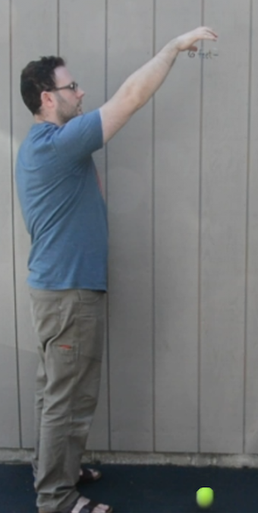

- 1.88 seconds
- 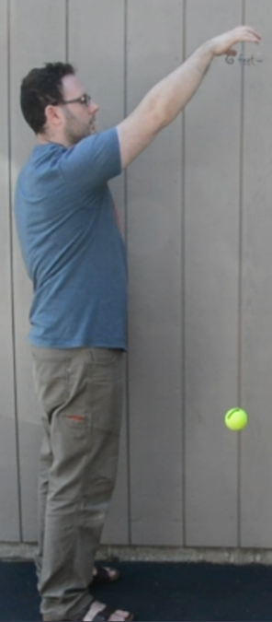

- 2.25 seconds
- 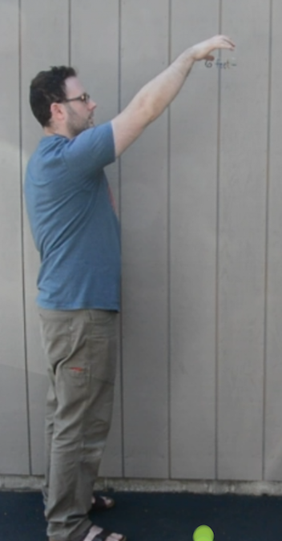
- time  (seconds) | - height  (feet)
- 0
- 0.28
- 0.54
- 0.74
- 1.03
- 1.48
- 1.88
- 2.25
- 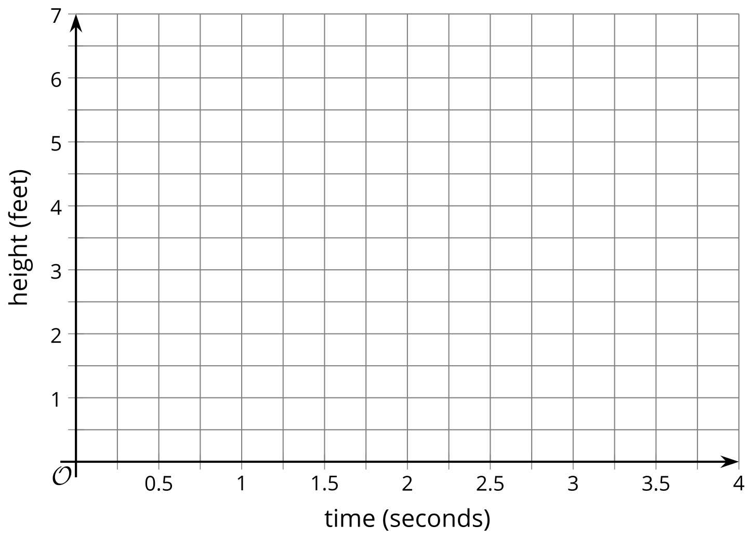
- Identify horizontal and vertical intercepts of the graph. Explain what the coordinates tell us about the tennis ball.
- Find the maximum and minimum values of the function. Explain what they tell us about the tennis ball.
© CC BY 2019 by Illustrative Mathematics®

