Unit 7 Lesson 15: Decompose a Ten and a Hundred to Subtract

WU Choral Count: Hundreds and Tens (Warm up)

Student Task Statement

1 Elena’s Thinking

Student Task Statement
Elena’s thinking:
Step 1:

Step 2:
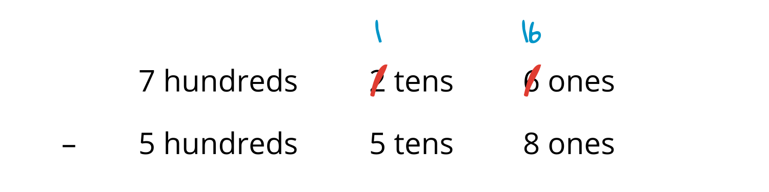
Step 3:
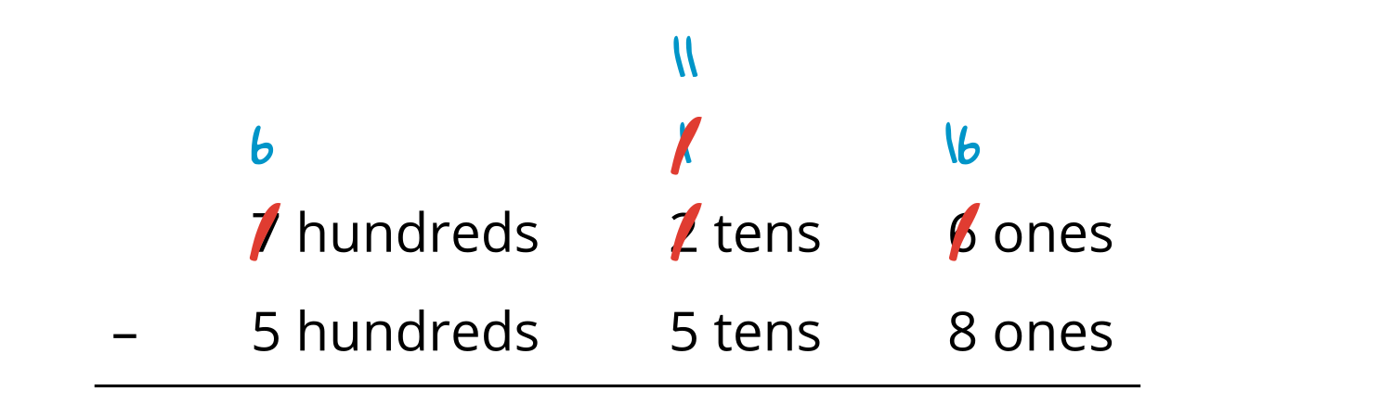
- Use base-ten blocks or a base-ten diagram to show Elena’s steps.
- Finish Elena’s work to find the value of $726−558$.
- What is another way you could use numbers or equations to show subtracting by place to find the value of $726−558$?

2 Walk About and Subtract

Student Task Statement
- Find someone with a different number than you.
- Find the difference between your numbers.
- Show your thinking.
- Trade cards and find a new partner.
- Partner 1:
- Partner 2:
- Partner 3:

© CC BY 2021 Illustrative Mathematics®

