Grade 2
Unit 7Lesson 16CC BY NC 2024 Illustrative Mathematics®
Unit 7, Lesson 16

Subtract within 1,000
- Let’s subtract in a way that makes sense.
Grade 2
Unit 7Lesson 16CC BY NC 2024 Illustrative Mathematics®

Warm-up True or False: Equations Based on Place Value
Decide if each statement is true or false. Be prepared to explain your reasoning.
- 2 hundreds $+$ 3 tens $+$ 4 ones $=$ 2 hundreds $+$ 3 tens $+$ 14 ones
- 2 hundreds $+$ 3 tens $+$ 4 ones $=$ 1 hundred $+$ 13 tens $+$ 4 ones
- 1 hundred $+$ 13 tens $+$ 4 ones $=$ 1 hundred $+$ 12 tens $+$ 14 ones
Grade 2
Unit 7Lesson 16CC BY NC 2024 Illustrative Mathematics®

Activity 1 Jada’s Thinking
Lin’s diagram
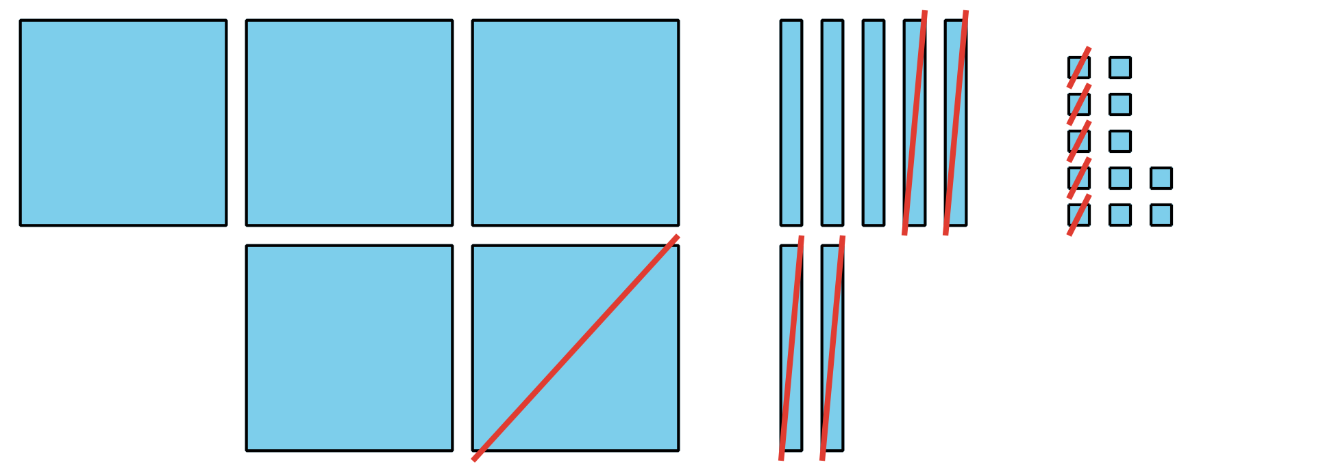
Jada’s equations
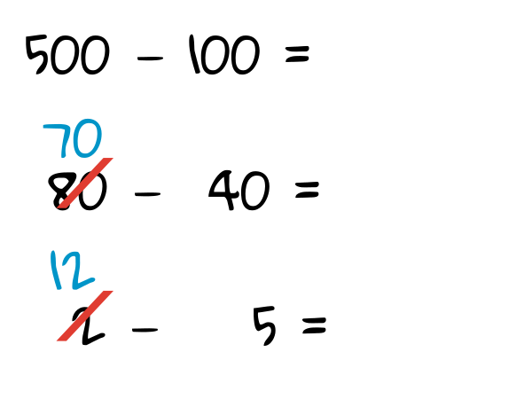

  - Discuss how Jada’s equations match Lin’s diagram.
  - Finish Jada’s work. Find the value of $582−145.$
- Jada is thinking about how to find the value of $402−298.$
  - Jada knows a way to count on to find the difference. She shows her thinking, using a number line.
  - 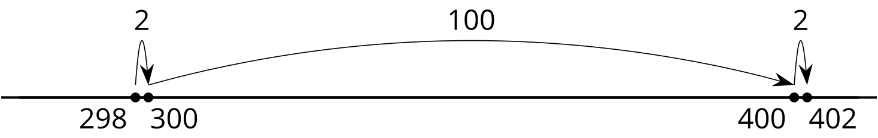
  - Explain Jada’s thinking.
  - Jada says she can’t decompose to find the value of $402−298$, because there aren’t any tens. Do you agree? Show your thinking, using objects, drawings, numbers, or words.
Grade 2
Unit 7Lesson 16CC BY NC 2024 Illustrative Mathematics®

Activity 2Find It Your Way
Find the value of each expression in a way that makes sense to you. Show your thinking, using drawings, numbers, or words.
- $535−214$
- $700−589$
- $683−398$
- $918−608$
- $735−457$
- $602−487$

Section C Summary
We learned ways to subtract 3-digit numbers, using place value. We used base-ten blocks, diagrams, and equations to subtract hundreds from hundreds, tens from tens, and ones from ones. We decomposed a hundred, a ten, or both to subtract by place. We looked closely at numbers in expressions. We planned how to decompose. We used friendly numbers or the relationship between addition and subtraction.
Base-Ten Diagram
$256−64$
Unit Form
$726−558$
