Lesson 6: Different Forms
- Let’s use the different forms of polynomials to learn about them.

6.1: Which One Doesn’t Belong: Small Differences
Which one doesn’t belong?
A: $y=\left(x+4\right)\left(x−6\right)$
B: $y=2x^{2}−8x−24$
C: $y=x^{2}+5x−25$
D: $y=x^{3}+3x^{2}−10x−24$

6.2: The Return of the Box
Earlier, we learned we can make a box from a piece of paper by cutting squares of side length $x$ from each corner and then folding up the sides. Let’s say we now have a piece of paper that is 8.5 inches by 14 inches. The volume $V$, in cubic inches, of the box is a function of the side length $x$ where $V\left(x\right)=\left(14−2x\right)\left(8.5−2x\right)\left(x\right)$.
- Identify the degree and leading term of the polynomial. Explain or show your reasoning.
- Without graphing, what can you say about the horizontal and vertical intercepts of the graph of $V$? Do these points make sense in this situation?

6.3: Using Diagrams to Multiply
- Use the distributive property to show that each pair of expressions is equivalent.
  - $\left(x+2\right)\left(x+4\right)$ and $x^{2}+6x+8$
  - $\left(x+6\right)\left(x+\text{-}5\right)$ and $x^{2}+x−30$
  - $\left(x^{2}+10x+7\right)\left(2x−1\right)$ and $2x^{3}+19x^{2}+4x−7$
  - $\left(4x^{3}−8\right)\left(x^{2}+3\right)$ and $4x^{5}+12x^{3}−8x^{2}−24$
- Write a pair of expressions that each have 2 or 3 terms, and trade them with your partner. Multiply the expressions they gave you.

6.4: Spot the Differences
Let $f\left(x\right)=\left(x−2\right)\left(x+3\right)\left(x−7\right)$ and $g\left(x\right)=\frac{1}{2}\left(x−2\right)\left(x+3\right)\left(x−7\right)$.
- Use graphing technology to graph both functions in the same window of $\text{-}10≤x≤10$ and $\text{-}100≤y≤100$. Describe how the two graphs are the same and how they are different.
- What degree do these polynomials have? Rewrite each expression in standard form to check.
- Let $h\left(x\right)=\left(3x−6\right)\left(x+3\right)\left(x−7\right)$. What do you think the graph of $y=h\left(x\right)$ will look like compared to $y=f\left(x\right)$? Use graphing technology to check your prediction.

Are you ready for more?
Here are the graphs of two polynomial functions, $f$ and $g$. We know that $g\left(x\right)=k⋅f\left(x\right)$.
- Why do the two graphs have different vertical intercepts but the same horizontal intercepts?
- What is the value of $k$?
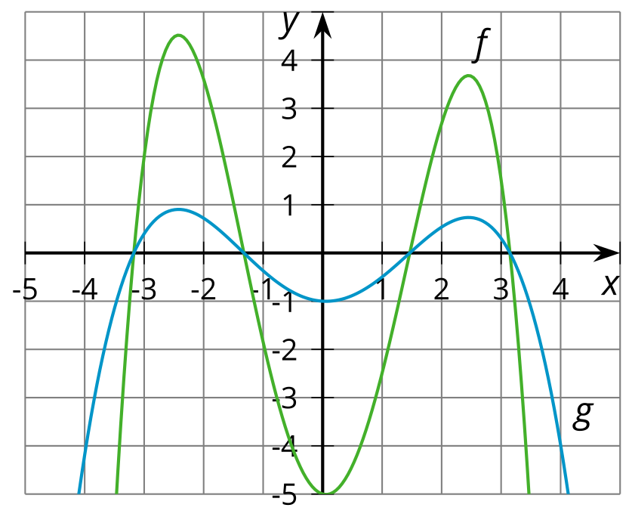

Lesson 6 Summary
We can express polynomials in different, equivalent, algebraic forms. These forms can give us different information about features of the polynomial and its graph. Earlier, we learned about expressing a polynomial function in factored form to identify zeros. The standard form of a polynomial, that is, the expanded version of factored form, makes it easier to identify different information about a polynomial.
For example, here are the expressions for a polynomial $P\left(x\right)$ written in factored form and standard form:
$P\left(x\right)=0.25{\left(x−1\right)}^{2}\left(x+2\right)\left(x−3\right)\left(x+3\right)$
$P\left(x\right)=0.25x^{5}−3x^{3}+0.5x^{2}+6.75x−4.5$
In standard form, two key features of the polynomial function can be identified: the constant term and the degree.
The constant term, shown as -4.5 in the example, tells us the value of the function when $x=0$. In a graph of the function, this point is known as the vertical intercept.
The degree, shown as 5 in the example, tells us about the general shape of the graph of the polynomial, which is something we’ll learn more about in future lessons.
© CC BY 2019 by Illustrative Mathematics®

