Unit 7 Lesson 23: Comparing Functions

1 Math Talk: Evaluating Functions (Warm up)

Student Task Statement
Mentally evaluate each of the functions when $x=3$.
$f\left(x\right)=x^{2}−4x+1$
$g\left(x\right)=6x−2x^{2}$
$h\left(x\right)=\left(x−4\right)\left(x−3\right)$
$j\left(x\right)=2\left(x−1\right)\left(x+2\right)$

2 Comparing Functions

Images for Launch
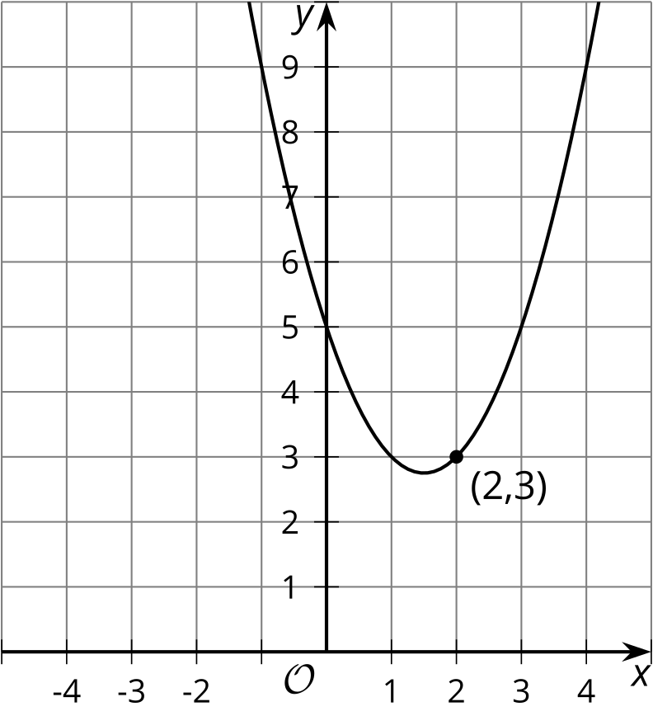

Student Task Statement
The notation $f\left(2\right)$ means the output of function $f$ when $x$ is 2. For each function, determine whether $f\left(2\right)>f\left(3\right)$, $f\left(2\right)<f\left(3\right)$, or $f\left(2\right)=f\left(3\right)$.
- $f\left(x\right)=x^{2}+2x+3$
- $f\left(x\right)=\left(x−2\right)\left(x−3\right)$
- $f\left(x\right)=\text{-}x^{2}+5$
- 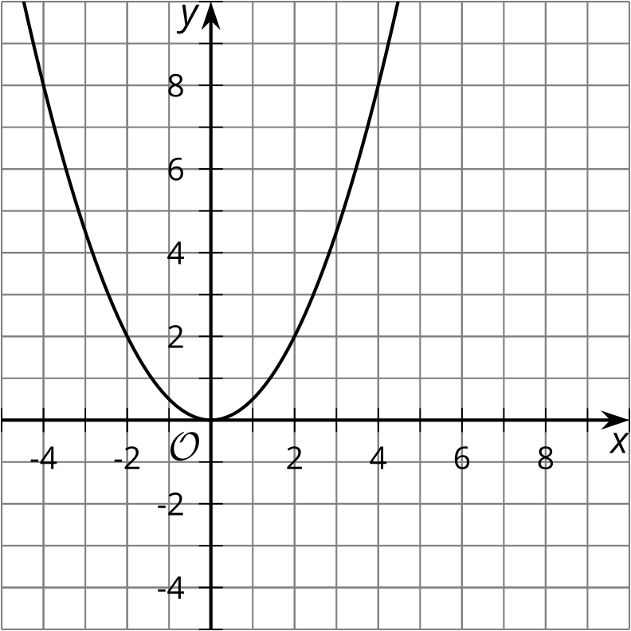
- 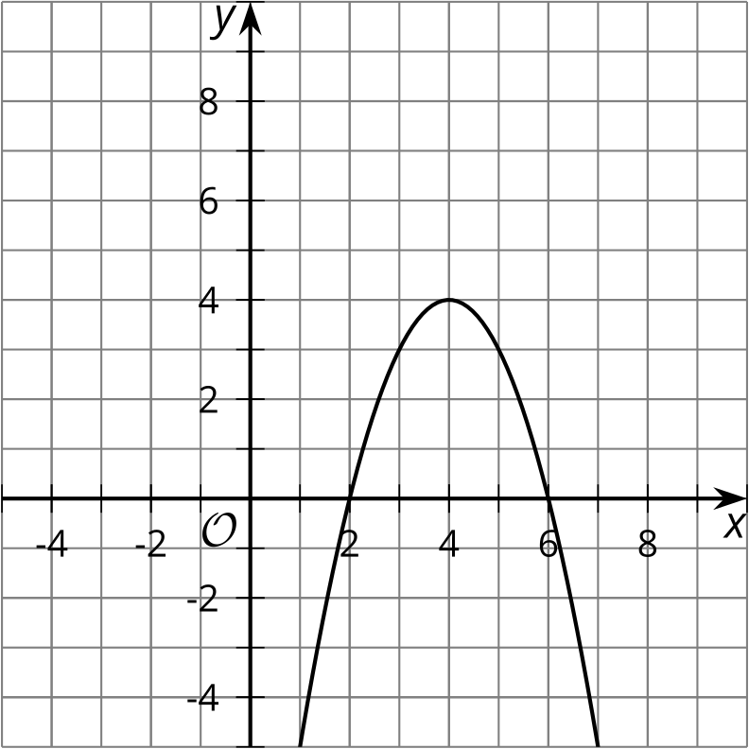
- 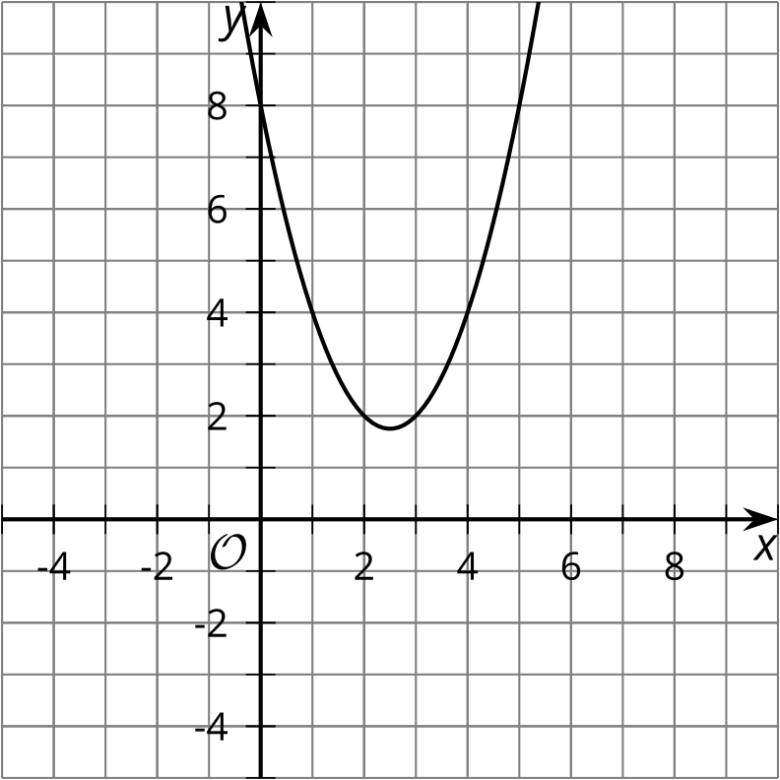
- 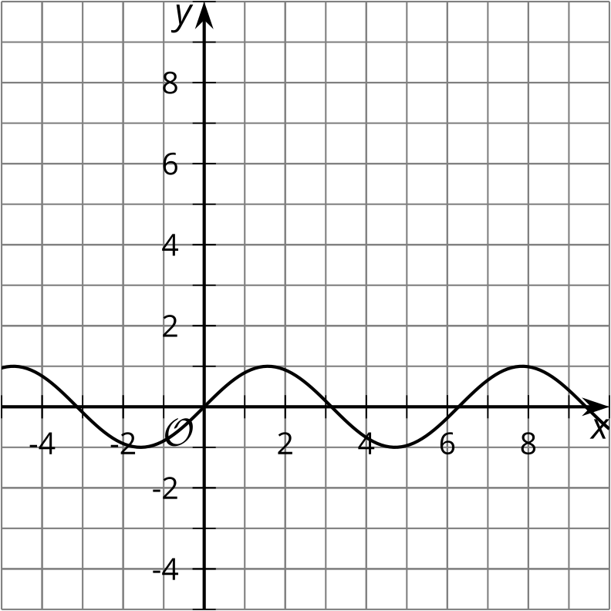

3 Finding the Vertex

Student Task Statement
Write each function in vertex form, then find the coordinates of the vertex.
- $y=x^{2}−4x+7$
- $y=\left(x−1\right)\left(x+3\right)$
- $y=\left(x−2\right)\left(x+2\right)$
- $y=x^{2}−2x+1$
- $y=\text{-}x^{2}−2x−6$
- $y=2x^{2}−12x+22$
- 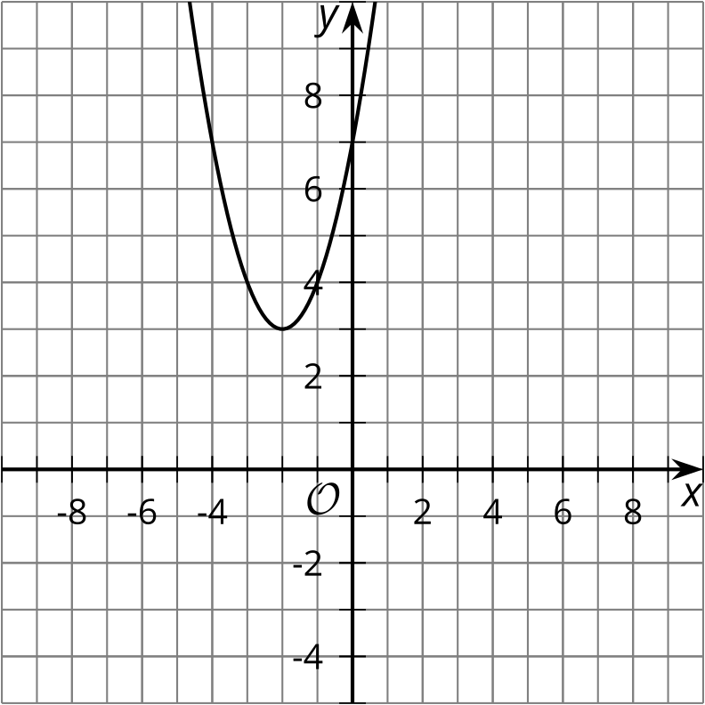
© CC BY 2019 by Illustrative Mathematics®

