Grade 2
Unit 7Lesson 8CC BY NC 2024 Illustrative Mathematics®
Unit 7, Lesson 8

Compose Tens and Hundreds to Add
- Let’s compose tens and hundreds to add.
Grade 2
Unit 7Lesson 8CC BY NC 2024 Illustrative Mathematics®

Warm-up How Many Do You See: Too Many Tens
How many do you see? How do you see them?
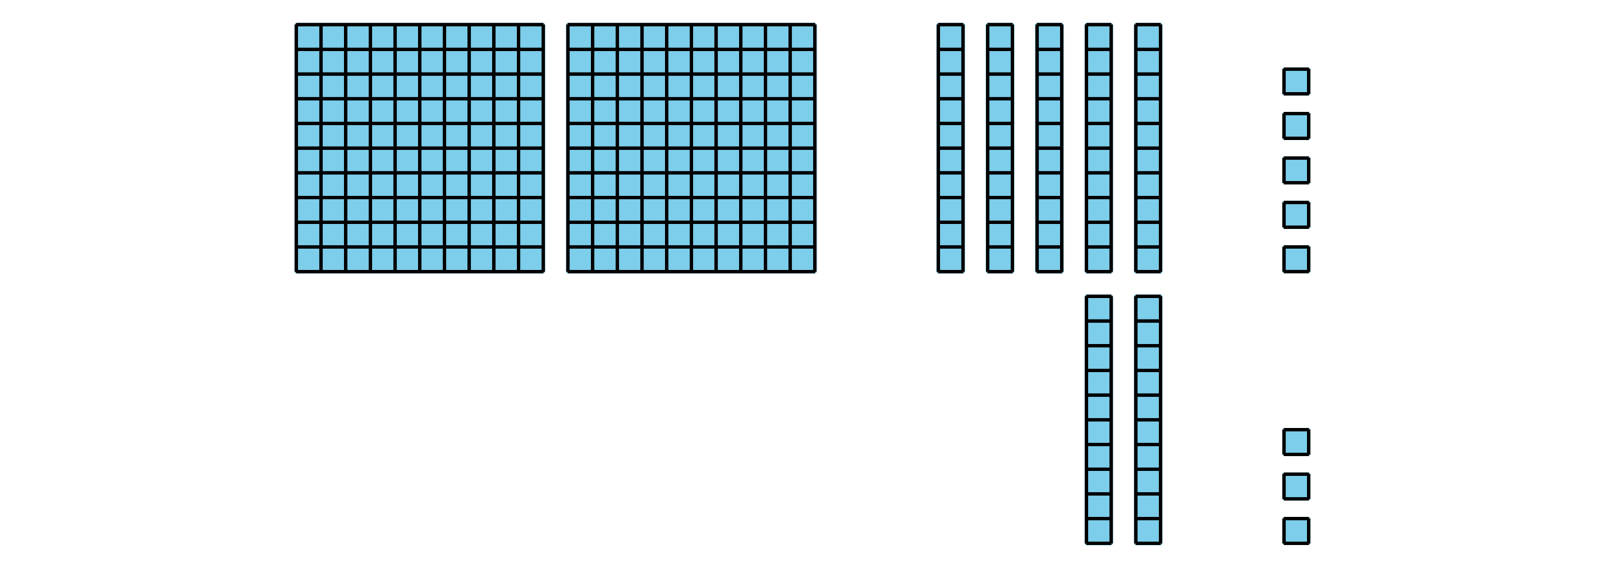
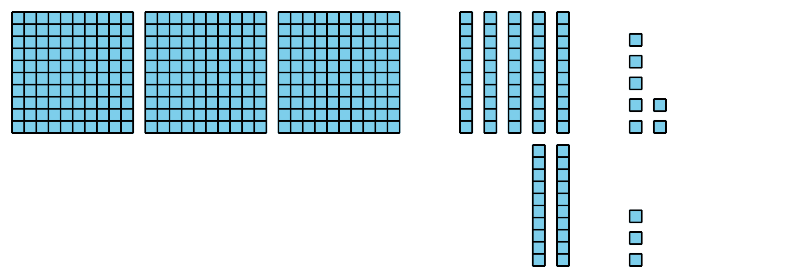
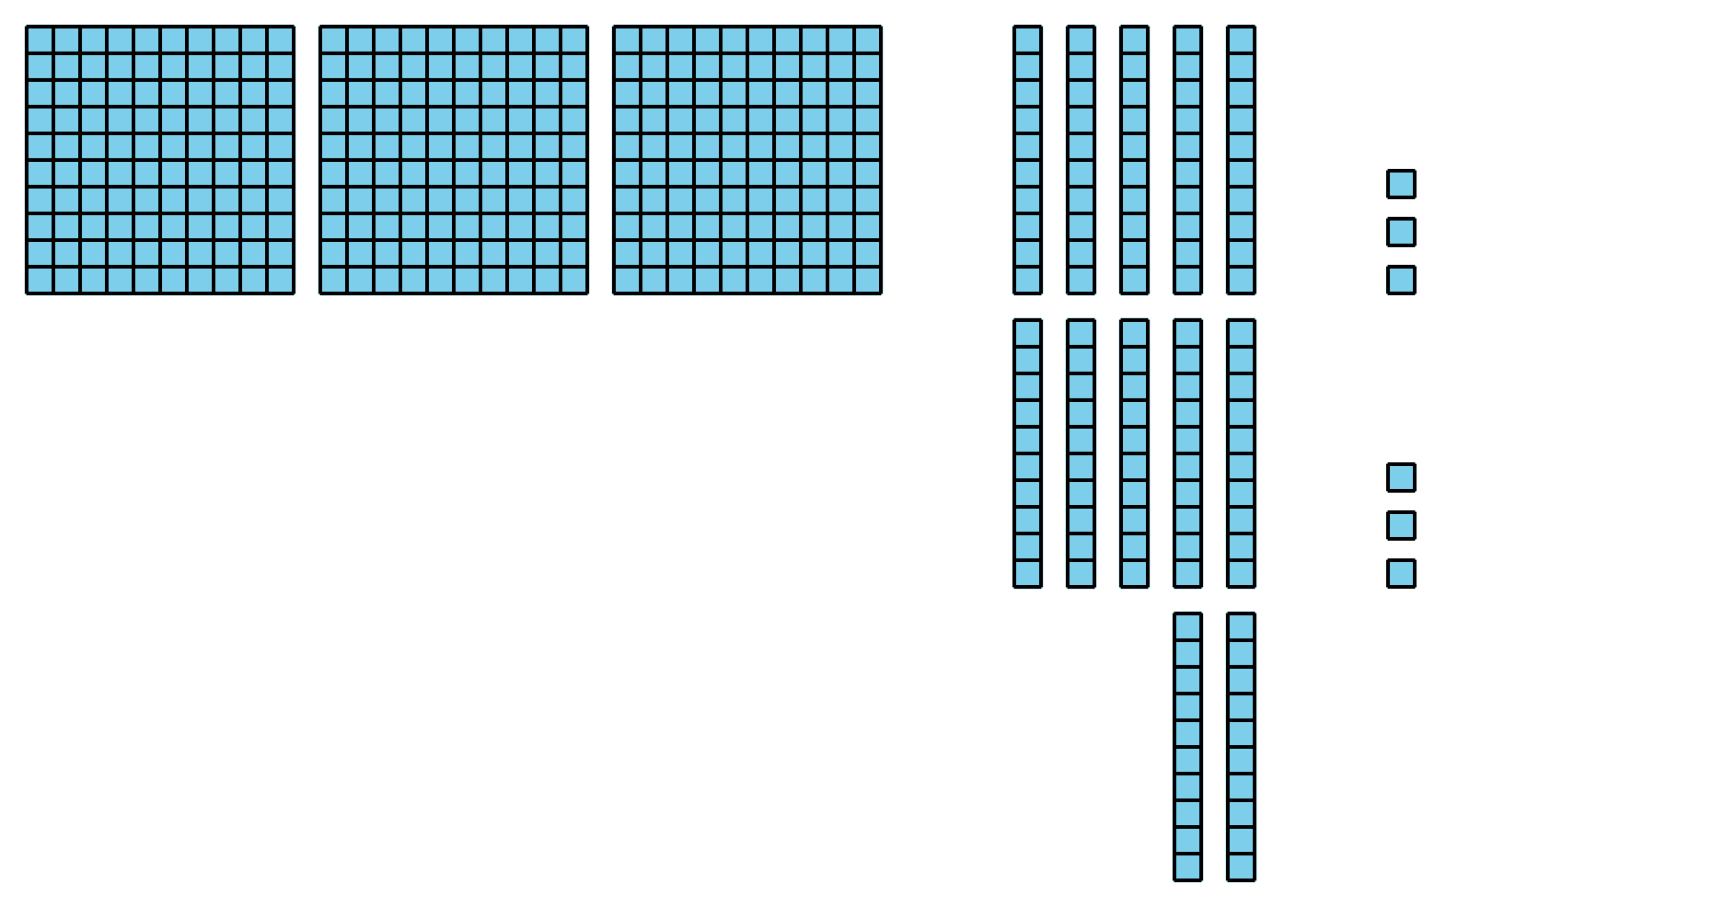
Grade 2
Unit 7Lesson 8CC BY NC 2024 Illustrative Mathematics®

Activity 1Compare the Sums
Find the value of each sum. Show your thinking, using objects, drawings, numbers, or words.
- $273+18$
- $273+81$
- $273+88$
- How are the sums alike? How are they different?
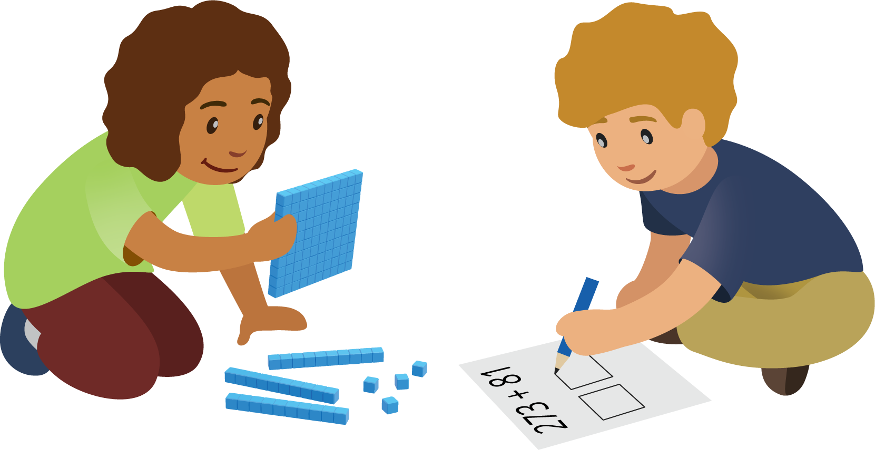
Grade 2
Unit 7Lesson 8CC BY NC 2024 Illustrative Mathematics®

Activity 2 Different Ways to Show Your Thinking
- Priya and Lin find the value of $358+67$.
- Priya’s work
- 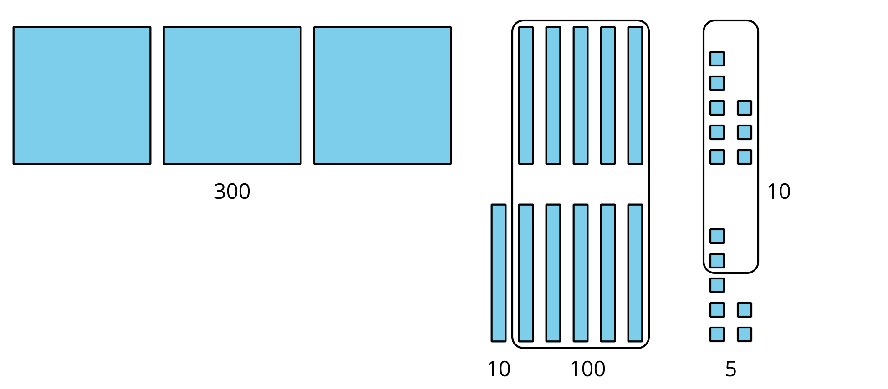
- 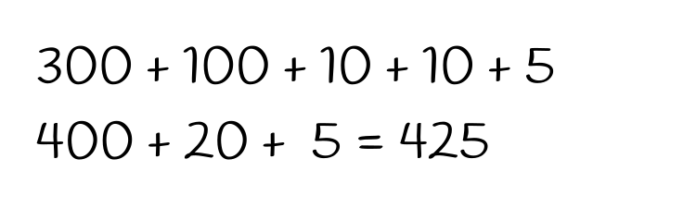
- Lin’s work
- 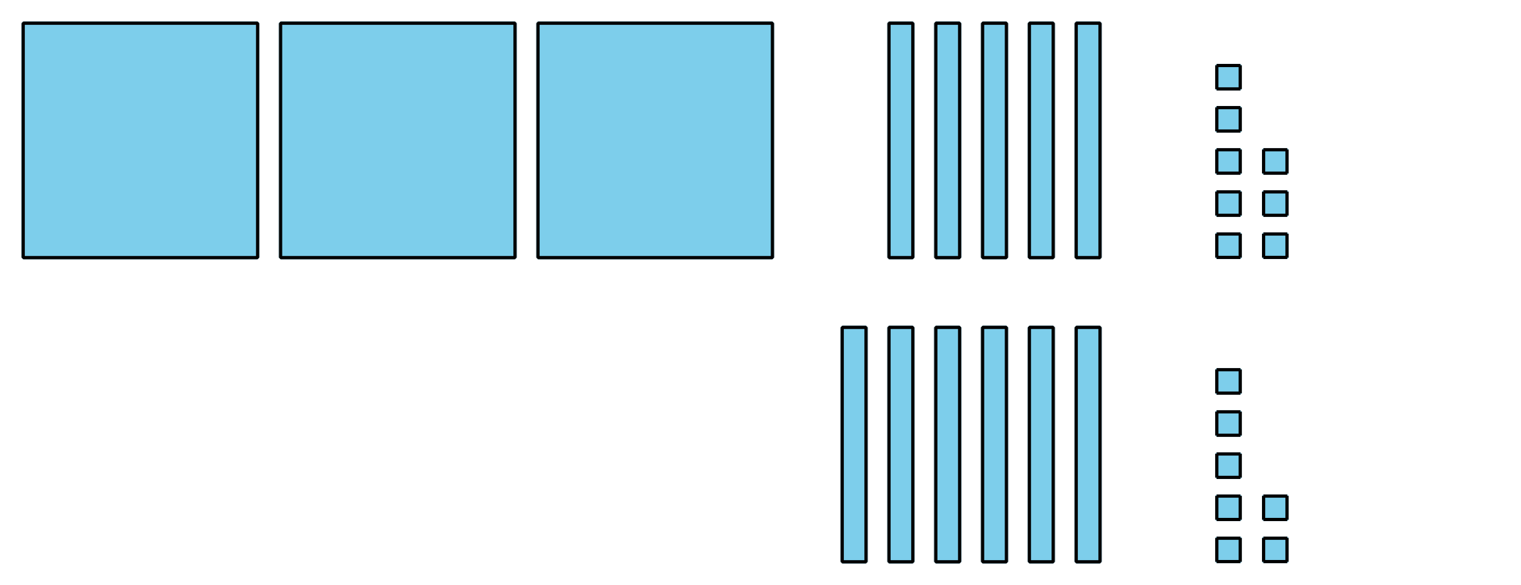
- 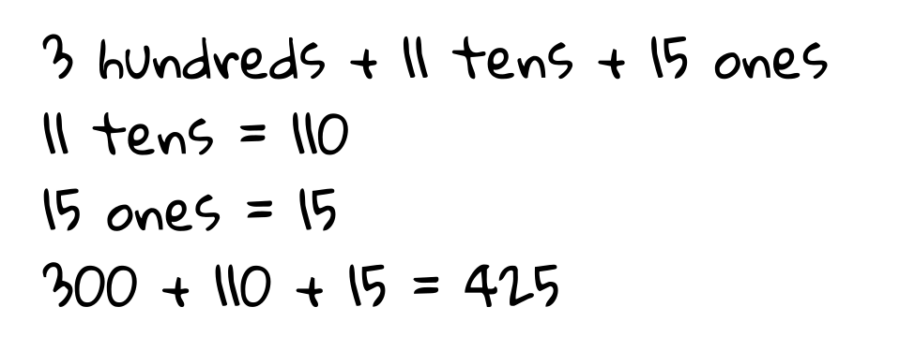
- How are Priya’s and Lin’s work alike? How are they different? Explain your reasoning.
- Find the value of $546+86$.
- Show your thinking, using objects, drawings, numbers, or words.

