Lesson 9: Compare Numbers on the Number Line
- Let’s compare numbers on the number line.

Warm-up: Estimation Exploration: Hundreds
What number could this be?
- Record an estimate that is:
- too low | - about right | - too high
- Record an estimate that is:
- too low | - about right | - too high

9.1: Compare Comparisons
Each student compared 371 and 317, but represented their thinking in different ways.
Diego
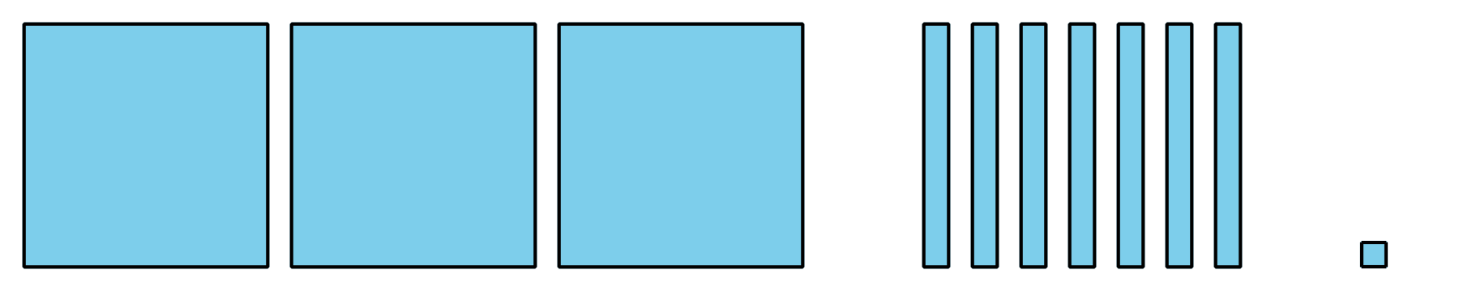

- I see 3 hundreds for each number.
- 317 only has 1 ten, but 371 has 7 tens.
- $371>317$
Clare
- Each has 3 hundreds.
- 371 has 7 tens, but 317 only has 1 ten.
- $317<371$
Jada
- I can see that 371 is farther to the right on my number line, so I know it is greater than 317.
- $371>317$
- What is the same and different about these students’ representations?
- Discuss with a partner.
- Try Jada’s way.
- Estimate the location of 483 and 443 on the number line. Mark each number with a point. Label the point with the number it represents.
- Use $>$, $=$, or $<$ to compare 483 and 443.
- ______________________________

9.2: Compare in Different Ways
- Locate and label 420 and 590 on the number line.
- Use $<$, $>$, and $=$ to compare 420 and 590.
- ______________________________
- Estimate the location of 378 and 387 on the number line. Mark each number with a point. Label the point with the number it represents.
- Use $<$, $>$, and $=$ to compare 378 and 387.
- ______________________________
- Diego and Jada compared 2 numbers. Use their work to figure out what numbers they compared. Then use $<$, $>$, and $=$ to compare the numbers.
- 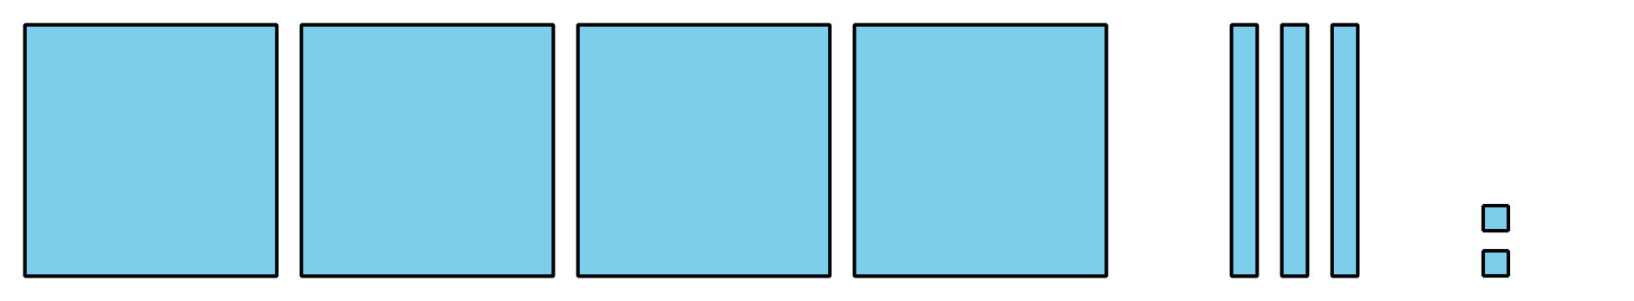
- 
- ______________________________
- Which representation was most helpful to compare the numbers? Why?
© CC BY 2021 Illustrative Mathematics®

