Grade 6
Unit 5Lesson 9CC BY NC Illustrative Mathematics, based on IM 6–8 Math, CC BY Open Up Resources.
Unit 5, Lesson 9

Using Base-Ten Diagrams to Divide
Let's use base-ten diagrams to find quotients.
Grade 6
Unit 5Lesson 9CC BY NC Illustrative Mathematics, based on IM 6–8 Math, CC BY Open Up Resources.

9.1Representing $372÷3$
Elena used base-ten diagrams to find $372÷3$.
She started by representing 372.
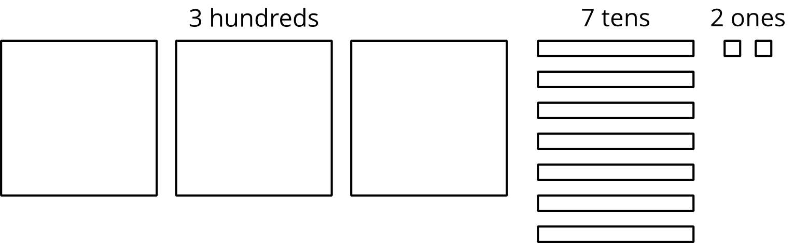
She made 3 groups, each with 1 hundred. Then, she put the tens and ones in each of the 3 groups. Here is her diagram for $372÷3$.
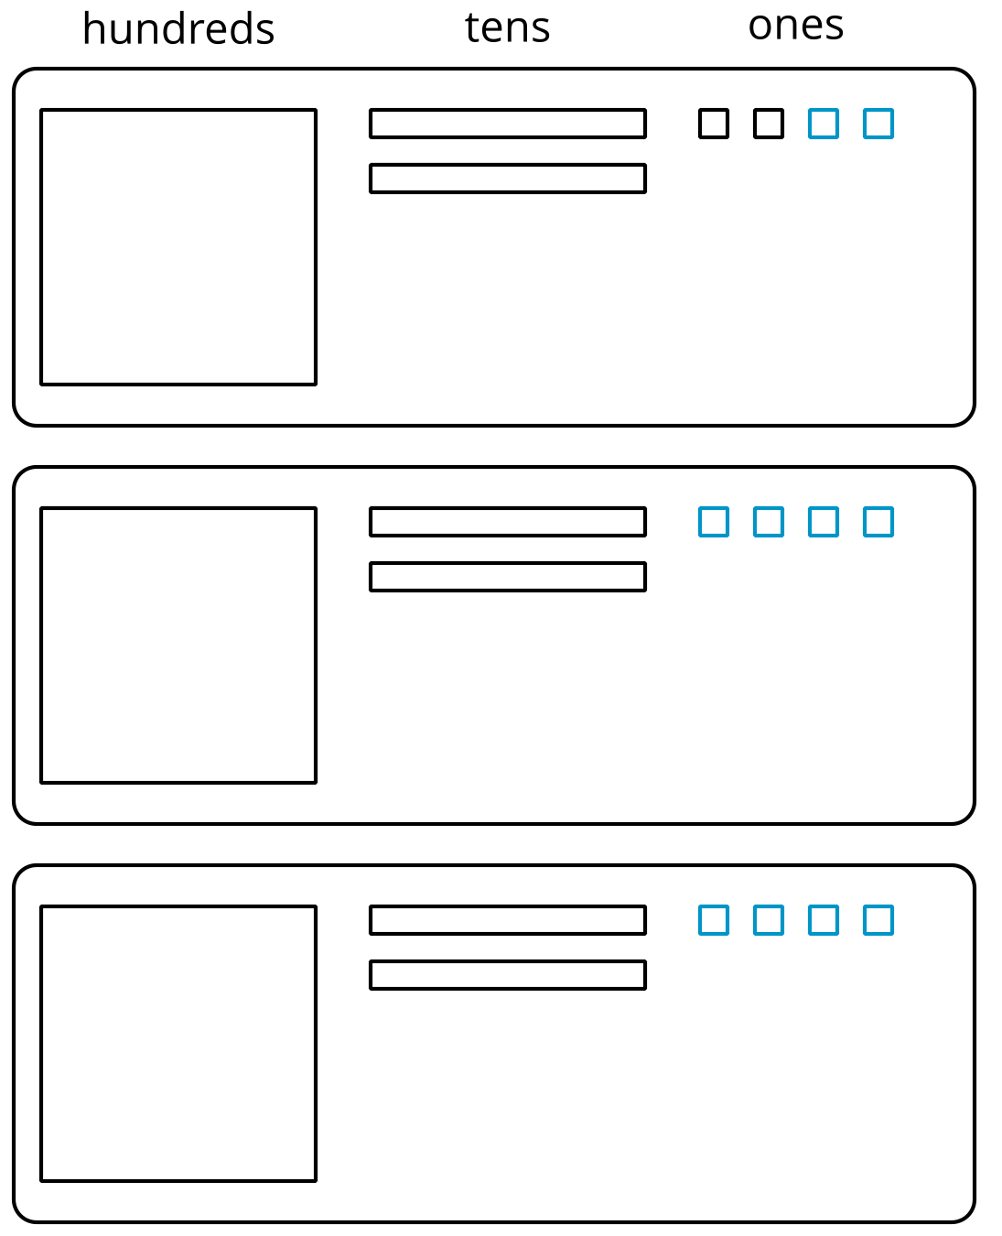
Discuss with a partner:
- Elena’s diagram for 372 has 7 tens. The one for $372÷3$ has only 6 tens. Why?
- Where did the extra ones (small squares) come from?
Grade 6
Unit 5Lesson 9CC BY NC Illustrative Mathematics, based on IM 6–8 Math, CC BY Open Up Resources.

9.2Keep Dividing
Mai used base-ten diagrams to calculate $62÷5$. She started by representing 62.
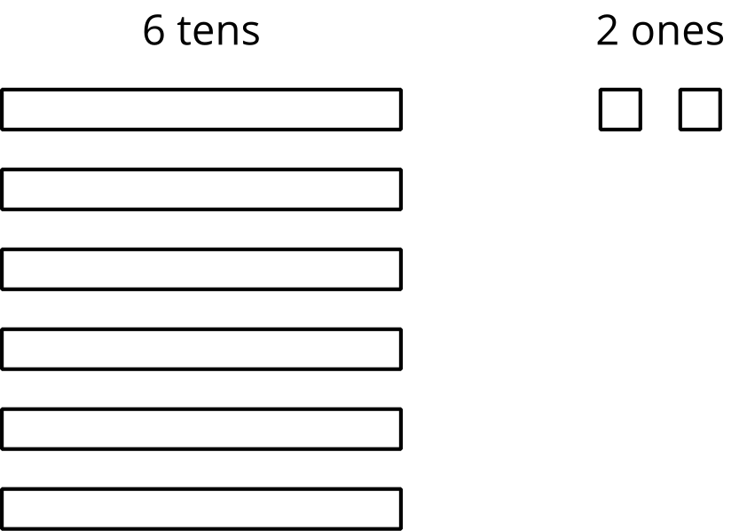
She then made 5 groups, each with 1 ten. There was 1 ten left. She decomposed it into 10 ones and distributed the ones across the 5 groups.
Here is Mai’s diagram for $62÷5$.
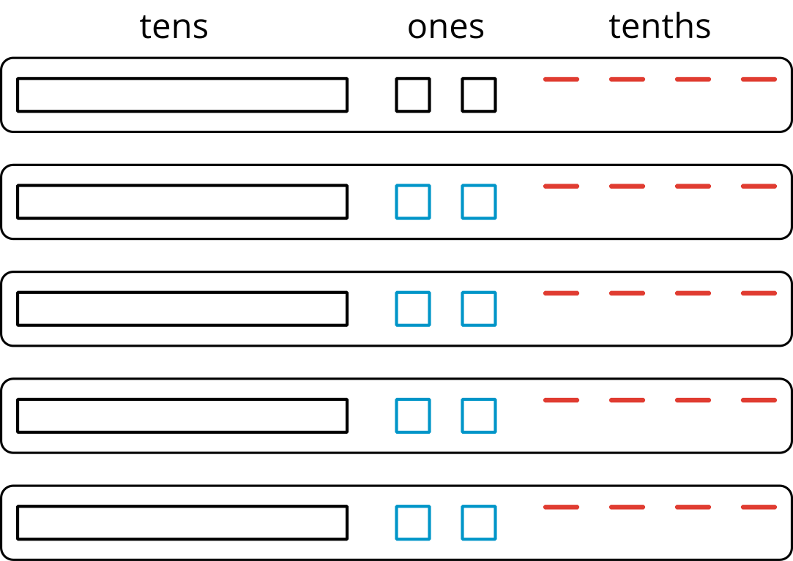
- Discuss these questions with a partner:
  - Mai should have a total of 12 ones, but her diagram shows only 10. Why?
  - She did not originally have tenths, but in her diagram each group has 4 tenths. Why?
  - What value has Mai found for $62÷5$?
- Find the quotient of $511÷5$. Show your reasoning. If you get stuck, try drawing a base-ten diagram or using base-ten representations.
- Four students share a $271 prize from a science competition. How much does each student get if the prize is shared equally? Show your reasoning.
Grade 6
Unit 5Lesson 9CC BY NC Illustrative Mathematics, based on IM 6–8 Math, CC BY Open Up Resources.

9.3Explaining a Representation of Division
To find $53.8÷4$ using diagrams, Elena began by representing 53.8.
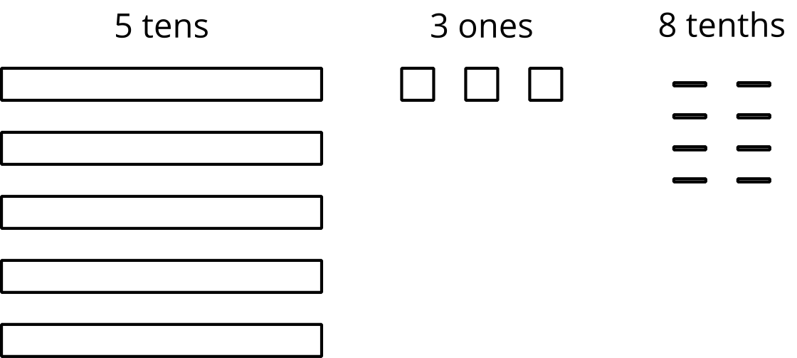
She placed 1 ten into each group, decomposed the remaining 1 ten into 10 ones, and went on distributing the units.
This diagram shows Elena’s initial placement of the units and the decomposition of 1 ten.
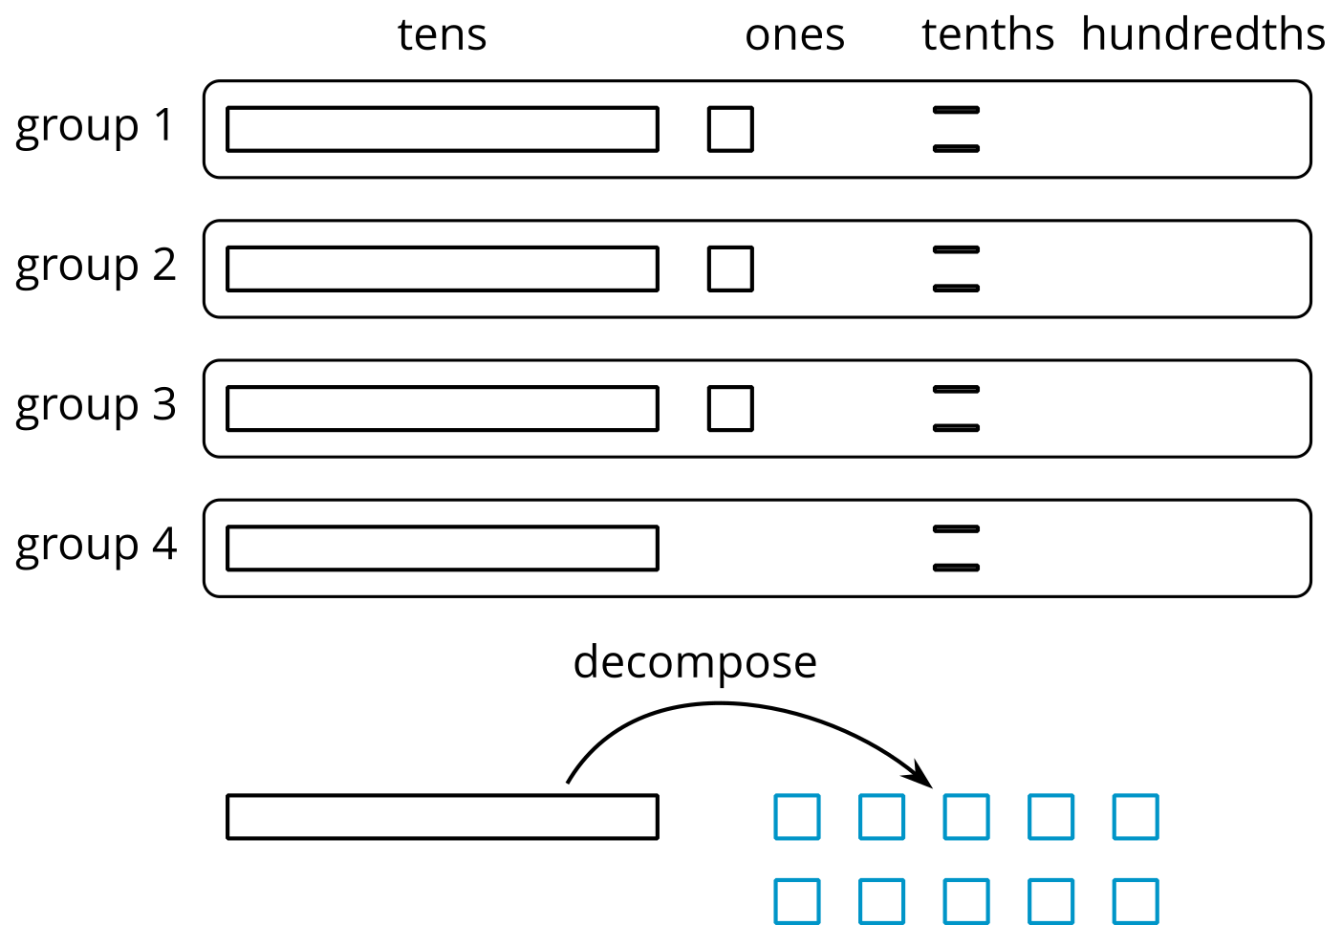
​​​​​​
Here’s Elena’s finished diagram, showing the quotient of $53.8÷4$.
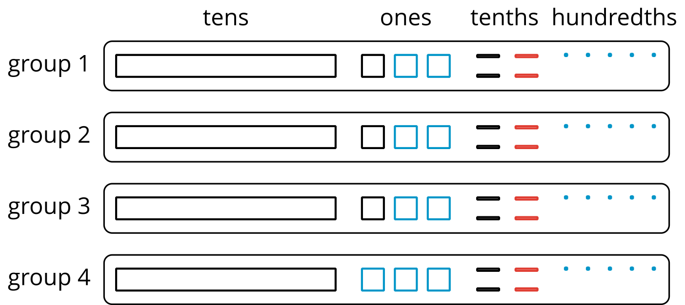
Discuss with a partner:
- What did Elena do after decomposing the 1 ten into 10 ones? How did she get to the last diagram?
- Based on Elena’s work, what is the value of $53.8÷4$?

Are you ready for more?
In a game, special stones are used for bartering. The values of the stones are based on their color and are ranked as shown, with red having the highest value.
red
orange
yellow
green
blue
indigo
violet
Each color is valued at 3 times the color below it in the ranking. So the value of a red stone is 3 times that of an orange stone, and the value of a green stone is 3 times that of a blue stone.
A team of 4 players work together to earn 1 of each stone. If they split the stones evenly amongst themselves, which stone does each player get?

Lesson 9 Summary
One way to find the quotient of two numbers, such as $345÷3$, is to use a base-ten diagram to represent the hundreds, tens, and ones and to create equal-size groups.
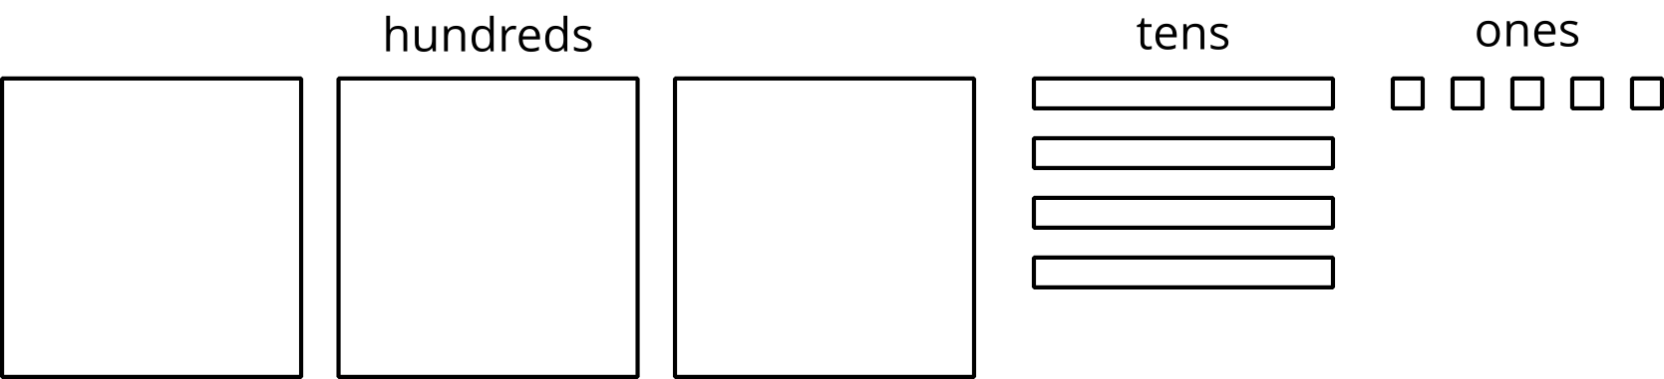
We can think of the division by 3 as splitting up 345 into 3 equal groups.
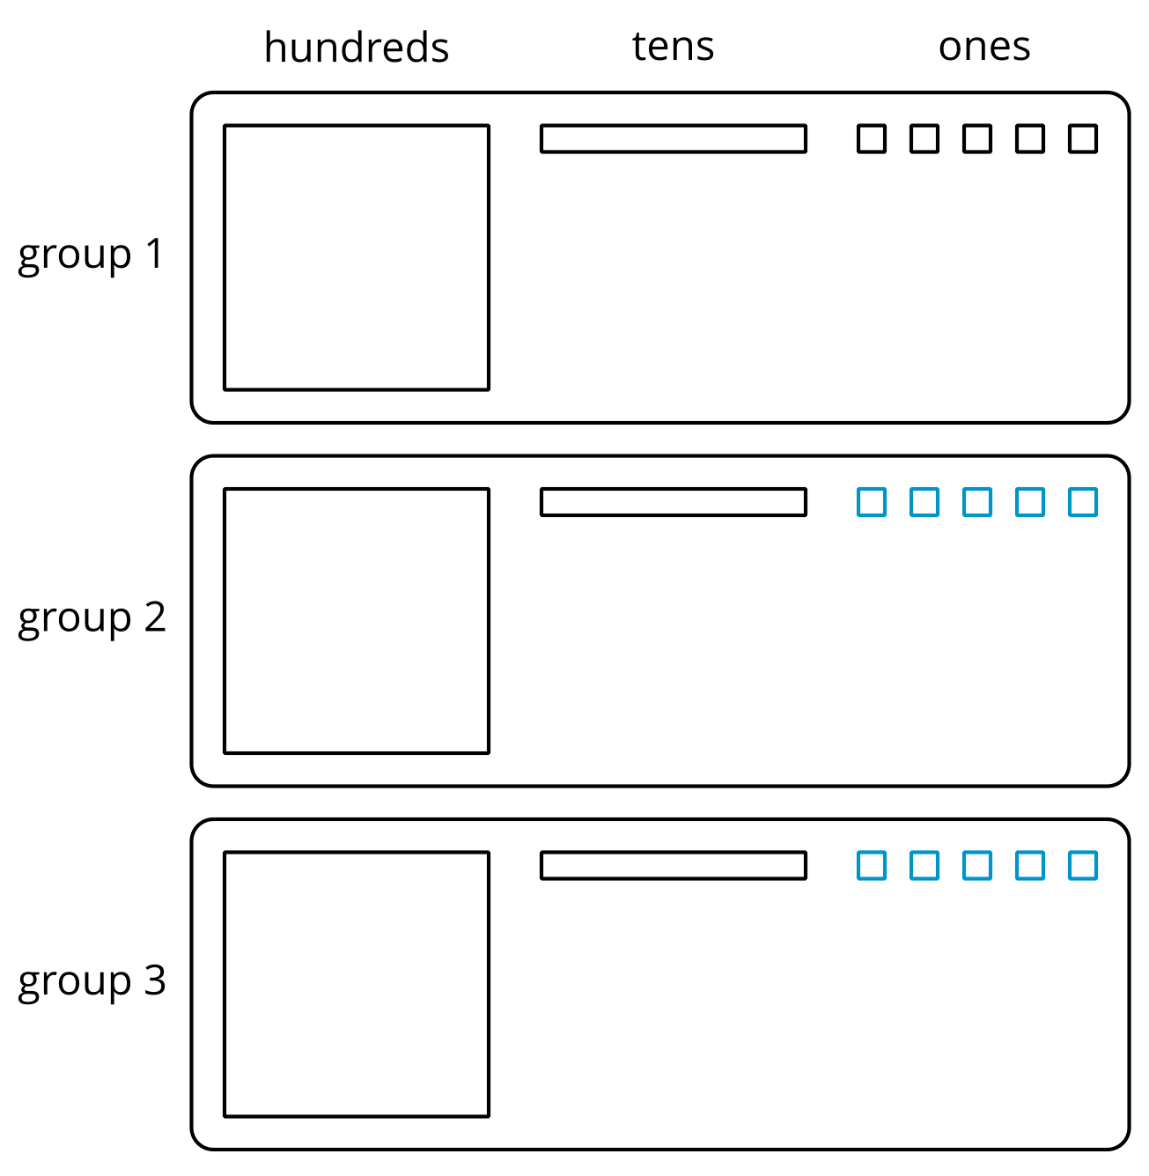
Each group has 1 hundred, 1 ten, and 5 ones, so $345÷3=115$. Notice that in order to split 345 into 3 equal groups, one of the tens had to be decomposed into 10 ones.
Base-ten diagrams can also help us think about division when the result is not a whole number. Let’s look at $86÷4$, which we can think of as dividing 86 into 4 equal groups.
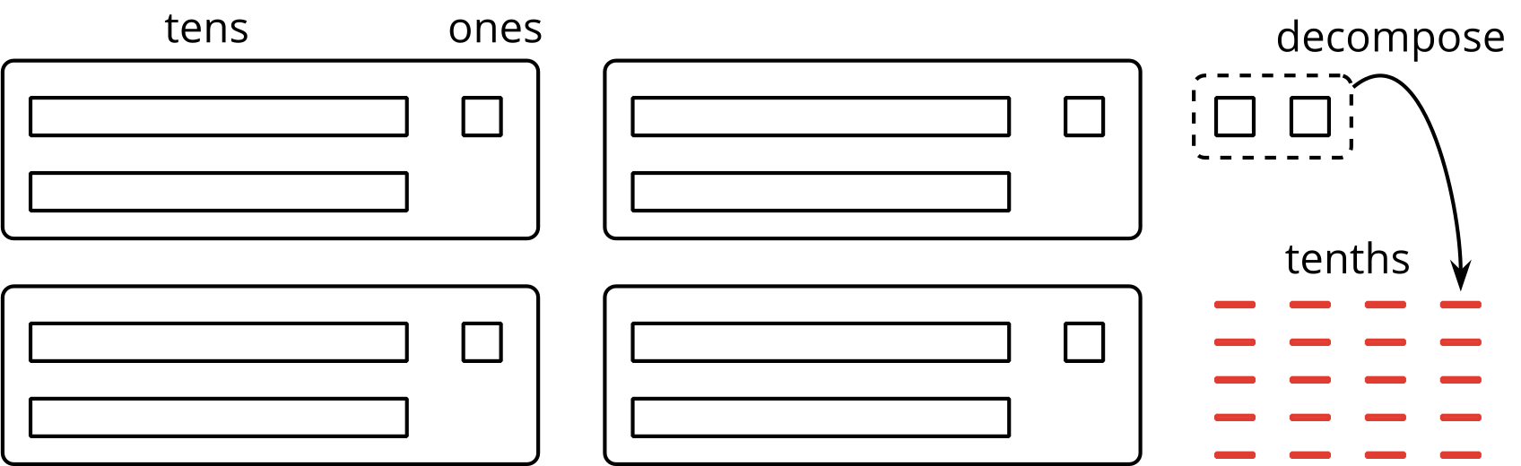
We can see that there are 4 groups of 21 in 86 with 2 ones left over. To find the quotient, we need to distribute the 2 ones into the 4 groups. To do this, we first need to decompose the 2 ones into 20 tenths and then put 5 tenths in each group.
Once the 20 tenths are distributed, each group will have 2 tens, 1 one, and 5 tenths, so $86÷4=21.5$.
For some division problems, such as $1,​248÷36$ or $9.65÷1.5$, it is not convenient to draw and reason with base-ten diagrams. We will look at other strategies in upcoming lessons.

