Unit 7 Lesson 22: Features of Parabolas

1 Matching Quadratic Graphs (Warm up)

Student Task Statement
Match the equation to the graph. Be prepared to explain your reasoning.
- $y=x^{2}+x$
- $y=\text{-}x^{2}−3x$
- $y=\left(x−1\right)\left(x+5\right)$
- $y=x^{2}+5x+1$

- A
- 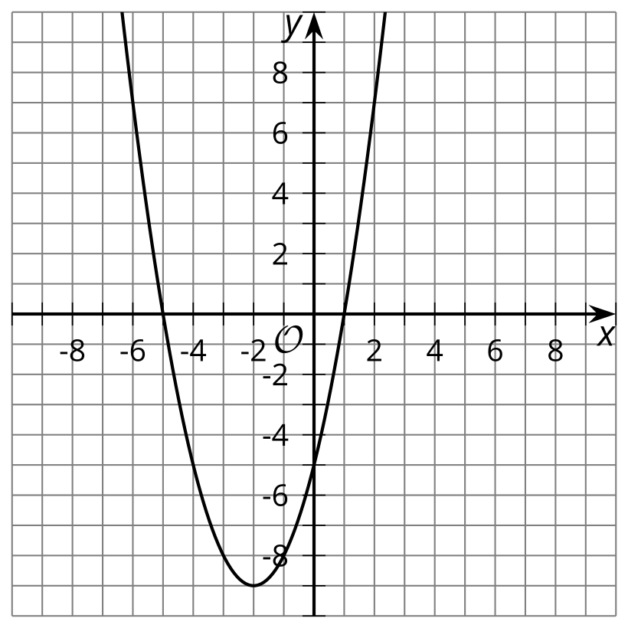

- B
- 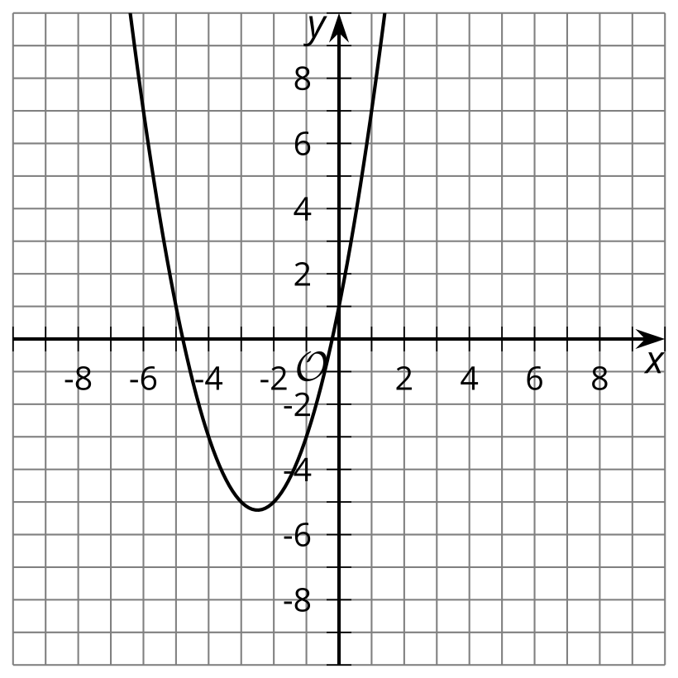

- C
- 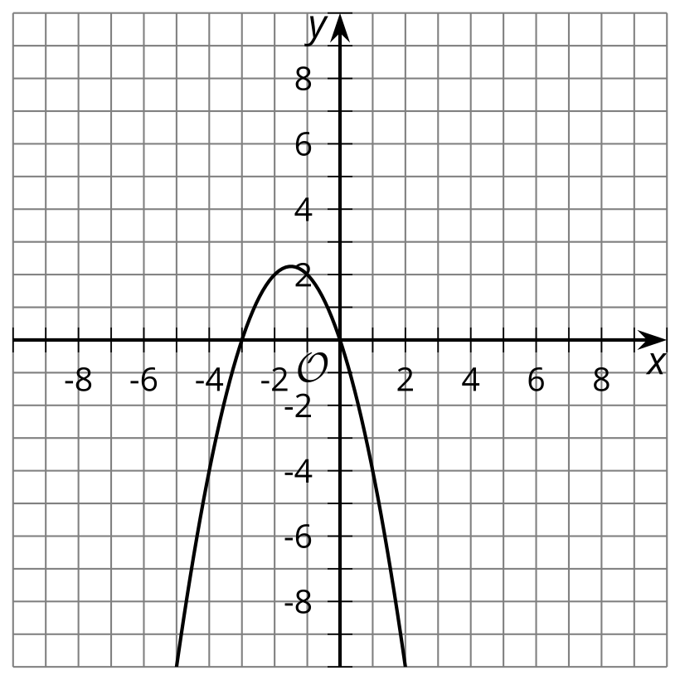

- D
- 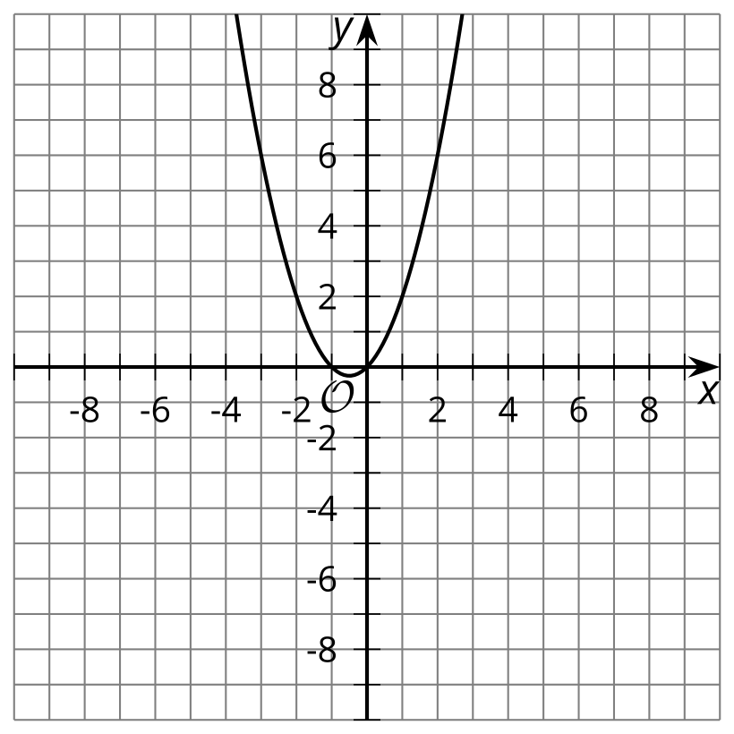

2 Features of a Quadratic Graph

Images for Launch
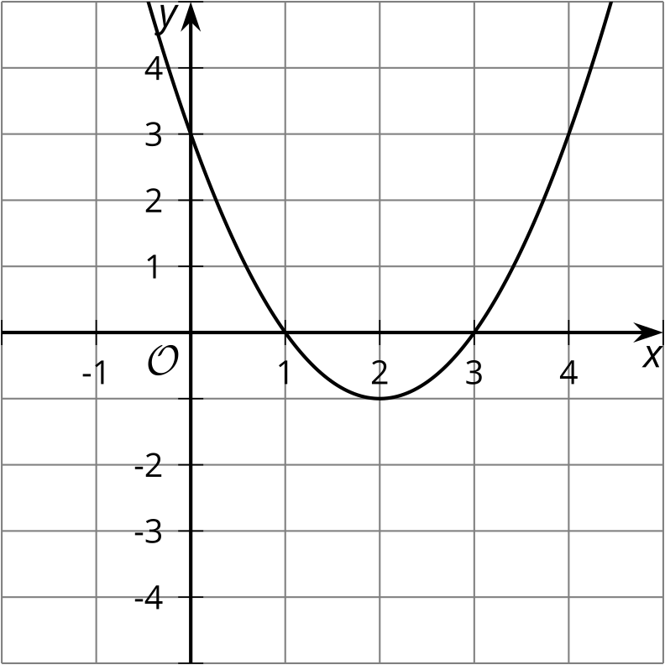

Student Task Statement
- Graph the function $y=x^{2}−10x+16$.
- Find the coordinates for the
  - $x$-intercepts
  - $y$-intercept
  - vertex
- Draw a dashed line along the line of symmetry for the graph.
- What do you notice about the line of symmetry as it relates to the:
  - vertex
  - $x$-intercepts
- Use the line of symmetry and the $y$-intercept to find another point on the parabola.

3 What Do You Know?

Student Task Statement
- Write a function that is represented by a graph with $x$-intercepts at $\left(\text{-}3,0\right)$ and $\left(1,0\right)$.
  - Without graphing the function, find the $y$-intercept. Explain or show your reasoning.
  - Without using graphing technology, use the three points you know to sketch the graph of this function.
  - 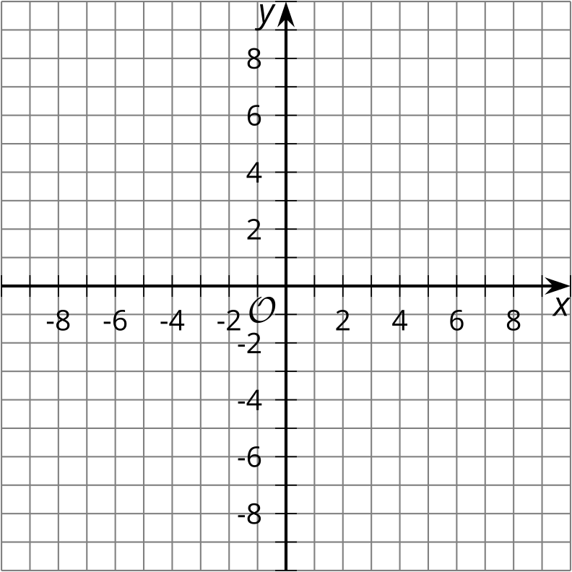
  - What is the $x$-coordinate of the vertex? Explain your reasoning.
  - Using the $x$-coordinate you found for the vertex, find the coordinate pair for the vertex.
- 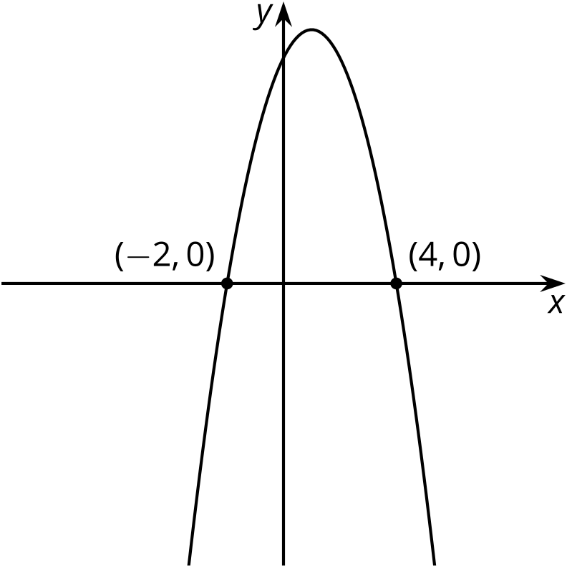
  - What do you know about the coordinates of the $y$-intercept?
  - What do you know about the coordinates of the vertex?
© CC BY 2019 by Illustrative Mathematics®

