Grade 2
Unit 8Lesson 2CC BY NC 2024 Illustrative Mathematics®
Unit 8, Lesson 2

Partners Make Pairs
- Let’s make pairs with groups of objects.
Grade 2
Unit 8Lesson 2CC BY NC 2024 Illustrative Mathematics®

Warm-upWhich Three Go Together: Laundry Day
Which 3 go together?
A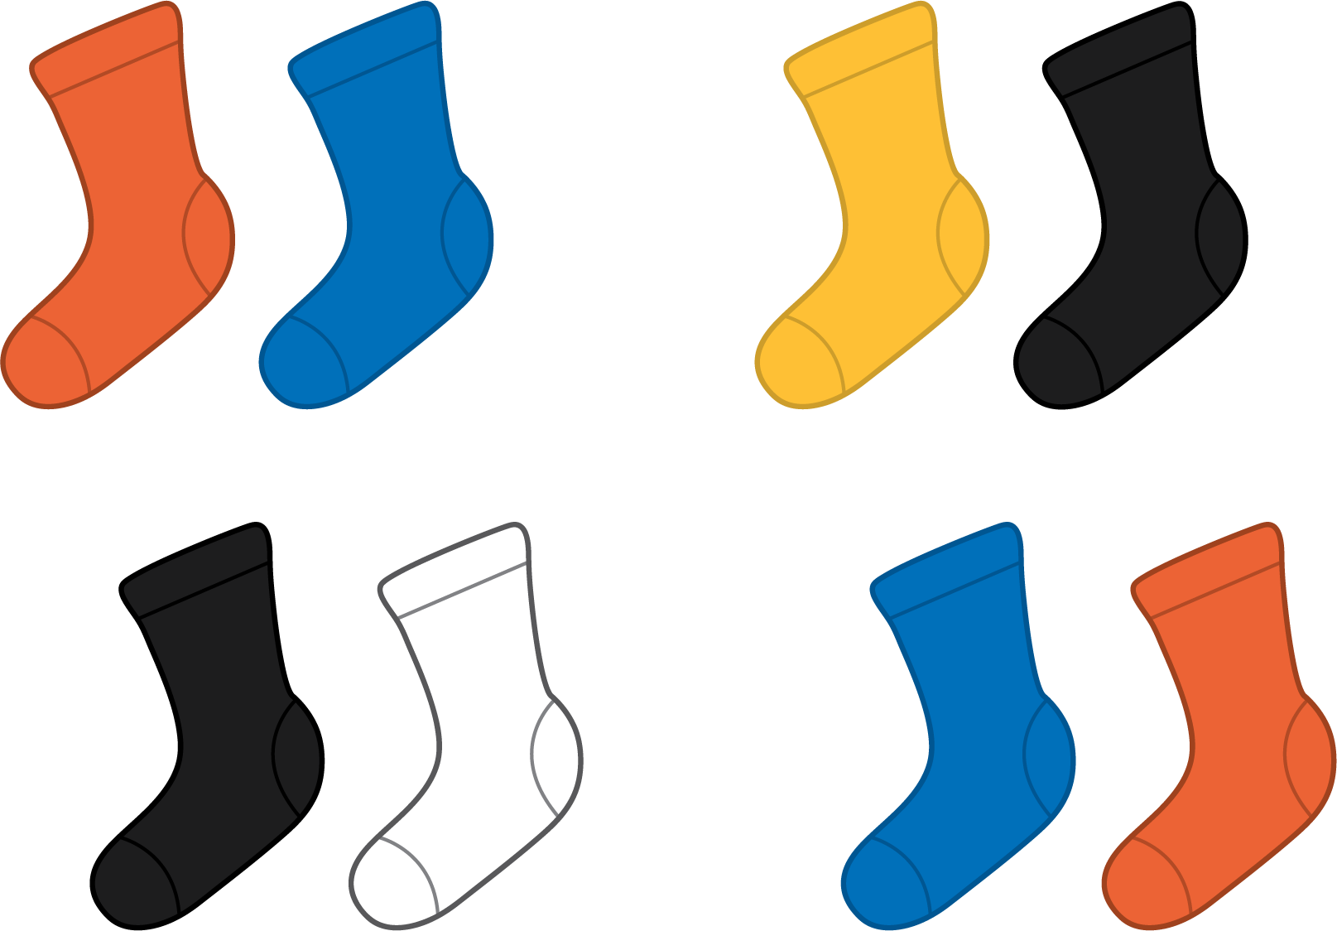
B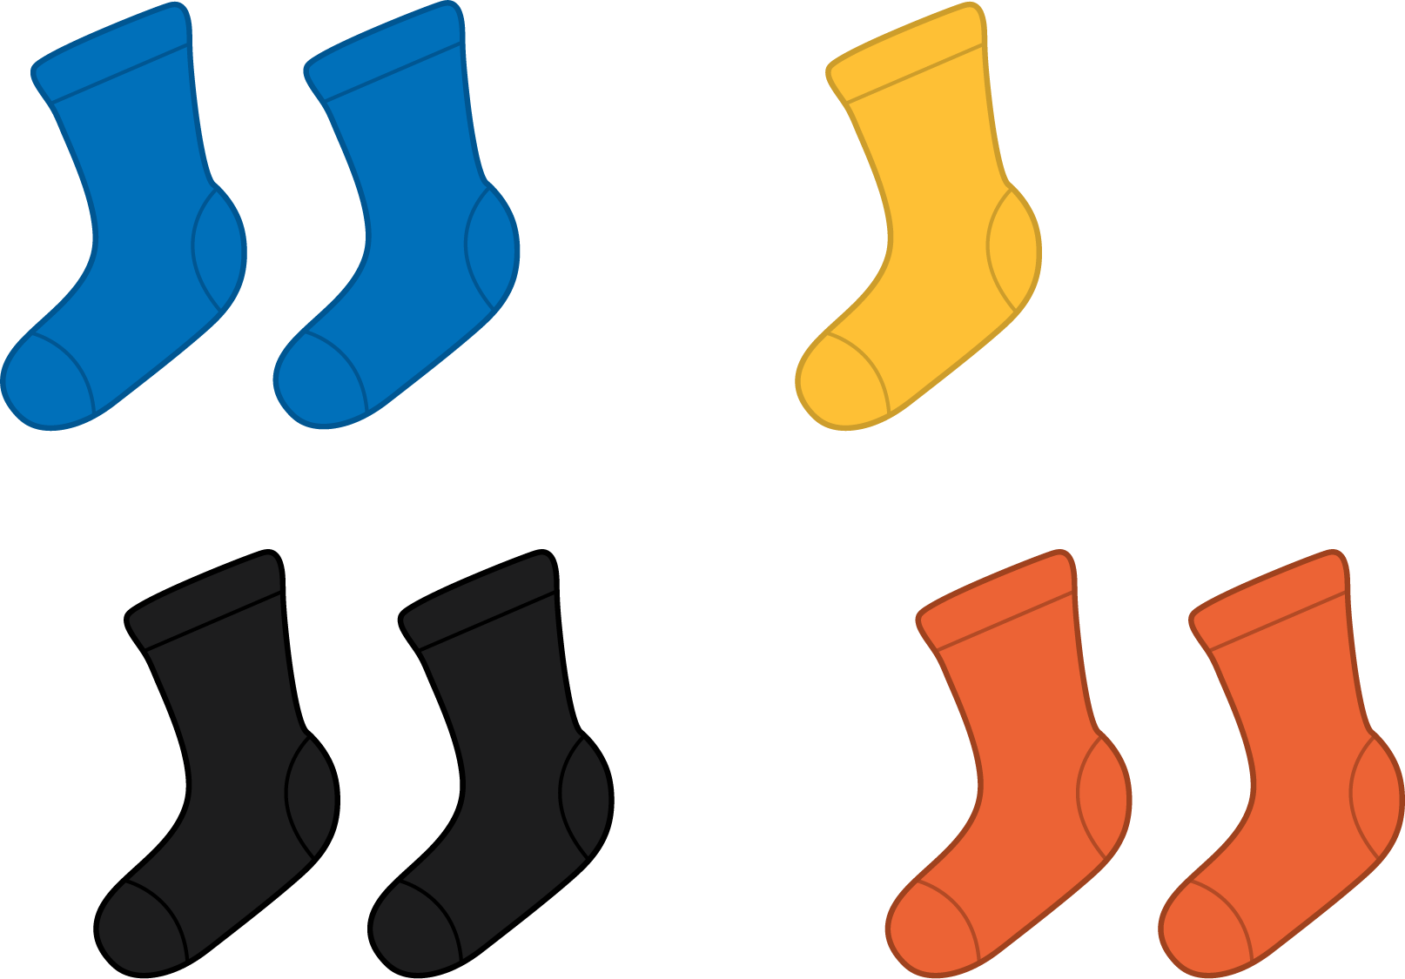
C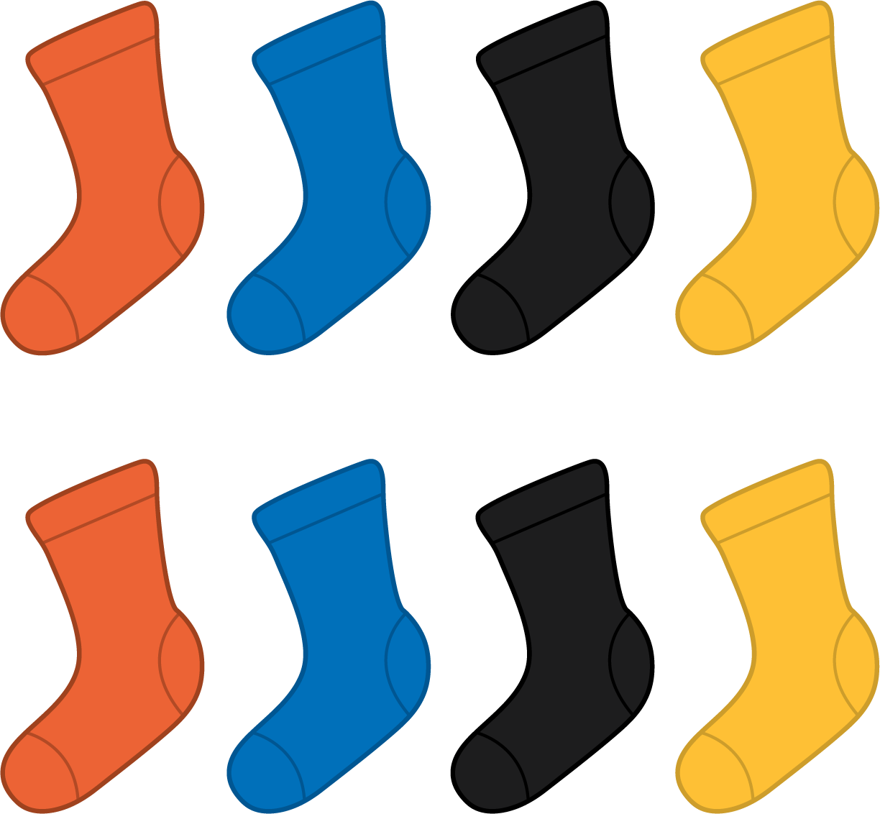
D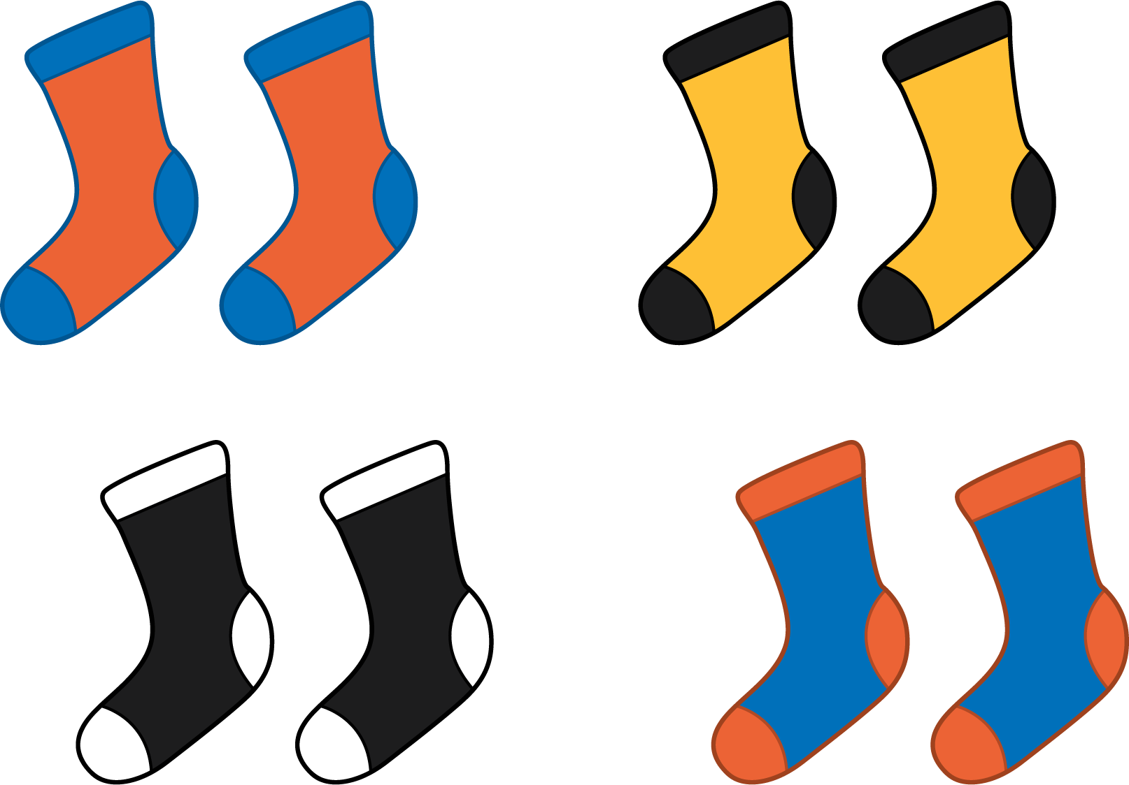
Grade 2
Unit 8Lesson 2CC BY NC 2024 Illustrative Mathematics®

Activity 1 Pair Up
Make pairs with 1 yellow counter and 1 red counter.
my counters
Unable to process <img src="/tikz_files/240104.svg">Failed: rsvg-convert --format png --dpi-x 300 --dpi-y 300 /app/tmp/svgtopng-1786381373.5032544.svg --output /app/tmp/svgtopng-1786381373.5032544.png Backtrace: /app/app/services/script/runner.rb:34:in `block in run_cmd' <internal:kernel>:90:in `tap' /app/app/services/script/runner.rb:32:in `run_cmd' /app/app/services/script/svg_to_png.rb:27:in `convert_svg_to_png' /app/app/services/script/svg_to_png.rb:17:in `to_png' /app/vendor/bundle/ruby/3.3.0/gems/embeddable_content-1.1.0/app/services/embeddable_content/images/image_downloader.rb:37:in `png_rendered_from_svg' /app/vendor/bundle/ruby/3.3.0/gems/embeddable_content-1.1.0/app/services/embeddable_content/images/image_downloader.rb:33:in `raw_image_data' /app/vendor/bundle/ruby/3.3.0/gems/embeddable_content-1.1.0/app/services/embeddable_content/images/image_downloader.rb:13:in `block in save' <internal:kernel>:90:in `tap' /app/vendor/bundle/ruby/3.3.0/gems/embeddable_content-1.1.0/app/services/embeddable_content/images/image_downloader.rb:13:in `save'
total counters
Unable to process <img src="/tikz_files/240104.svg">Failed: rsvg-convert --format png --dpi-x 300 --dpi-y 300 /app/tmp/svgtopng-1786381373.546841.svg --output /app/tmp/svgtopng-1786381373.546841.png Backtrace: /app/app/services/script/runner.rb:34:in `block in run_cmd' <internal:kernel>:90:in `tap' /app/app/services/script/runner.rb:32:in `run_cmd' /app/app/services/script/svg_to_png.rb:27:in `convert_svg_to_png' /app/app/services/script/svg_to_png.rb:17:in `to_png' /app/vendor/bundle/ruby/3.3.0/gems/embeddable_content-1.1.0/app/services/embeddable_content/images/image_downloader.rb:37:in `png_rendered_from_svg' /app/vendor/bundle/ruby/3.3.0/gems/embeddable_content-1.1.0/app/services/embeddable_content/images/image_downloader.rb:33:in `raw_image_data' /app/vendor/bundle/ruby/3.3.0/gems/embeddable_content-1.1.0/app/services/embeddable_content/images/image_downloader.rb:13:in `block in save' <internal:kernel>:90:in `tap' /app/vendor/bundle/ruby/3.3.0/gems/embeddable_content-1.1.0/app/services/embeddable_content/images/image_downloader.rb:13:in `save'
leftover counters
Grade 2
Unit 8Lesson 2CC BY NC 2024 Illustrative Mathematics®

Activity 2 Are You Feeling Left Out?
Show your thinking using objects, drawings, numbers, or words.
- There are 18 students in Clare’s class. Can everyone be in a group of 2?
- There are 20 students in Priya’s class. Can everyone be in a group of 2?
- There are 19 students in Noah’s class. Can everyone be in a group of 2?

