Lesson 7: Respondamos preguntas sobre gráficas de barras con escala

Standards Alignments
Building On | 2.OA.C.3
Addressing | 3.MD.B.3
Building Towards | 3.MD.B.3

Teacher-facing Learning Goals
- Solve one-step “how many more” and “how many fewer” problems within 100, based on the data presented in scaled bar graphs.

Student-facing Learning Goals
- Respondamos preguntas sobre datos representados en gráficas de barras.

Lesson Purpose
The purpose of this lesson is for students to solve one-step “how many more” and “how many fewer” problems based on data presented in a scaled bar graph.
In grade 2, students solved simple Put Together, Take Apart, and Compare problems using data represented in a single-unit scaled bar graph.
In this lesson, students solve one-step Compare problems using data represented in scaled bar graphs.

Access for:

Students with Disabilities
- Representation (Activity 2)

English Learners
- MLR8 (Activity 2)

Instructional Routines
How Many Do You See? (Warm-up)

Materials to Gather
- Materials from a previous lesson: Activity 1

Lesson Timeline
Warm-up | 10 min
Activity 1 | 15 min
Activity 2 | 20 min
Lesson Synthesis | 10 min
Cool-down | 5 min

Teacher Reflection Question
Think about a time you recently made a mistake during math class. How did you leverage your mistake to show students that mistakes are just learning in process?

Cool-down
(to be completed at the end of the lesson) 5min
Deportes favoritos

Student-facing Task Statement
A un grupo de estudiantes le preguntaron: “¿Cuál es tu deporte favorito?”.
Sus respuestas se muestran en esta gráfica de barras:
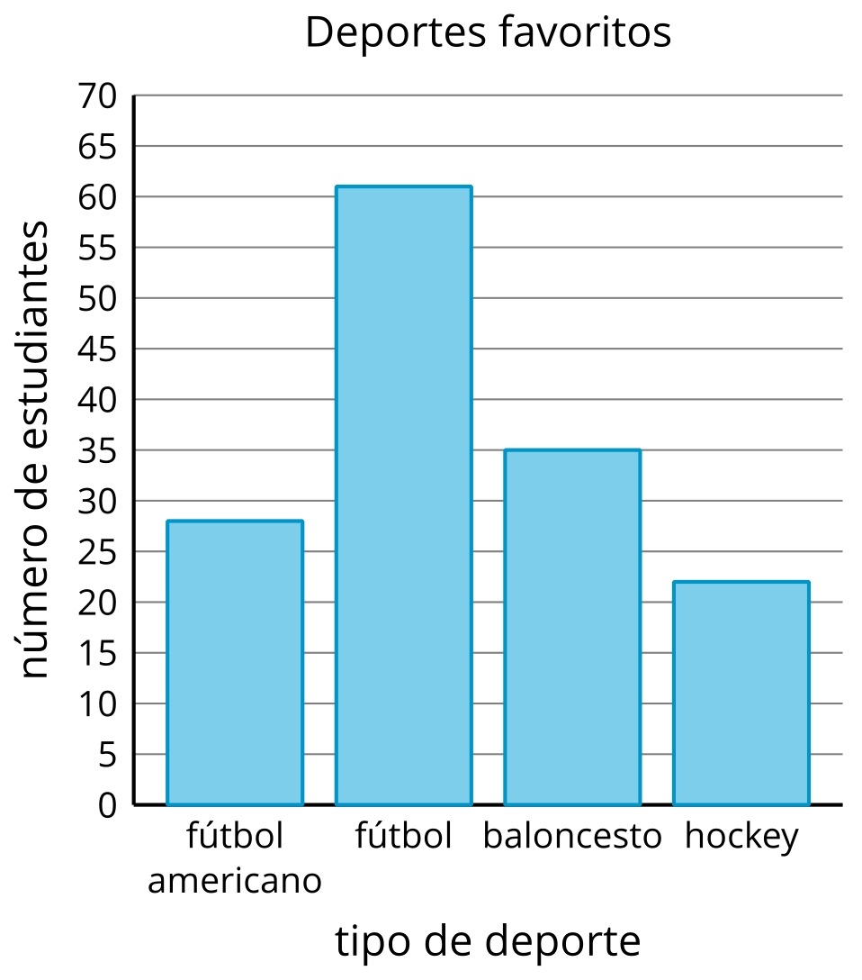
Usa la gráfica para responder las preguntas.
- ¿Cuántos estudiantes más escogieron fútbol que fútbol americano? Muestra cómo pensaste. Usa expresiones o ecuaciones.
- ¿Cuántos estudiantes menos escogieron hockey que baloncesto? Muestra cómo pensaste. Usa expresiones o ecuaciones.

Student Responses
- 33 students. Sample response: $28+2=30$, $30+31=61$, and $2+31=33$.
- 13 students. Sample response: $35−22=13$

