Unit 7 Lesson 2: Adjacent Angles

1 Estimating Angle Measures (Warm up)

Student Task Statement
Estimate the degree measure of each indicated angle.
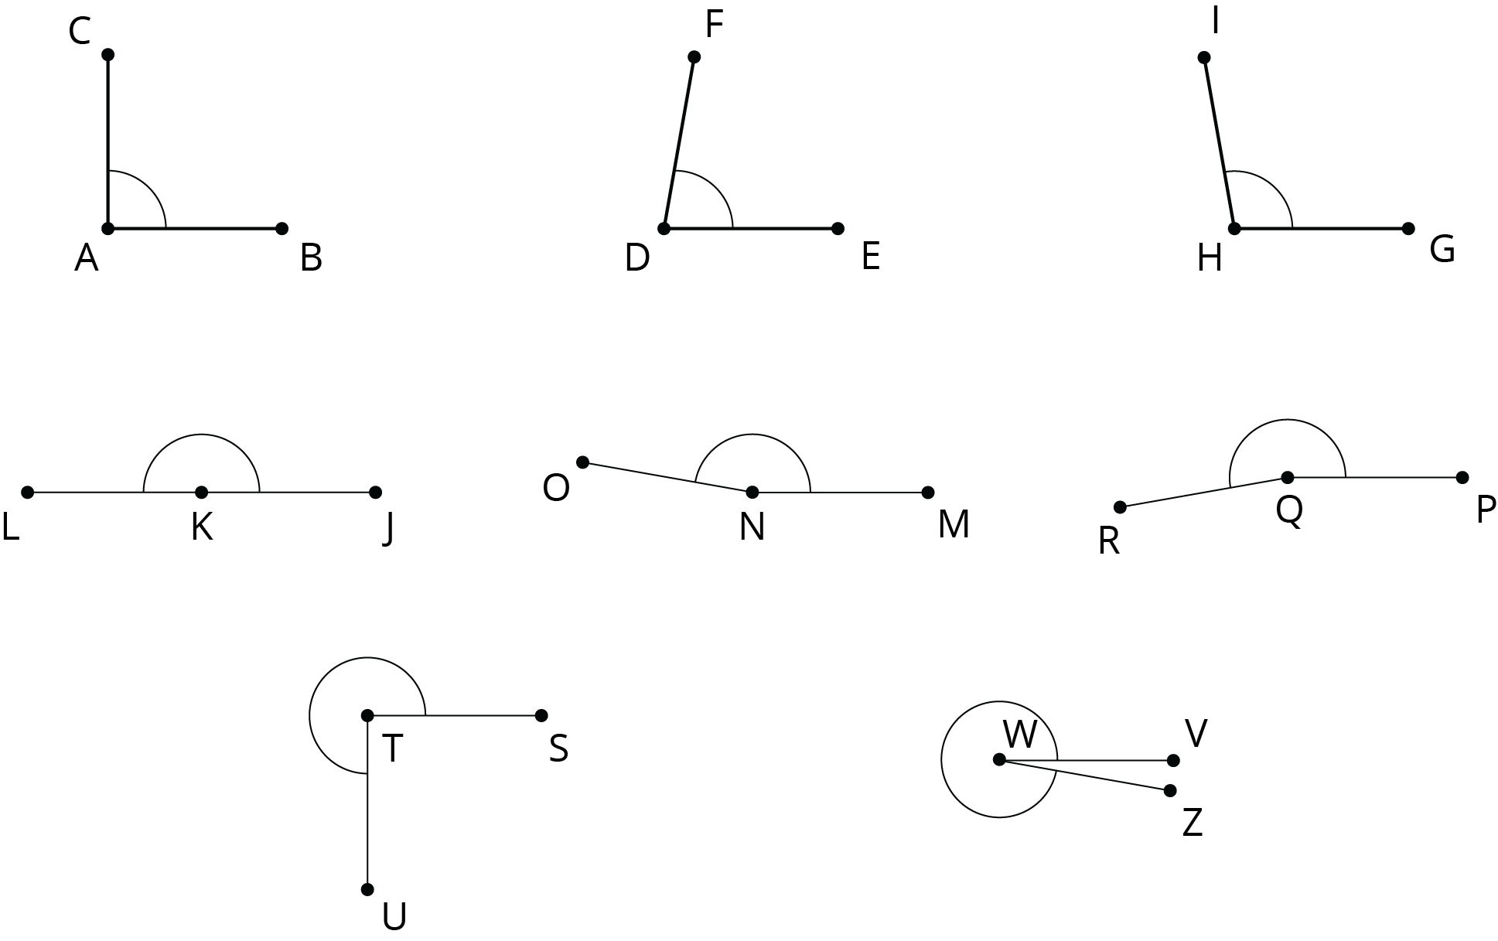

2 Cutting Rectangles

Student Task Statement
Your teacher will give you two small, rectangular papers.
- On one of the papers, draw a small half-circle in the middle of one side.
- 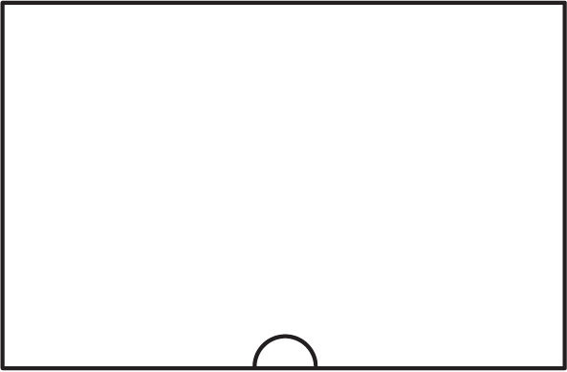
- Cut a straight line, starting from the center of the half-circle, all the way across the paper to make 2 separate pieces. (Your cut does not need to be perpendicular to the side of the paper.)
- On each of these two pieces, measure the angle that is marked by part of a circle. Label the angle measure on the piece.
- What do you notice about these angle measures?
- Clare measured 70 degrees on one of her pieces. Predict the angle measure of her other piece.
- On the other rectangular paper, draw a small quarter-circle in one of the corners.
- 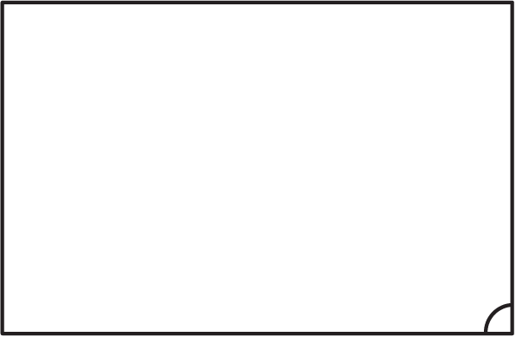
- Repeat the previous steps to cut, measure, and label the two angles marked by part of a circle.
- What do you notice about these angle measures?
- Priya measured 53 degrees on one of her pieces. Predict the angle measure of her other piece.

3 Is It a Complement or Supplement?

Student Task Statement
- Use the protractor in the picture to find the measure of angles $BCA$ and $BCD$.
- 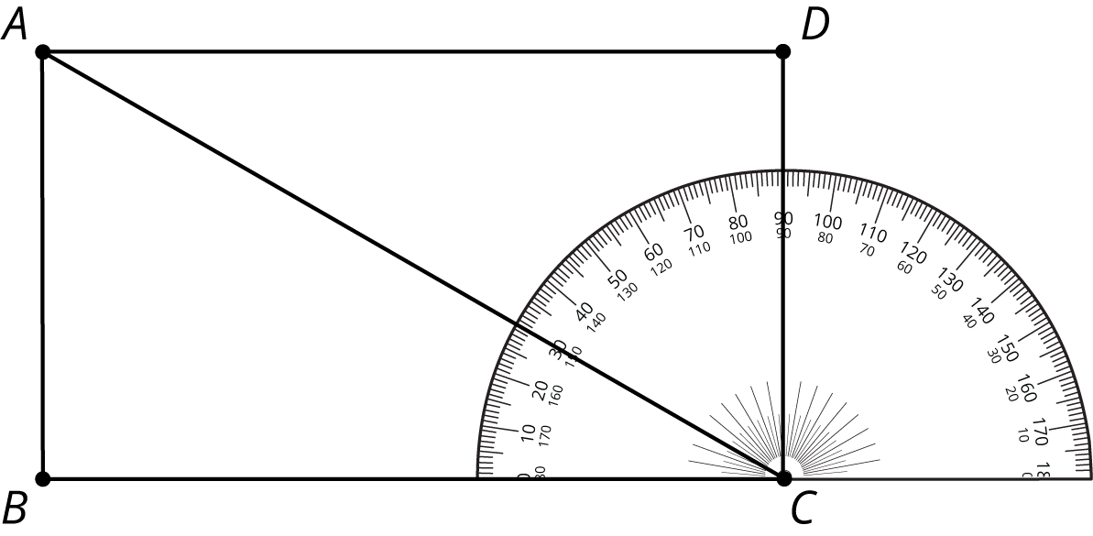
- Explain how to find the measure of angle $ACD$ without repositioning the protractor.
- Use the protractor in the picture to find the measure of angles $LOK$ and $LOM$.
- 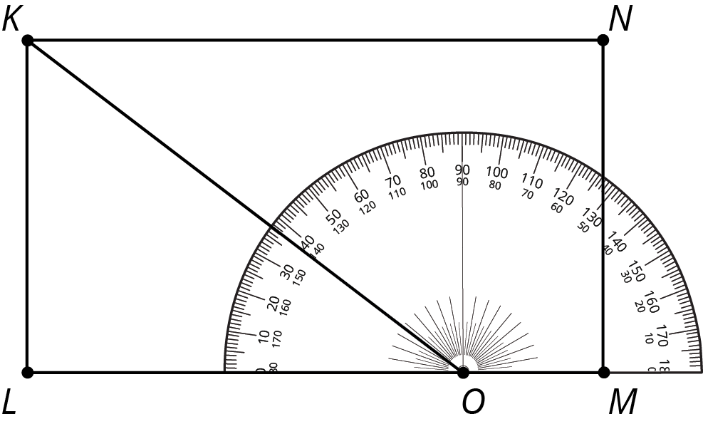
- Explain how to find the measure of angle $KOM$ without repositioning the protractor.
- Angle $BAC$ is a right angle. Find the measure of angle $CAD$.
- 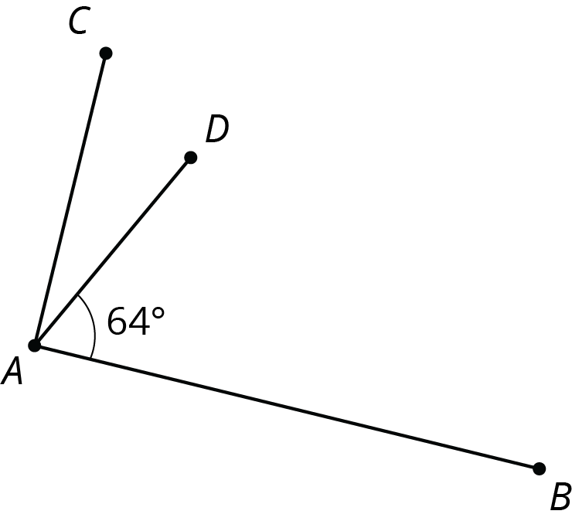
- ​​​​​
- Point $O$ is on line $RS$. Find the measure of angle $SOP$.
- 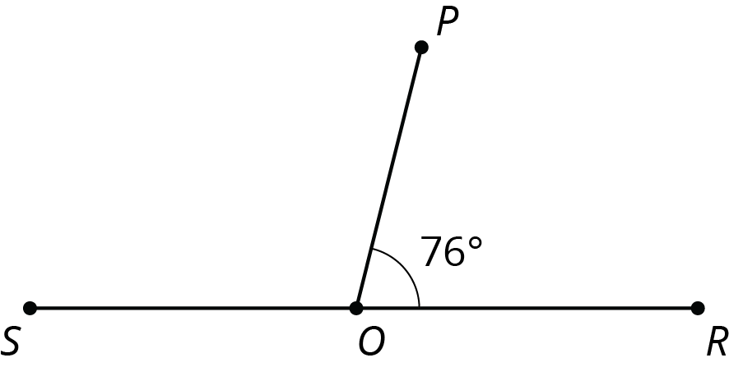
© CC BY Open Up Resources. Adaptations CC BY IM.

