Grade 2
Unit 7Lesson 9CC BY NC 2024 Illustrative Mathematics®
Unit 7, Lesson 9

Add 3-Digit Numbers
- Let’s practice adding within 1,000.
Grade 2
Unit 7Lesson 9CC BY NC 2024 Illustrative Mathematics®

Warm-up Number Talk: Ten and Some More
Find the value of each expression mentally.
- $528+2$
- $528+7$
- $487+3$
- $487+8$
Grade 2
Unit 7Lesson 9CC BY NC 2024 Illustrative Mathematics®

Activity 1How Did You Add 3-Digit Numbers?
Find the value of each expression. Show your thinking, using drawings, numbers, or words.
- $384+409$
- $757+152$
- $227+673$
- $575+166$
Grade 2
Unit 7Lesson 9CC BY NC 2024 Illustrative Mathematics®

Activity 2 Analyze and Add
Noah and Kiran find the value of $267+338$.
Noah’s work
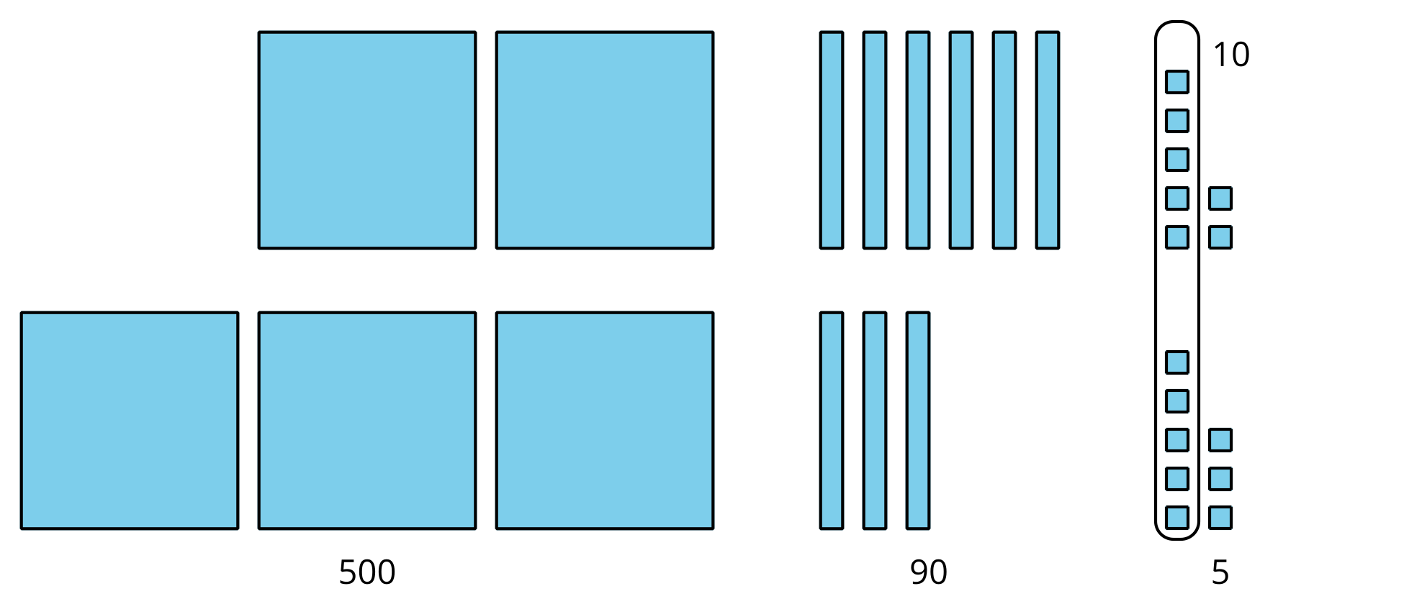

Kiran’s work
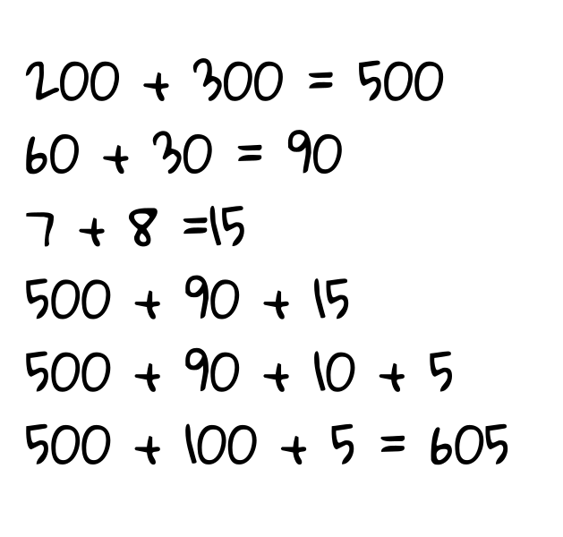
- How are Noah’s and Kiran’s work alike? How are they different?
- Who found the correct value? Explain your reasoning.


