Grade 2
Unit 6Lesson 4CC BY NC 2024 Illustrative Mathematics®
Unit 6, Lesson 4

Solid Shapes
- Let’s identify and describe solid shapes.
Grade 2
Unit 6Lesson 4CC BY NC 2024 Illustrative Mathematics®

Warm-up Notice and Wonder: What Is That Shape?
What do you notice? What do you wonder?
A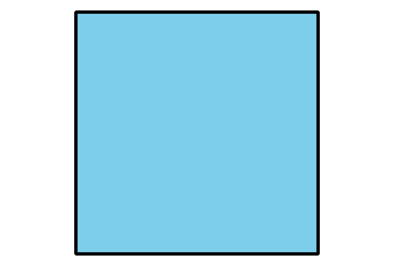
B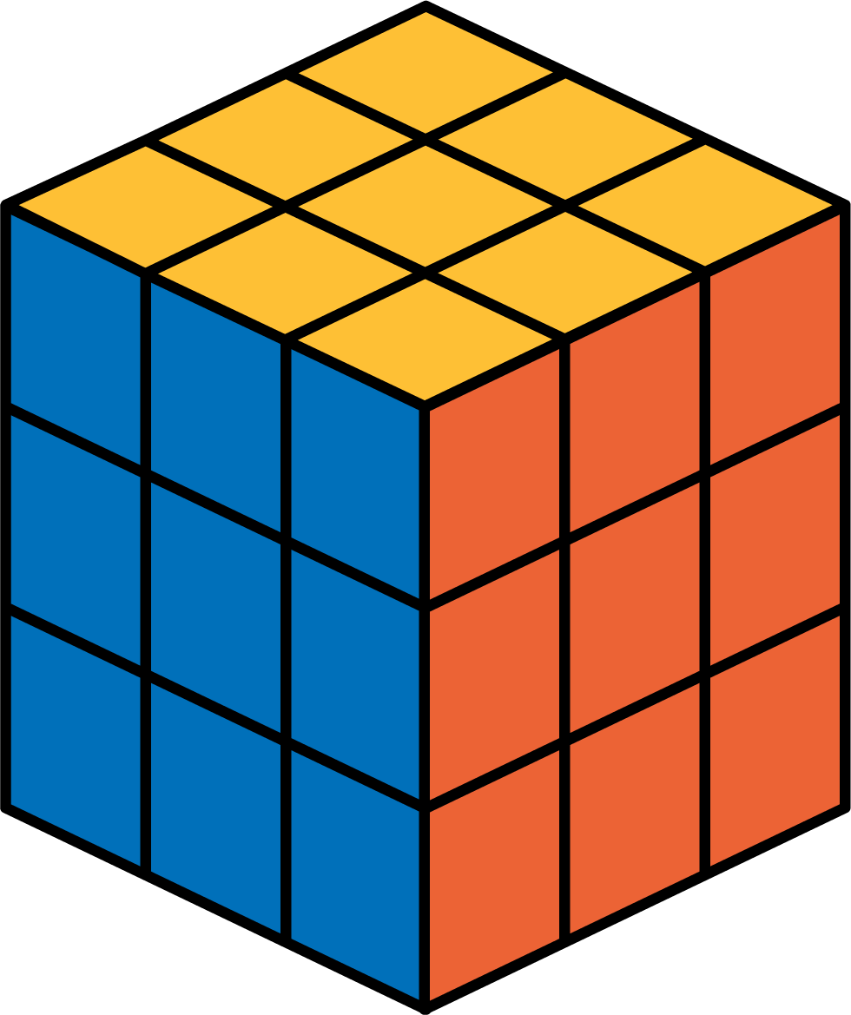
C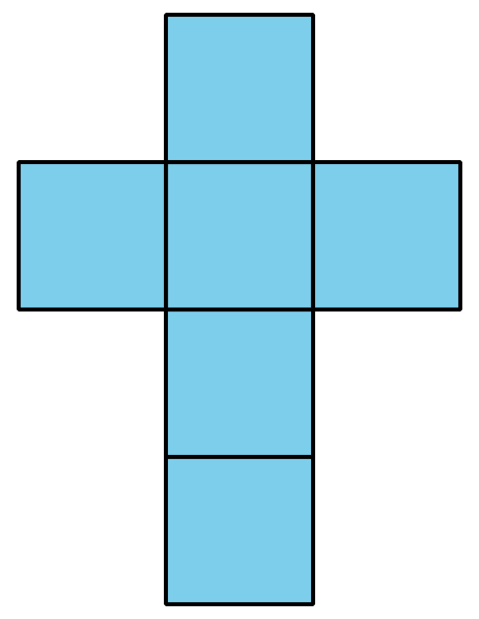
D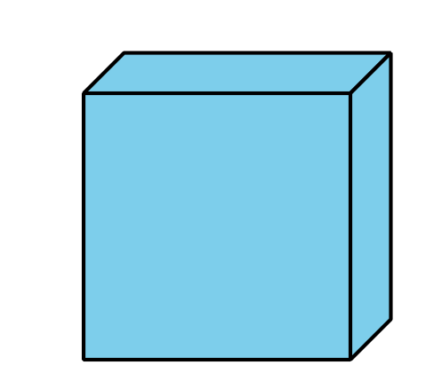
Grade 2
Unit 6Lesson 4CC BY NC 2024 Illustrative Mathematics®

Activity 1 What Is the Missing Shape?
Make a poster that describes your solid shape. Show your thinking, using drawings, numbers, or words. Help other groups name your shape.
Grade 2
Unit 6Lesson 4CC BY NC 2024 Illustrative Mathematics®

Activity 2 Card Sort: Sort and Build Solid Shapes
Your teacher will give you a set of cards that show designs made up of different shapes.
- Sort the cards into categories of your choosing. Be ready to explain the meaning of your categories.
- Match 1 of your cards to a solid shape.
- Which shape designs can you fold to make cubes? Explain your reasoning.
- Fold your 2 shape designs into cubes. Compare your cubes with your partner.

Section A Summary
We named and drew shapes, based on their numbers of sides and corners. We drew shapes with different side lengths.
- A triangle is a shape with 3 sides and 3 corners
- A quadrilateral is a shape with 4 sides and 4 corners.
- A pentagon is a shape with 5 straight sides and 5 corners.
- A hexagon is a shape with 6 straight sides and 6 corners.
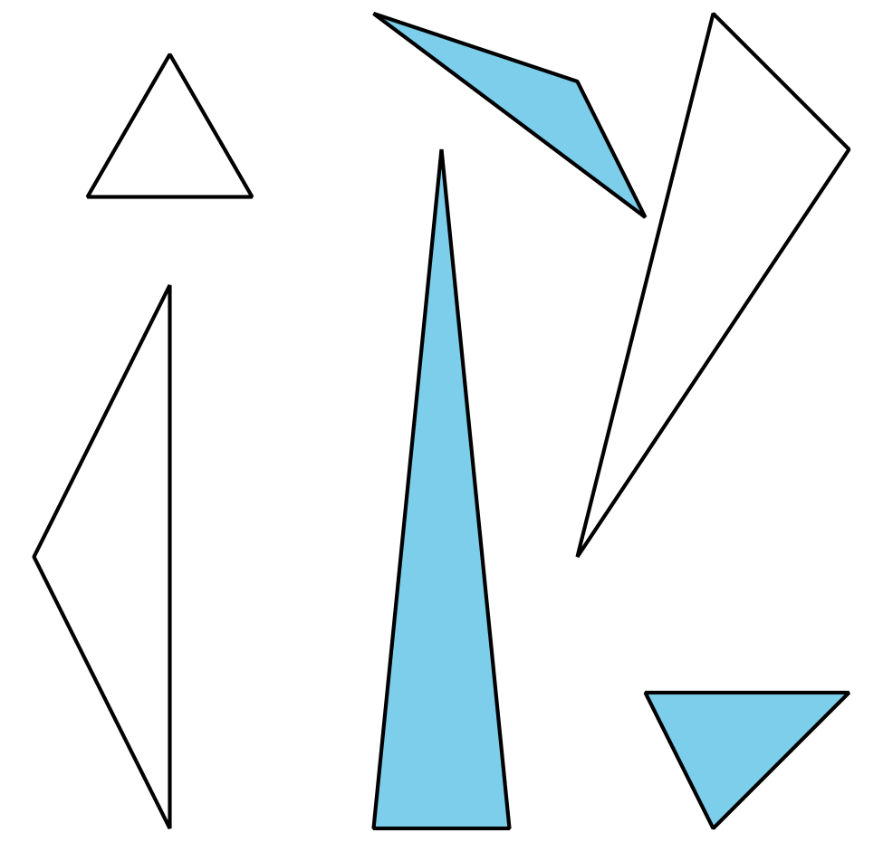
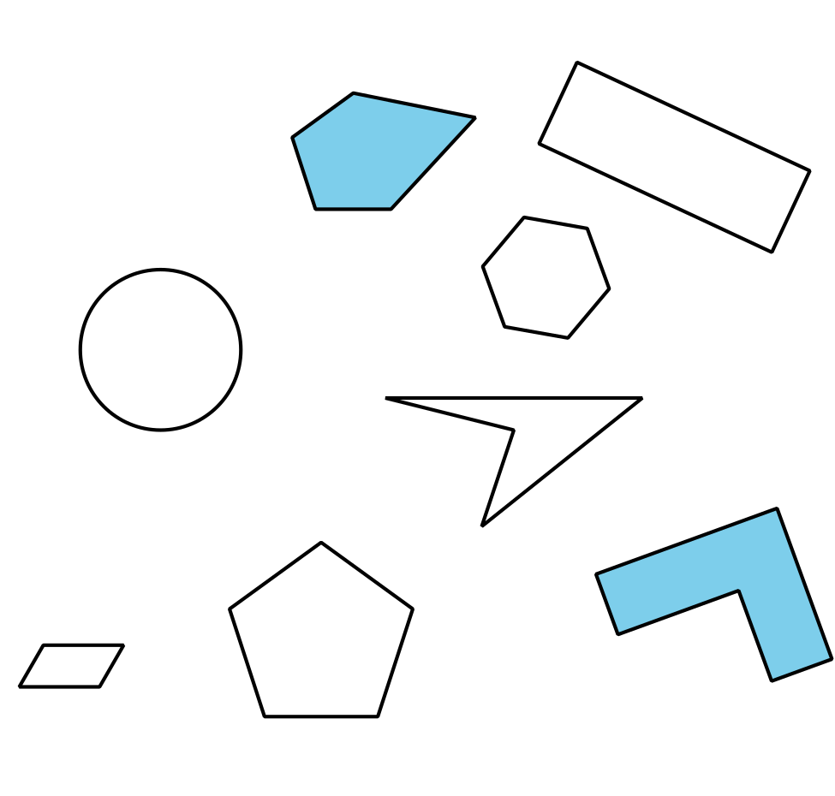
We described solid shapes, based on the number and shape of their faces. A face is a flat side of a solid shape. For example, a cube is a solid shape with 6 square faces that are the same size.

