Grade 6
Unit 7Lesson 4CC BY NC Illustrative Mathematics, based on IM 6–8 Math, CC BY Open Up Resources.
Unit 7, Lesson 4

Ordering Rational Numbers
Let’s order rational numbers.
Grade 6
Unit 7Lesson 4CC BY NC Illustrative Mathematics, based on IM 6–8 Math, CC BY Open Up Resources.

4.1How Do They Compare?
Use the symbols >, <, or = to compare each pair of numbers. Be prepared to explain your reasoning.
- $12 \underset{_}{} 19$
- $212 \underset{_}{} 190$
- $15 \underset{_}{} 1.5$
- $9.02 \underset{_}{} 9.2$
- $6.050 \underset{_}{} 6.05$
- $0.4 \underset{_}{} \frac{9}{40}$
- $\frac{19}{24} \underset{_}{} \frac{19}{21}$
- $\frac{16}{17} \underset{_}{} \frac{11}{12}$
Grade 6
Unit 7Lesson 4CC BY NC Illustrative Mathematics, based on IM 6–8 Math, CC BY Open Up Resources.

4.2Ordering Rational Number Cards
Your teacher will give you a set of number cards. Take turns with your partner placing a card from the set in order from least to greatest.
- For each placement that you make, explain your reasoning to your partner.
- For each placement that your partner makes, listen carefully to their explanation. If you disagree, discuss your thinking, and work to reach an agreement.
- Pause after the first set so your teacher can review your ordering.
- Your teacher will give you a second set of cards to add in order with the first set.
Grade 6
Unit 7Lesson 4CC BY NC Illustrative Mathematics, based on IM 6–8 Math, CC BY Open Up Resources.

4.3Comparing Points on a Line
The number line shows 4 points: $M$, $N$, $P$, and $R$.
Use each of the following phrases in a sentence describing or comparing the values of 2 of the points.
- greater than
- less than
- opposite of (or opposites)
- negative number

Are you ready for more?
Tell what the value of each point $M$, $N$, $P$, and $R$ would be if:
- $P$ is $2\frac{1}{2}$.
- $N$ is -0.4.
- $R$ is 200.
- $M$ is -15.

Lesson 4 Summary
When ordering rational numbers from least to greatest, they can be listed in the order they appear on the number line from left to right. For example, we can see that the numbers
-2.7, -1.3, 0.8
are listed from least to greatest because of the order they appear on the number line.
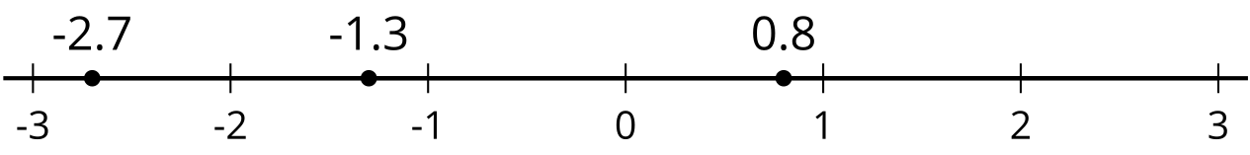
On a horizontal number line, numbers to the left are smaller than numbers to the right. We can say that -2.7 is less than -1.3. We can write $\text{-}2.7<\text{1}.3$.
Similarly, numbers to the right are greater than numbers to the left. We can say that 0.8 is greater than -2.7. We can write $0.8>\text{-}2.7$.

