Grade 2
Unit 6Lesson 1CC BY NC 2024 Illustrative Mathematics®
Unit 6, Lesson 1

Identify and Sort Shapes
- Let’s sort and name shapes, based on their sides and corners.
Grade 2
Unit 6Lesson 1CC BY NC 2024 Illustrative Mathematics®

Warm-up Notice and Wonder: Groups of Shapes
What do you notice? What do you wonder?
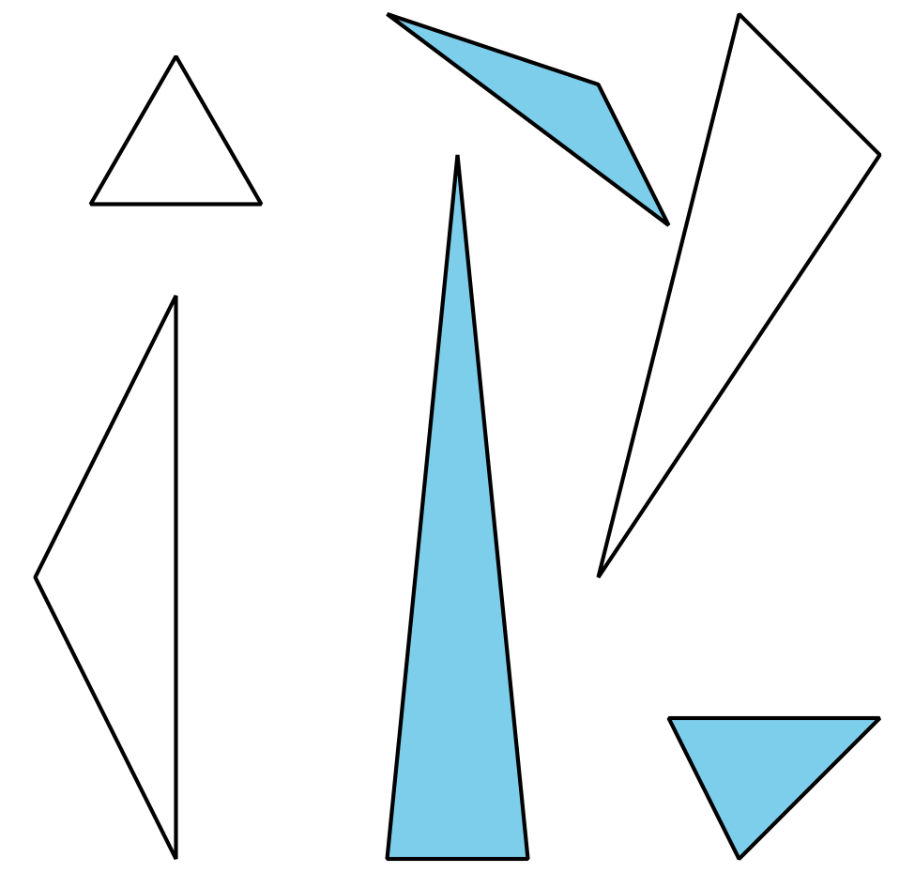
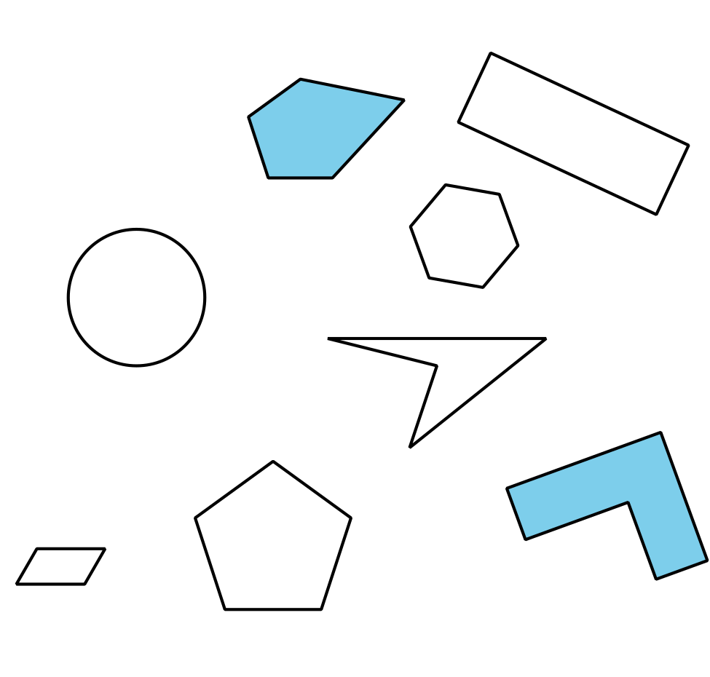
Grade 2
Unit 6Lesson 1CC BY NC 2024 Illustrative Mathematics®

Activity 1Card Sort: Shapes
Your teacher will give you a set of cards that show shapes.
Sort the shapes into categories of your choosing. Be ready to explain the meaning of your categories.
Grade 2
Unit 6Lesson 1CC BY NC 2024 Illustrative Mathematics®

Activity 2 Penta-What?
Gather clues to find out what kind of shapes belong in each category.
triangle
pentagon
hexagon
quadrilateral
- Ask the teacher if a shape card belongs in 1 of these categories.
- Use this question frame:
- Is Shape _______ a ______________________________?
- Use your clues to make a true statement.
- Shape _______ is a ______________________________ because it has
- ___________________________________________________________.
- Do these shapes belong to any of the categories? Explain your reasoning.
- A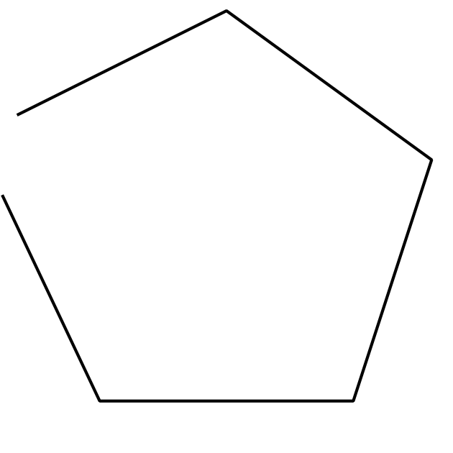
- B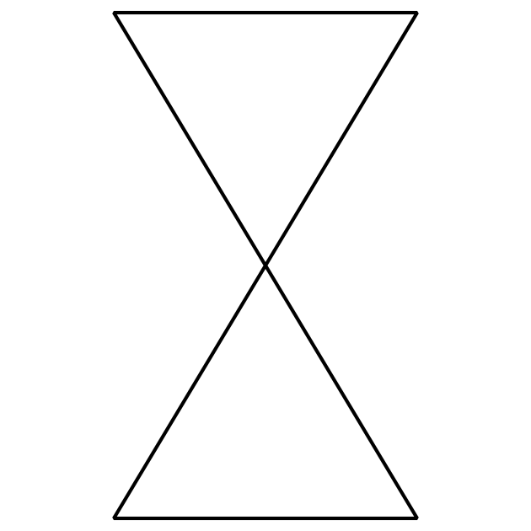
- C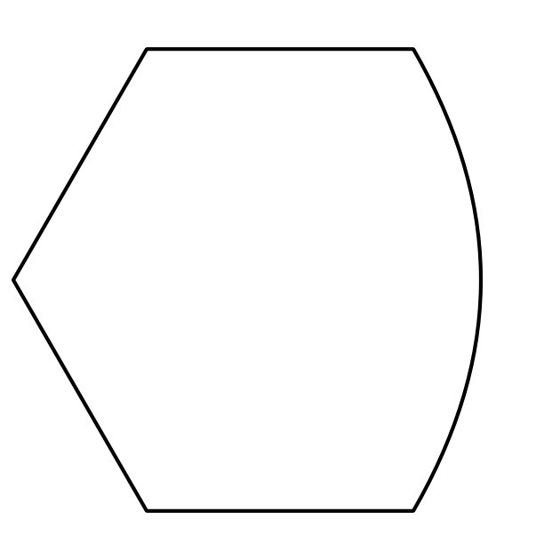
Grade 2
Unit 6Lesson 1CC BY NC 2024 Illustrative Mathematics®

Activity 3 Compare Shapes
Pick 1 shape card.
Name and describe your shape to a partner.

