Grade 2
Unit 4Lesson 6CC BY NC 2024 Illustrative Mathematics®
Unit 4, Lesson 6

Center Day 1
- Let’s put numbers on a number line.
Grade 2
Unit 4Lesson 6CC BY NC 2024 Illustrative Mathematics®

Warm-up Number Talk: Decompose and Subtract
Find the value of each expression mentally.
- $65−25$
- $65−27$
- $55−17$
- $46−18$
Grade 2
Unit 4Lesson 6CC BY NC 2024 Illustrative Mathematics®

Activity 2 Centers: Choice Time
Choose a center.
Capture Squares
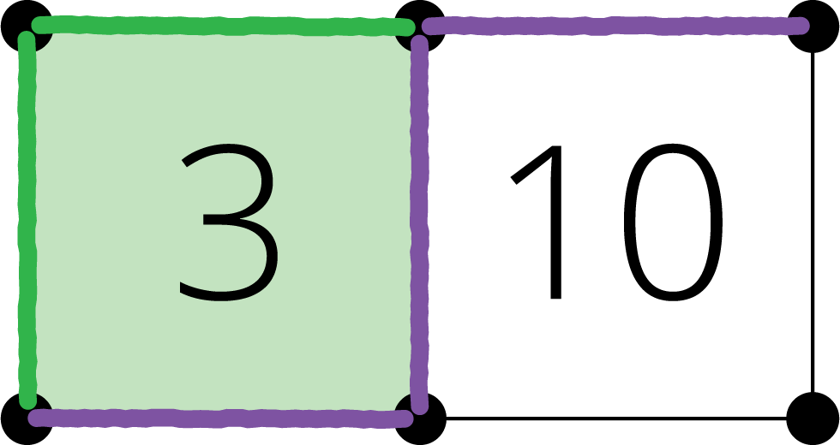
Number Line Scoot
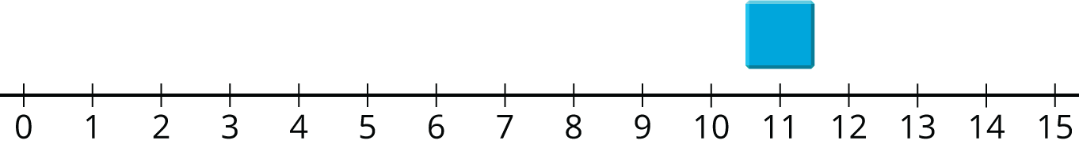
Number Puzzles
