Lesson 13 Practice Problems
- At the supermarket you can fill your own honey bear container. A customer buys 12 oz of honey for $5.40.
  - How much does honey cost per ounce?
  - How much honey can you buy per dollar?
  - Write two different equations that represent this situation. Use $h$ for ounces of honey and $c$ for cost in dollars.
- 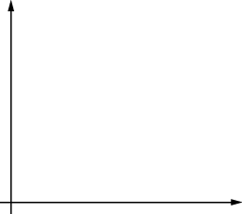
  - Choose one of your equations, and sketch its graph. Be sure to label the axes.
- The point $\left(3,\frac{6}{5}\right)$ lies on the graph representing a proportional relationship. Which of the following points also lie on the same graph? Select all that apply.
  - $\left(1,0.4\right)$
  - $\left(1.5,\frac{6}{10}\right)$
  - $\left(\frac{6}{5},3\right)$
  - $\left(4,\frac{11}{5}\right)$
  - $\left(15,6\right)$
- A trail mix recipe asks for 4 cups of raisins for every 6 cups of peanuts. There is proportional relationship between the amount of raisins, $r$ (cups), and the amount of peanuts, $p$ (cups), in this recipe.
  - Write the equation for the relationship that has constant of proportionality greater than 1. Graph the relationship.
  - Write the equation for the relationship that has constant of proportionality less than 1. Graph the relationship.
- Here is a graph that represents a proportional relationship.
  - Come up with a situation that could be represented by this graph.
  - Label the axes with the quantities in your situation.
  - Give the graph a title.
  - Choose a point on the graph. What do the coordinates represent in your situation?
- 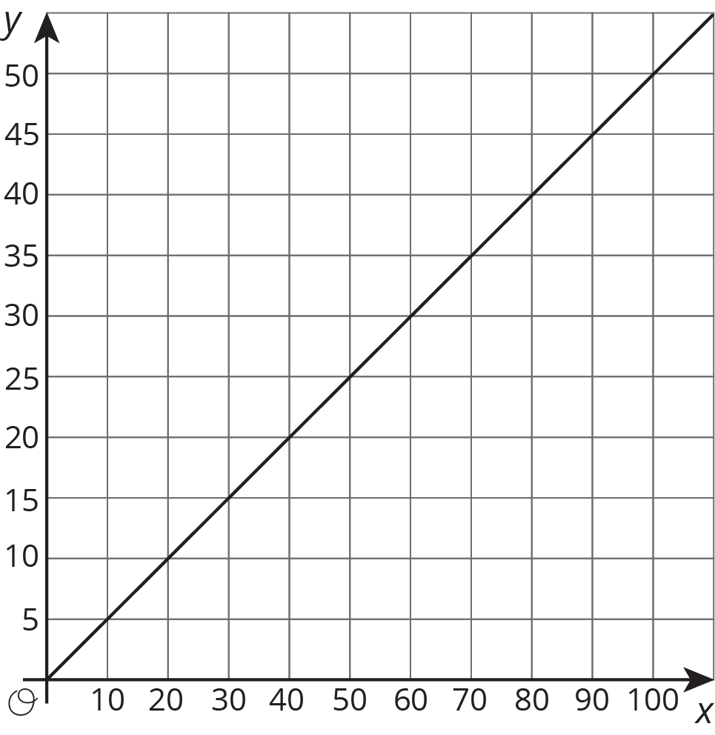
- (From Unit 2, Lesson 11.)
© CC BY Open Up Resources. Adaptations CC BY IM.

