Grade 2
Unit 3Lesson 8CC BY NC 2024 Illustrative Mathematics®
Unit 3, Lesson 8

What Is an Inch?
- Let’s measure in inches.
Grade 2
Unit 3Lesson 8CC BY NC 2024 Illustrative Mathematics®

Warm-upNotice and Wonder: Inches and Centimeters
What do you notice? What do you wonder?
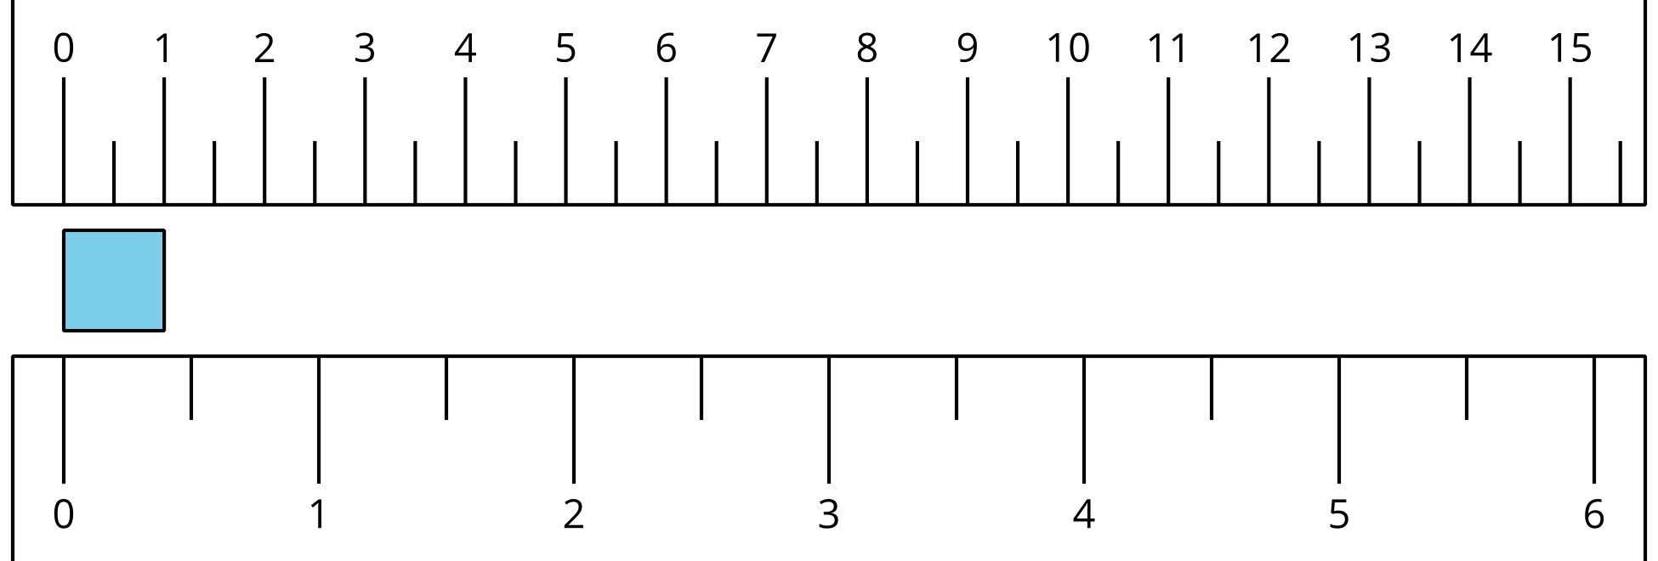
Grade 2
Unit 3Lesson 8CC BY NC 2024 Illustrative Mathematics®

Activity 1What Is an Inch?
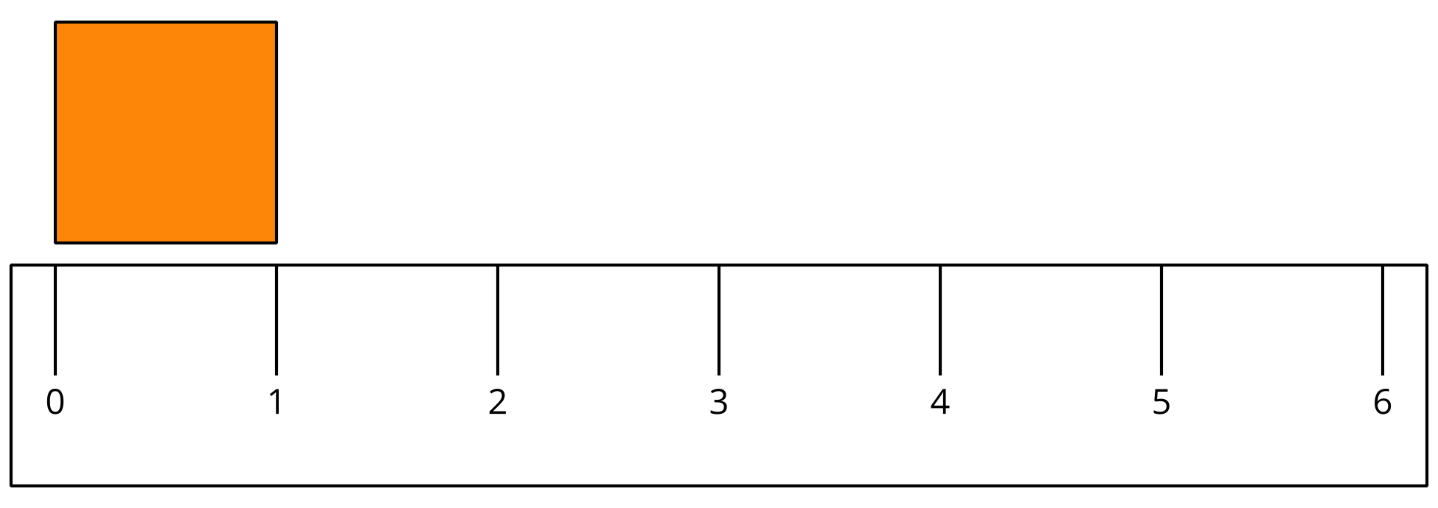
- Find 2 items that are about an inch long.
  - ________________________________________
  - ________________________________________
- Measure the length of each object.
object to measure | length in inches
marker
colored pencil
11 connecting cubes
a book
your choice objects:
Grade 2
Unit 3Lesson 8CC BY NC 2024 Illustrative Mathematics®

Activity 2Measure the Sides of Shapes
- Here is a rectangle.
- 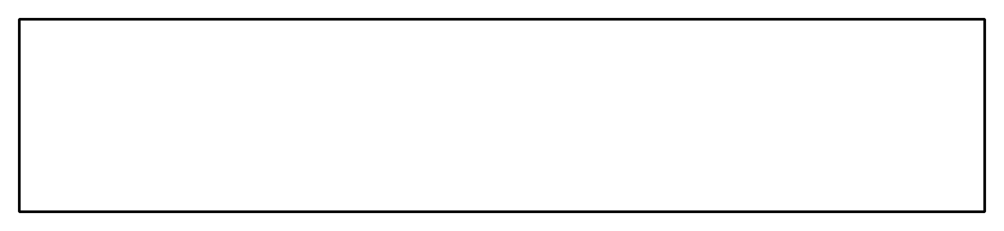
- Estimate the length of the long side of the rectangle. Use inches.
- Estimate: ____________ in
- Measure the long side of the rectangle. Use inches.
- Actual length: ____________ in
- Here is a square.
- 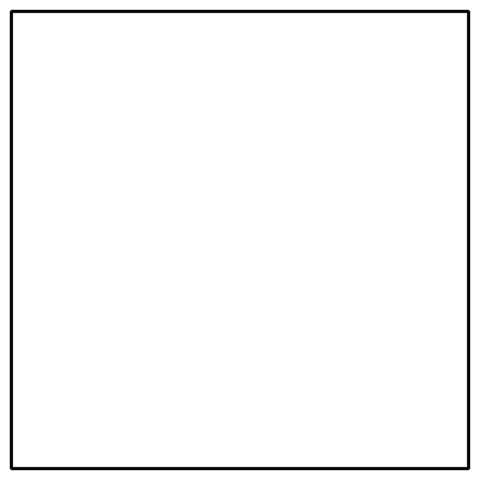
- Estimate the length of 1 side of the square. Use inches.
- Estimate: ____________ in
- Measure 1 side of the square. Use inches.
- Actual length: ____________ in
- Here is a triangle.
- 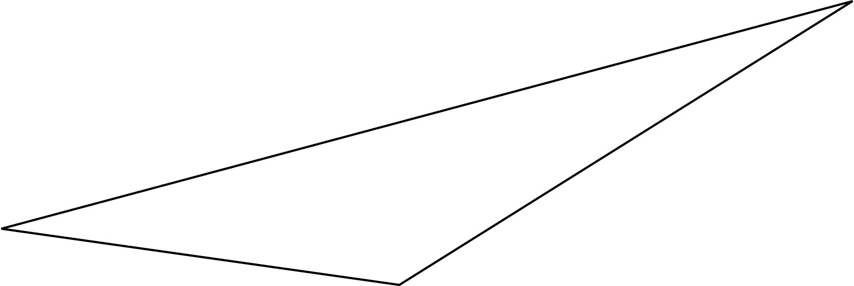
- Estimate the length of the longest side of the triangle. Use inches.
- Estimate: ____________ in
- Measure the longest side of the triangle. Use inches.
- Actual length: ____________ in

