Grade 2
Unit 5Lesson 5CC BY NC 2024 Illustrative Mathematics®
Unit 5, Lesson 5

Expanded Form of Numbers
- Let’s represent 3-digit numbers as a sum of the value of each digit.
Grade 2
Unit 5Lesson 5CC BY NC 2024 Illustrative Mathematics®

Warm-up True or False: Value of Digits
Decide if each statement is true or false. Be prepared to explain your reasoning.
- $800+90+7=897$
- $156=50+100+6$
- $407=70+400$
- $632=22+10+600$
Grade 2
Unit 5Lesson 5CC BY NC 2024 Illustrative Mathematics®

Activity 1Expressions and 3-Digit Numbers
- Andre has 3 hundreds. Tyler has 5 tens. Mai has 7 ones. They want to represent the amount with an expression.
- 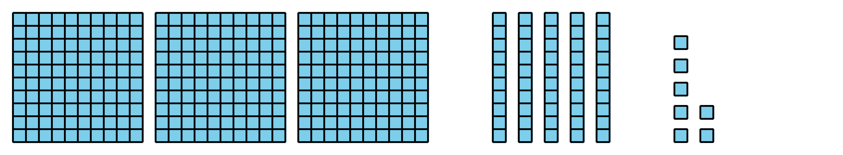
- Write an expression to represent the sum of their values.
- __________ + __________ + __________
- Write the total value as a 3-digit number.
- _______________
- Write each number as the sum of hundreds, tens, and ones. This is called expanded form. Then write the 3-digit number.
- 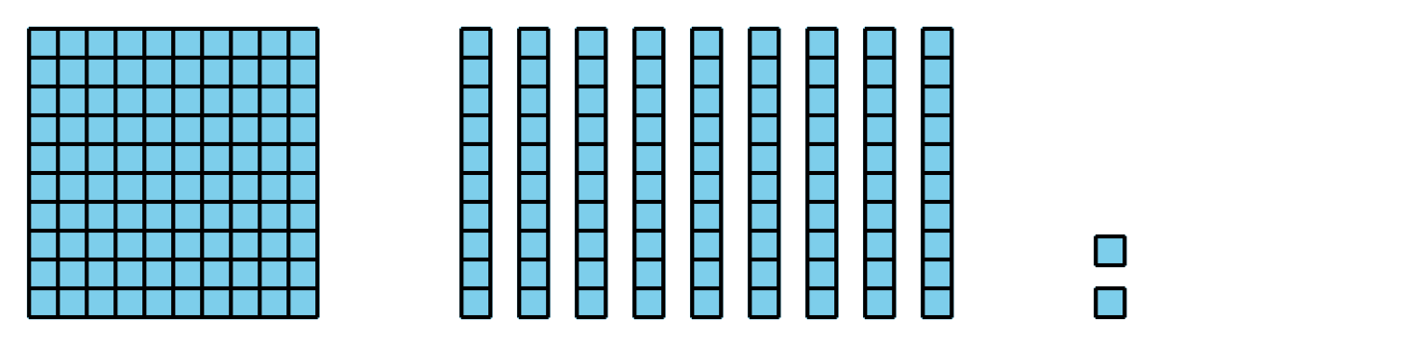
- Expanded form: _________________________
- 3-digit number: _________________________
- 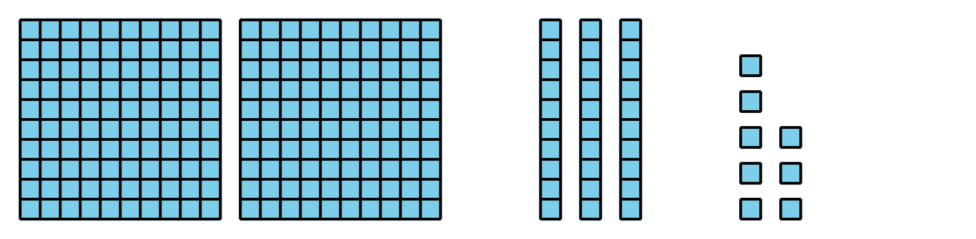
- Expanded form: _________________________
- 3-digit number: _________________________
- 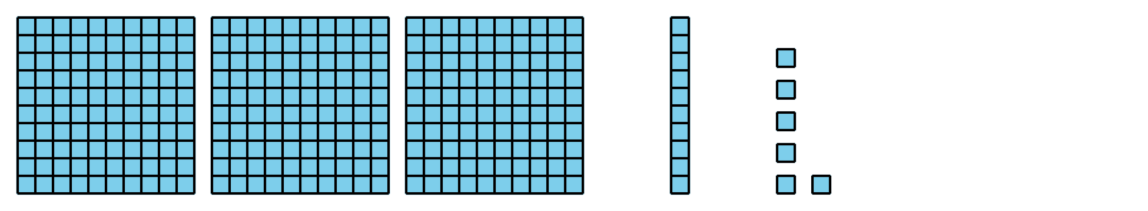
- Expanded form: _________________________
- 3-digit number: _________________________
- 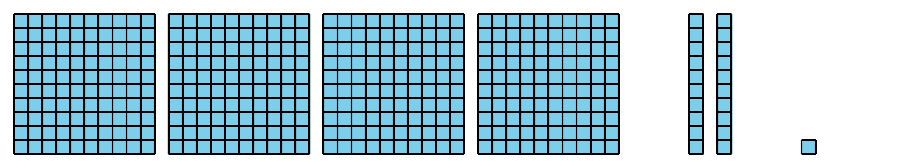
- Expanded form: _________________________
- 3-digit number: _________________________
Grade 2
Unit 5Lesson 5CC BY NC 2024 Illustrative Mathematics®

Activity 2Make It and Expand It
- Roll the number cubes.
- Make the largest number possible.
- Write it as a 3-digit number. ___________
- Write it in expanded form.
- Roll the number cubes.
- Make the smallest number possible.
- Write it as a 3-digit number. ___________
- Write it in expanded form.
- Roll the number cubes.
- Use the same digits. Make a different number than your partner.
- Write it in expanded form.
- Write it as a 3-digit number. ___________
