Grade 6
Unit 5Lesson 3CC BY NC Illustrative Mathematics, based on IM 6–8 Math, CC BY Open Up Resources.
Unit 5, Lesson 3

Adding and Subtracting Decimals with Few Non-Zero Digits
Let’s add and subtract decimals.
Grade 6
Unit 5Lesson 3CC BY NC Illustrative Mathematics, based on IM 6–8 Math, CC BY Open Up Resources.

3.1Do the Zeros Matter?
- Find the value mentally: $1.009+0.391$
- Decide if each statement is true or false. Be prepared to explain your reasoning.
  - $34.56000=34.56$
  - $25=25.0$
  - $2.405=2.45$
Grade 6
Unit 5Lesson 3CC BY NC Illustrative Mathematics, based on IM 6–8 Math, CC BY Open Up Resources.

3.2Calculating Sums
- Andre and Jada drew base-ten diagrams to represent $0.007+0.004$.
- Andre drew 11 small rectangles.
Jada drew only two figures: a square and a small rectangle.
- 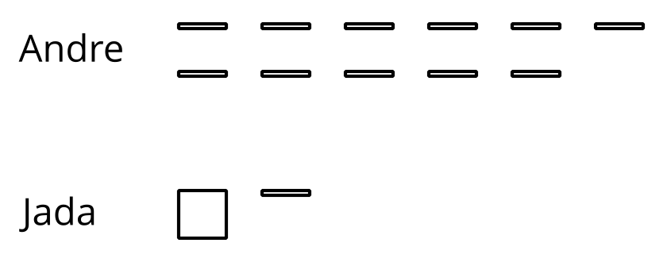
  - If both students represented the sum correctly, what value does each small rectangle represent? What value does each square represent?
  - Draw or describe a diagram that could represent the sum $0.008+0.07$.
- Here are two calculations of $0.2+0.05$. Which is correct? Explain why one is correct and the other is incorrect.
- 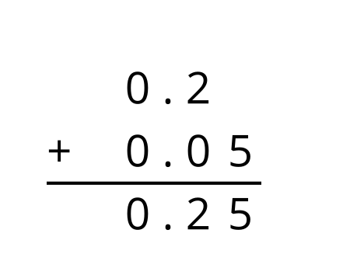
- 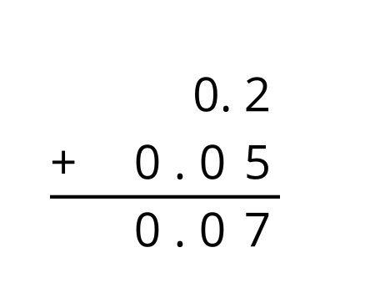
- Compute each sum. If you get stuck, consider drawing base-ten diagrams to help you.

  - 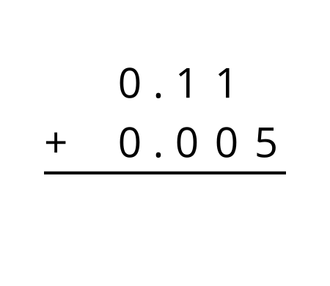
  - $0.209+0.01$
  - $10.2+1.1456$
Grade 6
Unit 5Lesson 3CC BY NC Illustrative Mathematics, based on IM 6–8 Math, CC BY Open Up Resources.

3.3Subtracting Decimals of Different Lengths
Diego and Noah drew different diagrams to represent $0.4−0.03$. Each rectangle represents 0.1. Each square represents 0.01.
- Diego started by drawing 4 rectangles to represent 0.4. He then replaced 1 rectangle with 10 squares and crossed out 3 squares to represent subtraction of 0.03, leaving 3 rectangles and 7 squares in his diagram.
- 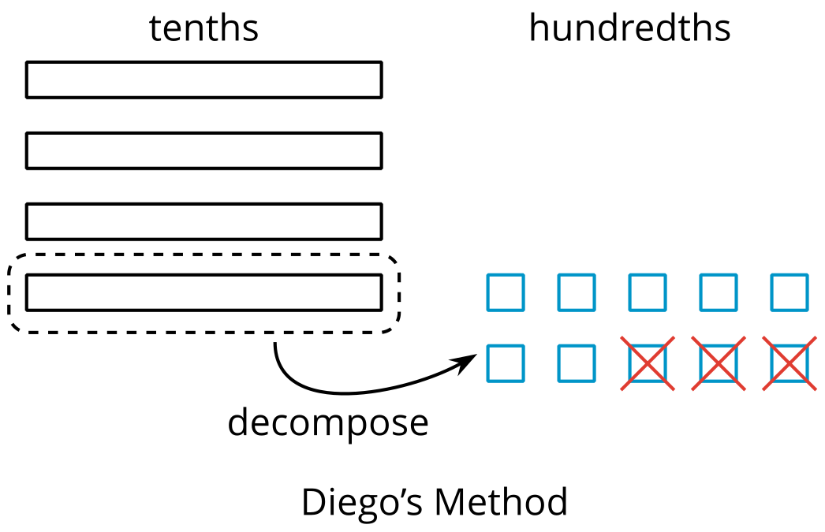
- Noah started by drawing 4 rectangles to represent 0.4. He then crossed out 3 rectangles to represent the subtraction, leaving 1 rectangle in his diagram.
- 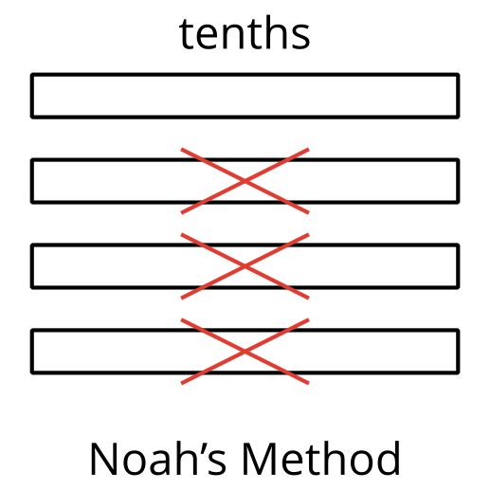
- Do you agree that either diagram correctly represents $0.4−0.03$? Discuss your reasoning with a partner.
- Elena also drew a diagram to represent $0.4−0.03$. She started by drawing 4 rectangles. She then replaced all 4 rectangles with 40 squares and crossed out 3 squares to represent subtraction of 0.03, leaving 37 squares in her diagram. Is her diagram correct? Discuss your reasoning with a partner.
- 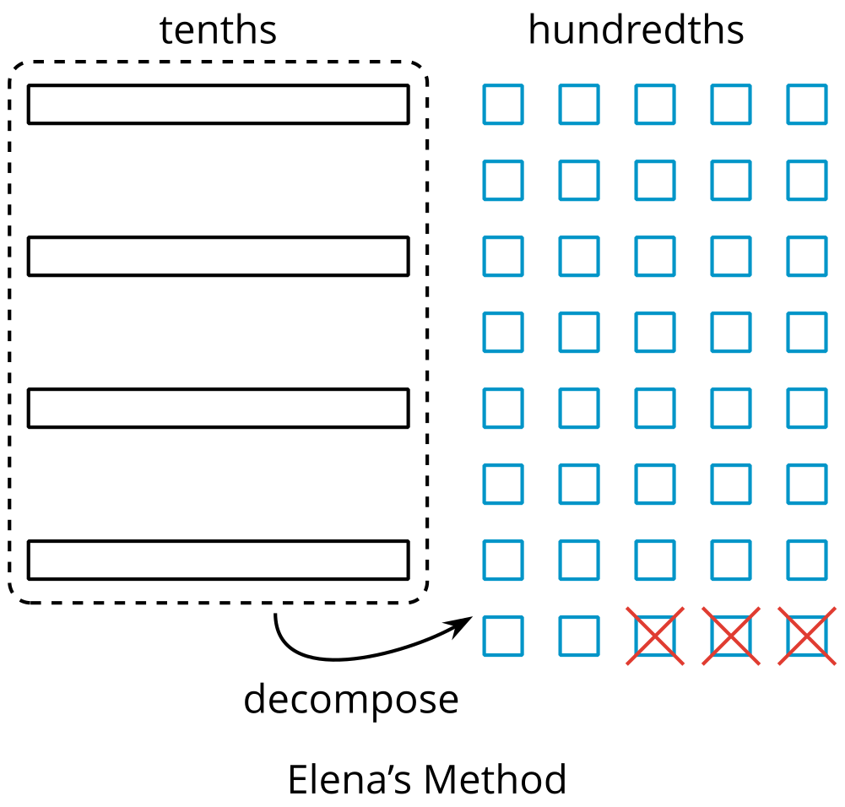
- Find each difference. Be prepared to explain your reasoning. If you get stuck, you can use base-ten blocks or diagrams to represent each expression and find its value.
  - $0.3−0.05$
  - $2.1−0.4$
  - $1.03−0.06$
  - $0.02−0.007$

Are you ready for more?
In a game, special stones are used for bartering. The values of the stones are based on their color and are ranked as shown, with red having the highest value.
red
orange
yellow
green
blue
indigo
violet
Each color is valued at 3 times the color below it in the ranking. So the value of a red stone is 3 times that of an orange stone, and the value of a green stone is 3 times that of a blue stone.
The stones can be used to buy items. Suppose you want to buy a tool that is worth 2 yellow stones, 2 green stones, 2 blue stones, and 1 indigo stone. You go into the store with 1 red stone, 1 yellow stone, 2 green stones, 1 blue stone, and 2 violet stones.
What stones would the shopkeeper give you for the change? Assume the shopkeeper would use as few stones as possible.

Lesson 3 Summary
Base-ten diagrams can help us understand subtraction. Suppose we are finding $0.23−0.07$. Here is a diagram showing 0.23, or 2 tenths and 3 hundredths.
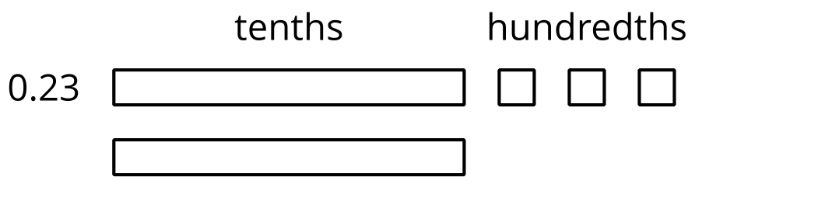
Subtracting 7 hundredths means removing 7 small squares, but we do ;not have enough to remove. Because 1 tenth is equal to 10 hundredths, we can decompose one of the tenths (1 rectangle) into 10 hundredths (10 small squares).
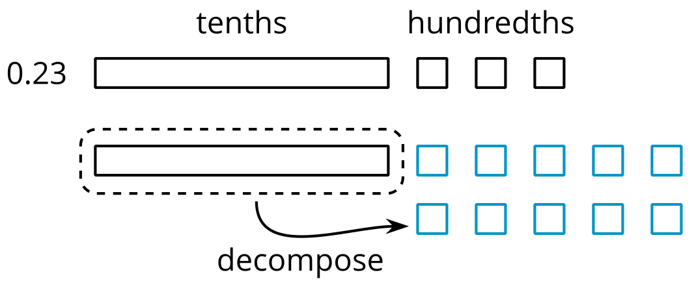
We now have 1 tenth and 13 hundredths, from which we can remove 7 hundredths.
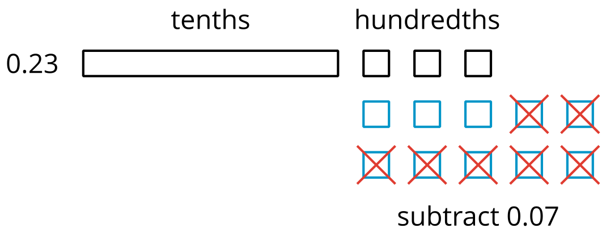
We have 1 tenth and 6 hundredths remaining, so $0.23−0.07=0.16$.
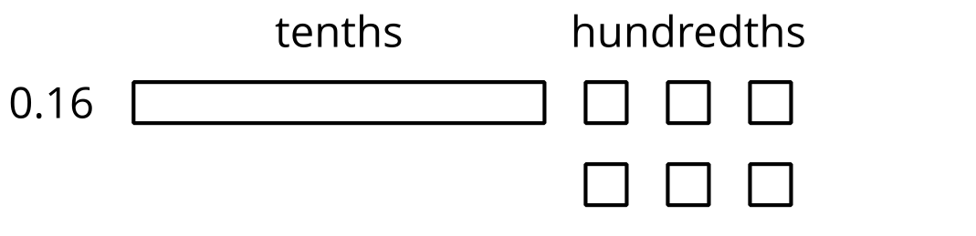
Here is a vertical calculation of $0.23−0.07$.
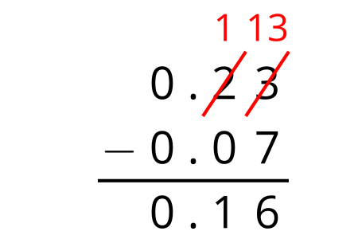
Notice how this representation also shows that a tenth is decomposed into 10 hundredths in order to subtract 7 hundredths.
This works for any decimal place. Suppose we are finding $0.023−0.007$. Here is a diagram showing 0.023.
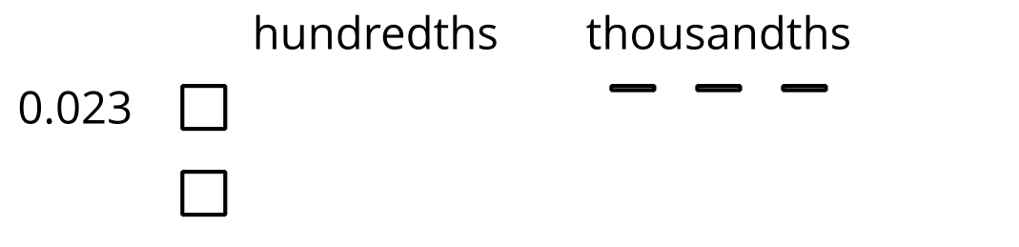
We want to remove 7 thousandths (7 small rectangles). We can decompose one of the hundredths into 10 thousandths.
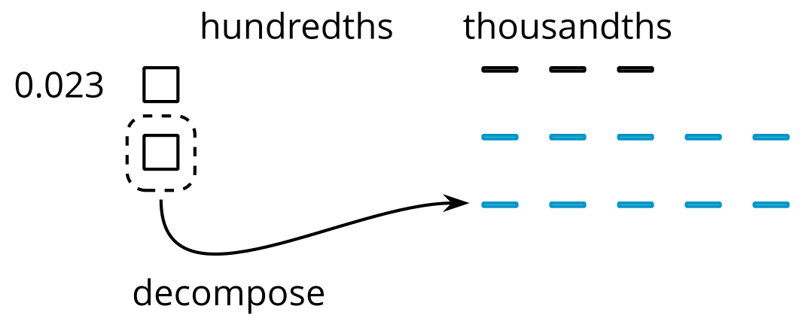
Now we can remove 7 thousandths.
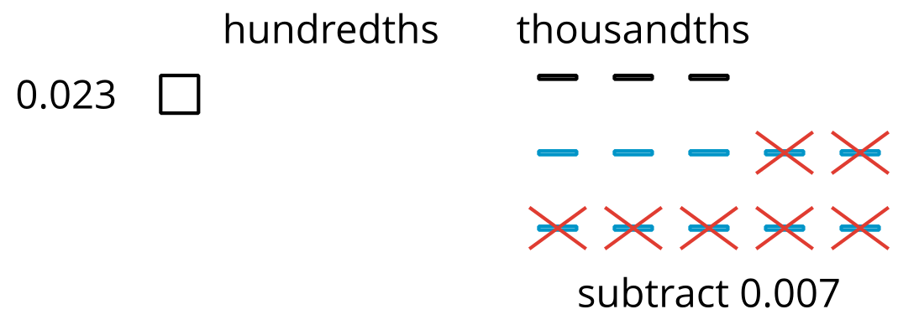
We have 1 hundredth and 6 thousandths remaining, so $0.023−0.007=0.016$.
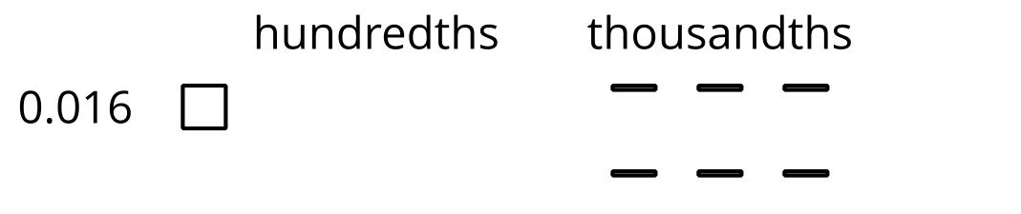
Here is a vertical calculation of $0.023−0.007$.
