Grade 6
Unit 3Lesson 9CC BY NC Illustrative Mathematics, based on IM 6–8 Math, CC BY Open Up Resources.
Unit 3, Lesson 9

More about Constant Speed
Let’s investigate constant speed some more.
Grade 6
Unit 3Lesson 9CC BY NC Illustrative Mathematics, based on IM 6–8 Math, CC BY Open Up Resources.

9.1Back on the Treadmill Again
While training for a race, Andre’s dad ran 12 miles in 75 minutes on a treadmill. If he runs at that rate:
- How long would it take him to run 1 mile? Show your reasoning.
- How far could he run in 1 minute? Show your reasoning.
Grade 6
Unit 3Lesson 9CC BY NC Illustrative Mathematics, based on IM 6–8 Math, CC BY Open Up Resources.

9.2Camels on a Desert Trail
A young camel in Town A is traveling on a flat desert trail to Town B, which is 24 miles away. An older camel in Town B is traveling on the same trail to Town A.
The two camels depart at the same time.
The young camel walks at a speed of 3.4 miles per hour while the older camel walks 3 miles per hour.
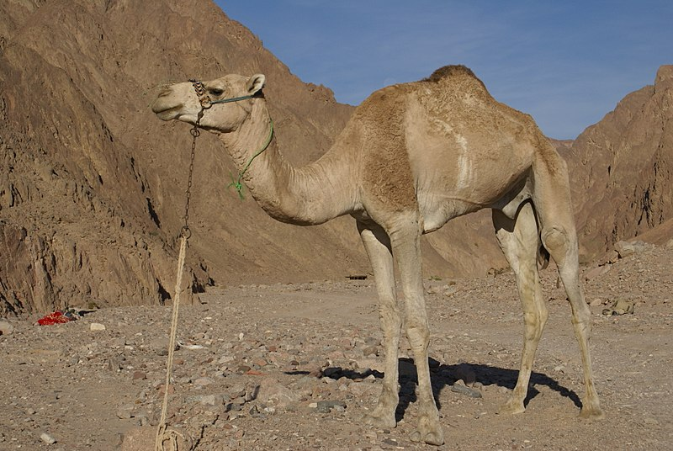
For each question, explain or show your reasoning.
- How far apart will they be in 0, 1, 2, and 3 hours? Complete the first four rows of the table.
- elapsed time (hours) | - distance apart (miles)
- 0
- 1
- 2
- 3
- How much time after their departure will the camels meet? (You can use the empty rows in the table if you think it’d be helpful.)
- The next day, the older camel travels back to Town B at 6.4 miles per hour. The young camel stays in Town B.
- Here are three statements about this situation. Do you agree with each statement? Explain or show your reasoning.
  - The two camels will be the same distances apart after 0, 1, 2, and 3 hours as they were the day before.
  - The camels will meet the same amount of time after departure as they did the day before.
  - The camels will meet at the same point along the trail as they did the day before.

Are you ready for more?
A horse departs from Town B at the same time as the older camel and also heads toward Town A. It meets the young camel 2.5 hours later. How fast was the horse going? Explain or show your reasoning.
Grade 6
Unit 3Lesson 9CC BY NC Illustrative Mathematics, based on IM 6–8 Math, CC BY Open Up Resources.

9.3Swimming and Biking
Jada bikes 2 miles in 12 minutes. Jada’s cousin swims 1 mile in 24 minutes.
For each question, explain or show your reasoning.

  - Who is moving faster?
  - How much faster is that person than the other?
- One day Jada and her cousin line up on the end of a swimming pier on the edge of a lake. At the same time, they start swimming and biking in opposite directions.
  - How far apart will they be after 15 minutes?
  - How long will it take them to be 5 miles apart?

Lesson 9 Summary
We can describe how fast an object moves by its speed and pace.
- Speed tells us how far an object moves in a certain amount of time. We measure speed in units of distance per unit of time, like miles per hour or meters per second.
- Pace tells us how much time it takes an object to travel a certain distance. We measure pace in units of time per unit of distance, like hours per mile or seconds per meter.
A cyclist who bikes 20 kilometers in 2 hours has:
- A speed of 10 kilometers per hour.
- A pace of $\frac{1}{10}$, or 0.1, hour per kilometer.
distance (kilometers) | time (hours)
20 | 2
10 | 1
1 | $\frac{1}{10}$
Speed and pace are the two unit rates describing a situation that involves a ratio of distance and time. They can help us compare the movements of objects that are each traveling at a constant speed.
Suppose two remote-control cars are racing at a constant speed from a starting line. Car A travels 24 meters in 8 seconds. Car B travels 50 meters in 20 seconds. Which car travels faster?
- The speed of Car A is $\frac{24}{8}$ or 3 meters per second. The speed of Car B is $\frac{50}{20}$ or 2.5 meters per second. Car A travels farther in 1 second, so it is faster.
- The pace of Car A is $\frac{8}{24}$ or $\frac{1}{3}$ second per meter. The pace of Car B is $\frac{20}{50}$ or $\frac{2}{5}$ second per meter. Car B takes more time to travel 1 meter, so it is slower.
How much farther is one car from the other 10 seconds after the start of the race? Because speed is a rate per 1 unit of time, we can multiply the amount of time by the speed to find the distance.
- Car A travels 30 meters ($10⋅3=30$), and Car B travels 25 meters from the start line ($10⋅2.5=25$). Ten seconds after the start of the race, Car A has traveled 5 meters farther than Car B has traveled.

