Algebra 1
Unit 6Lesson 1CC BY NC 2024 Illustrative Mathematics®
Unit 6, Lesson 1

Growing and Growing
Let's choose the better deal.
Algebra 1
Unit 6Lesson 1CC BY NC 2024 Illustrative Mathematics®

1.1Splitting Bacteria

Some bacteria are growing in a dish. Every hour, each bacterium splits into 3 bacteria.
- This diagram shows a bacterium at hour 0 and then at hour 1. Draw what has happened at hours 2 and 3.
- 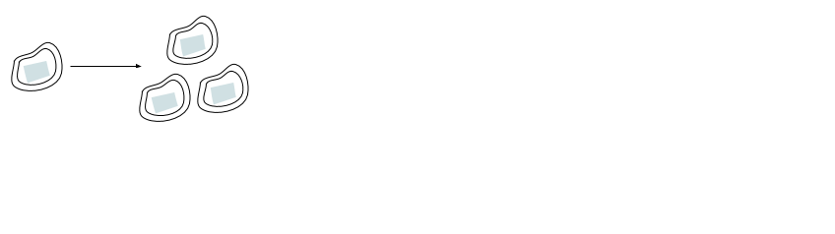
- How many bacteria are there at hours 2 and 3?
Algebra 1
Unit 6Lesson 1CC BY NC 2024 Illustrative Mathematics®

1.2A Magical Offer
While walking along a beach, you notice a fish trapped in a small pool. You release the fish into the ocean, but before it swims away, it turns to reward you for your good deed.
It tells you, "Thank you for freeing me from that tide pool! I was getting claustrophobic. You can choose one of these purses as a reward. You cannot add money to the purses, and once you take any money out, the magic is broken and no more money will be added, but you may keep what is inside."
- Purse A contains $1,000 today. If you leave it alone, it will contain $1,200 tomorrow (by magic). The next day, it will contain $1,400. This pattern of $200 additional dollars per day will continue.
- Purse B contains 1 penny today. Leave that penny in there, because tomorrow it will (magically) turn into 2 pennies. The next day, there will be 4 pennies. The amount in the purse will continue to double each day.
time passed | 0 days | 1 day | 2 days | 7 days  (1 week) | 14 days  (2 weeks) | 21 days  (3 weeks) | 30 days  (1 month)
Purse A | $1,000 | $1,200 | $1,400
Purse B | $0.01 | $0.02 | $0.04
Complete the table for the amount of money in each purse for the given number of days after the fish offers the purses. Be prepared to explain your reasoning for each value.
Algebra 1
Unit 6Lesson 1CC BY NC 2024 Illustrative Mathematics®

1.3Graphing the Fish's Offers
Here are graphs showing how the amount of money in the purses changes. Remember Purse A starts with $1,000 and grows by $200 each day. Purse B starts with $0.01 and doubles each day. Point P has the coordinates $\left(9,5.12\right)$, and point Q has the coordinates $\left(5,2,​000\right)$.
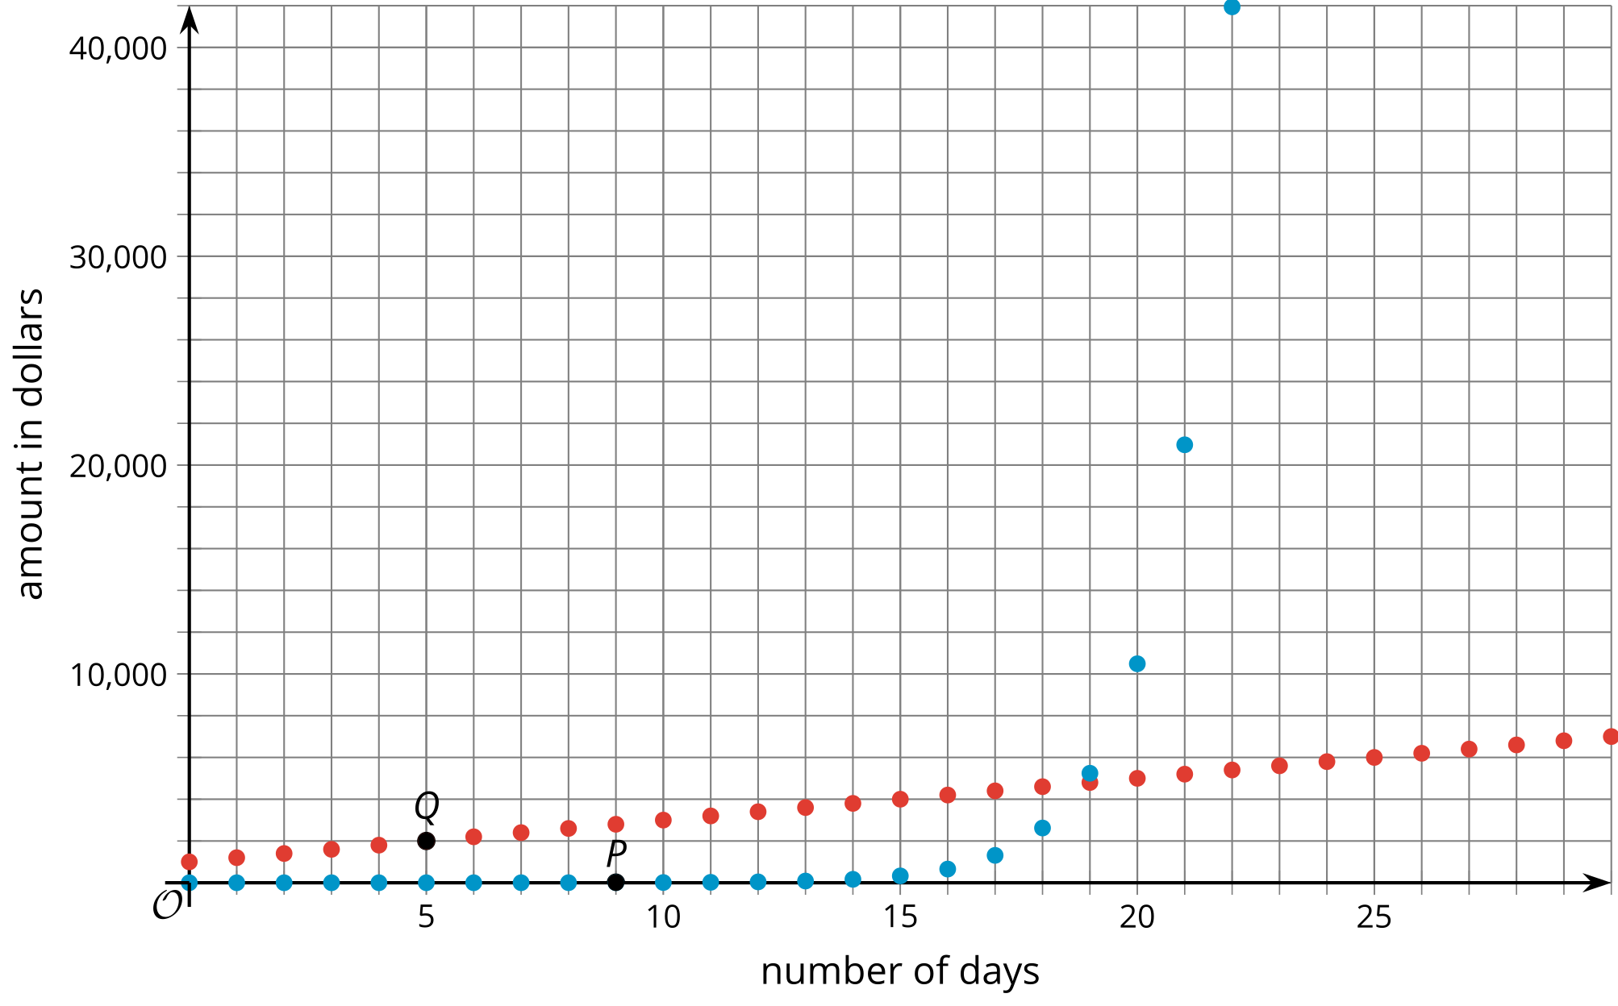
- Which graph shows the amount of money in Purse A? Which graph shows the amount of money in Purse B? Explain how you know.
- Points $P$ and $Q$ are labeled on the graph. Explain what they mean in terms of the fish's offer.
- What are the coordinates of the vertical intercept for each graph? Explain how you know.
- When does Purse B become a better choice than Purse A? Explain your reasoning.
- Knowing what you know now, which purse would you choose? Explain your reasoning.

Are you ready for more?
Before the fish gets too far, it turns around again and says, “I will give you an even more enticing deal. Purse B stays the same, but Purse A now increases by $250,000 every day. The purses gain money only on days that you return to this beach and rescue any trapped fish for one mile on each side of this spot. If you miss a day, the magic is broken and the purses will not gain any more money.” Which purse should you choose?

Lesson 1 Summary
When we repeatedly double a positive number, it eventually becomes very large. Let's start with 0.001. The table shows what happens when we begin to double.
number of times doubled | 0 | 1 | 2 | 3 | 4
number | 0.001 | 0.002 | 0.004 | 0.008 | 0.016
If we want to continue this process, it is convenient to use an exponent. For example, the last entry in the table, 0.016, is 0.001 doubled 4 times, or $\left(0.001\right)⋅2⋅2⋅2⋅2$, which can be expressed as $\left(0.001\right)⋅2^{4}$.
Even though we started with a very small number, 0.001, we don't have to double it that many times to reach a very large number. For example, if we double it 30 times, represented by $\left(0.001\right)⋅2^{30}$, the result is greater than 1 million.
Throughout this unit, we will look at many situations in which quantities grow or decrease by applying the same factor repeatedly.

