Unit 2 Lesson 21: Graphing Linear Inequalities in Two Variables (Part 1)

1 Math Talk: Less Than, Equal to, or More Than 12? (Warm up)

Student Task Statement
Here is an expression: $2x+3y$.
Decide if the values in each ordered pair, $\left(x,y\right)$, make the value of the expression less than, greater than, or equal to 12.
$\left(0,5\right)$
$\left(6,0\right)$
$\left(\text{-}1,\text{-}1\right)$
$\left(\text{-}5,10\right)$

2 Solutions and Not Solutions

Images for Launch
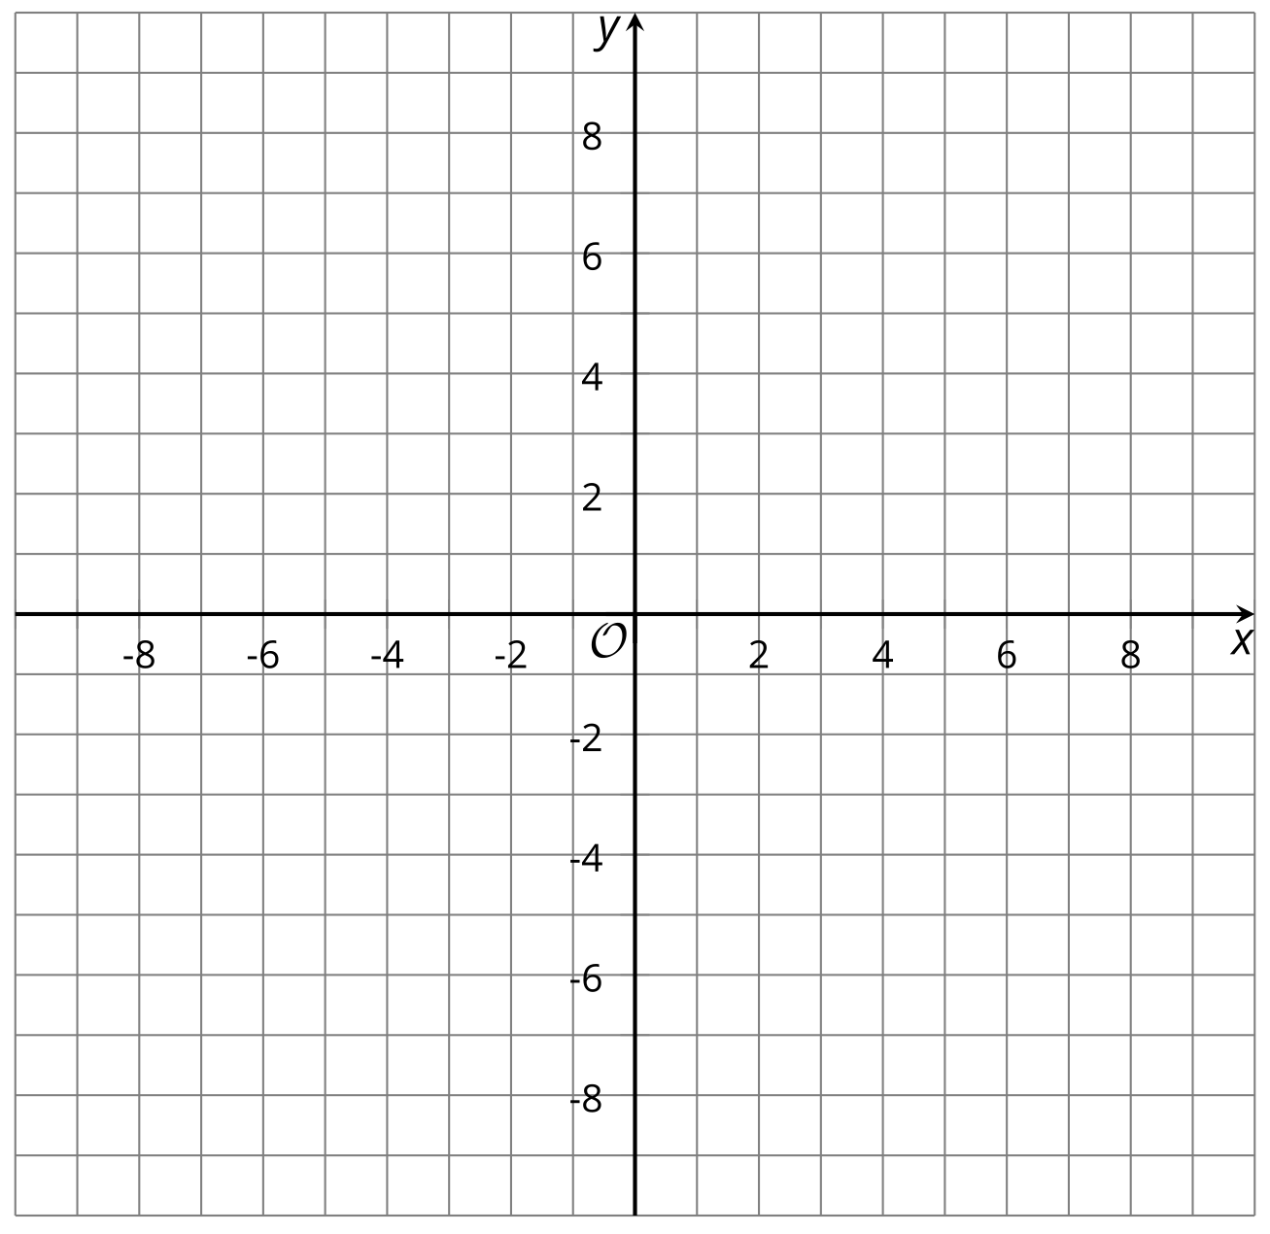
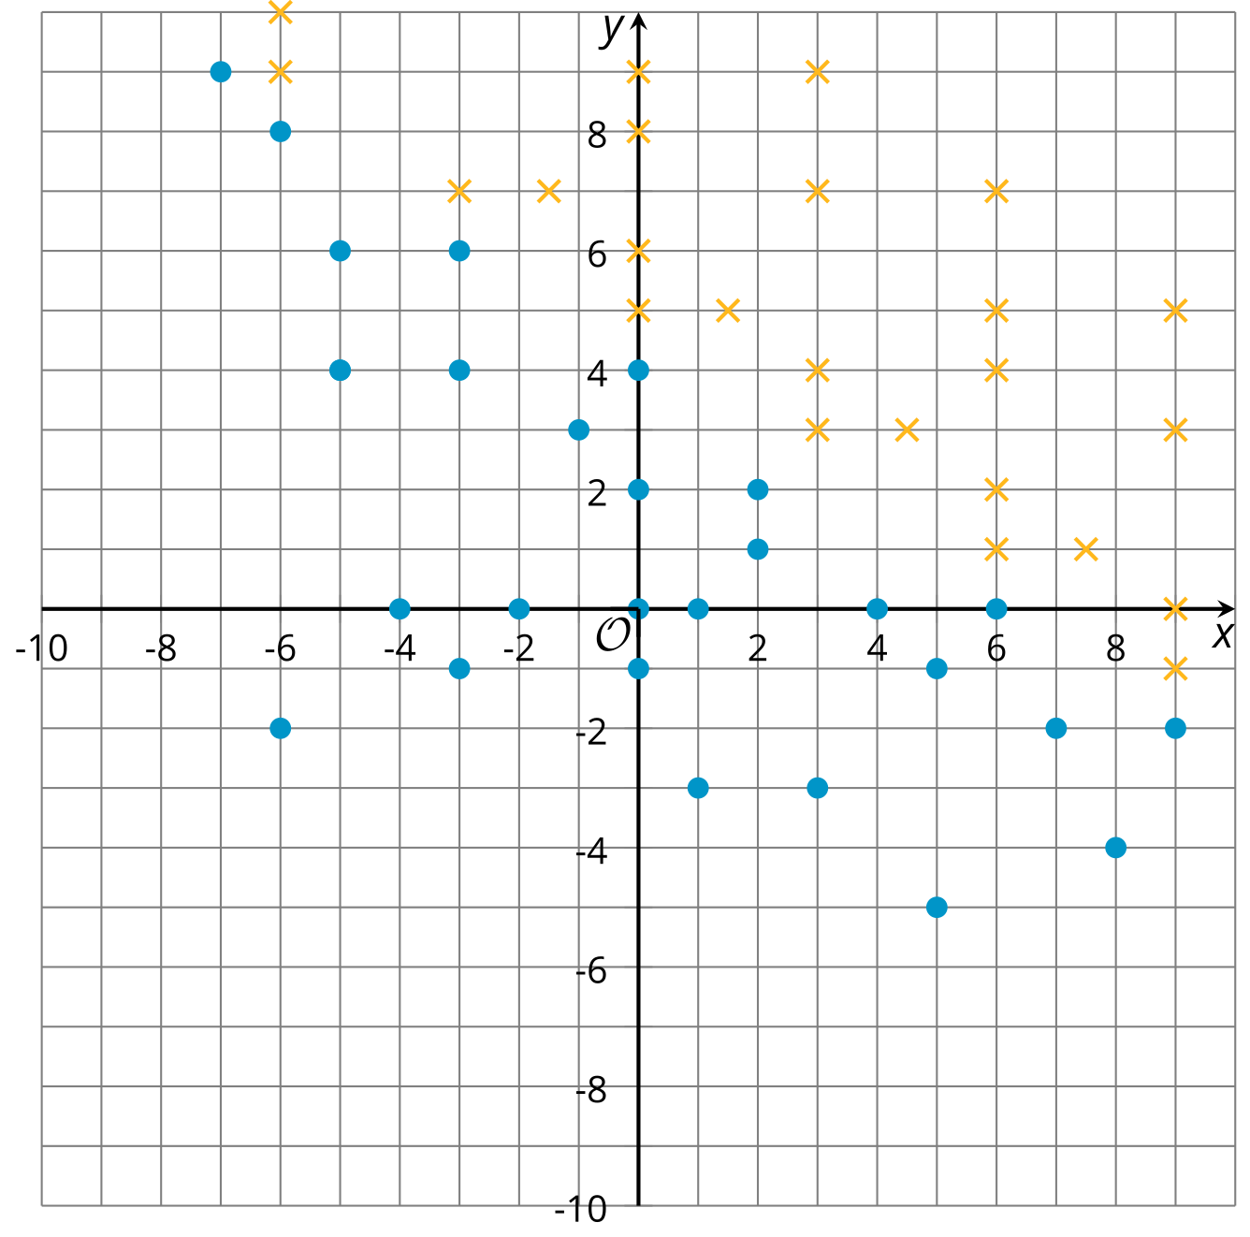

Student Task Statement
Here are four inequalities. Study each inequality assigned to your group and work with your group to:
- Find some coordinate pairs that represent solutions to the inequality and some coordinate pairs that do not represent solutions.
- Plot both sets of points. Either use two different colors or two different symbols like X and O.
- Plot enough points until you start to see the region that contains solutions and the region that contains non-solutions. Look for a pattern describing the region where solutions are plotted.

$x≥y$

$\text{-}2y≥\text{-}4$

$3x<0$

$x+y>10$

Activity Synthesis

$x≥y$
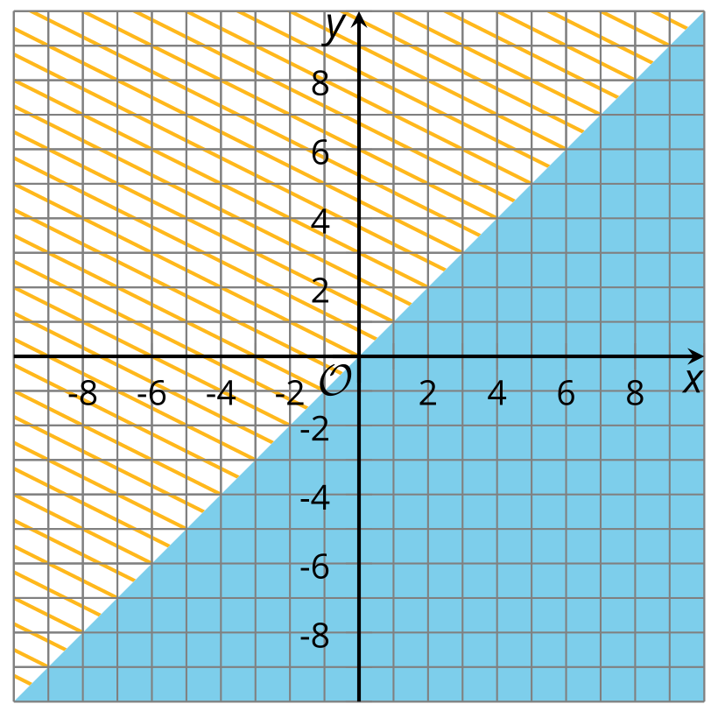

$\text{-}2y≥\text{-}4$
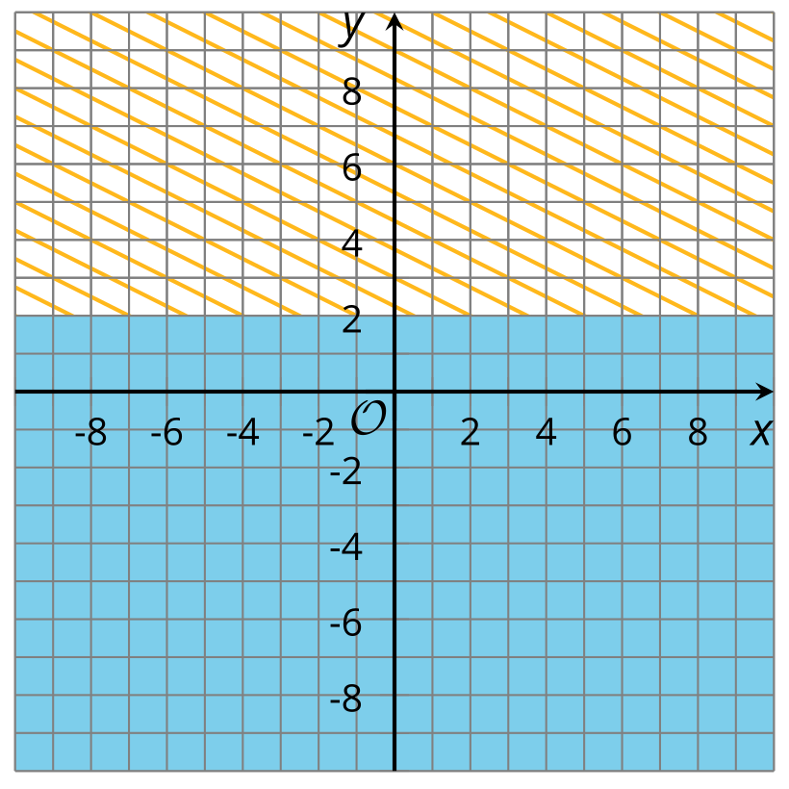

$3x<0$
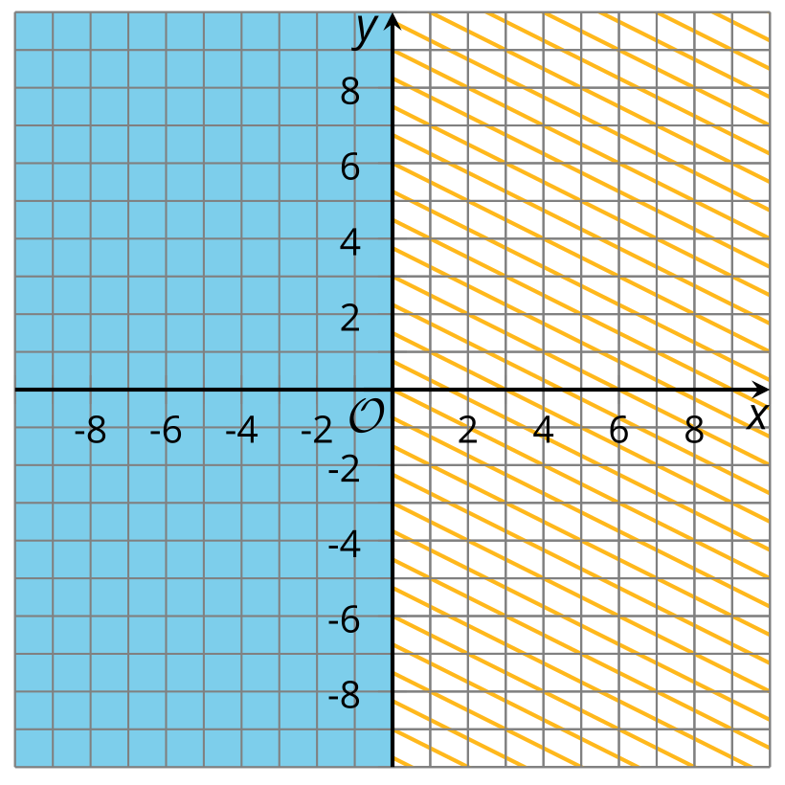

$x+y>10$
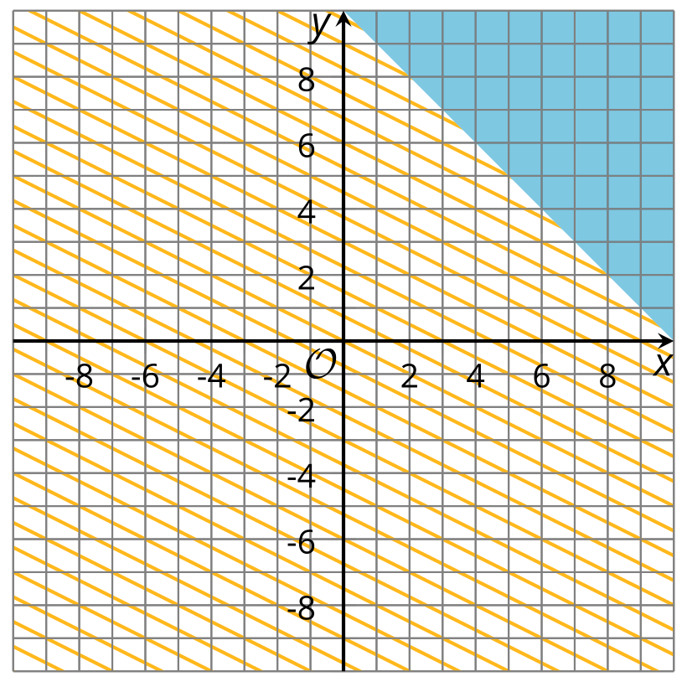

3 Sketching Solutions to Inequalities

Images for Launch
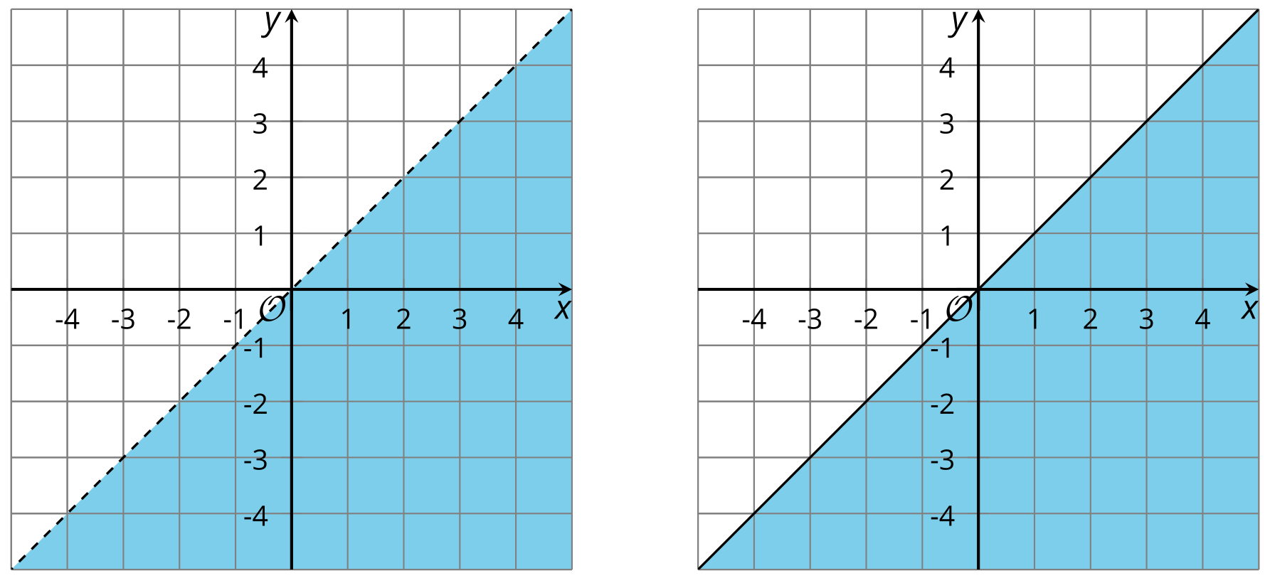

Student Task Statement
- Here is a graph that represents solutions to the equation $x−y=5$.
- 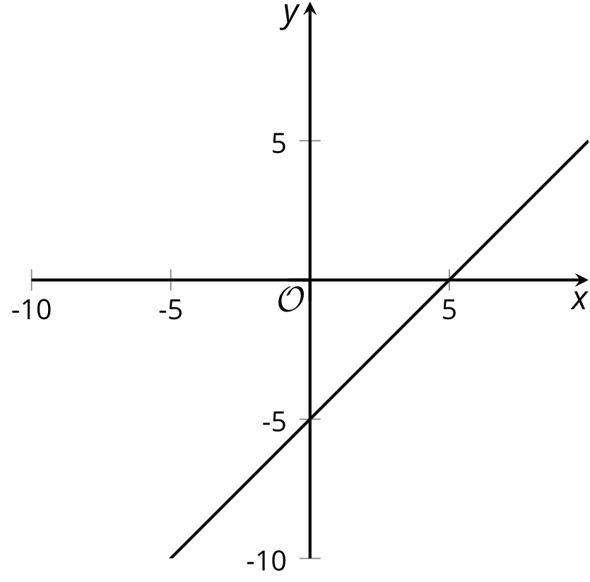
- Sketch 4 quick graphs representing the solutions to each of these inequalities:
- $x−y<5$
- 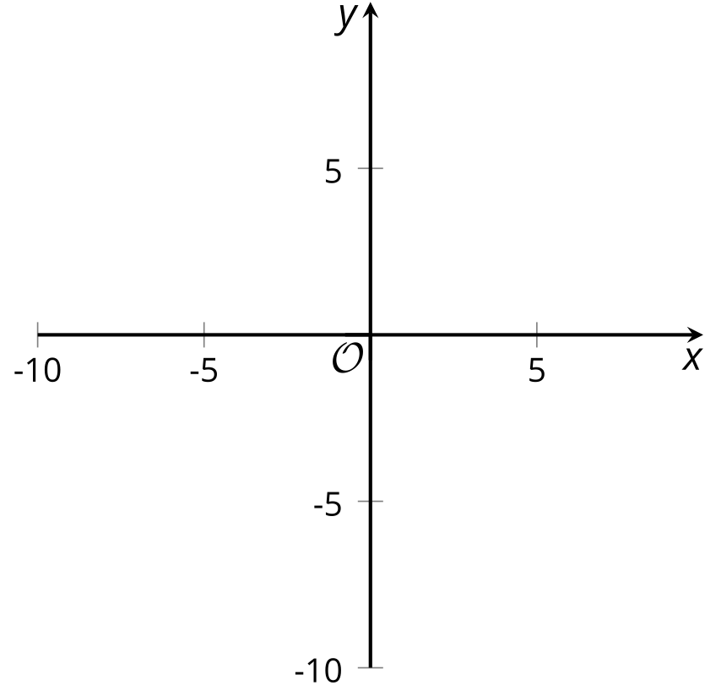
- $x−y≤5$
- $x−y>5$
- $x−y≥5$
- For each graph, write an inequality whose solutions are represented by the shaded part of the graph.

- A
- 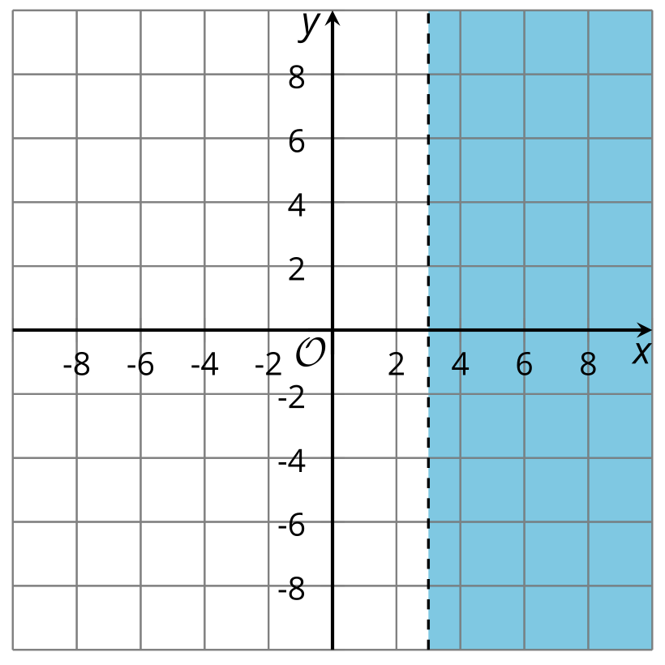

- B
- 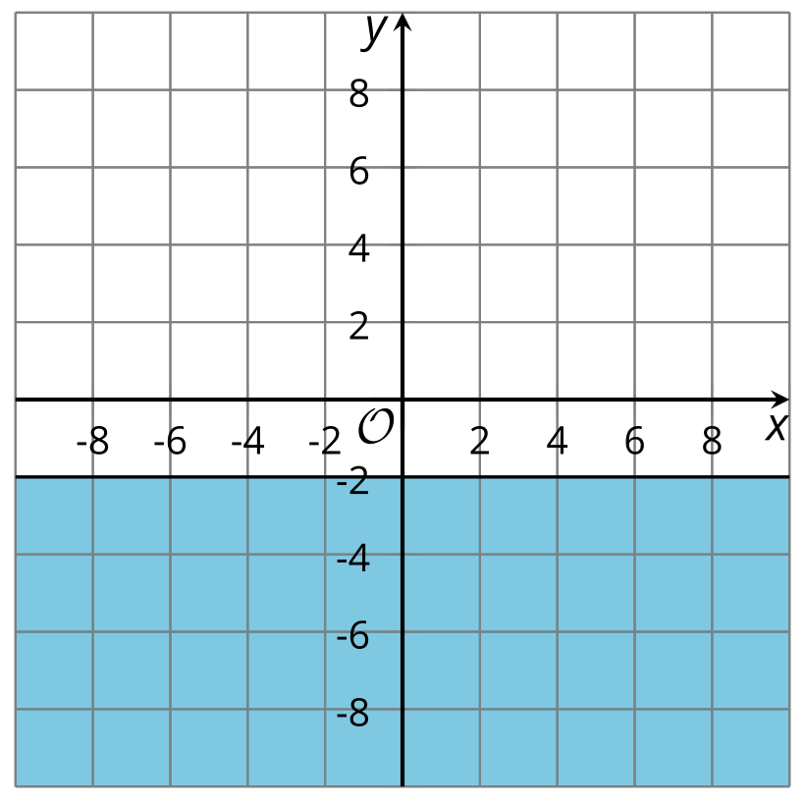

- C
- 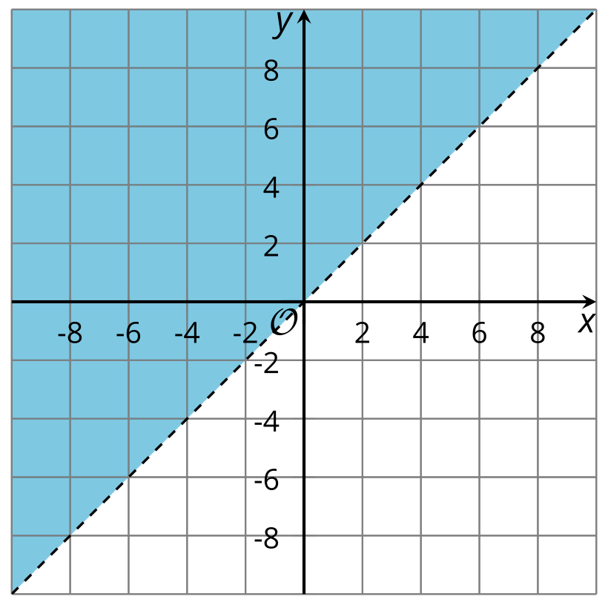

- D
- 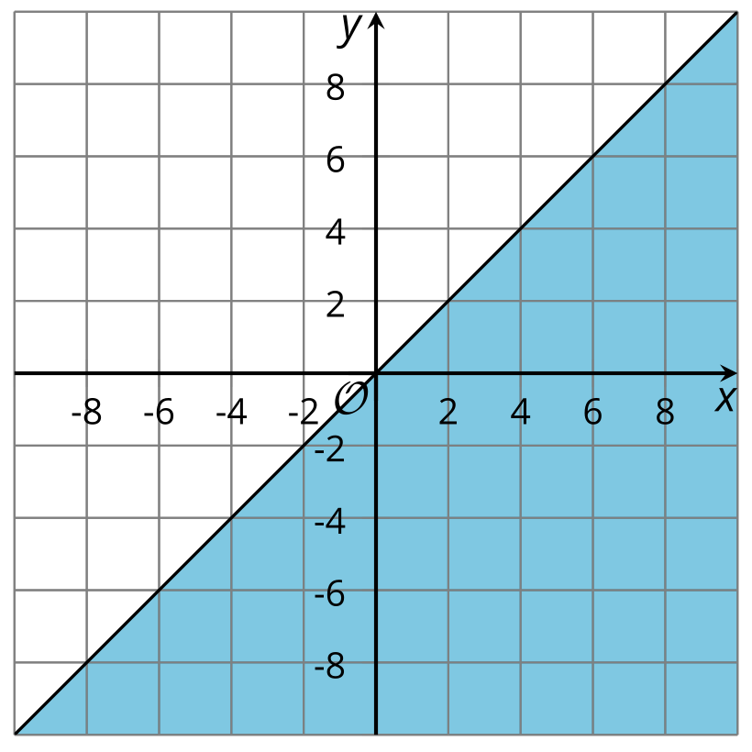
© CC BY 2019 by Illustrative Mathematics®

