Lesson 11: Solve Problems Involving Time (Part 2)
- Let’s solve more problems involving time.

Warm-up: Notice and Wonder: Band Practice
What do you notice? What do you wonder?
Han ate his dinner before he caught a bus.
When he got off the bus, he had to hurry to get to band practice on time.
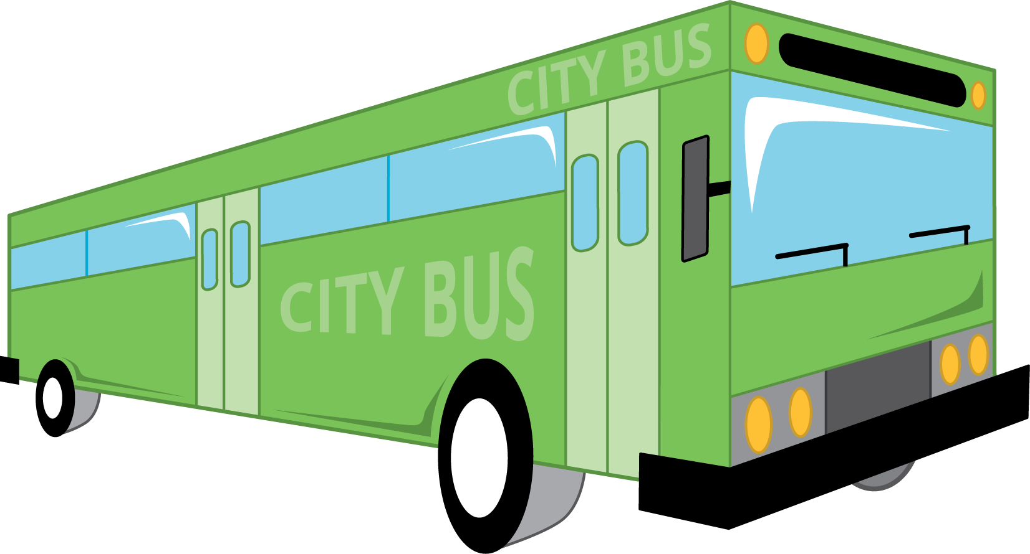

11.1: On the Bus Again
- For how many minutes was Han on the bus? Explain or show your reasoning.
- the time Han got on the bus:
- 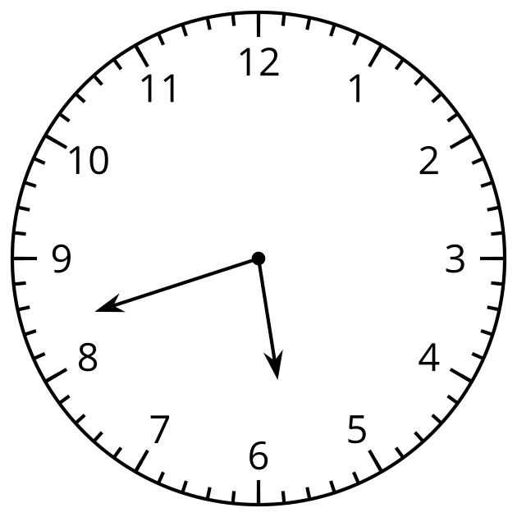
- the time Han got off the bus:
- 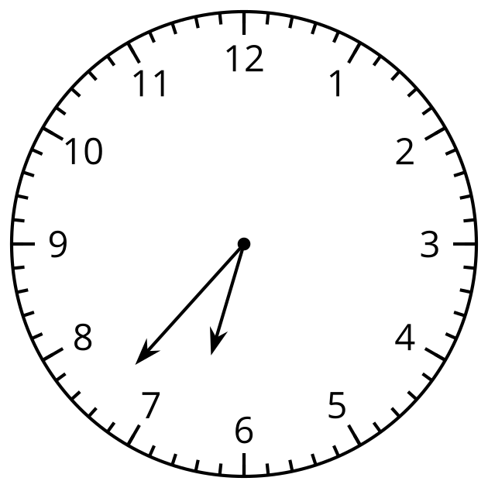
- Draw the minute hand to show that Elena waited for the bus for 32 minutes.
- the time Elena started waiting:
- 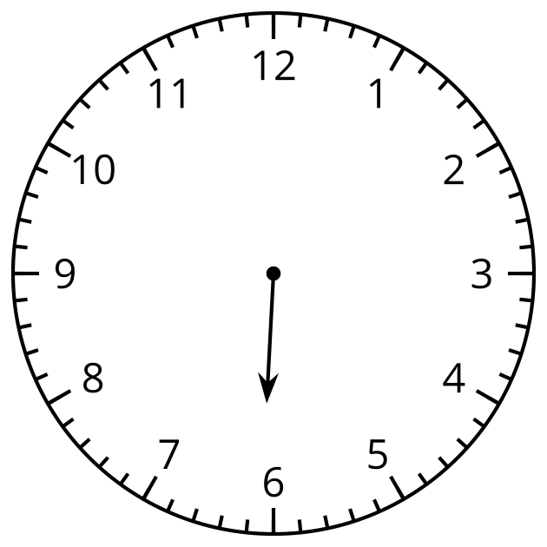
- the time Elena got on the bus:
- 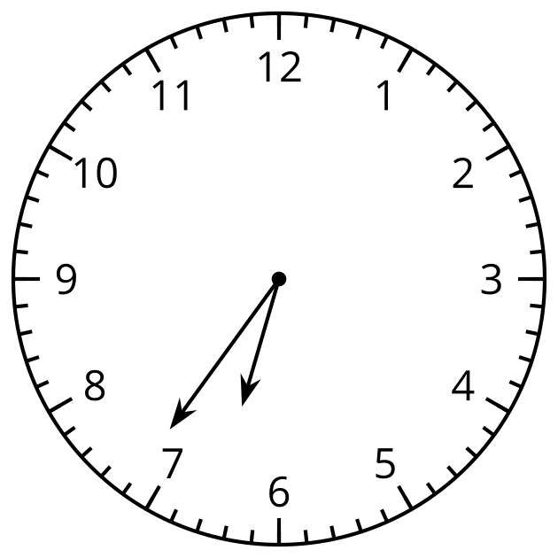

11.2: Math Libs Time
For each problem, fill in a name and an activity, and then solve the problem. Show your thinking. Organize it so it can be followed by others.
- $\underset{_}{}$ started $\underset{_}{}$ at 8:25 a.m. and finished at 8:50 a.m. How much time was spent doing that activity?
- $\underset{_}{}$ finished $\underset{_}{}$ at 5:38 p.m, after spending 20 minutes. What was the start time?
- $\underset{_}{}$ started $\underset{_}{}$ at 10:45 a.m. and finished at 11:18 a.m. How much time was spent on it?
- $\underset{_}{}$ started $\underset{_}{}$ at 3:30 p.m and took 45 minutes to complete it. What was the finish time?

Section Summary
Section Summary
In this section, we learned to tell and write time to the nearest minute. We solved addition and subtraction problems about time.
the time Han got on the bus:
the time Han got off the bus:
Here is one way to find out how much time Han spent on the bus:
- Count up 3 minutes from 5:42 to 5:45, and then 15 minutes from 5:45 to 6:00.
- Count up 30 minutes from 6:00 to 6:30, and then 7 more minutes to 6:37.
- Add the minutes, $3+15+30+7$, to get 55.
© CC BY 2021 Illustrative Mathematics®

