Unit 2 Lesson 9: More, Fewer, or the Same

WU Questions About Us: Apples or Bananas? (Part 1) (Warm up)

Student Task Statement

1 Compare 5-frame Cards

Images for Launch

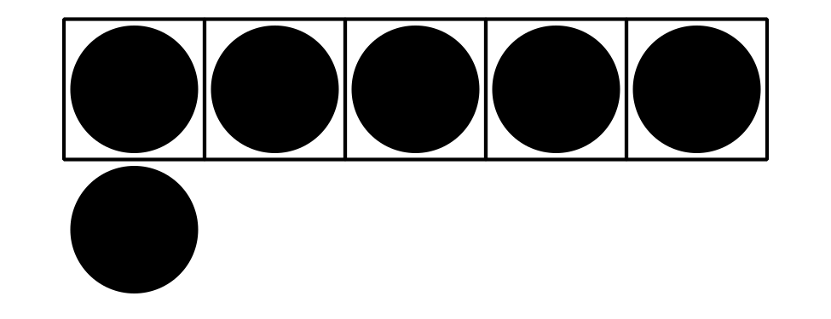

Student Task Statement

Activity Synthesis
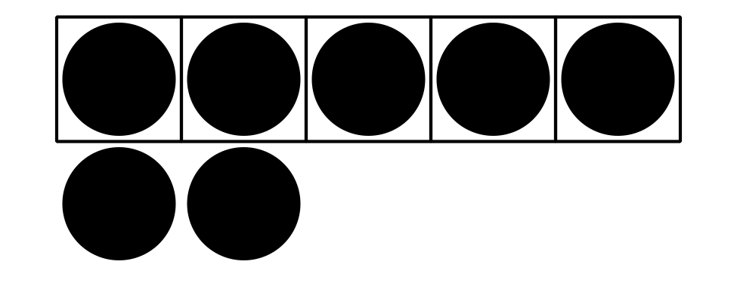


2 More and Fewer with 5-frames and Fingers

Images for Launch

Student Task Statement

Activity Synthesis
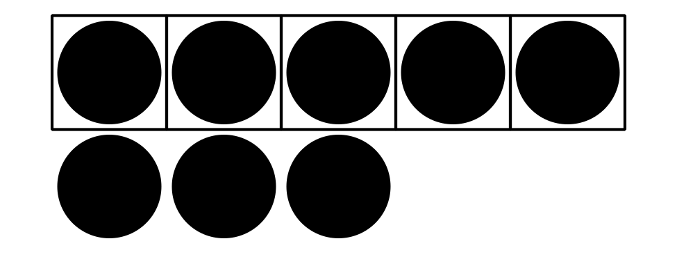

3 Introduce Bingo, Images

Images for Launch




Student Task Statement
Choose a center.
Bingo
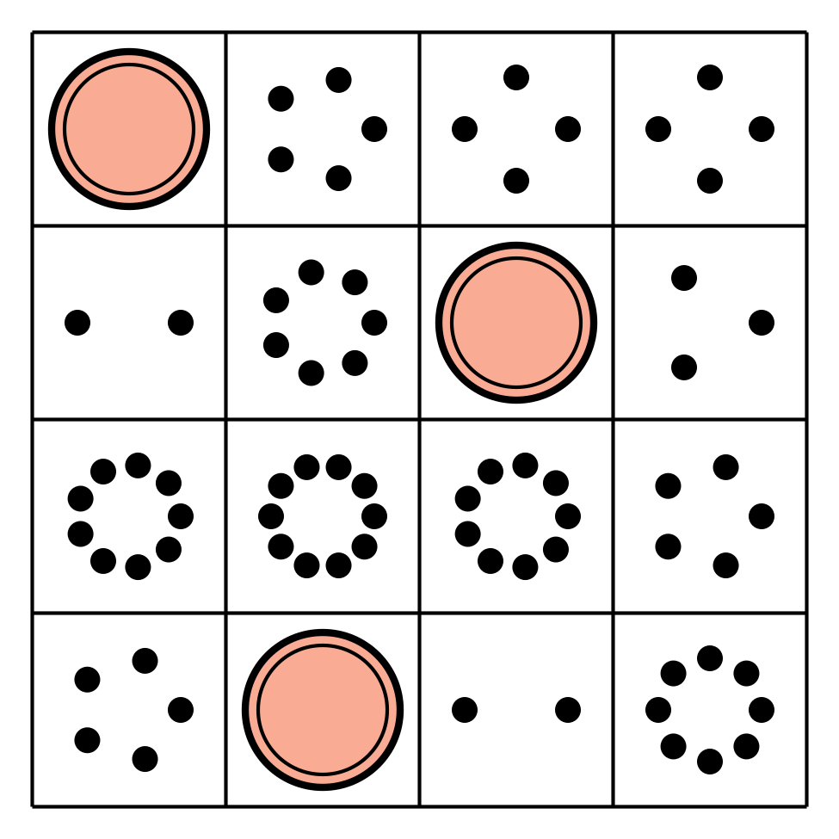
Math Stories

Connecting Cubes
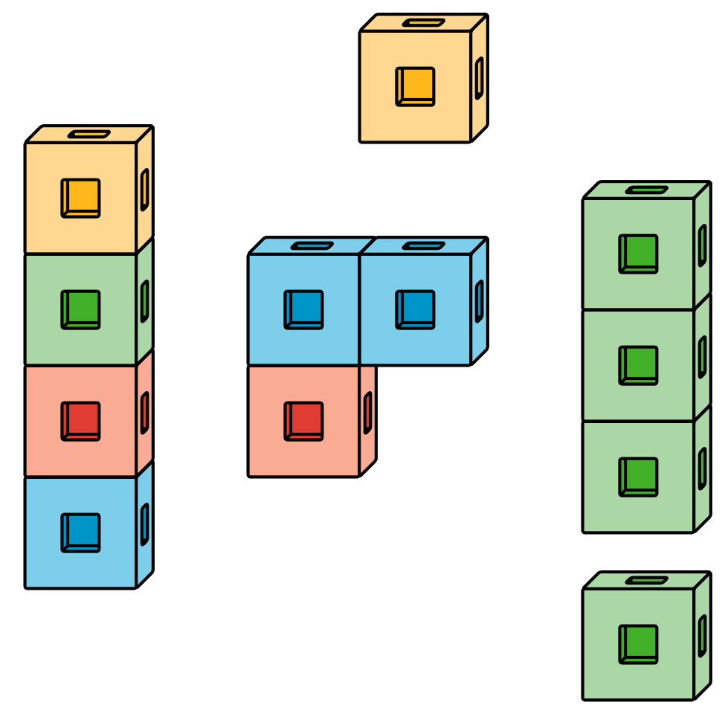
Number Race
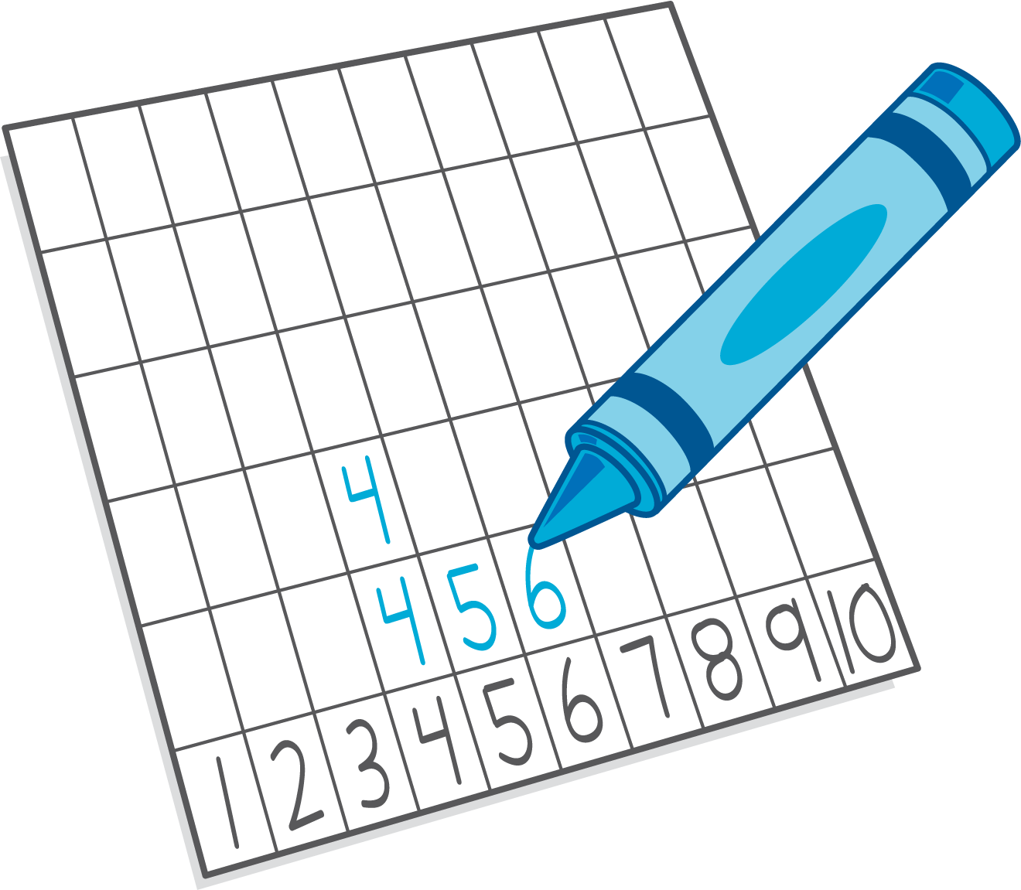

Images for Activity Synthesis

© CC BY 2021 Illustrative Mathematics®

