Algebra 1
Unit 7Lesson 15CC BY NC 2024 Illustrative Mathematics®
Unit 7, Lesson 15

Vertex Form
- Let’s find out about the vertex form.
Algebra 1
Unit 7Lesson 15CC BY NC 2024 Illustrative Mathematics®

15.1Notice and Wonder: Two Sets of Equations
What do you notice? What do you wonder?
Set 1:
$f\left(x\right)=x^{2}+4x$
$g\left(x\right)=x\left(x+4\right)$
$h\left(x\right)={\left(x+2\right)}^{2}−4$
Set 2:
$p\left(x\right)=\text{-}x^{2}+6x−5$
$q\left(x\right)=\left(5−x\right)\left(x−1\right)$
$r\left(x\right)=\text{-}1{\left(x−3\right)}^{2}+4$

Algebra 1
Unit 7Lesson 15CC BY NC 2024 Illustrative Mathematics®

15.2A Whole New Form
Here are two sets of equations for quadratic functions that you saw earlier. In each set, the expressions that define the output are equivalent.
Set 1:
$f\left(x\right)=x^{2}+4x$
$g\left(x\right)=x\left(x+4\right)$
$h\left(x\right)={\left(x+2\right)}^{2}−4$
Set 2:
$p\left(x\right)=\text{-}x^{2}+6x−5$
$q\left(x\right)=\left(5−x\right)\left(x−1\right)$
$r\left(x\right)=\text{-}1{\left(x−3\right)}^{2}+4$
The expressions that define $h$ and $r$ are written in vertex form. We can show that $h$ is equivalent to the expression defining $f$ by expanding the expression:
$\begin{matrix}{\left(x+2\right)}^{2}−4 & =\left(x+2\right)\left(x+2\right)−4 \\ & =x^{2}+2x+2x+4−4 \\ & =x^{2}+4x\end{matrix}$
- Show that the expressions defining $r$ and $p$ are equivalent.
- Here are graphs representing the quadratic functions. Why do you think expressions such as those defining $h$ and $r$ are said to be written in vertex form?

- Graph of $h$
- 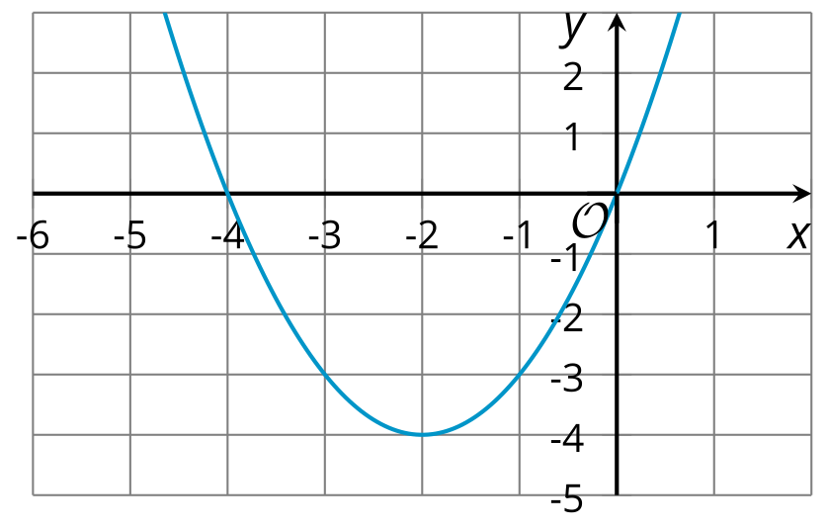

- Graph of $r$
- 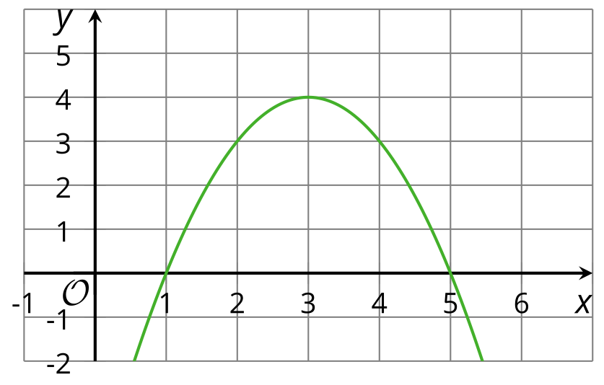
Algebra 1
Unit 7Lesson 15CC BY NC 2024 Illustrative Mathematics®

15.3Playing with Parameters
- Using graphing technology, graph $y=x^{2}$. Then, add different numbers to $x$ before it is squared (for example, $y={\left(x+4\right)}^{2}$, $y={\left(x−3\right)}^{2}$), and observe how the graph changes. Record your observations.
- Graph $y={\left(x−1\right)}^{2}$. Then, experiment with each of the following changes to the function, and see how they affect the graph and the vertex:
  - Adding different constant terms to ${\left(x−1\right)}^{2}$ (for example: ${\left(x−1\right)}^{2}+5$, ${\left(x−1\right)}^{2}−9$).
  - Multiplying ${\left(x−1\right)}^{2}$ by different coefficients (for example: $y=3{\left(x−1\right)}^{2}$, $y=\text{-}2{\left(x−1\right)}^{2}$).
- Without graphing, predict the coordinates of the vertex of the graphs of these quadratic functions, and predict whether the graph opens upward or opens downward. Ignore the last row until the next question.
- equations | - coordinates of vertex | - graph opens upward or downward?
- $y={\left(x+10\right)}^{2}$
- $y={\left(x−4\right)}^{2}+8$
- $y=\text{-}{\left(x−4\right)}^{2}+8$
- $y=x^{2}−7$
- $y=\frac{1}{2}{\left(x+3\right)}^{2}−5$
- $y=\text{-}{\left(x+100\right)}^{2}+50$
- $y=a{\left(x+m\right)}^{2}+n$
- Use graphing technology to check your predictions. If they are incorrect, revise them. Then complete the last row of the table.

Are you ready for more?
- What is the vertex of this graph?
- Find a quadratic equation whose graph has the same vertex, and adjust it (if needed) so that it has the graph shown.
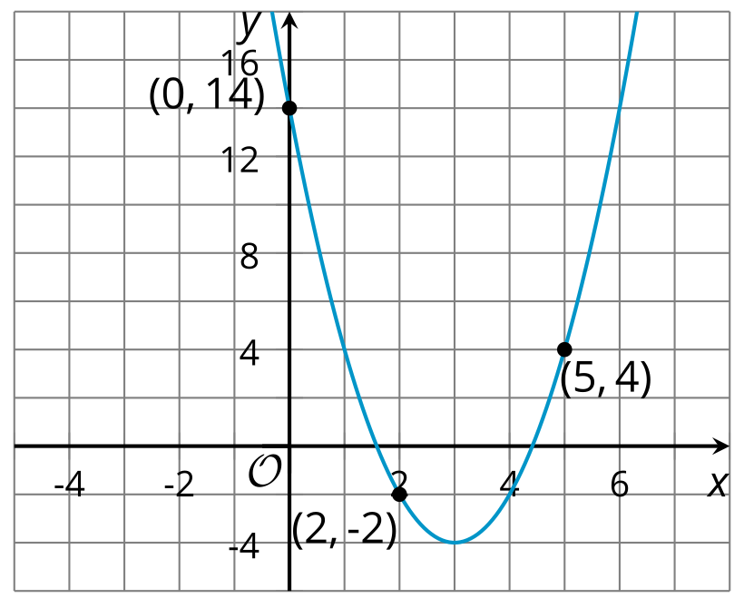

Lesson 15 Summary
Sometimes the expressions that define quadratic functions are written in vertex form. The function $f\left(x\right)={\left(x−3\right)}^{2}+4$ is in vertex form and is shown in this graph.
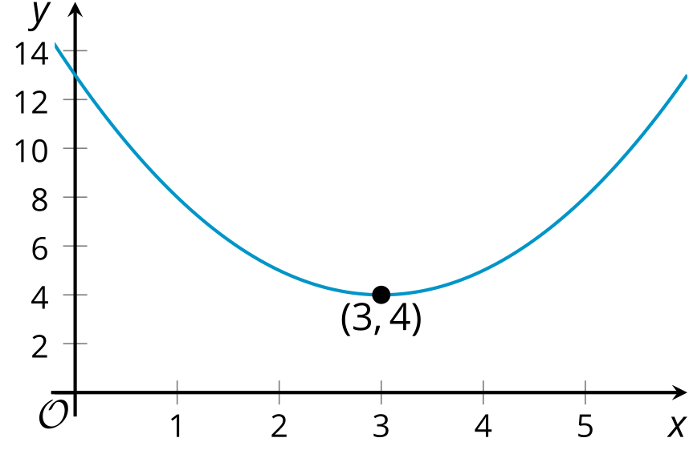
The vertex form can tell us about the coordinates of the vertex of the graph of a quadratic function. The expression ${\left(x−3\right)}^{2}$ reveals that the $x$-coordinate of the vertex is 3, and the constant term, 4, reveals that the $y$-coordinate of the vertex is 4. Here the vertex represents the minimum value of function $f$, and its graph opens upward.
In general, a quadratic function expressed in vertex form is written as $y=a{\left(x−h\right)}^{2}+k$. The vertex of its graph is at $\left(h,k\right)$. The graph of the quadratic function opens upward when the coefficient, $a$, is positive and opens downward when $a$ is negative.

