Unit 2 Lesson 2: Representations of Fractions (Part 2)

WU Which One Doesn’t Belong: All Cut Up (Warm up)

Student Task Statement
Which one doesn’t belong?
A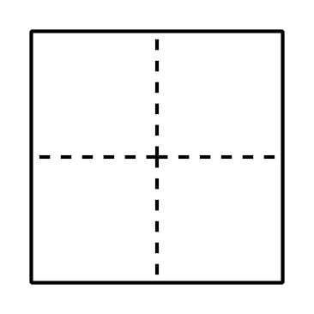
B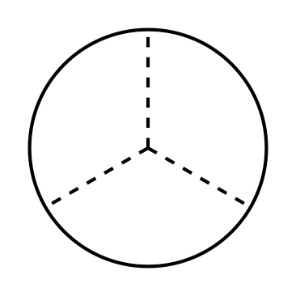
C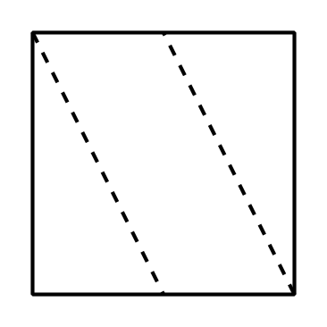
D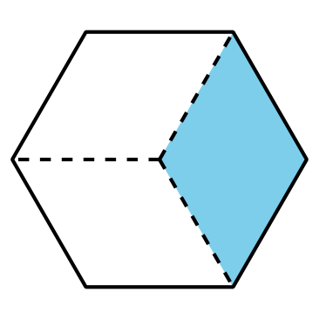

1 A Diagram for Each Fraction

Student Task Statement
Each full diagram represents 1. Match each fraction to a diagram whose shaded parts represents it.
Two of the fractions are not represented. Create a representation for each of them.
$\frac{2}{3}:\underset{_}{} \frac{3}{8}:\underset{_}{} \frac{4}{10}:\underset{_}{} \frac{4}{6}:\underset{_}{} \frac{6}{6}:\underset{_}{}$
$\frac{3}{5}:\underset{_}{} \frac{4}{8}:\underset{_}{} \frac{6}{12}:\underset{_}{} \frac{6}{10}:\underset{_}{} \frac{3}{4}:\underset{_}{}$
$\frac{5}{6}:\underset{_}{} \frac{2}{5}:\underset{_}{} \frac{5}{12}:\underset{_}{} \frac{7}{10}:\underset{_}{} \frac{7}{8}:\underset{_}{}$
A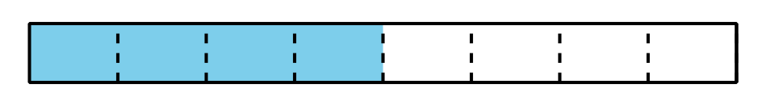
B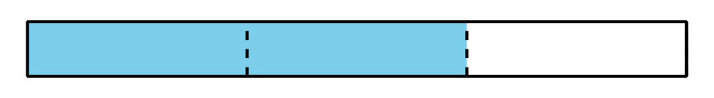
C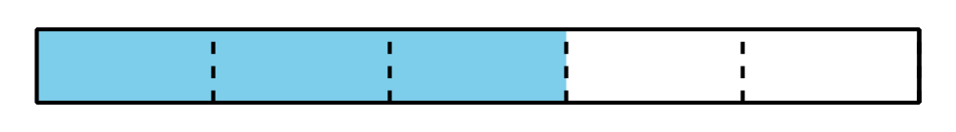
D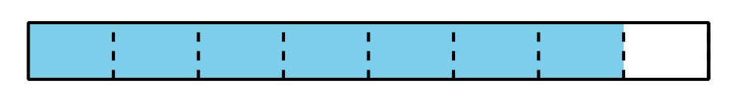
E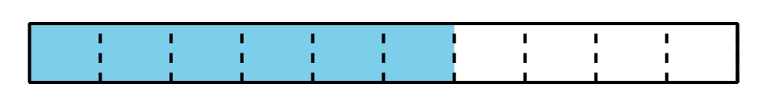
F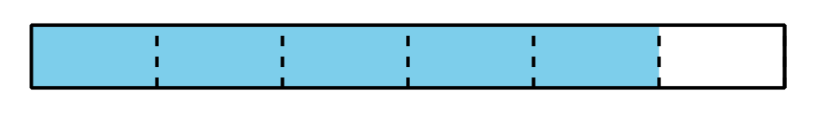
G 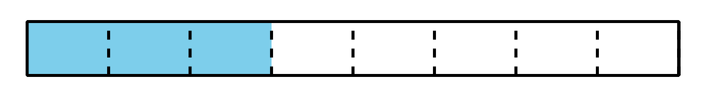
H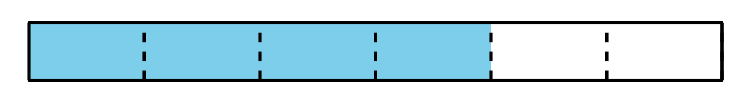
I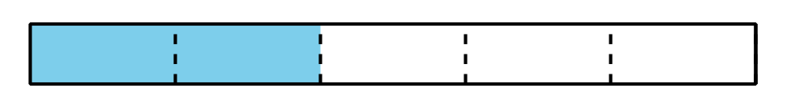
J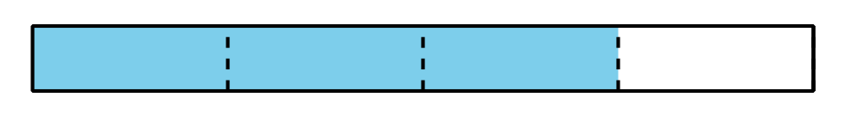
K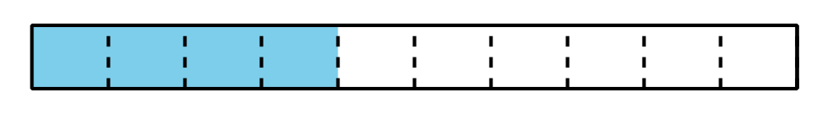
L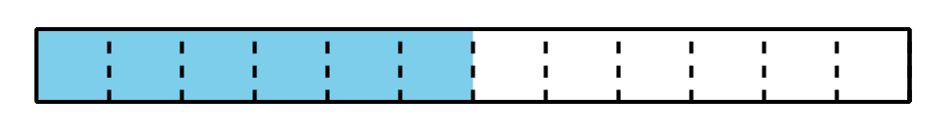
M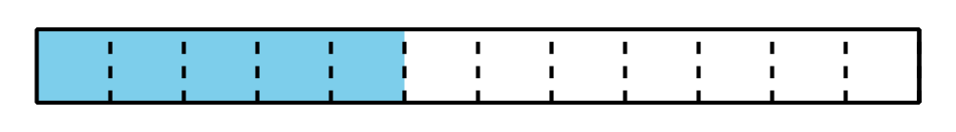
N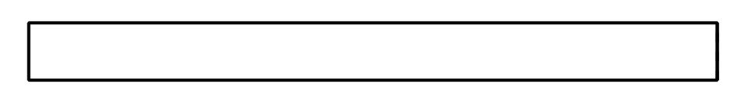
O

2 Diagrams for Some Other Fractions

Images for Launch
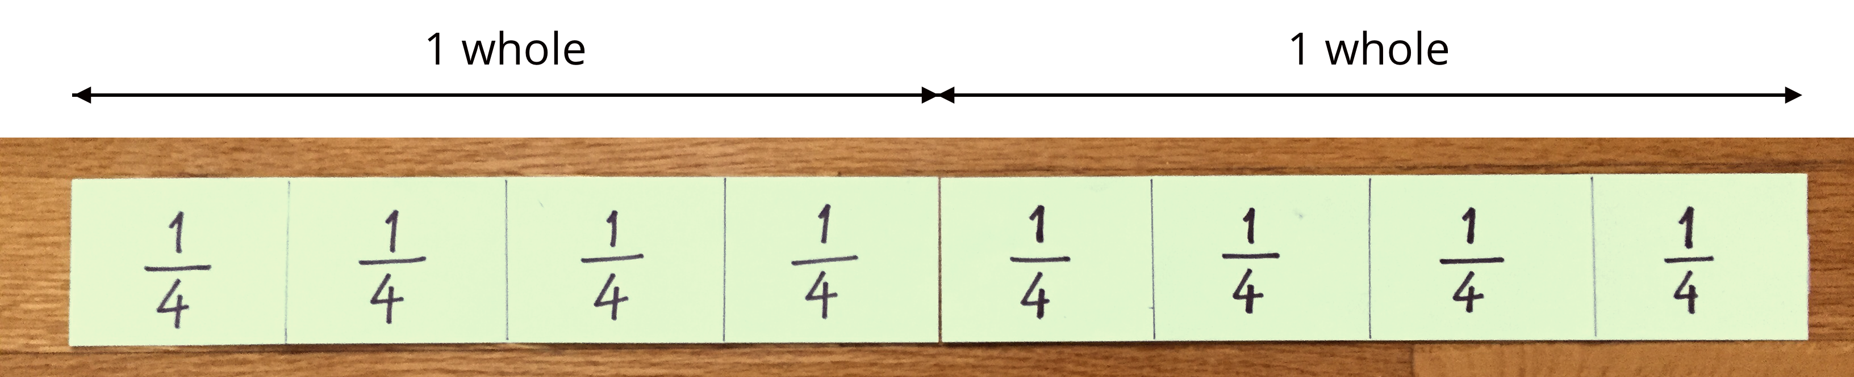

Student Task Statement
- What fraction do the shaded parts represent?
  - 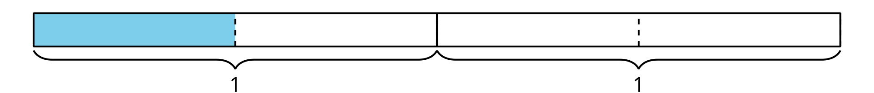
- Here are four fractions and four blank diagrams. Partition each diagram and shade the parts to represent the fraction.
  - $\frac{2}{2}$
  - 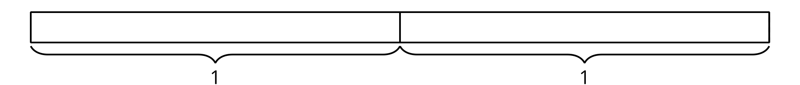
  - $\frac{4}{2}$
  - $\frac{5}{4}$
  - $\frac{10}{8}$
© CC BY 2021 Illustrative Mathematics®

