Grade 2
Unit 5Lesson 1CC BY NC 2024 Illustrative Mathematics®
Unit 5, Lesson 1

How Do We Compose a Hundred?
- Let’s compose a hundred.
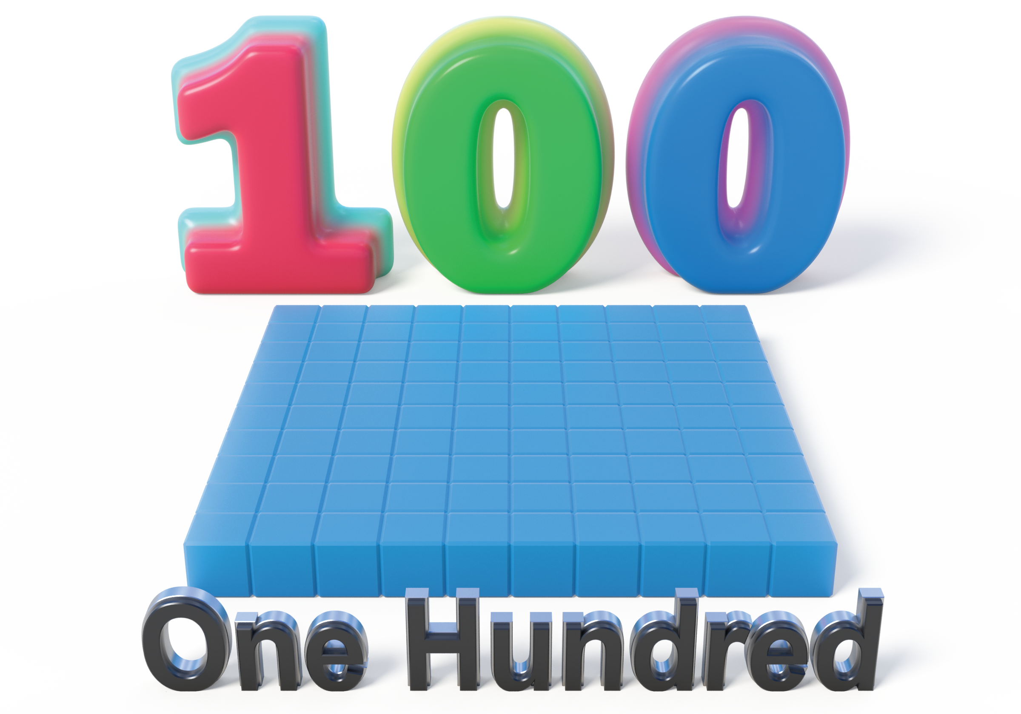
Grade 2
Unit 5Lesson 1CC BY NC 2024 Illustrative Mathematics®

Activity 1 How Do We Make a Hundred?
- How many do you see? How do you see them?
- 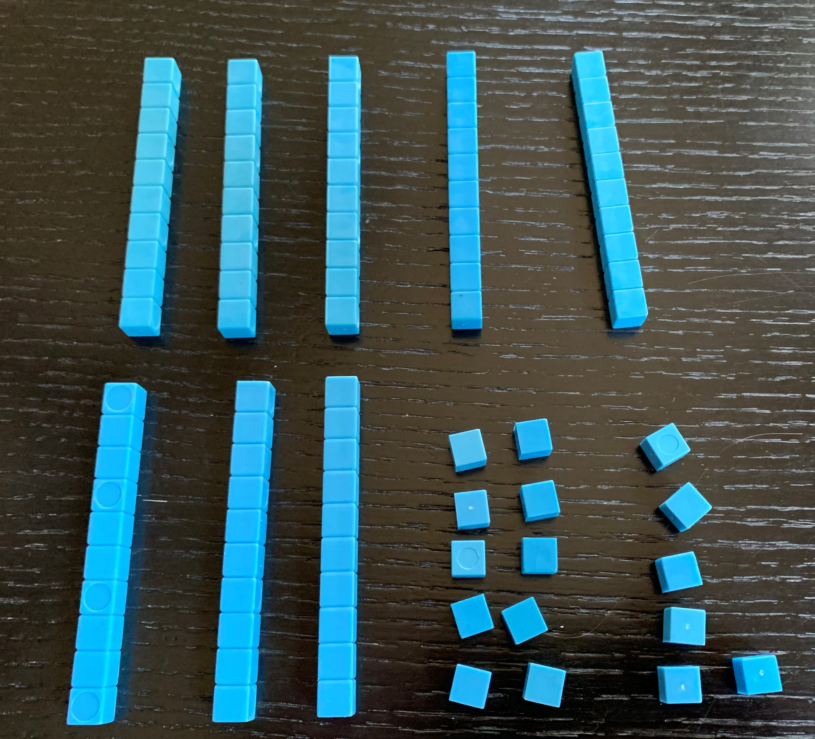
- Andre added more blocks.
- 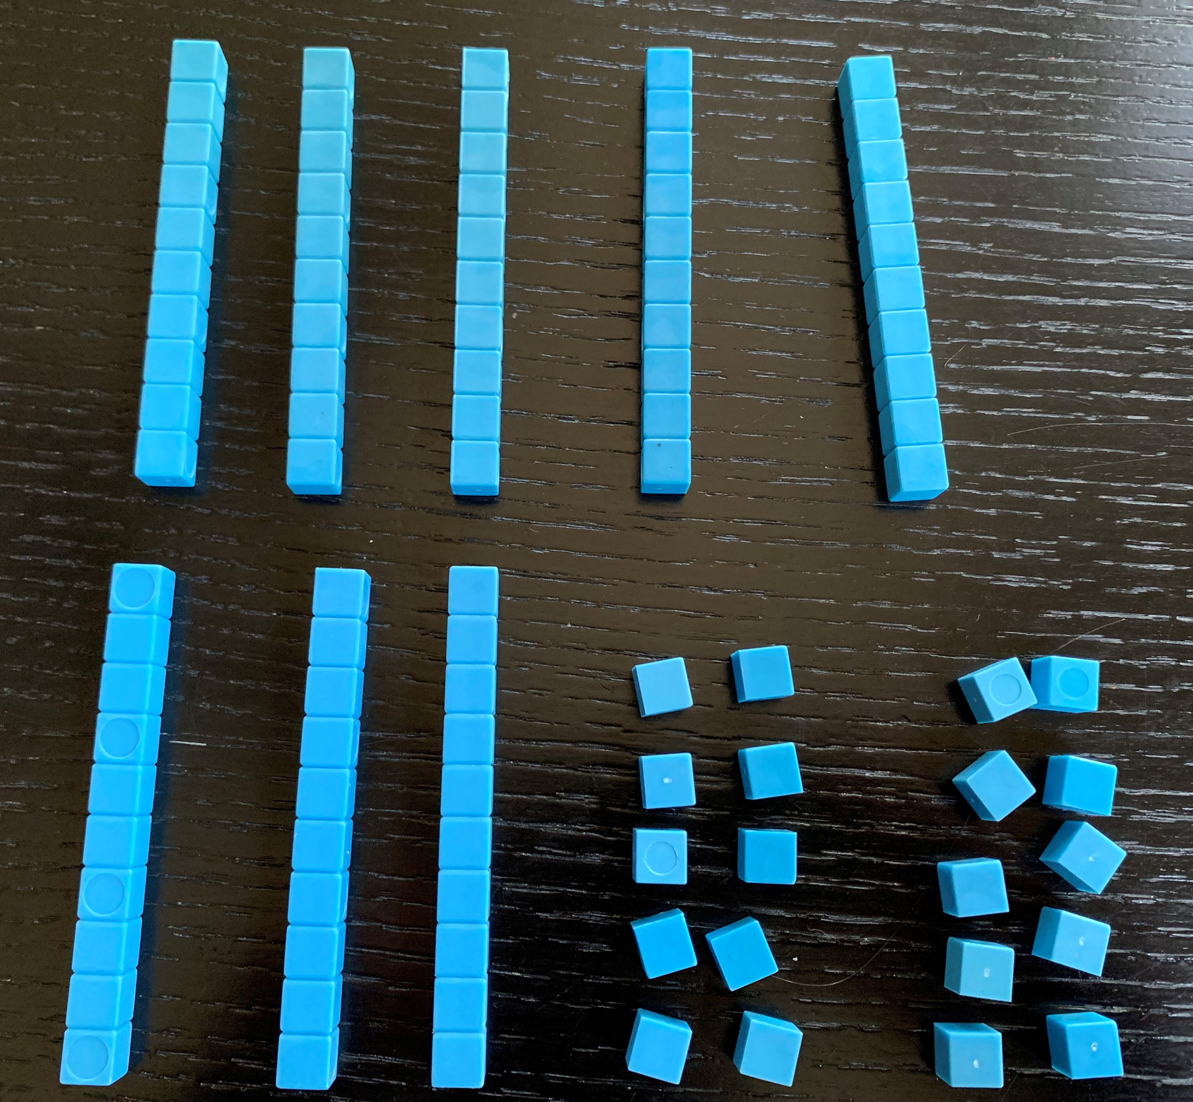
  - What is the value of his blocks now?
  - How many tens and ones does he have?
- Andre made the same number with the fewest number of blocks possible. Draw a base-ten diagram to show how the number looks now. Use your base-ten blocks to help.
Grade 2
Unit 5Lesson 1CC BY NC 2024 Illustrative Mathematics®

Activity 2Different Ways to Make 100
Three students look at 100 small squares arranged this way.
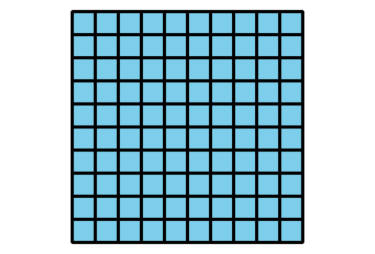
- Match the diagrams to the statements. Label each diagram with a, b, or c.
  - Priya said, “I see 100 ones.”
  - Kiran said, “I see 10 tens.”
  - Lin said, “I see 1 hundred.”
- 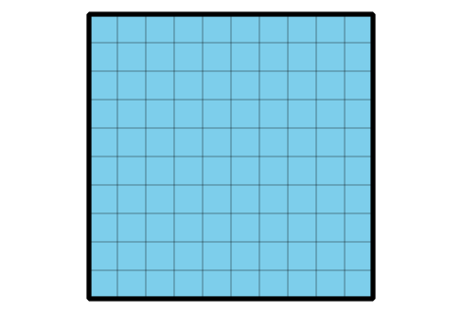
- 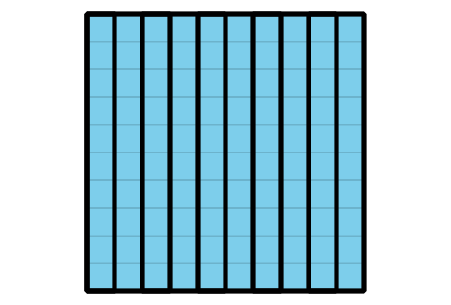
- 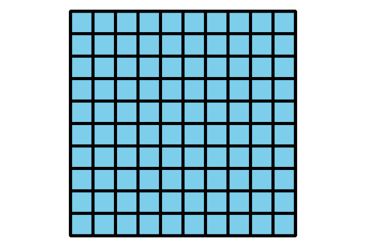
- ____________
- ____________
- ____________
- Represent $100+11$ with blocks or a diagram.

