Grade 6
Unit 1Lesson 13CC BY NC Illustrative Mathematics, based on IM 6–8 Math, CC BY Open Up Resources.
Unit 1, Lesson 13

Polyhedra
Let’s investigate polyhedra.
Grade 6
Unit 1Lesson 13CC BY NC Illustrative Mathematics, based on IM 6–8 Math, CC BY Open Up Resources.

13.1What Are Polyhedra?
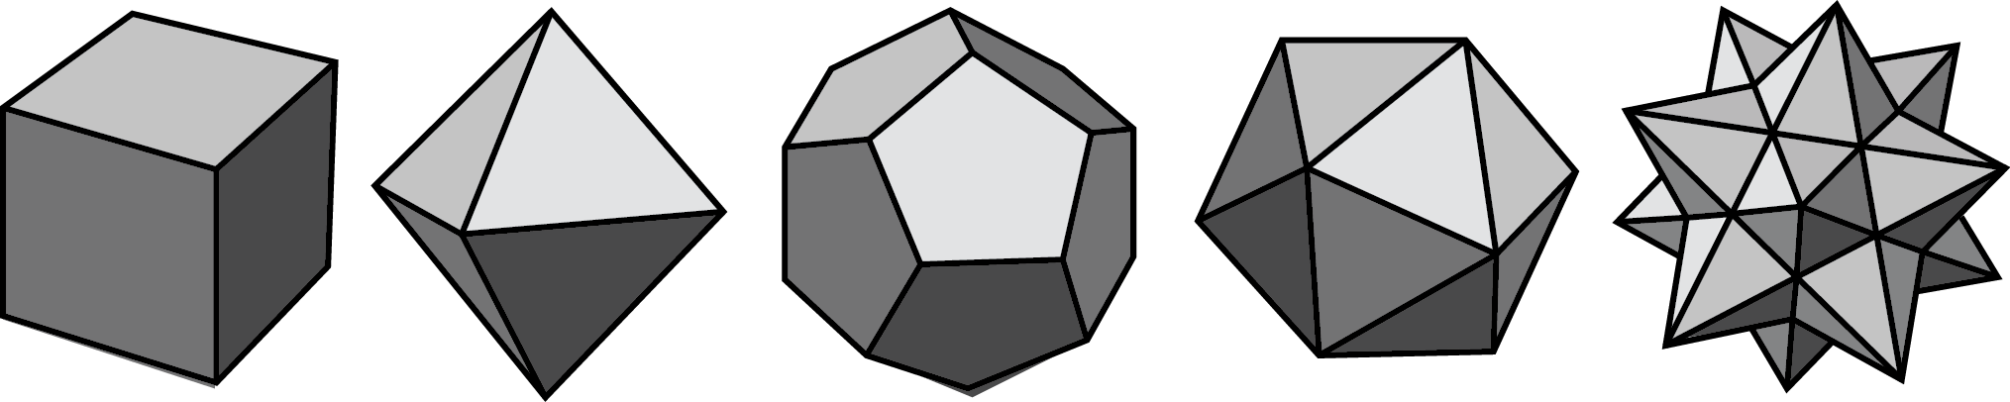
These five drawings represent polyhedra.
The next four drawings do not represent polyhedra.
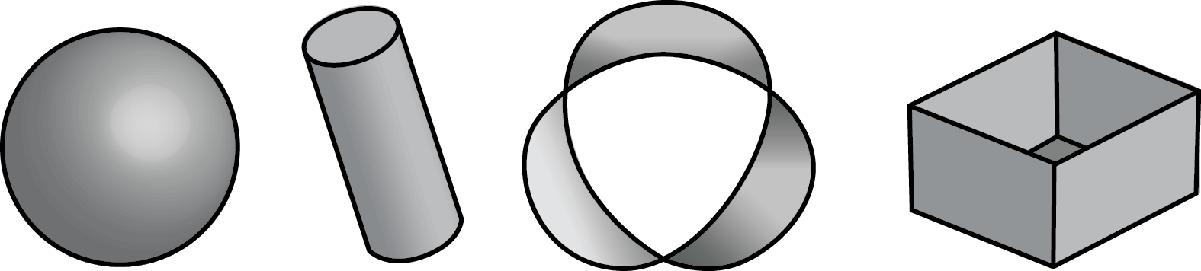

- Your teacher will give you some figures or objects. Sort them into polyhedra and non-polyhedra.
- What characteristics helped you distinguish the polyhedra from the other figures?
Grade 6
Unit 1Lesson 13CC BY NC Illustrative Mathematics, based on IM 6–8 Math, CC BY Open Up Resources.

13.2Prisms and Pyramids
- Here are some polyhedra called prisms.
- A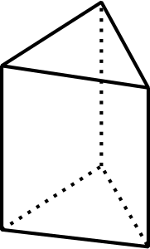
- B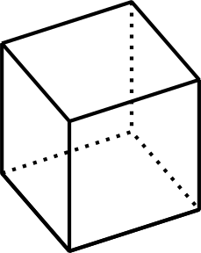
- C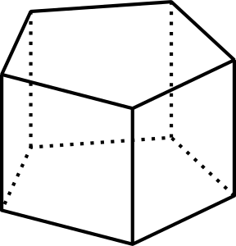
- D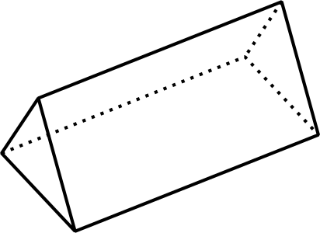
- E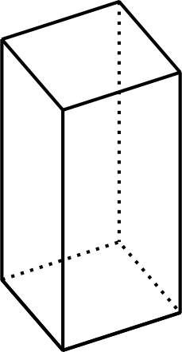
- F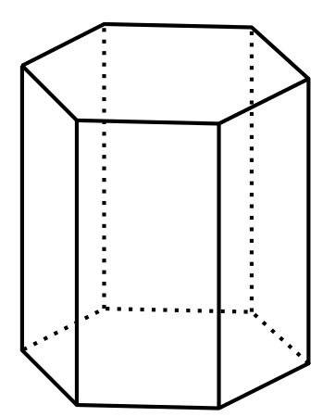
- Here are some polyhedra called pyramids.
- P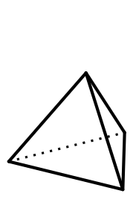
- Q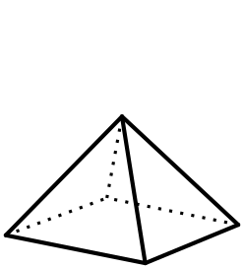
- R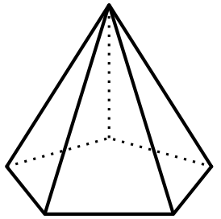
- S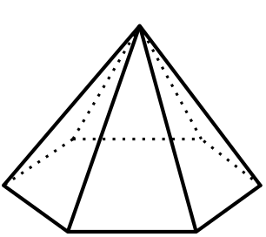
  - Look at the prisms. What are their characteristics?
  - Look at the pyramids. What are their characteristics?
- Which of these nets can be folded into Pyramid P? Select all that apply.
- 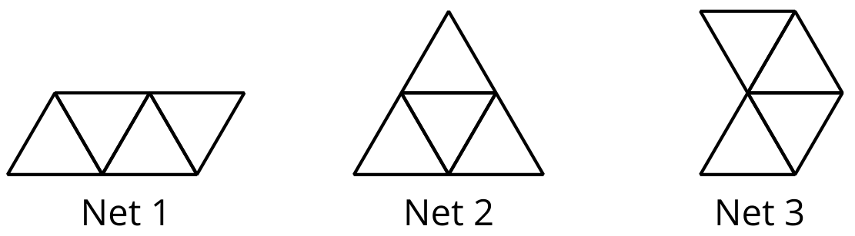
- Your teacher will give your group some polygons and assign a polyhedron.
  - Decide which polygons are needed to compose your assigned polyhedron. List the polygons and how many of each are needed.
  - Arrange the cut-outs into a net that, if taped and folded, can be assembled into the polyhedron. Sketch the net. If possible, show a different net for the same polyhedron.

Are you ready for more?
What is the smallest number of faces a polyhedron can possibly have? Explain how you know.
Grade 6
Unit 1Lesson 13CC BY NC Illustrative Mathematics, based on IM 6–8 Math, CC BY Open Up Resources.

13.3Assembling Polyhedra
- Your teacher will give you the net of a polyhedron. Cut out the net, and fold it along the edges to assemble a polyhedron. Tape or glue the flaps so that there are no unjoined edges.
- How many vertices, edges, and faces are in your polyhedron?

Lesson 13 Summary
A polyhedron is a three-dimensional figure composed of faces. Each face is a polygon and meets only one other face along a complete edge. The ends of the edges meet at points that are called vertices.
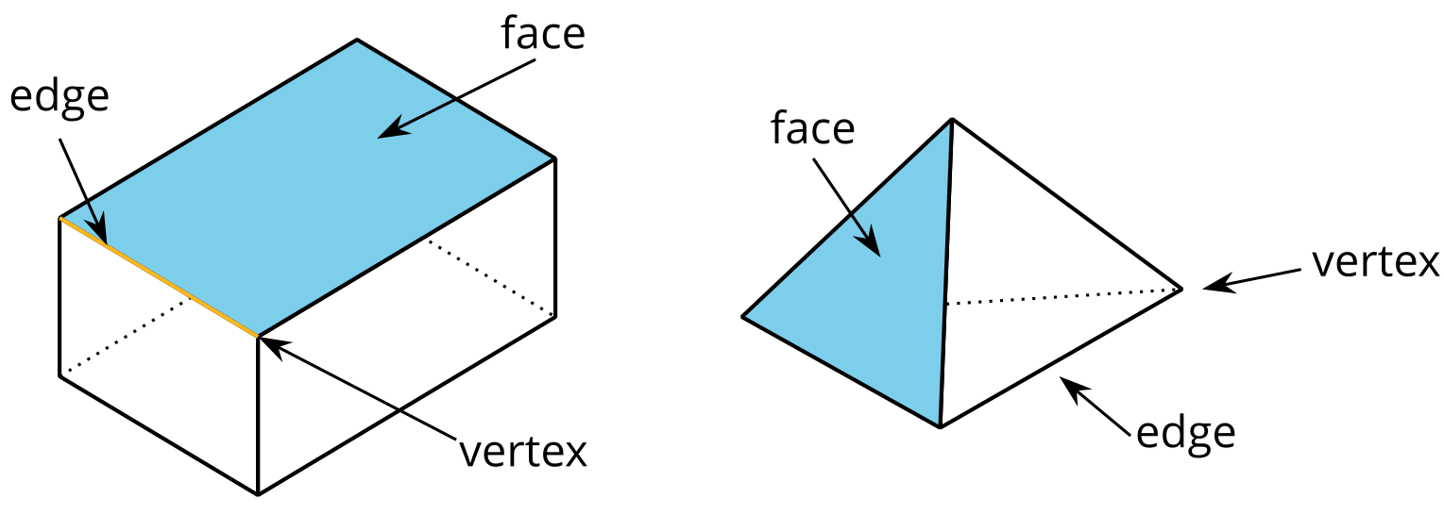
A polyhedron always encloses a three-dimensional region.
The plural of polyhedron is polyhedra. Here are some drawings of polyhedra:
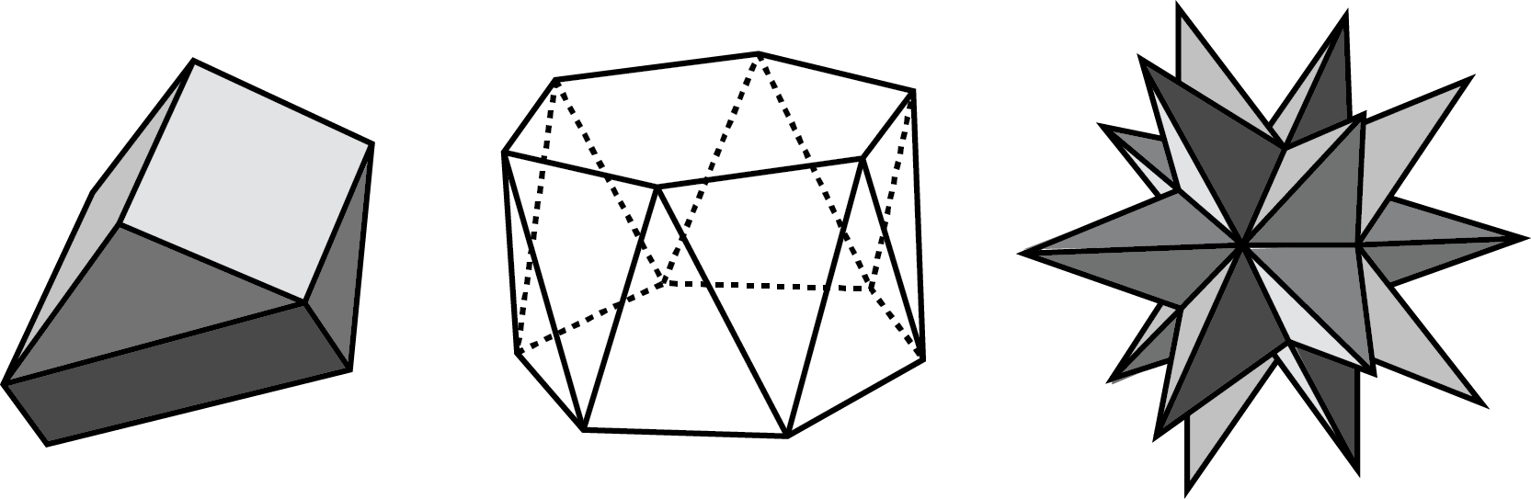
A prism is a type of polyhedron with two identical faces that are parallel to each other and that are called bases. The bases are connected by a set of rectangles (or sometimes parallelograms that aren’t rectangles).
A prism is named for the shape of its bases. For example, if the base is a pentagon, then it is called a “pentagonal prism.”
triangular prism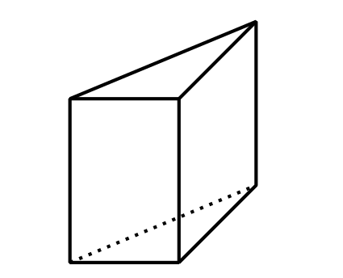
pentagonal prism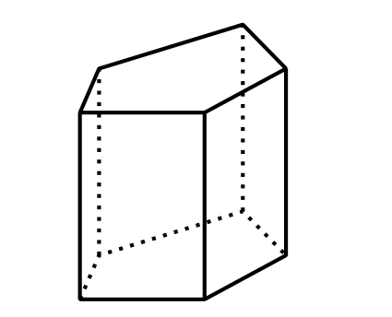
rectangular prism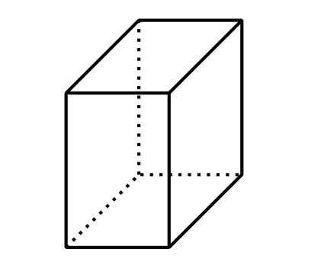
A pyramid is a type of polyhedron that has one special face called the base. All of the other faces are triangles that all meet at a single vertex.
A pyramid is named for the shape of its base. For example, if the base is a pentagon, then it is called a “pentagonal pyramid.”
rectangular pyramid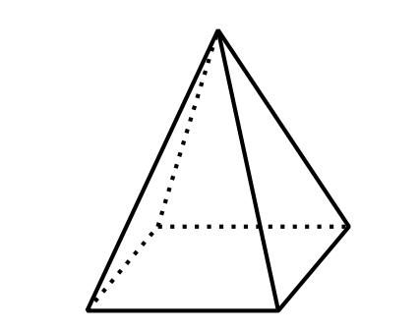
hexagonal pyramid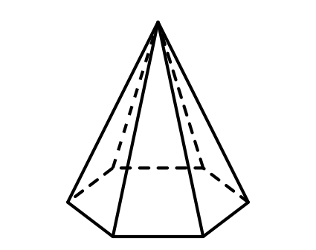
heptagonal pyramid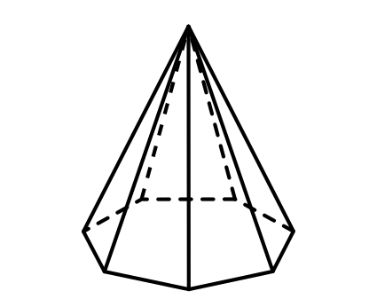
A net is a two-dimensional representation of a polyhedron. It is composed of polygons that form the faces of a polyhedron.
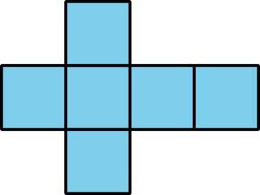
A cube has 6 square faces, so its net is composed of six squares, as shown here.
A net can be cut out and folded to make a model of the polyhedron.
In a cube, every face shares its edges with 4 other squares. In a net of a cube, not all edges of the squares are joined with another edge. When the net is folded, each of these open edges will join another edge.

