Grade 6
Unit 3Lesson 1CC BY NC Illustrative Mathematics, based on IM 6–8 Math, CC BY Open Up Resources.
Unit 3, Lesson 1

Anchoring Units of Measurement
Let’s see how big different things are.
Grade 6
Unit 3Lesson 1CC BY NC Illustrative Mathematics, based on IM 6–8 Math, CC BY Open Up Resources.

1.1Estimating Volume
Estimate the volume of the tiny salt shaker.
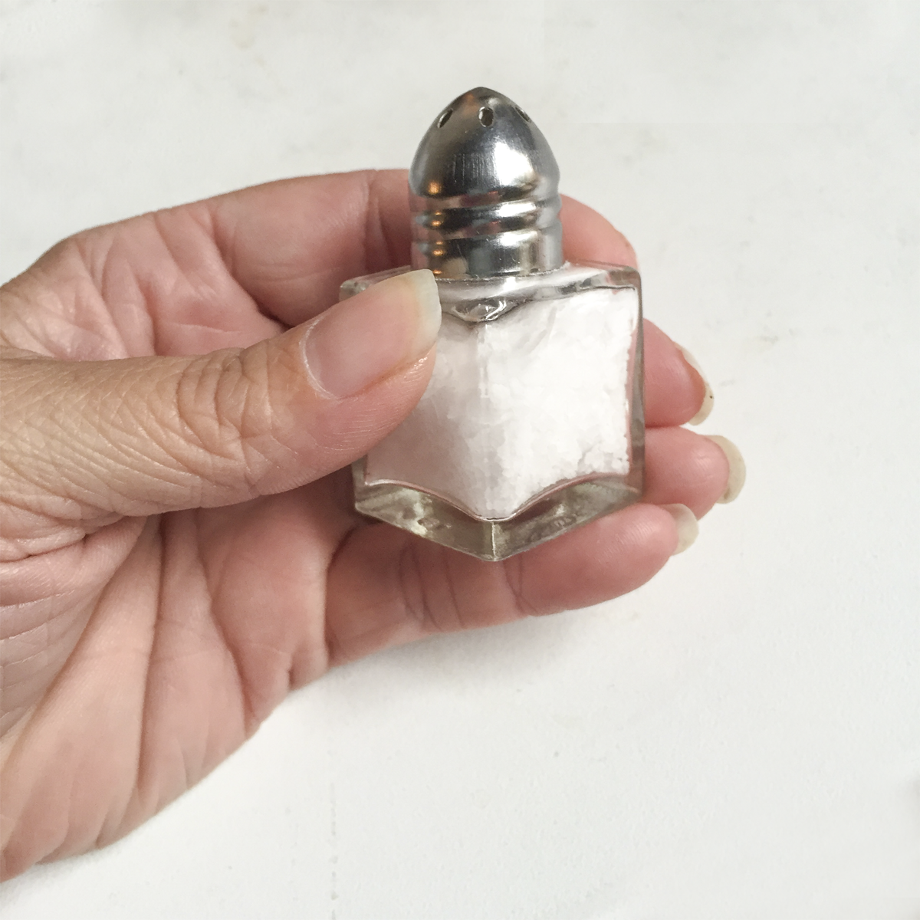
Grade 6
Unit 3Lesson 1CC BY NC Illustrative Mathematics, based on IM 6–8 Math, CC BY Open Up Resources.

1.2What Do They Measure?
Write each unit in the appropriate column based on whether it measures length, volume, or weight or mass.
centimeter
cup
foot
gallon
gram
inch
kilogram
kilometer
liter
meter
mile
milliliter
millimeter
ounce
pound
quart
ton
yard
length | volume | weight or mass
Grade 6
Unit 3Lesson 1CC BY NC Illustrative Mathematics, based on IM 6–8 Math, CC BY Open Up Resources.

1.3Cutting String
Your teacher will assign you one of the following lengths:
1 centimeter, 1 foot, 1 inch, 1 meter, or 1 yard.
Estimate and cut a piece of string as close to your assigned length as you can without using a measurement tool.
Grade 6
Unit 3Lesson 1CC BY NC Illustrative Mathematics, based on IM 6–8 Math, CC BY Open Up Resources.

1.4Card Sort: Measurement Benchmarks
Your teacher will give you a set of cards, each with a picture of an object and a letter in the top right corner. Use the graphic organizers to sort the cards with the same letter.
- Match each picture card that has the letter “L” to a unit of length that is closest to the length of the object.
- Match each picture card that has the letter “V” to a unit of volume that is closest to the volume of the object.
- Match each picture card that has the letter “WM” to a unit of weight or mass that is closest to the weight or mass of the object.

Lesson 1 Summary
We can use everyday objects to estimate standard units of measurement. Here are some examples.
unit of length | is about . . .
1 millimeter | the thickness of a dime
1 centimeter | the width of a pinky finger
1 inch | the length from the tip of your thumb to the first knuckle
1 foot | the length of a football
1 yard | the length of a baseball bat
1 meter | the length of a baseball bat and ball
1 kilometer | the distance someone walks in 10 minutes
1 mile | the distance someone runs in 10 minutes

unit of volume | is about . . .
1 milliliter | the volume of a eyedropper
1 cup | the volume of a school milk carton
1 quart | the volume of a large bottle of sports drink
1 liter | the volume of a reusable water bottle
1 gallon | the volume of a large milk jug

unit of weight or mass | is about . . .
1 gram | the mass of a raisin
1 ounce | the weight of a slice of bread
1 pound | the weight of a loaf of bread
1 kilogram | the mass of a textbook
1 ton | the weight of a small car

